Spatial Data Mining: Practical Approaches
for Analyzing Relationships Within and Among Maps

Joseph K. Berry

Keck Scholar in Geo-Sciences, University of Denver – Principal, Berry and Associates
2000 South College Avenue, Suite 300, Fort Collins, Colorado 80525

Phone: 970-215-0825 – Email: jberry@innovativegis.com – Website: www.innovativegis.com/basis

Abstract: In the past thirty years GIS technology has progressed from computer mapping to spatial database management and, more recently, to quantitative map analysis and modeling. However, many applications still rely on visceral/visual analysis for determining similarity within and among maps. Various quantitative techniques for analysis and comparison of mapped data are becoming available in inexpensive and easy-to-use packages that seamlessly interface with existing desktop mapping systems. This paper introduces the conceptual basis and practical considerations in evaluating data patterns within a single map and relationships among sets of map layers. The grid-based procedures discussed include density analysis, similarity index, data zoning/clustering and predictive modeling. Considerable attention is given to the nature of mapped data, assumptions inherent in the techniques, and mechanisms for evaluating results. Examples emphasize natural resource and geo-business applications yet apply to any discipline seeking to quantify descriptive and predictive relationships within and among maps.

PowerPoint slide set is available online at…

Further information is available online at…

http://www.innovativegis.com/basis/MapAnalysis/Default.html

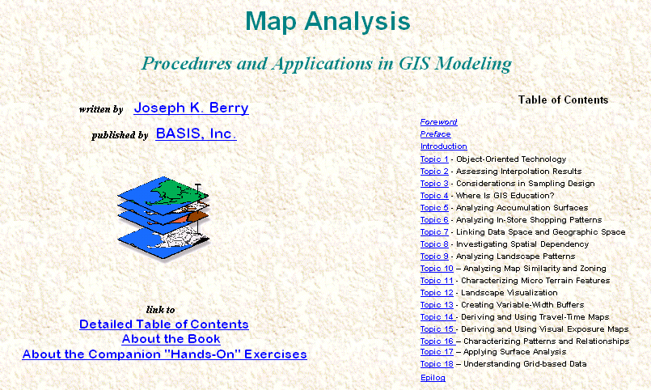

…select Topic 10, Analyzing Map Similarity and Zoning for discussion on map comparison, correlation and prediction procedures.

…select Topic 16, Characterizing Patterns and Relationships for discussion on map similarity, zoning, clustering, prediction and stratification procedures

