

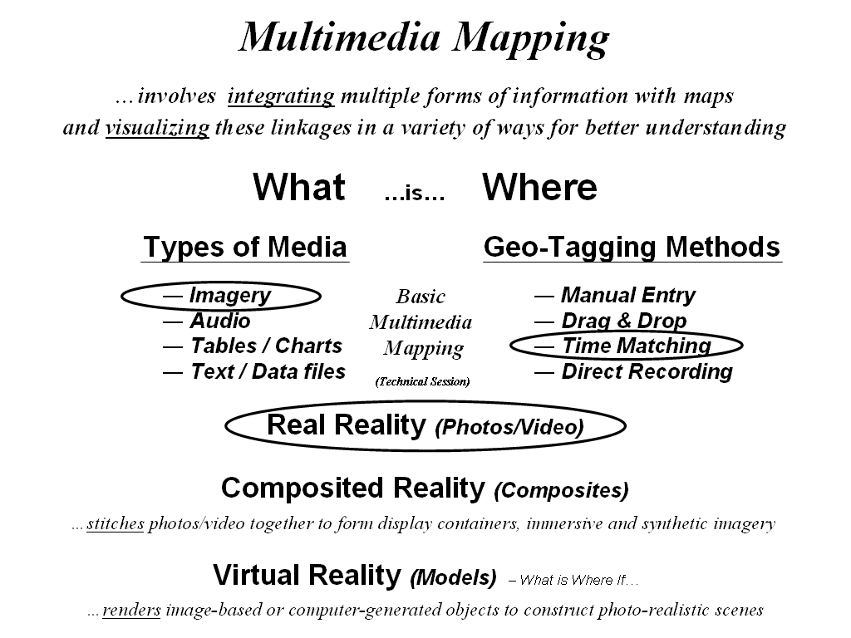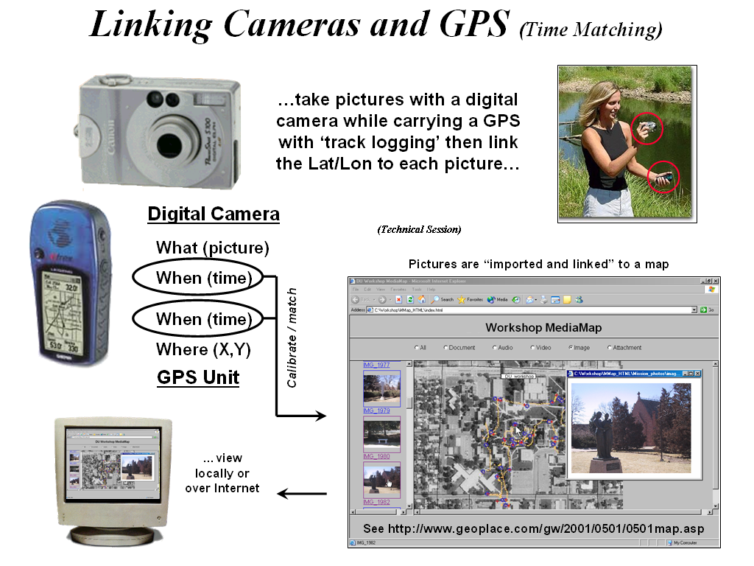

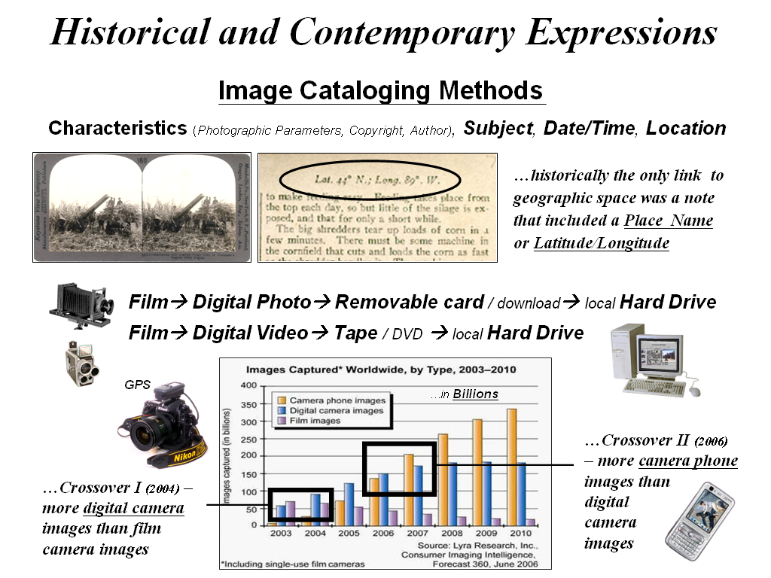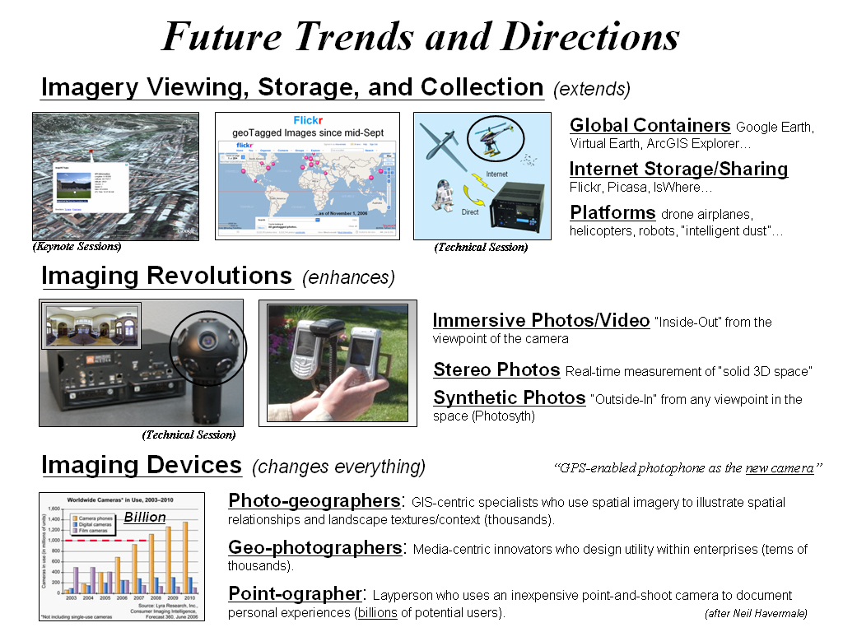

Key Words to “Google” — General: multimedia mapping, geospatial media, linking maps and GPS, MediaMapper. Geotagging: geotag, geotagging, geocoding, time-matching geotagging, JPEG2000 EXIF format, IsWhere. Viewing/Storage/Collection: Google Earth, Virtual Earth, ArcGIS Explorer beta, Google Earth mash-ups, GeoFlickr; Picasa, BlockRocker, Zillow. Immersive Photos/Video: immersive photos, immersive video, iPixs, Telemmersion. Stereo Photos: close-range stereo photogrammetry. Synthetic Photos: image matching, image stitching, Photosynth. Imaging Devices: Nikon D1X-GPS camera, sDVR recorder, GPS camera phone, e911 mobile phones.

Technical Sessions …experience with cutting-edge MMM technology

Multimedia Mapping Basics  by Dr. Joseph Berry  Red Hen Systems | Building a GeoImmersive Imagery DB  by Fuad Khan  Immersive Media | Drone Helicopter Imaging Platform  by Dale Knock  Talon Positioning Solutions
This presentation investigates how photos, streaming video and other multimedia can be directly linked to maps. The process automatically links the media to their field collection locations by either directly recording GPS coordinates with the files or by post-processing the GPS and media time stamps. Clicking on the interactive map pops-up the image or video associated with a location. Multimedia maps come alive with sights and sounds of locations, such as hiking trails, infrastructure assets, real estate offerings, schools and other facilities. In this presentation, MediaMapper will be used to create a “media map” of a portion of the NAIT campus.  www.redhensystems.com | Immersive video maps provide users with an on the ground experience that extends the traditional fixed frame video “tunnel” into a 3D experience allowing the viewer to look in all directions along a streaming video path. This revolutionizes how maps are conceptualized in a large number of disciplines ranging from government and industrial situational awareness, urban planning and asset management, energy and resource planning, environmental and academic research. In this presentation, IMC will describe imagery collection process and demonstrate GeoImmersive imagery integrated with various mapping solutions including web deployment.  www.immersivemedia.com | Talon Positioning Solutions Inc. is pleased to demonstrate Autocopter; Canada’s first and only fully autonomous commercially available helicopter. The helicopter is capable of flying a predetermined 3D flight path via waypoints, or in Semi Autonomous mode it may be flown by an operator with very little experience using a joystick. The helicopter can carry a payload of up to 20 lbs, and fly for up to two hours providing a stable platform for various devices such as multi-spectral imagery, methane leak detectors, high resolution digital video and stills. All imagery is captured with GPS coordinates ready to be added to a GIS/CAD system as soon as the helicopter lands.  dale@talonsurvey.com

