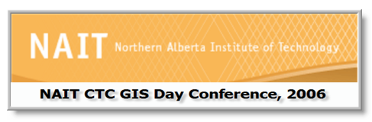

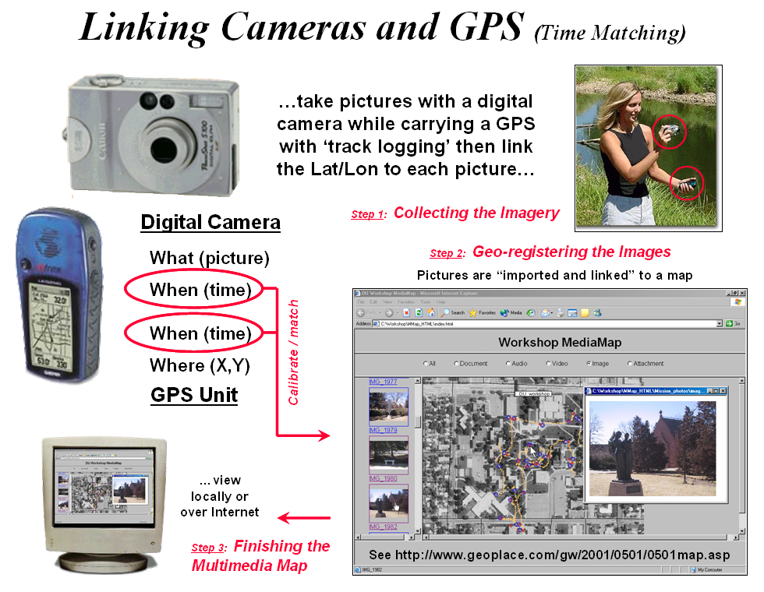

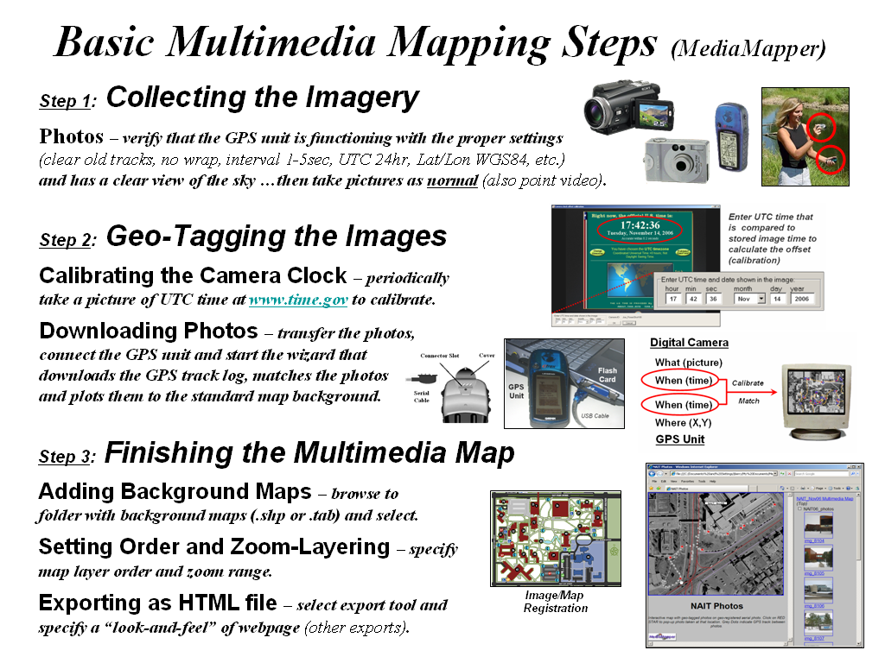

…using MediaMapperTM software by Red Hen Systems, www.redhensystems.com

RHS also offers hardware and software solutions for streaming video mapping
as well as direct geo-tagging for digital cameras and photophones

