Bridging GIS and Map Analysis:
Identifying and Utilizing Spatial relationships

Joseph K. Berry
Keck Scholar in Geosciences, University of Denver
Principal, Berry & Associates // Spatial Information Systems (BASIS)
2000 South College Avenue, Suite 300, Fort Collins, Colorado 80525
jberry@innovativegis.com

ABSTRACT

Most human endeavors are inherently spatial. The world we live in surrounds us with opportunities and challenges that are spatially dependent on “Where is What” tempered by “Why and So What” within cognitive contexts. In just three decades GIS technology has revolutionized our perspective on what constitutes a map and the information it can project. The underlying data are complex, as two descriptors are required— precise location, as well as a clear description. Manually drafted maps emphasized accurate location of physical features. Today, maps have evolved from guides of physical space into management tools for exploring spatial relationships and perceptions. The journey from the map room to the conference room has transformed maps from static wall hangings into interactive mapped data that address complex spatial issues. It also has sparked an entirely new analytical tool set that provides needed insight for effective decision-making. This new perspective marks a turning point in the use of maps— from one emphasizing physical descriptions of geographic space, to one of interpreting mapped data and successfully communicating spatially based decision factors. This paper investigates the context, conditions and forces forming the bridge from maps to mapped data, spatial analysis and beyond.

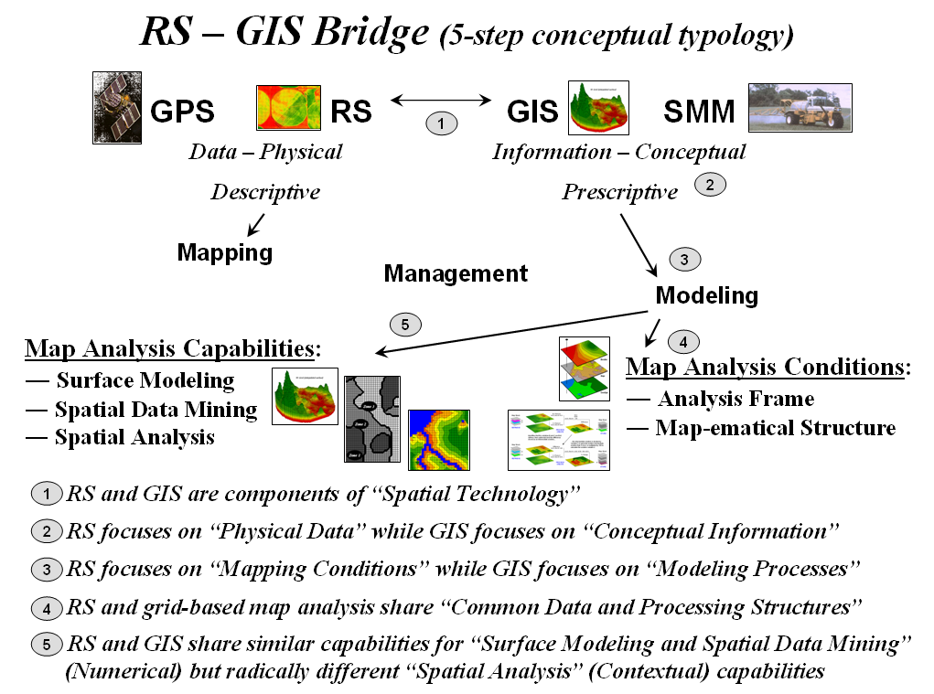
______________________________________________________________________
…for more information on grid-based map analysis, paper and PowerPoint slide set, see

www.innovativegis.com/basis/, select “Presentations/Papers”

