Exercise #1 – Map Analysis Framework (MapCalc)

Installing MapCalc Learner. Place the MapCalc Learner CD in your CD drive and it will self-boot to the main menu…

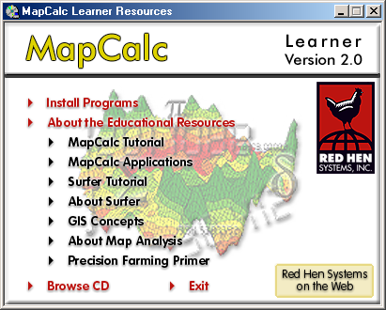 …note: if the CD doesn’t self-boot, enter Start→ Run and navigate to your CD drive then select “Setup.exe.”

Select Install Programs then click on Install MapCalc Learner 2.0 and follow the instructions. Repeat for the Install Surfer 7.0 Demo selection.

Once both programs are installed, click on Back to Educational Resources. As time permits, review the Educational Resources provided on the MapCalc Learner CD.

Accessing MapCalc. To begin a MapCalc session:
- Click on Window’s Start button.
- Navigate to Program Files à Red Hen Systems à MapCalc and click on the MapCalc.exe.
- Choose Open existing map set from the MapCalc Quick Start menu and open the “Tutor25.rgs” database. The .RGS table will be accessed, several of the base maps will be opened and a 2-D display of the Elevation map will be maximized.

…note: you can make a shortcut to MapCalc Learner on your desktop by using Windows Explorer to navigate to the program (C:\Program Files\Red Hen Systems\MapCalc\Map.exe) then right-click on the program and select Send to→ Desktop (create shortcut). Double-clicking on the shortcut icon on your desktop will access the MapCalc program.

Slowly move the cursor over the map and observe the map values associated with various locations. The color levels identified in the map legend aggregate the elevation values into ten 200-foot contour intervals ranging from 500 to 2500 feet.

Click on the Layer mesh button on the main tool bar. The grid configuration for the Tutor25 database is 25 columns by 25 rows (25 x 25= 625 grid cells). Each cell is 100 x 100 meters (10,000 square meters; one hectare; 2.54 acres). The maps in the database are hypothetical and the Latitude and Longitude coordinates for the project area were arbitrarily assigned. The contour lines and interactive data labels for the Elevation map are interpolated “on-the-fly” from the underlying grid data.

Click on the Use cells button. The display switches from “Lattice” to “Grid” display type with the contour color codes assigned to entire cells.

Click on the Toggle 3D view button. The display switches to a “3-D Grid” display type. The color-coding at the top of each projected cell identifies the elevation value at that location.

The navigation tools enable you to zoom, pan and rotate a display.

- Click on the Zoom in button then click-and-drag a rectangular portion of the displayed map to enlarge that area.
- Click on the Zoom out button then click-and-hold while sliding up and down to continuously rescale the display when you release the mouse button.
- Click on the Move button and click-and-hold to move the display to another part of the screen.
- Click on the Rotate button then click-and-hold as you rotate the plot cube.
- Click on the Reset view button to return to the default display settings.

Click off the Use cells button to switch to a “3-D Lattice” display type, commonly called a “wireframe” display. Note that the navigation tools operate in the same manner for both the grid and lattice display types.

Click off and on the Layer contoured and Layer contour lines buttons to turn off and on the contour-fill colors and lines.

Click off and on the Floor contours/lines and Ceiling contours/lines buttons and note the changes in the 2-D projected planes in the plot cube.

Click on the word “Map” in the main menu, then select “Overlay” and choose the “Slope” map. The result is a graphical overlay of the Slope map on the 3-D display of the Elevation map. Note that the areas classified as steep (green tones) align with the steepest portions of the terrain surface.

Click on the Arrange windows buttons to view all of the open map windows in different arrangements. Click on the Maximize button in the Slope map’s window to enlarge the display to fit the entire work area. For review, repeat the display tools exercises you just completed using the elevation map on the Slope map.

Clicking on the word “Window” on the main menu produces a listing of open windows and window management tools. Clicking on any of the open map windows listed will cause that map to be maximized in the work area.

Click on the Layer Manager (View, Rename and Delete layers) button to pop-up a listing of the current maps in the Tutor25 database. You can Rename and Delete existing maps. As new maps are created they are added to the list. The View function opens a map in a new window. It is important to note that you can have multiple windows open of the same map (Clone view). While this can cause some initial confusion, experienced MapCalc users find it useful for positioning side-by-side views of the same data, such as a 2-D display and a 3-D plot. On the Main Menu, click File→ Exit (no need to save your work).

Note: see Educational Resources→ MapCalc Tutorials for more information MapCalc operation and grid-based map analysis fundamentals.
Exercise #2 – Example of a Simple GIS Model (MapCalc)

Cross-reference to ESRI Grid and Spatial Analysis operations…

MapCalc Command | Grid / Spatial Analyst
Slope creates a map indicating the slope (1st derivative) along a continuous surface. | Surface function SLOPE
Drain creates a map indicating the number of steepest paths (optimal path density) from a set of locations along a surface. | Hydrologic function FLOWACCUMULATION
Renumber assigns new values to the categories on a map. | Reclassification function RECLASS
Calculate creates a map as the mathematical or statistical function evaluating an equation using a stack of map layers. | Arithmetic operators  *, +, -, DIV, MOD

Exercise #3 – Grid Display Forms and Data Types (MapCalc)

Exercise #4 – Reclassify and Overlay Techniques (MapCalc)

Access the MapCalc software system and select the Tutor25.rgs database.

Generate the following displays of the Elevation surface…(remember how?)
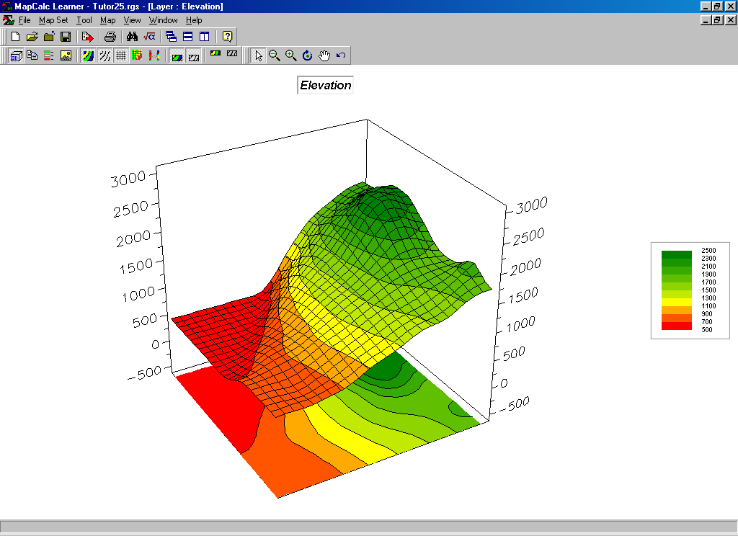
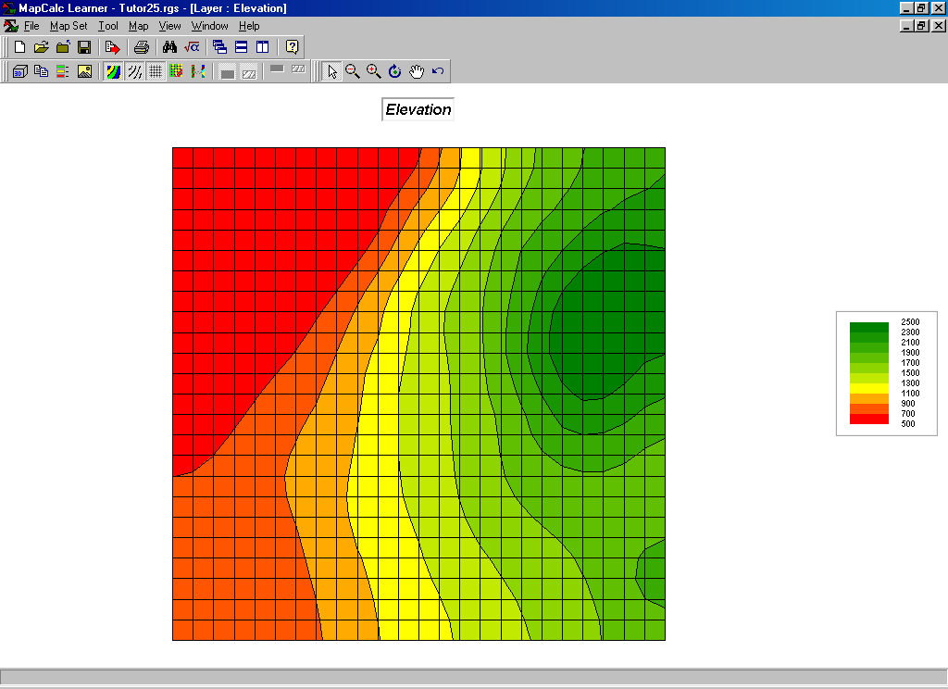
2D Contour map display with analysis grid 3D Wireframe display

Derive maps of terrain steepness (Slopemap) and terrain orientation (Aspectmap) by…

Press the Map Analysis button to pop-up the Map Analysis dialog box.
Select Neighbors→ Slope to pop-up the Slope dialog box. Complete the form as shown below.

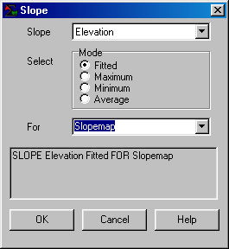

Re-display the Elevation map (Window→ Elevation) then select Map→ Overlay→ Slopemap to “drape” the Slopemap over the terrain surface and note the alignment of the two maps.

Press the Map Analysis button to pop-up the Map Analysis dialog box.
Select Neighbors→ Orient to pop-up the Orient dialog box. Complete the form as shown below.

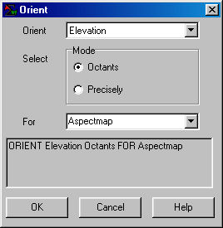

Re-display the Elevation map (Window→ Elevation) then select Map→ Overlay→ Aspectmap to “drape” the Aspectmap over the terrain surface and note the alignment of the two maps.

Access the Habitat.scr script file by…

Press the Map Analysis button to pop-up the Map Analysis dialog box.

On the Map Analysis menu click on Scripts→ Open→ navigate to the …\Scripts folder and select the Habitat.scr file.

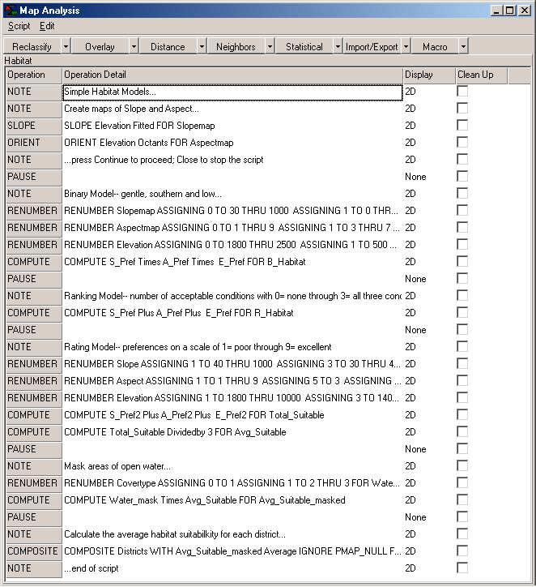 Habitat.scr script

You completed the first two command lines…
SLOPE Elevation Fitted FOR Slopemap
ORIENT Elevation Octants FOR Aspectmap
…in the previous section.

Double-click on the next command line…
RENUMBER Slopemap ASSIGNING 0 TO 30 THRU 1000
ASSIGNING 1 TO 0 THRU 30 FOR S_Pref
…to pop-up the Renumber dialog box for this step of the habitat command script.

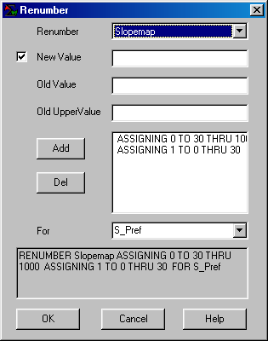

Note the command assignments and interpret what processing is involved. Press OK to submit the command and generate the specified map. Evaluate the map that was created and interpret what the map values represent…
0= Unsuitable
1= Suitable for Hugags (not too steep as <30% slope)
Repeat the procedure to call-up the next command line; review the command specification and interpret the new map’s values.
0= Unsuitable
1= Suitable for Hugags (3= Easterly through 7=Westerly oriented)

Repeat for the elevation preference…
0= Unsuitable
1= Suitable for Hugags (not to high as < 1800 feet elevation)

Create a “Binary” preference map that locates suitable areas by entering…
COMPUTE S_Pref Times A_Pref Times E_Pref FOR B_Habitat
Where,
0= Unsuitable
1= Suitable for Hugags (1 * 1* 1= 1)

Now create a “Ranking” map of habitat quality by entering…

COMPUTE S_Pref Plus A_Pref Plus E_Pref FOR R_Habitat
Where,
0= Unsuitable
1= Poor suitability (only 1 criterion)
2= Moderate suitability (2 criteria)
3= Good suitability (all 3 criteria)

Create a “Rating” habitat map…

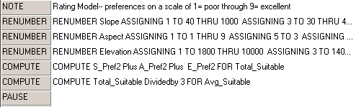

…that 1) “calibrates” the Slopemap, Aspectmap and Elevation maps on a goodness scale from 1= poor to 9= excellent, 2) computes the total goodness points (Total_Suiatble), then 3) calculates the average suitability rating for each map location (Avg_Suitable).

Since Hugags can’t swim we need to eliminate areas of open water.

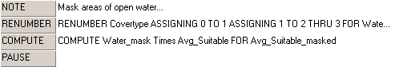

Finally, use region-wide overlay to determine the average habitat suitability rating for each of the management districts in the project area. The Districts map serves as the “template map” that summarizes (average) the suitability values on the “data map” within each of the regions.

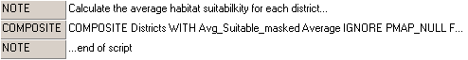

As time permits, investigate the other Reclassify (Clump, Configure, Size, Slice) and Overlay commands (Cover, Intersect)
______________________________________________________

Cross-reference to ESRI Grid and Spatial Analysis operations…

MapCalc Command | Grid / Spatial Analyst
Slope creates a map indicating the slope (1st derivative) along a continuous surface. | Surface function SLOPE
Orient creates a map indicating aspect along a continuous surface. | Surface function ASPECT  Distance function EUCDIRECTION
Renumber assigns new values to the categories on a map. | Reclassification function RECLASS
Compute creates a map as the mathematical or statistical function evaluating an equation using a stack of map layers. | Arithmetic operators  *, +, -, DIV, MOD
Composite creates a map summarizing values from one map that coincide with the categories of another. | Zonal functions ZONALFILL, ZONALMAX, ZONAL MEAN, ZONALMIN, ZONALRANGE, ZONALSTD, ZONALSUM, ZONALVARIETY

Exercise #5 – Measuring Distance and Connectivity Techniques (MapCalc)

Cross-reference to ESRI Grid and Spatial Analysis operations…

MapCalc Command | Grid / Spatial Analyst
Spread creates a map indicating the shortest effective distance from specified cells to all other locations. | Distance functions CORRIDOR (compute sum), COSTALLOCATION (slice), COSTDISTANCE, EUCALLOCATION, EUDIRECTION (orient), EUCDISTANCE  Shape Analysis functions EXPAND, SHRINK  Hydrologic function WATERSHED, BASIN
Renumber assigns new values to the categories on a map. | Reclassification function RECLASS
Radiate creates a map indicating areas that are visible from specified locations. | Visibility tools VISENCODE, VISIBILITY
Cover creates a new map where non-zero values of the top map replace the values on the previous (bottom) map, or stack of maps. | Selection functions SELECTBOX, SELECTCIRCLE, SELECTMASK, SELECTPOINT, SELECTPOLYGON
Stream creates a map identifying the steepest downhill route along a surface (optimal path). | Distance functions COSTBACKLINK, COSTPATH, PATHDISTANCE  Hydrologic function FLOWDIRECTION (orient)

Exercise #6 – Characterizing Neighborhoods (MapCalc)

Cross-reference to ESRI Grid and Spatial Analysis operations…

MapCalc Command | Grid / Spatial Analyst
Scan creates a map summarizing the values that occur within the vicinity of each cell. | Statistical operation POPULARITY  Focal functions FOCALFLOW, FOCALMAX, FOCALMEAN, FOCALMIN, FOCALRANGE, FOCALSTD, FOCALSUM, FOCALVARIETY  Conditional statement  IF, WHILE, DOCELL  Data Clean-up functions BOUNDARYCLEAN, MAJORITYFILTER, NIBBLE, THIN  Hydrologic functions  FILL, SINK
Compute creates a map as the mathematical or statistical function evaluating an equation using a stack of map layers. | Arithmetic operators  *, +, -, DIV, MOD
Profile creates a map indicating the cross-sectional profile along a continuous surface. | Surface functions  SAI, SHADE
Intersect creates a map by assigning new values to pair wise combinations of the values on two maps. | Combinatorial function COMBINE

Exercise #7 – Spatial Interpolation (Surfer)

Cross-reference to ESRI Grid and Spatial Analysis operations…

Surfer Operation | Grid / Spatial Analyst
Inverse Distance Weighted performs an inverse distance weighted interpolation of point data. | Statistical Function  IDW
Kriging performs spatial interpolation of point data using the kriging algorithm. | Statistical Function  KRIG
Grid math creates a map as the mathematical or statistical function evaluating an equation using a stack of map layers. | Arithmetic operators  *, +, -, DIV, MOD

Exercise #8 -- Investigating Spatial Relationships (MapCalc)

Cross-reference to ESRI Grid and Spatial Analysis operations…

MapCalc Command | Grid / Spatial Analyst
Similarity quantifies the similarity of a map to an evaluation data pattern, or set of comparison values. | No comparable operation
Cluster identifies areas with similar characteristics on a set of map layers. | Image Analyst  CLUSTER
Correlate derives a correlation matrix from a stack of maps. | Image Analyst CORRELATE
Regress performs linear regression analysis by using the "least squares" method to fit a line through a set of data points in multiple maps. | Statistical function REGRESSION

Exercise #9 – Data Exchange Techniques (MapCalc, Surfer, ArcView)

Exercise #10 – Campground Suitability Model (MapCalc)

Access the MapCalc software system and select the Tutor25.rgs data base.

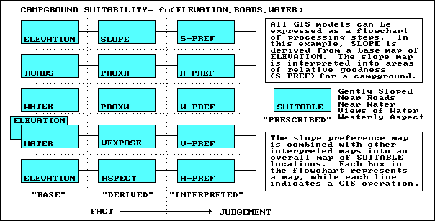

Campground Suitability Model

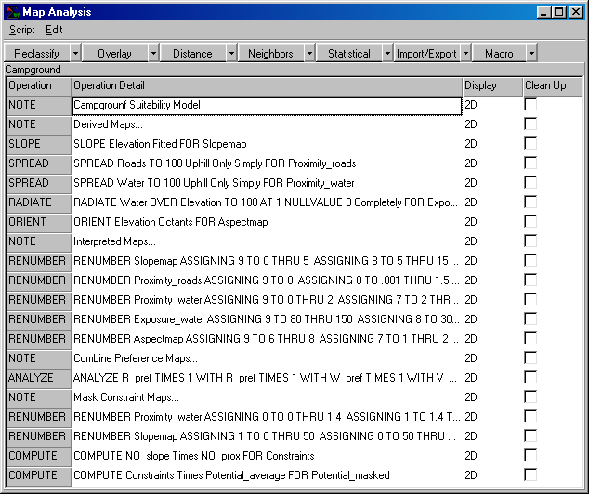

Campground script

Part 1. Implementing the Campground Suitability Model

Open the Campground.scr script and execute it a command line at a time under the direction of the instructor. Relate the map analysis operations to the logical flow identified in the flowchart of the Campground Suitability Model.

Part 2. Implementing another viewpoint of (change decision criteria weights)

Identify a different campground suitability map by interactively completing the following sequence of commands…

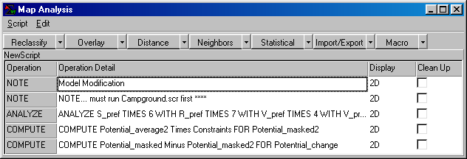

1) Enter a new Analyze command that weights the five preference maps are weight-averaged as…

ANALYZE S_pref TIMES 6 WITH R_pref TIMES 7 WITH W_pref TIMES 4
WITH V_pref TIMES 10 WITH A_pref TIMES 1 FOR Potential_average2

…relative importance.

2) Use the Compute command to mask the constrained areas.

3) Use Compute to compare the simple average and weighted-average maps.

…What was the greatest change? Where did occur? Which decision scenario (Potential or Potential2) had the higher rating?

______________________________________________________

Cross-reference to ESRI Grid and Spatial Analysis operations…

MapCalc Command | Grid / Spatial Analyst
Slope creates a map indicating the slope (1st derivative) along a continuous surface. | Surface function SLOPE
Spread creates a map indicating the shortest effective distance from specified cells to all other locations. | Distance functions CORRIDOR (compute sum), COSTALLOCATION (slice), COSTDISTANCE, EUCALLOCATION, EUDIRECTION (orient), EUCDISTANCE  Shape Analysis functions EXPAND, SHRINK  Hydrologic function WATERSHED, BASIN
Radiate creates a map indicating areas that are visible from specified locations. | Visibility tools VISENCODE, VISIBILITY
Orient creates a map indicating aspect along a continuous surface. | Surface function  ASPECT  Distance function EUCDIRECTION
Renumber assigns new values to the categories on a map. | Reclassification function RECLASS
Analyze creates a new map of the simple or weighted average, standard deviation and other statistical summaries of two or more maps | Statistical function  MEAN, MED, MIN, MAX, MAJORITY, MINORITY, POPULARITY, VARIETY
Compute creates a map as the mathematical or statistical function evaluating an equation using a stack of map layers. | Arithmetic operators  *, +, -, DIV, MOD

