GIS MODELING AND APPLICATION ISSUES

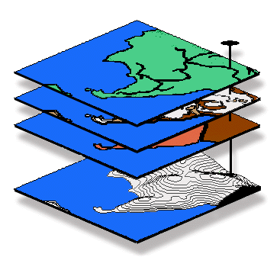SITUATION Most desktop mapping and GIS applications have focused on mapping and spatial data management responding to inventory assessments of "Where Is What" (geo-query of mapped data). GIS modeling provides new tools and processing structures for incorporating spatial relationships that address "Why and So What" in a decision-making context (map analysis and modeling). This extension of descriptive to prescriptive mapping involves entirely new spatial reasoning concepts and procedures that are not reflected in our paper map legacy.

WORKSHOP DESCRIPTION This intermediate level workshop presents basic concepts, procedures and applications of GIS modeling emphasizing natural resources and environmental management applications. The concepts presented are reinforced through several practical exercises. The first portion of the workshop establishes the concept of “maps as data” by introducing basic data structure issues impacting spatial analysis capabilities. The discussion focuses on individual operations, such as, map comparison, effective distance, optimal paths, visual exposure, roving windows and shape/pattern indices that are used in modeling spatial relationships. The next portion of the workshop discuses issues surrounding spatial interpolation of point data and spatial data mining techniques to discover relationships within and among maps. These concepts are presented within practical contexts for a basic understanding of the procedures and their utility. The final portion describes the concepts, procedures and considerations of a generalized GIS modeling framework required for sound application models, as well as providing a glimpse of trends and future directions in GIS technology.

WHO SHOULD ATTEND Managers and GIS specialists who are currently involved in the development of systems that use and analyze spatial data should attend. This is an intermediate-level workshop and prior GIS experience and familiarity with basic statistical concepts are recommended.

WORKSHOP TOPICS

Topic #1, Spatial Analysis— discusses data considerations and individual spatial analysis operations emphasizing grid-based techniques, such as shape/pattern indices, effective distance, optimal path connectivity, visual exposure, and roving windows. Maps as Data (Exer#1– Map Analysis Framework); Map-ematics (Exer#2– Example of a Simple GIS Model); Data Issues (Exer#3– Grid Data Types and Display Forms)
; Reclassifying and Overlaying Maps (Exer#4–R&O Techniques); Measuring Distance and Connectivity (Exer#5– Distance and Connectivity Techniques); Neighborhood Characterization (Exer#6– Neighborhood Techniques)

Topic #2, Spatial Data Mining— establishes the fundamental concepts and procedures used in spatial interpolation and analyzing relationships within and among mapped data. Surface Modeling (Exer#7– Spatial Interpolation); Spatial Data Mining (Exer#8– Investigating Spatial Relationships); Data Exchange Issues (Exer#9– Data Exchange)

Topic #3, GIS Modeling— describes procedures involved in constructing sound application models and suggests future directions in GIS technology. Model Development and Execution (Exer#10a– Suitability Modeling); Spatial Reasoning and Dialogue (Exer#10b– Model Modification); Optional homework (MapCalc Learner software)

ABOUT THE INSTRUCTOR


Dr. Joseph K. Berry is president of Berry and Associates // Spatial Information Systems, consultants and software developers in Geographic Information Systems (GIS) technology. He also serves as Special Projects Manager for Red Hen Systems, Special Faculty member at Colorado State University and the Keck Scholar in Geosciences at the University of Denver. He is the author of the “Beyond Mapping” column for GEOWorld, the column “Inside the GIS Toolbox” for ag/Innovator and has written over two hundred papers on the analytic capabilities of GIS. He is the author of the popular books Beyond Mapping and Spatial Reasoning and is involved in the development of the MapCalc software system for grid-based map analysis. He holds a B.S. degree in Forestry, an M.B.A. in operations research and finance, and a Ph.D. emphasizing remote sensing and land use planning.

SOFTWARE USED IN THE WORKSHOP
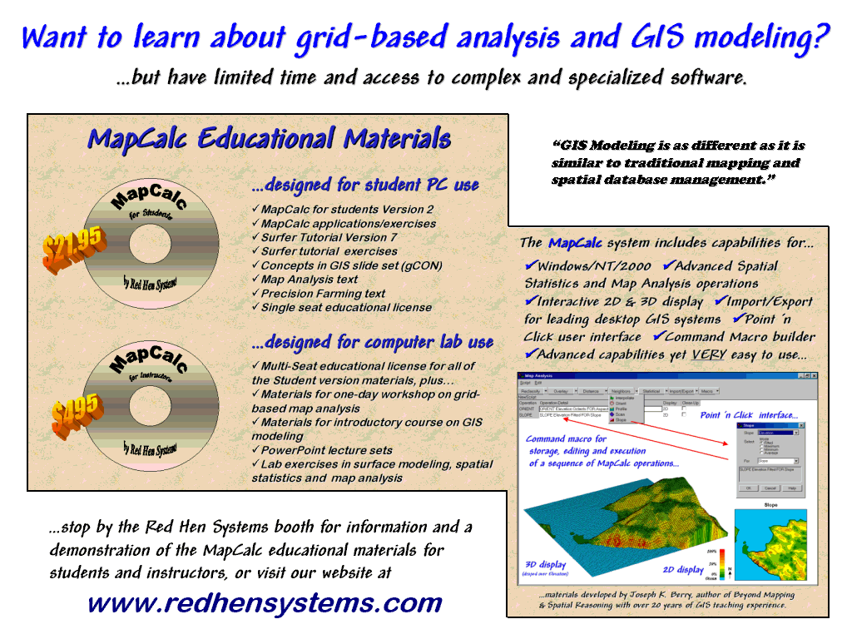
The MapCalc educational system comes in two forms—the MapCalc Learner package for students and the MapCalc Academic for instructors. The Learner CD contains the MapCalc and Surfer tutorial systems, exercises/databases, application demos and two online texts—Map Analysis, a compilation of Dr. Berry’s “Beyond Mapping” column in GEOWorld and The Precision Farming Primer compiled from agInnovator’s “GIS Toolbox” column . The MapCalc software by Red Hen Systems has extensive capabilities in spatial analysis and modeling. The Surfer system by Golden Software provides extended capabilities in surface modeling and 3-D graphics. The MapCalc tutorial version is constrained to a 100x100 grid configuration (10,00 grid cells) and some of Surfer’s output features are constrained in the tutorial version. Both software systems have data exchange tools and accept data for creating your own databases. More information at…
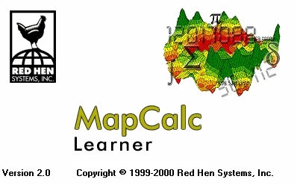
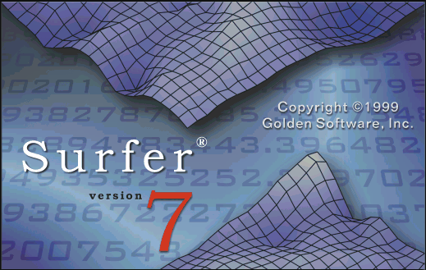
www.redhensystems.com
www.goldensoftware.com

Lecture Notes

Part 1 – Data Considerations and Spatial Analysis Procedures

Part 2 – Concepts and techniques in Surface Modeling

Part 3 – Uncovering Spatial Relationships Through Data Mining

Part 4 – Developing Spatial Reasoning Skills and GIS Models

Exercises

Exercise #1 – Map Analysis Framework

Exercise #2 – Example of a Simple GIS Model

Exercise #3 – Grid Display and Data Types

Exercise #4 – Reclassify and Overlay Techniques

Exercise #5 –Distance and Connectivity Techniques

Exercise #6 – Characterizing Neighborhoods

Exercise #7 – Spatial Interpolation Techniques

Exercise #8 – Investigating Spatial Relationships

Exercise #9 – Data Exchange Techniques

Exercise #10 – Campground Suitability Model

Background Reading

…see the MapCalc Learner disk available at the workshop for background readings, hands-on exercises and other supplemental materials including copies of the PowerPoint slide sets used in the lecture section.

…the references in the lecture slides refer to online materials including:
- Map Analysis at http://www.innovativegis.com/basis/MapAnalysis/Default.html
- MapCalc Applications at http://www.innovativegis.com/basis/Senarios/Default.html
and direct links to other online materials. The references are automatically when viewing the PowerPoint lecture slides from the workshop CD.
Beyond Mapping: Concepts, Algorithms and Issues in GIS, by Joseph K. Berry (1993, John Wiley Publishers)
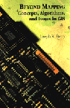
Beyond Mapping explores the basic concepts of map analysis and discusses emerging issues as GIS moves from the realm of research to widespread applications. The book is structured so the reader first can examine the broad issues and then delve into more detail. ISBN: 0-470-23633-7; $60.00
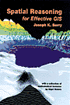
Spatial Reasoning for Effective GIS, by Joseph K. Berry (1995, John Wiley Publishers)

Spatial Reasoning explores the basic concepts of map analysis and discusses emerging issues as GIS moves from the realm of research to widespread applications. It is an incisive book describing the expansion of geographic technology from maps that simply tell us "Where is what" to systems that help us decide "So what?" ISBN: 0-470-23676-0; $60.00

These books, based on Joe Berry’s popular "Beyond Mapping" columns in GEOWorld magazine, discuss the new breed of map analysis tools and how they can be used to better characterize and communicate spatial relationships. Both books can be purchased online from www.wiley.com and www.amazon.com.

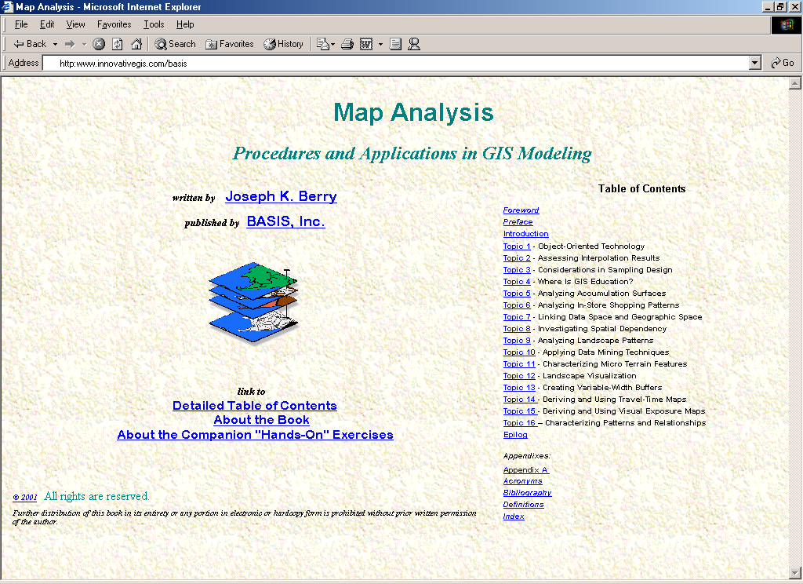
Map Analysis: Procedures and Applications in GIS Modeling
by Joseph K. Berry
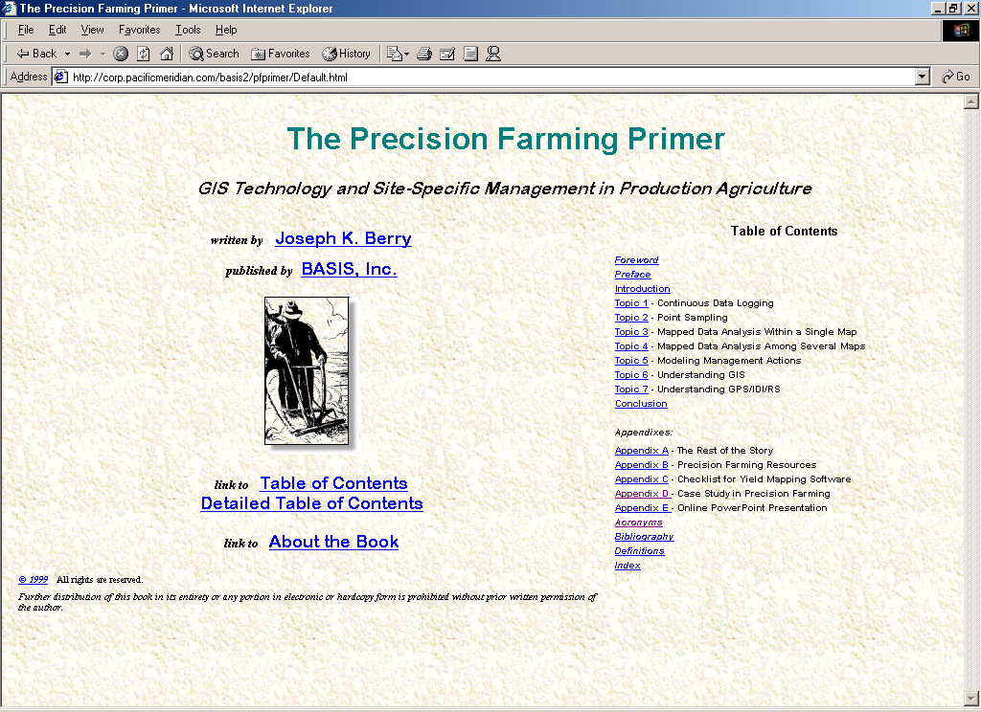
The Map Analysis book is a collection of Joe Berry's popular “Beyond Mapping” columns recently published in GEOWorld magazine (1996 through 2002). It serves as a self-instructional text or used in support of formal academic courses for study of grid-based map analysis. The draft manuscript is the third book in the series and is posted online at… www.innovativegis.com/basis, select “Map Analysis” book.
The Precision Farming Primer
by Joseph K. Berry
…the Precision Farming Primer is a collection of Joseph K. Berry's popular "Inside the GIS Toolbox" column published in the @gInnovator newsletter from 1993 through 2001. It uncovers the potential and pitfalls of the rapidly evolving field of precision farming—not only what precision farming can and can't not do, but how it does it. … www.innovativegis.com/basis, select “PF Primer” book.

…all three books are supported by MapCalc Learner software (US$ 21.95) for hands-on experience with the concepts and procedures used in grid-based GIS Modeling…
www.redhensystems.com, select “MapCalc” software

©Copyright 2001 by Joseph K. Berry. All right reserved.
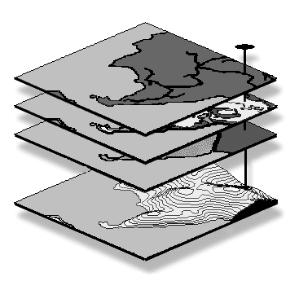
No part of this workbook may be reproduced, stored in a retrieval system, or transmitted, in any form or by any means, electronic, mechanical, photocopying, recording, or otherwise, without consent of the author. Holders of valid MapCalc Learner-Academic licenses may freely use the materials. Others need to contact Joseph K. Berry, Berry and Associates, 2000 South College Avenue, Suite 300, Fort Collins, Colorado, USA 80525; Phone: 970-215-0825; Email: jberry@innovativegis.com.

