Underlying Concerns and Considerations

in Remote Sensing of Crop Type and Condition

by Joseph K. Berry¹ and David K. Wright²

Click <here> to view the complete online slide set and notes accompanying this topic.



www.agriculture.com …Online articles and active discussion forum on technology

________________________________

Part 2 – In-Field Remote Sensing Applications in Agriculture

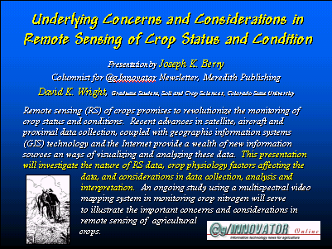 Remote sensing (RS) of crops promises to revolutionize the monitoring of crop status and conditions. Recent advances in satellite, aircraft and proximal data collection, coupled with geographic information systems (GIS) technology and the Internet provide a wealth of new information sources and ways of visualizing and analyzing these data. This two-part @gInnovator Online presentation will investigate the nature of RS data, crop physiology factors affecting the data, and considerations in data analysis and interpretation. An ongoing study using a multispectral video mapping system in monitoring crop nitrogen will serve to illustrate the important concerns and considerations in remote sensing of agricultural crops.

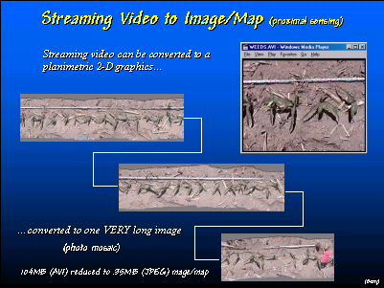 A video clip along a row of corn can be converted into a photo mosaic consisting of one long strip. In a similar fashion, a flight line across a field can be constructed and geo-registered.

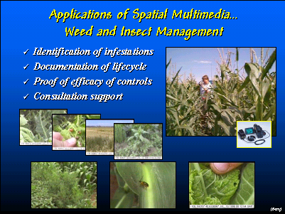 Video mapping in a field allows a farmer or crop scout to document conditions. The streaming video, still images, audio and text are attached to points on a base map that are retrieved by simply double-clicking on the map point.

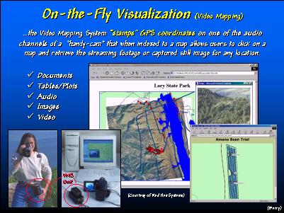 The video mapping unit is a small, lightweight box that is connected to the camera for field photographing. In the office the unit serves as an interface for playback and automatic construction of the computer map linking the imagery.

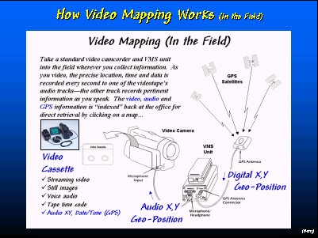 The VMS unit “stamps” the GPS signal onto one of the audio channels every second while the camera is recording.

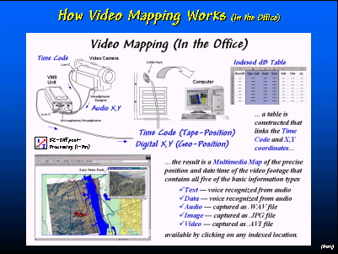 The recorded GPS coordinates (geographic position) are indexed to the camera’s time code (tape position) such that any image on the videotape is cross-referenced to its precise location on the map.

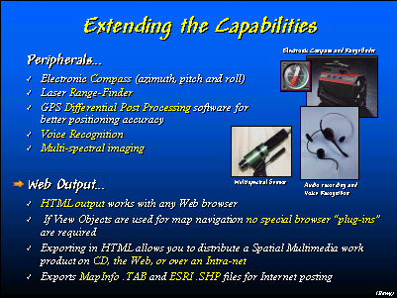 Still images and video clips can be “captured” from the tape and stored with the map for viewing over the Internet.

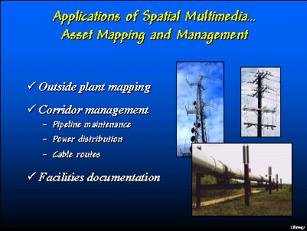 In addition to documenting crop conditions, video mapping technology can be used to document farm facilities and important fixed equipment.

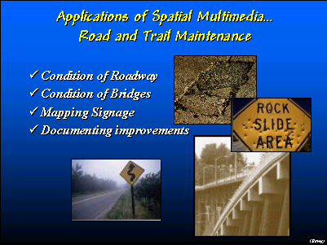 Condition of crops and facilities can captured at several time periods to assess and document changes.

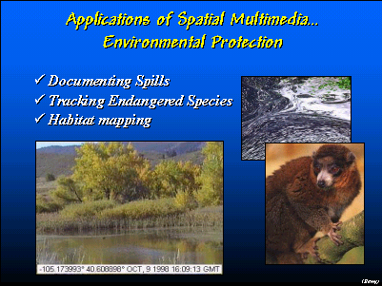 Environmental concerns can be documented and categorized for proof of compliance.

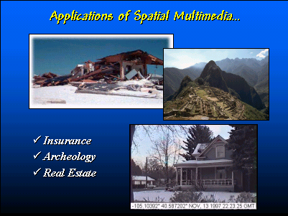 Insurance claims and farm improvements can be recorded.

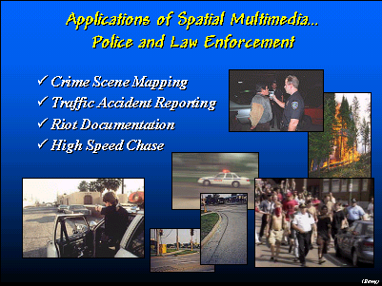 While the Video Mapping System (Red Hen Systems) was originally developed for crop scouts and harvest records, it is being applied to a wide variety of other disciplines from police work to geo-marketing.

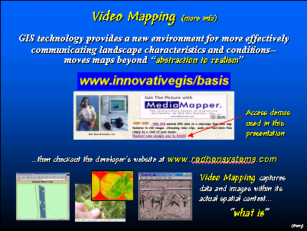 For further information on remote sensing applications in agriculture and video mapping contact Red Hen Systems.

__________________

These @gInnovator Online materials are based on an invited presentation for the Agriculture Discipline Forum, MidAmerica GIS Symposium on “Strengthening theGrowing Geodata Community,” Osage Beach, Missouri, May 14-18, 2000.

Underlying Concerns and Considerations in Remote Sensing of Crop Type and Condition

¹Joseph K. Berry, Columnist for @gInnovator Newsletter, Meredith Publishing
President, Berry and Associates // Spatial Information Systems
2000 South College Avenue, Suite 300, Fort Collins, CO 80525
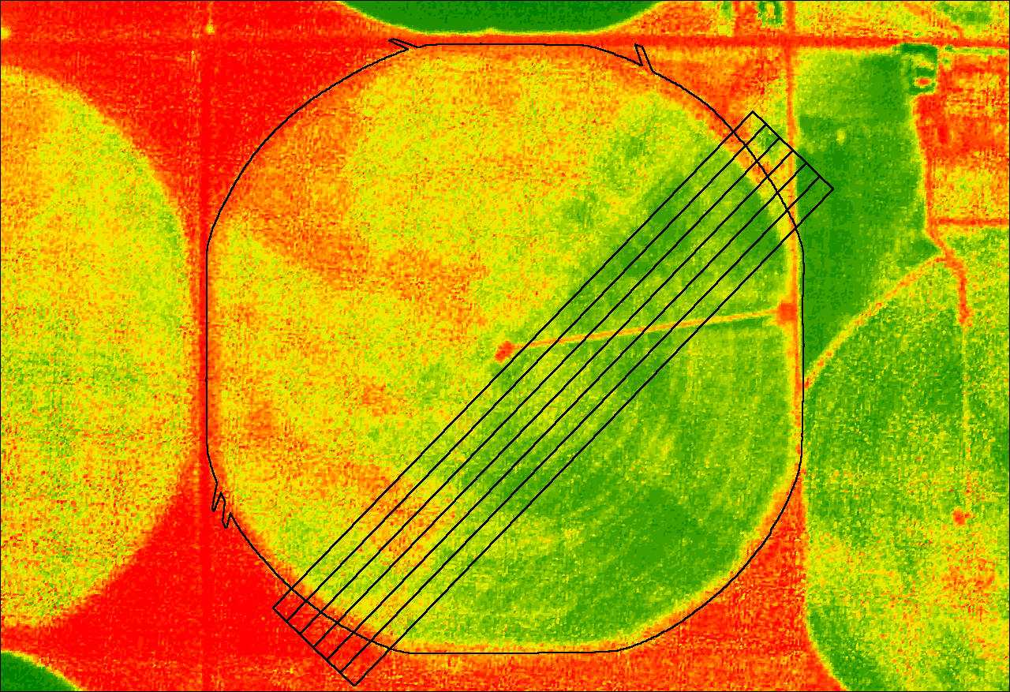
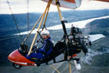
Phone: 970-215-0825 Email: jberry@innovativegis.com
Website: www.innovativegis.com/basis

²David K. Wright, Graduate Student
Department of Soil and Crop Sciences, Colorado State University
Research and Development, Red Hen Systems, Inc. Fort Collins, CO 80525

Abstract

Remote sensing (RS) of crops promises to revolutionize the monitoring of crop status and conditions. Recent advances in satellite, aircraft and proximal data collection, coupled with geographic information systems (GIS) technology and the Internet provide a wealth of new information sources an ways of visualizing and analyzing these data. This presentation will investigate the nature of RS data, crop physiology factors affecting the data, and considerations in data analysis and interpretation. An ongoing study using a multispectral video mapping system in monitoring crop nitrogen will serve to illustrate the important concerns and considerations in remote sensing of agricultural crops.
___________________

