Underlying Concerns and Considerations

in Remote Sensing of Crop Type and Condition

by Joseph K. Berry¹ and David K. Wright²

Click <here> to view the complete online slide set and notes accompanying this topic.



www.agriculture.com …Online articles and active discussion forum on technology

________________________________

Part 1 – Aerial Remote Sensing Applications in Agriculture

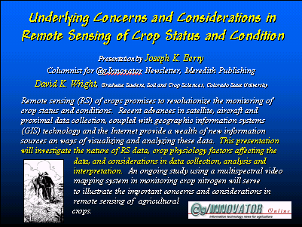 Remote sensing (RS) of crops promises to revolutionize the monitoring of crop status and conditions. Recent advances in satellite, aircraft and proximal data collection, coupled with geographic information systems (GIS) technology and the Internet provide a wealth of new information sources and ways of visualizing and analyzing these data. This two-part @gInnovator Online presentation will investigate the nature of RS data, crop physiology factors affecting the data, and considerations in data analysis and interpretation. An ongoing study using a multispectral video mapping system in monitoring crop nitrogen will serve to illustrate the important concerns and considerations in remote sensing of agricultural crops.

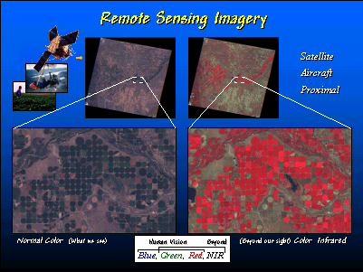 GIS and its closely related field of remote sensing form an alliance that greatly enhances the technical toolkit for mapping. Remote sensing is actually GIS's older brother, having its modern roots in World War II. Camouflage detection film was used to distinguish between healthy vegetation and cut branches piled on top of military equipment. To the human eye and normal film the healthy and cut branches were both green (at least for a few days), but on the new film they showed up as two different colors.

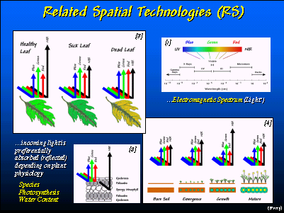 Remote sensing uses relative variations in electromagnetic radiation (EMR) to identify landscape characteristics and conditions. In fact, so do your eyes. Sunlight (the "visible" form of EMR) starts off with fairly equal parts of blue, green and red light. When sunlight interacts with an object, the object’s composition causes it to absorb varying amounts of the different wavelengths of EMR "light." What light isn’t absorbed is reflected to your eyes. Your brain interprets the subtle differences in the amount of blue, green and red in the reflected light to recognize the thousands of colors we relate to our surroundings.
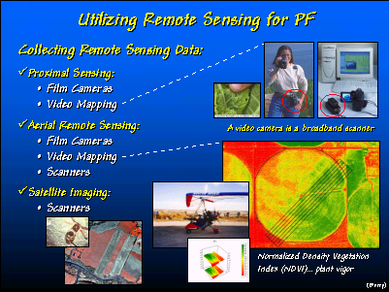 There are three levels of acquiring remote sensing images—satellite, aerial and proximal. Each has advantages and disadvantages including cost, availability and information content.

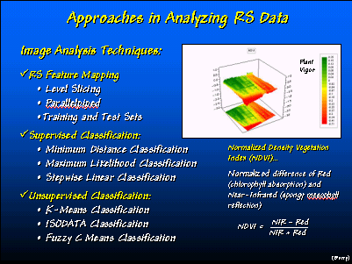 There are several techniques for computer enhancement and analysis of remote sensing data. The Normalized Density Vegetation Index (NDVI) is a widely used approach for extracting information on crops.

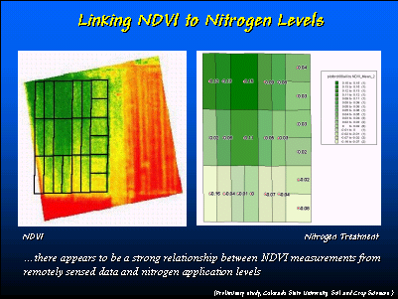 The map on the left is a NVDI image of nitrogen plots with the treatments shown in the map on the right. Note the corresponding patterns.

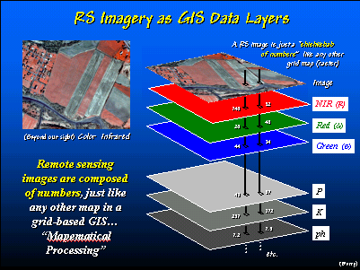 Within a GIS, remote sensing data becomes additional layers of information. The Blue, Green, Red and Near Infrared data can be analyzed for relationships linking crop type and condition to specific patterns of numbers on the maps.

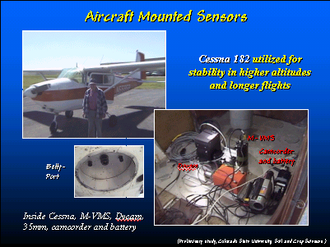 Airborne cameras have been used since the 1950’s. More recently, video and digital cameras have been tried because their low cost and digital nature of the data.

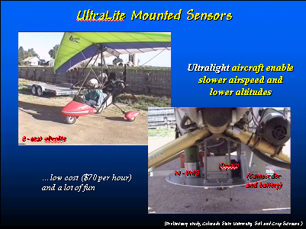 An alternative platform uses an ultralite (hang glider with an engine) that allows much slower airspeeds, lower altitudes and minimal costs.

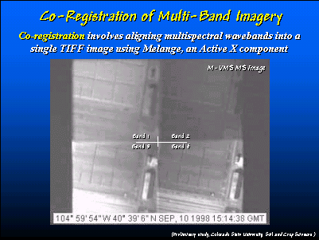 This is a multispectral composite image (four wavelength bands). Note the different levels of brightness that correspond to different amounts of reflected energy.

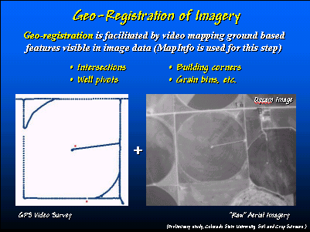 Geo-registration of aerial imagery is critical. The first step is to capture GPS coordinates for several readily identifiable features in the image.

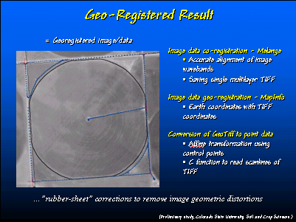 The second step in geo-registration uses a computer program to adjust the image (termed “rubbersheet”) to fit the coordinates.

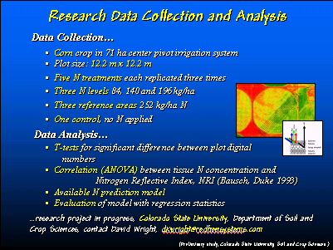 A comprehensive research project relating nitrogen treatments to remote sensing data is being conducted by Colorado State University.

__________________

These @gInnovator Online materials are based on an invited presentation for the Agriculture Discipline Forum, MidAmerica GIS Symposium on “Strengthening theGrowing Geodata Community,” Osage Beach, Missouri, May 14-18, 2000.

Underlying Concerns and Considerations in Remote Sensing of Crop Type and Condition

¹Joseph K. Berry, Columnist for @gInnovator Newsletter, Meredith Publishing
President, Berry and Associates // Spatial Information Systems
2000 South College Avenue, Suite 300, Fort Collins, CO 80525
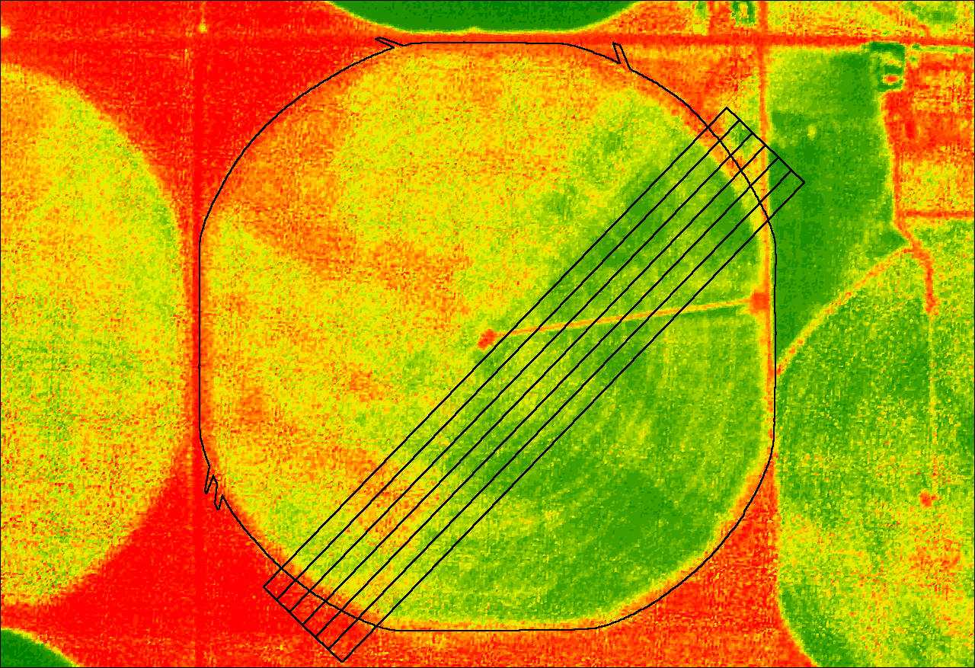
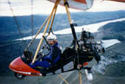
Phone: 970-215-0825 Email: jberry@innovativegis.com
Website: www.innovativegis.com/basis

²David K. Wright, Graduate Student
Department of Soil and Crop Sciences, Colorado State University
Research and Development, Red Hen Systems, Inc. Fort Collins, CO 80525

Abstract

Remote sensing (RS) of crops promises to revolutionize the monitoring of crop status and conditions. Recent advances in satellite, aircraft and proximal data collection, coupled with geographic information systems (GIS) technology and the Internet provide a wealth of new information sources and ways of visualizing and analyzing these data. This presentation will investigate the nature of RS data, crop physiology factors affecting the data, and considerations in data analysis and interpretation. An ongoing study using a multispectral video mapping system in monitoring crop nitrogen will serve to illustrate the important concerns and considerations in remote sensing of agricultural crops.
___________________

