Data Analysis Considerations and Procedures
for Site-Specific Crop Management

by Joseph K. Berry¹

Click <here> to view the complete online slide set and notes accompanying this topic.



www.agriculture.com …Online articles and active discussion forum on technology

________________________________

Part 1 – Understanding Mapped Data and Basic Analysis Approaches

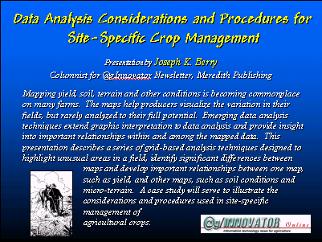 Mapping yield, soil, terrain and other conditions is becoming commonplace on many farms. The maps help producers visualize the variation in their fields, but rarely analyzed to their full potential. Emerging data analysis techniques extend graphic interpretation to data analysis and provide insight into important relationships within and among the mapped data. This two-part @gInnovator Online presentation describes a series of grid-based analysis techniques designed to highlight unusual areas in a field, identify significant differences between maps and develop important relationships between one map, such as yield, and other maps, such as soil conditions and micro-terrain. A case study will serve to illustrate the considerations and procedures used in site-specific management of agricultural crops.

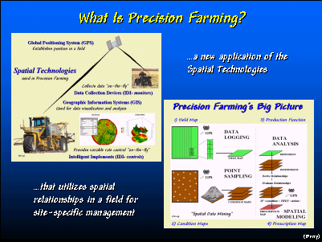 Precision farming combines GPS and GIS technology with intelligent devices/implements. Them result replaces “whole field” management with site-specific practices that changes farm inputs and actions throughout a field.

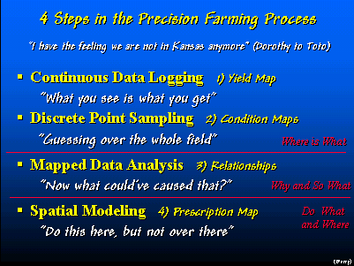 The first two steps in the Precision Farming Process create maps of important factors such as crop yield and soil nutient levels. The third step discovers relationships between the patterns contained in the map layers. The final step utilizes the relationships to establish a map of where management response should change.

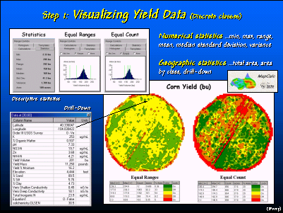 GIS maps are numbers first, pictures later. The maps are composed of an organized set of numbers that depict the spatial pattern in a field. In this example, the yield data for a central-pivot, corn field is displayed using two different ‘contouring” methods that form dramatically different visual impressions from the same data set.

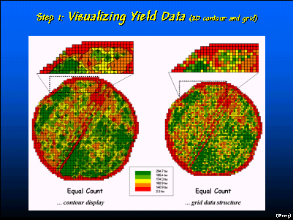 There are two map forms for displaying 2D maps—contour and grid display. While contour displays are most familiar, they create irregular data groupings (polygons) that are difficult to use in further analysis. Grid data structure, on the other hand, uses a consist analysis grid that contains the information and provides a means for analyzing relationships among sets of maps.

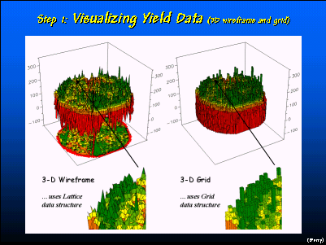 There are two map forms for displaying 3D maps—wireframe and grid display. A wireframe display connects the centroid of each grid cell (termed a lattice data structure) with lines. A 3D grid display, on the other hand, “extrudes” the cell sides to represent the map value at each location.

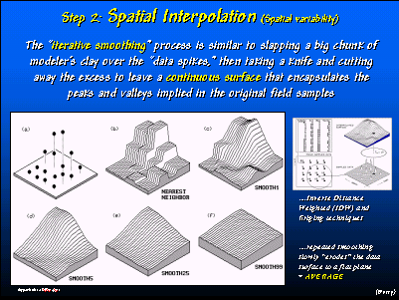 Point data can be spatially interpolated to create a continuous surface map that estimates values for locations between the samples. The surface represents the spatial distribution of samples. In this example, visual inspection of the plot of the point data (upper-left portion of the left figure) indicates higher values occur in the northeastern portion of the field. Continuous smoothing of the distribution results in a flat plane (lower-right portion of the left figure) that represents the simple average of the samples. Map analysis involves creating and analyzing map surfaces.

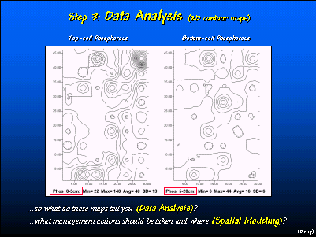 These two maps depict the relative amounts of phosphorous in the top and sub-soil in a cornfield. By simply viewing the two contour maps one is hard-pressed to see the differences and similarities in the patterns.

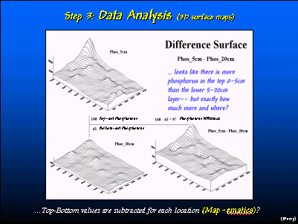 Map analysis uses the underlying data values to compute the differences between the two maps.

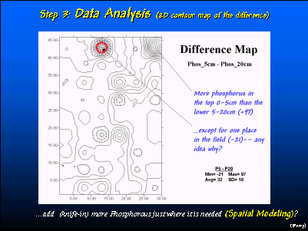 A contour display of the difference map locates subtle differences between the two maps. Note that the topsoil levels of phosphorous are much higher in most of the field— with very large differences in the northern portion of the field.

__________________

These @gInnovator Online materials are based on an invited presentation for the Agriculture Discipline Forum, MidAmerica GIS Symposium on “Strengthening theGrowing Geodata Community,” Osage Beach, Missouri, May 14-18, 2000.

Data Analysis Considerations and Procedures for Site-Specific Crop Management

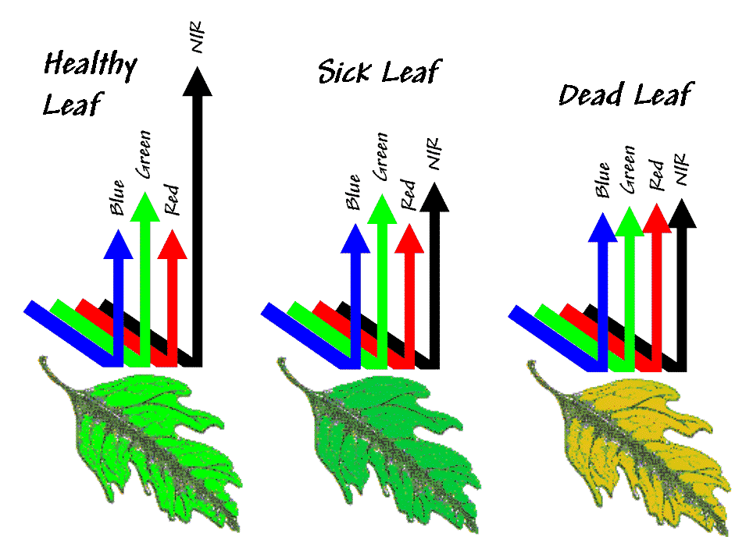
¹Joseph K. Berry, Columnist for @gInnovator Newsletter, Meredith Publishing
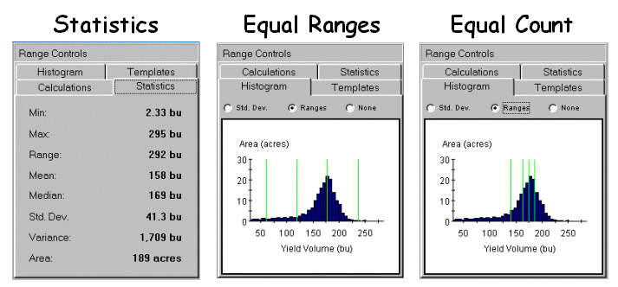
President, Berry and Associates // Spatial Information Systems
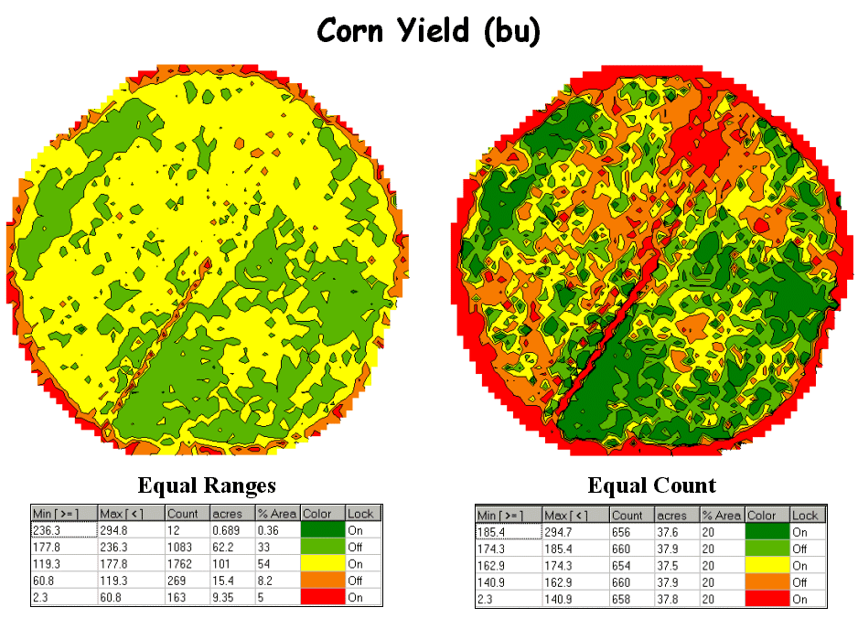
2000 South College Avenue, Suite 300, Fort Collins, CO 80525
Phone: 970-215-0825 Email: jberry@innovativegis.com
Website: www.innovativegis.com/basis

Abstract

Mapping yield, soil, terrain and other conditions is becoming commonplace on many farms. The maps help producers visualize the variation in their fields, but rarely analyzed to their full potential. Emerging data analysis techniques extend graphic interpretation to data analysis and provide insight into important relationships within and among the mapped data. This presentation describes a series of grid-based analysis techniques designed to highlight unusual areas in a field, identify significant differences between maps and develop important relationships between one map, such as yield, and other maps, such as soil conditions and micro-terrain. A case study will serve to illustrate the considerations and procedures used in site-specific management of agricultural crops.
___________________

