Exercises for GIS Modeling Workshop

- Exercise #1 – Map Analysis Framework (MapCalc)
- Exercise #2 – Example of a Simple Erosion Potential Model (MapCalc)
- Exercise #3 – Reclassify and Overlay Techniques (MapCalc)
- Exercise #4 – Measuring Distance and Connectivity (MapCalc)
- Exercise #5 – Characterizing Spatial Neighborhoods (MapCalc)
- Exercise #6 – Surface Modeling (Surfer and MapCalc)
- Exercise #7 – Spatial Data Mining (MapCalc)
- Exercise #8 – Gaining GIS Modeling Experience (MapCalc)
- Optional Exercise – Data Exchange Procedures (MapCalc)

Installing MapCalc— The Workshop CD comes with a 14-day evaluation copy of the MapCalc Learner software. To install MapCalc press Start→ Run→ then browse to the …\ Workshop\MapCalc\ folder on the CD and select the mapcalclearner.exe file. Follow the onscreen installation instructions. It is recommended that you accept the default specifications as the exercise write-ups assume this installation location.

Accessing MapCalc— Once MapCalc is installed, copy the entire …\ WorkshopData\ folder on the Workshop CD to the C:\Program Files\Red Hen Systems\MapCalc\MapCalc Data\ folder on your computer.

To access MapCalc press Start→ Programs→ MapCalc→ MapCalc Learner. In the Quick Start box select “Open existing map set” and browse to the …\WorkshopData\ folder on your computer and click on the appropriate ***.rgs database as instructed in the exercises (e.g., Exercise 1 uses Tutor25.rgs).

Uninstalling MapCalc— To uninstall MapCalc press Start→ Control Panel→ Add or Remove Programs→ and select MapCalc Learner to remove.
___________________________

Exercise #1 – Map Analysis Framework (MapCalc)

Install MapCalc and access MapCalc by Start→ Programs→ MapCalc Learner → MapCalc Learner and select “Open existing map set” then browse to …\WorkshopData\ and select Tutor25.rgs as the database.

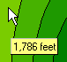 Slowly move the cursor over the map and observe the map values associated with various locations. The color levels identified in the map legend aggregate the elevation values into ten 200-foot contour intervals ranging from 500 to 2500 feet.

Click on the Layer mesh button on the main tool bar. The grid configuration for the Tutor25 database is 25 columns by 25 rows (25 x 25= 625 grid cells). Each cell is 100 x 100 meters (10,000 square meters; one hectare; 2.54 acres). The maps in the database are hypothetical and the Latitude and Longitude coordinates for the project area were arbitrarily assigned. The contour lines and interactive data labels for the Elevation map are interpolated “on-the-fly” from the underlying grid data.

Click on the Use cells button. The display switches from “Lattice” to “Grid” display type with the contour color codes assigned to entire cells.

Click on the Toggle 3D view button. The display switches to a “3-D Grid” display type. The color-coding at the top of each projected cell identifies the elevation value at that location.

The navigation tools enable you to zoom, pan and rotate a display.

- Click on the Zoom in button then click-and-drag a rectangular portion of the displayed map to enlarge that area.
- Click on the Zoom out button then click-and-hold while sliding up and down to continuously rescale the display when you release the mouse button.
- Click on the Move button and click-and-hold to move the display to another part of the screen.
- Click on the Rotate button then click-and-hold as you rotate the plot cube.
- Click on the Reset view button to return to the default display settings.

Click off the Use cells button to switch to a “3-D Lattice” display type, commonly called a “wireframe” display. Note that the navigation tools operate in the same manner for both the grid and lattice display types.

Click off and on the Layer contoured and Layer contour lines buttons to turn off and on the contour-fill colors and lines.

Click off and on the Floor contours/lines and Ceiling contours/lines buttons and note the changes in the 2-D projected planes in the plot cube.

Click on the word “Map” in the main menu, then select “Overlay” and choose the “Slope” map. The result is a graphical overlay of the Slope map on the 3-D display of the Elevation map. Note that the areas classified as steep (green tones) align with the steepest portions of the terrain surface.

Click on the Arrange windows buttons to view all of the open map windows in different arrangements. Click on the Maximize button in the Slope map’s window to enlarge the display to fit the entire work area. For review, repeat the display tools exercises you just completed using the elevation map on the Slope map.

Clicking on the word “Window” on the main menu produces a listing of open windows and window management tools. Clicking on any of the open map windows listed will cause that map to be maximized in the work area.

Click on the Layer Manager (View, Rename and Delete layers) button to pop-up a listing of the current maps in the Tutor25 database. You can Rename and Delete existing maps. As new maps are created they are added to the list. The View function opens a map in a new window. It is important to note that you can have multiple windows open of the same map (Clone view). While this can cause some initial confusion, experienced MapCalc users find it useful for positioning side-by-side views of the same data, such as a 2-D display and a 3-D plot. On the Main Menu, click File→ Exit (no need to save your work).

________________

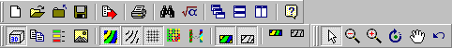 … additional demonstrations of basic grid-based data handling including map display (Lattice and Grid) shading manager (# Ranges, Equal Ranges, Equal Count), data types (Discrete and Continuous), data inspection/charting covered in the MapCalc Tutorials. On the special workshop disk, see…

…\MapCalc\MapCalc_Tutorials\MapCalc_Tutorials.pdf

for a printable file containing this basic set of tutorials covering MapCalc operation and grid-based map analysis fundamentals.
Exercise #2 – Example of a Simple Erosion Potential Model (MapCalc)

Access MapCalc using the Tutor25.rgs database by selecting Start→ Programs→ MapCalc Learner→ MapCalc Learner→ Open existing map set→ Tutor25.rgs by browsing to the …\WorkshopData\ folder you copied from the workshop CD.

Become familiar with the following simple model for estimating soil erosion potential…

Logical flowchart—

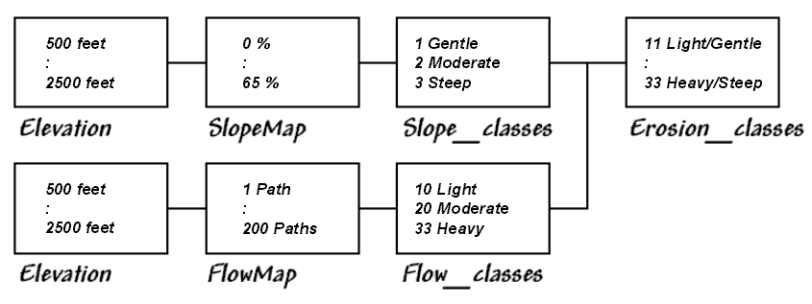

Command sequence (Script)—

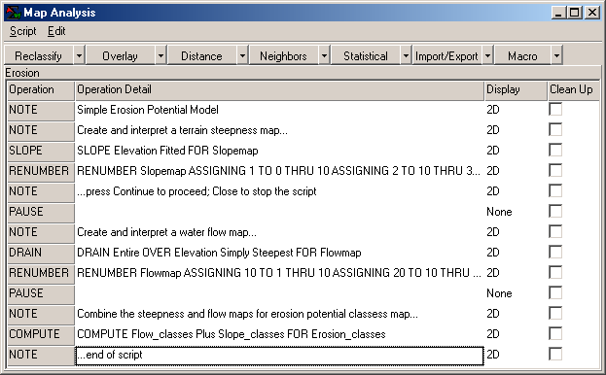

Press the Map Analysis button to pop-up the Map Analysis dialog box.
Select Script→ Open then browse to and select Program Files→ Red Hen Systems→ MapCalc→ MapCalc Data→ WorkshopData→ Scripts→ GM_Ex2_Erosion.scr file.

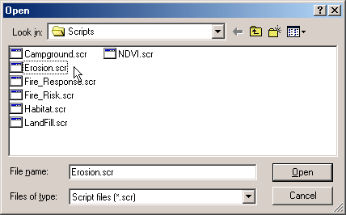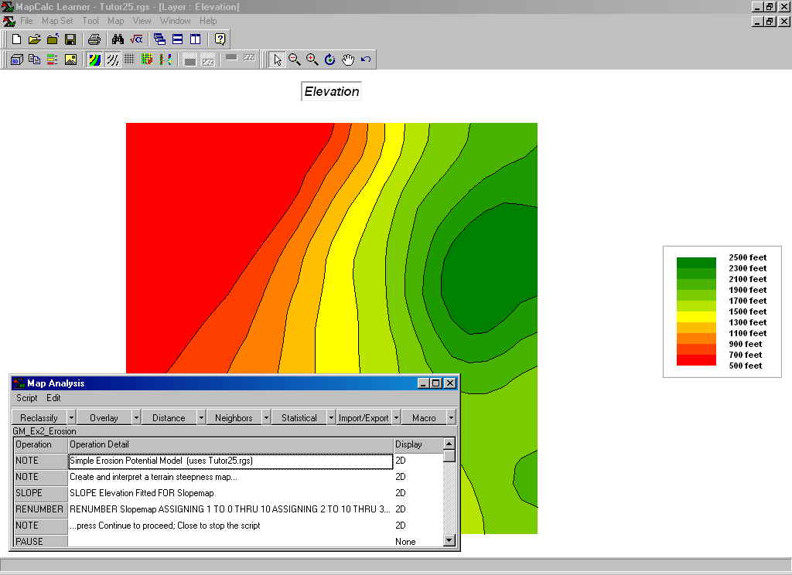
Resize and position the script window to the lower-left portion of the display window as shown.

Execute the command script a line at a time by double-clicking on the line and interpreting the dialog box information. Submit a command line by pressing OK.

The first portion of the erosion model…

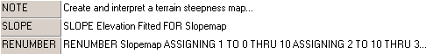

…creates a map of terrain steepness (Slopemap) then “calibrates” the steepness into three classes (1= Gentle, 2= Moderate, 3= Steep)

The next portion of the model…

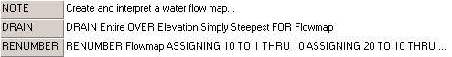

…creates a map of water confluence (Flowmap) then “calibrates” water flow into three classes (10= Light, 20= Moderate, 30= Heavy)

The final portion of the model…

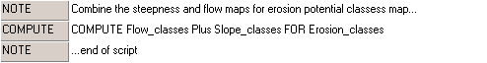

…combines the steepness and flow maps into a single erosion potential map to identify each map location by a two-digit code where the first number (tens digit) indicates the flow class and the second number (ones digit) indicates the steepness class. For example, 11= Light/Gentle (low erosion potential) and 33= Heavy/Steep (high erosion potential).

In turn, the erosion potential map can be used in a variety of other models, such as water flow and pooling analysis for a farmer’s field or in generating a variable-width buffer around spawning streams that reaches farther away from the stream in areas of high erosion potential.

See http://www.innovativegis.com/basis/Senarios/Default.html for an example applying the Erosion Potential Model to a central-pivot cornfield in Colorado—

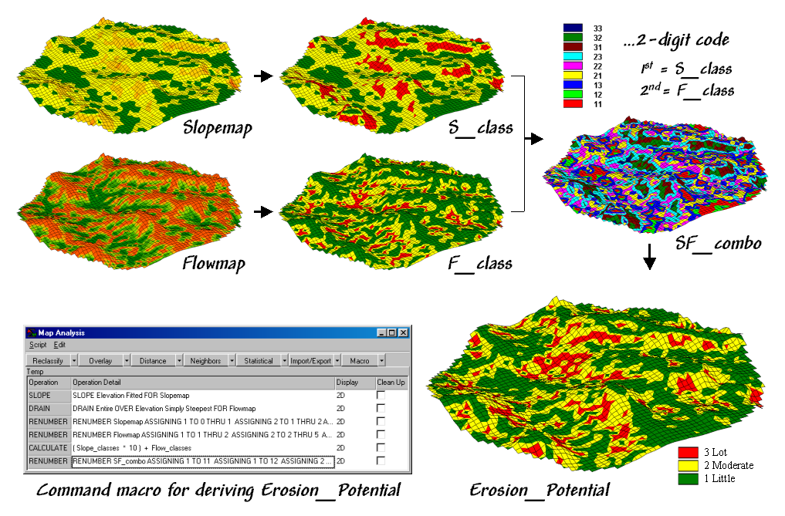

…note: the high erosion potential areas at the edge of the field indicating areas where sediments and chemicals easily move off the field.

______________________________________________________

Cross-reference to ESRI Grid and Spatial Analysis operations…

MapCalc Command | Grid / Spatial Analyst
Slope creates a map indicating the slope (1st derivative) along a continuous surface. | Surface function SLOPE
Drain creates a map indicating the number of steepest paths (optimal path density) from a set of locations along a surface. | Hydrologic function FLOWACCUMULATION
Renumber assigns new values to the categories on a map. | Reclassification function RECLASS
Calculate creates a map as the mathematical or statistical function evaluating an equation using a stack of map layers. | Arithmetic operators  *, +, -, DIV, MOD
Exercise #3 – Reclassify and Overlay Techniques (MapCalc)

(3a Part 1) Reclassify Operations

Access MapCalc using the Tutor25.rgs database by selecting Start→ Programs→ MapCalc Learner→ MapCalc Learner→ Open existing map set→ Tutor25.rgs in the …\WorkshopData\ folder.

Part 1. Reclassify Operations. Complete the following commands…

– View Button→ Covertype to display the map (note the shape of W, M and F features)
– SIZE Covertype FOR Covertype_size
This command calculates the area of each “region” (category value) on the map.

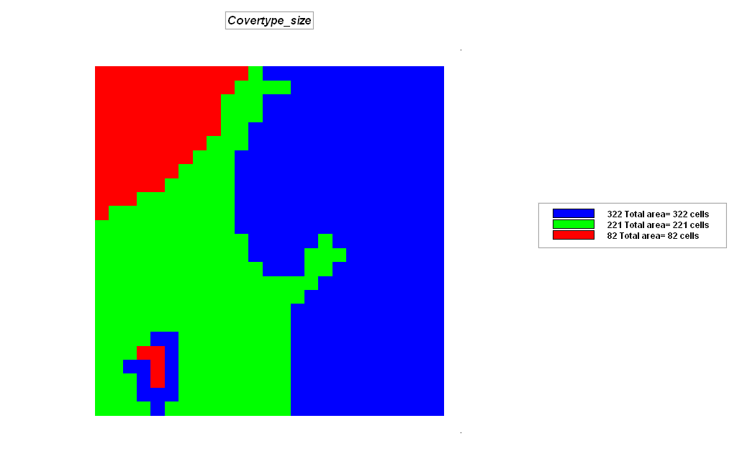 Three “regions”

– CLUMP Covertype AT 1 Diagonally FOR Covertype_clumps
This command assigns a sequential number to all of the individual occurrences (contiguous grouping) of each cover type “region” (category).

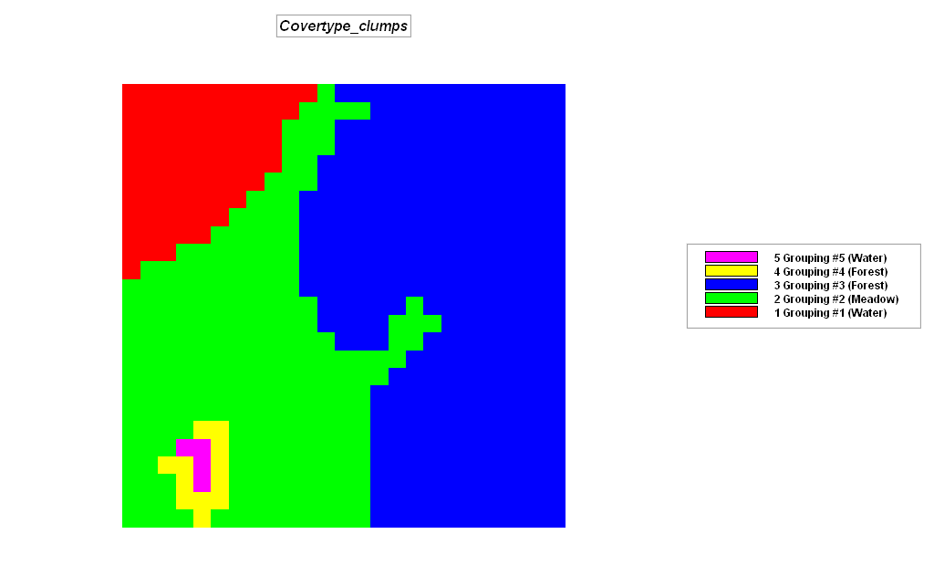 Five new “regions”

– SIZE Covertype_clumps FOR Covertype_clump_size
This command calculates the area of each “region” (category value) on the map …five separate occurrences of the three cover types.

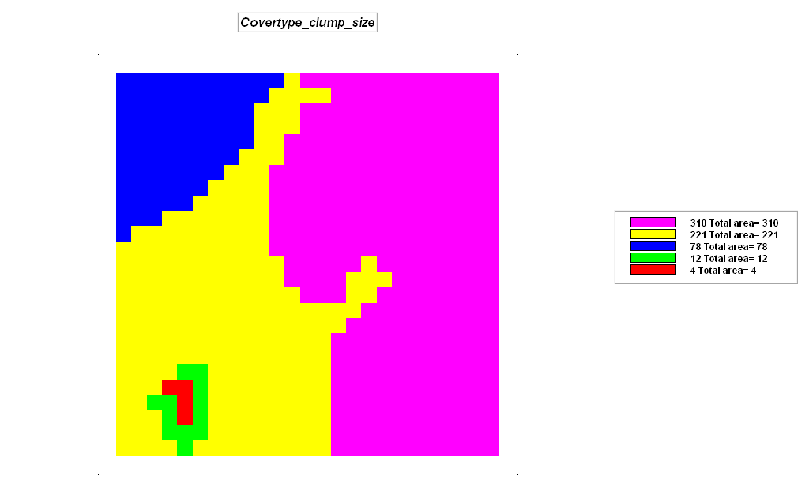 Size of each of the five new “regions”

– CONFIGURE Covertype_clumps Edges FOR Covertype_clumps_edges
This command counts the number of edge cells contained in each of the cover type clumps.

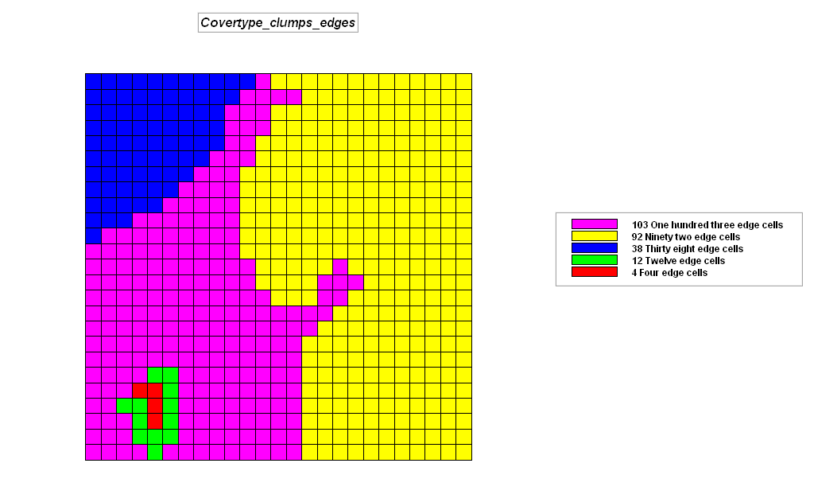

– CONFIGURE Covertype_clumps Convexity FOR Covertype_clumps_shape
This command calculates an index of shape as a function of the ratio of perimeter (edge) to area (interior) where 1= extremely irregular (almost all edge) to 100 (perfect circle).

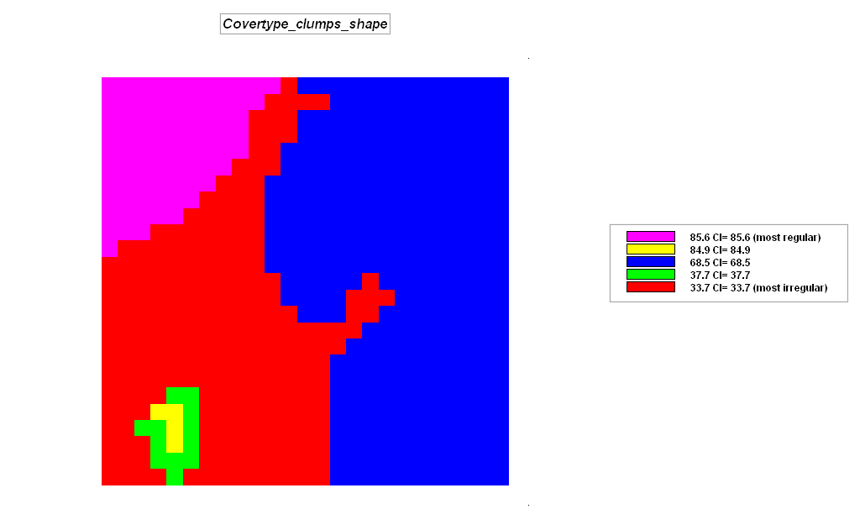

The Renumber command simply assigns a new number to a value (or value range) on an existing map. Entering a series of “reassignment phrases” to generate binary habitat maps is demonstrated below.

– Isolate locations of gentle slope
– RENUMBER Slope ASSIGNING 0 TO 30 THRU 1000
ASSIGNING 1 TO 0 THRU 30 FOR S_Pref

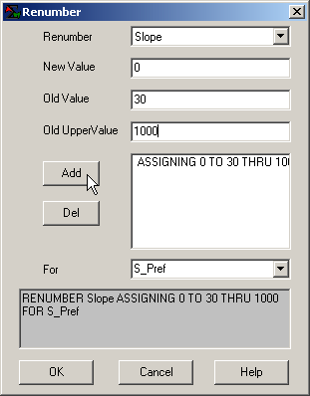 Select the Slope map  Enter 0 in the “New Value” field  Enter 30 in the “Old Value” field  Enter 1000 in the “Old UpperValue” field  Press the Add button to record the phrase | 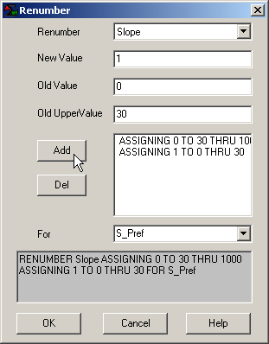 Enter 1 in the “New Value” field  Enter 0 in the “Old Value” field  Enter 30 in the “Old UpperValue” field  Press the Add button to record the phrase  Enter the S_Pref map name in the “For” field  Press OK to submit the command

– Repeat the Renumber process to isolate Southerly oriented locations
– RENUMBER Aspect ASSIGNING 0 TO 1 THRU 9
ASSIGNING 1 TO 3 THRU 7 FOR A_Pref

– Repeat the Renumber process to isolate the lower elevations
– RENUMBER Elevation ASSIGNING 0 TO 1800 THRU 2500
ASSIGNING 1 TO 500 THRU 1800 FOR E_Pref

(3a Part 2) Overlay Operations

Part 2. Overlay Operations. Complete the following commands…

– COMPUTE S_Pref Times A_Pref Times E_Pref FOR Binary_model
Note: Compute phrases are entered using the “Add” button in a similar fashion as Renumber

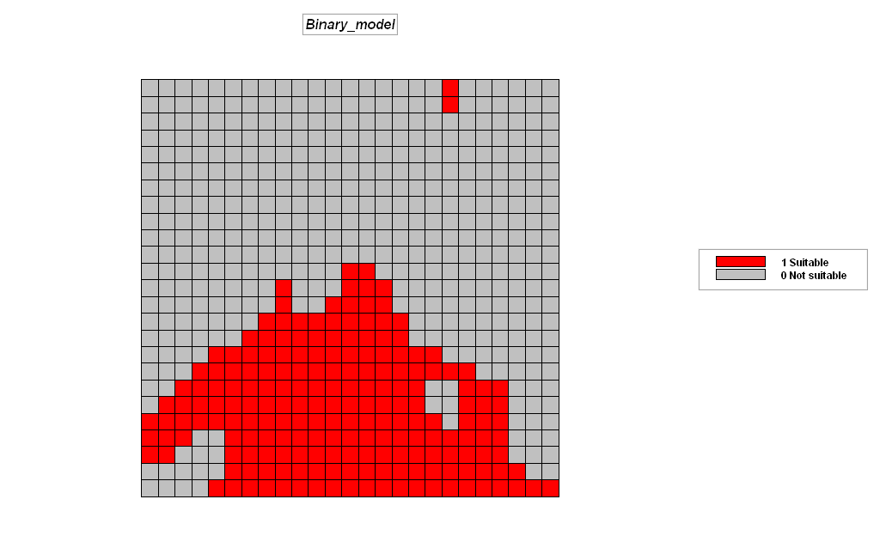 Click on the Data Type button to switch the map display to discrete data type.

– COMPUTE S_Pref Plus A_Pref Plus E_Pref FOR Ranking_model

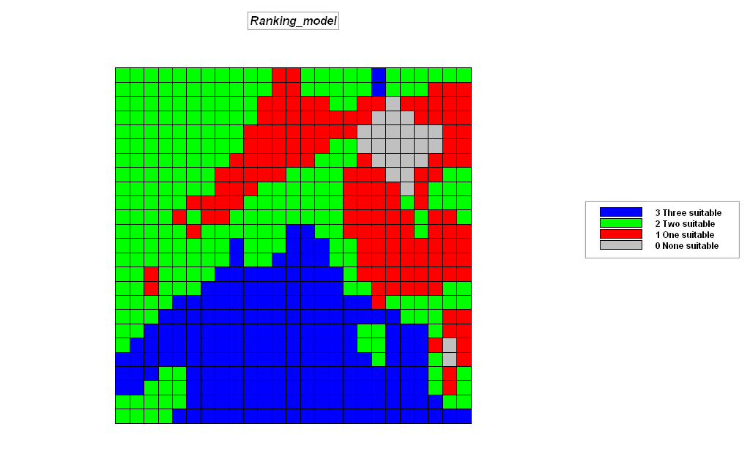 Click on the Data Type button to switch the map display to discrete data type.

– View Button→ Covertype to display the map (note the map values for the W, M and F features)
– View Button→ Water to display the map (note the map values for the various water features)
– CROSSTAB Covertype WITH Water Simply

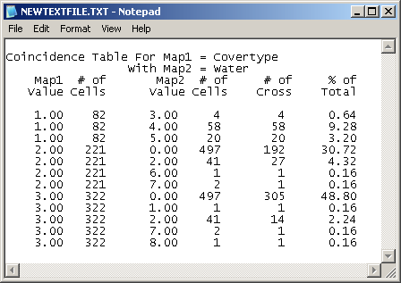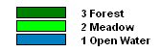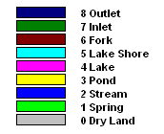

The Crosstab table summaries the spatial coincidence between two maps by counting the number of cells for each combination of the map categories. For example, Map1 (Covertype) value 1 (Open Water) jointly occurs in space with Map2 (Water) value 3 (Pond) for times (# of Crosses).

– CALCULATE (Covertype * 10) + Water FOR CW_codes

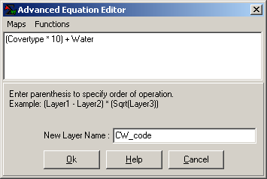 Click on the menu item “Maps” to select maps that are entered into the equation as shown.

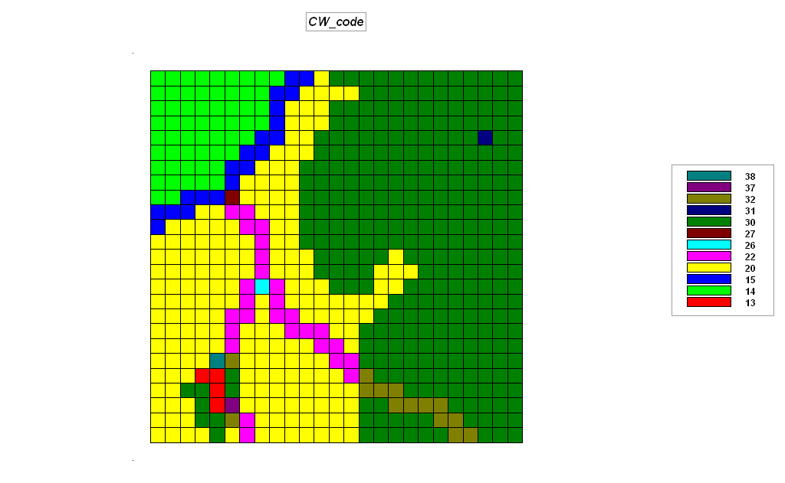 Click on the Data Type button to switch the map display to discrete data type.

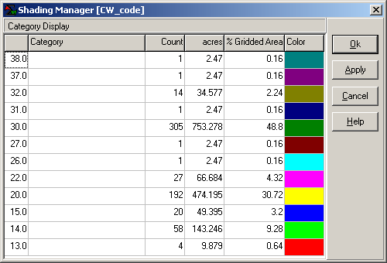 Double-click on the map to pop-up its Shading Manager with a tabular summary of the data. What condition does a “13” identify? How do the “Count” column statistics relate to those in the Cosstab table?

– COMPOSITE Covertype WITH Slope Average FOR Covertype_avgSlope

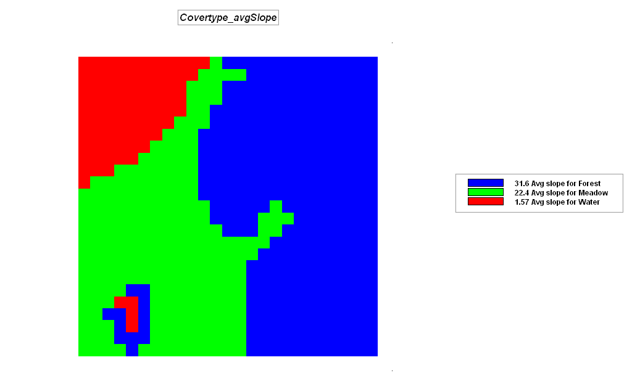

– RENUMBER Covertype ASSIGNING 0 TO 2 THRU 3 FOR OpenWater_binary
– COMPUTE OpenWater_binary Times Slope FOR OpenWater_slope

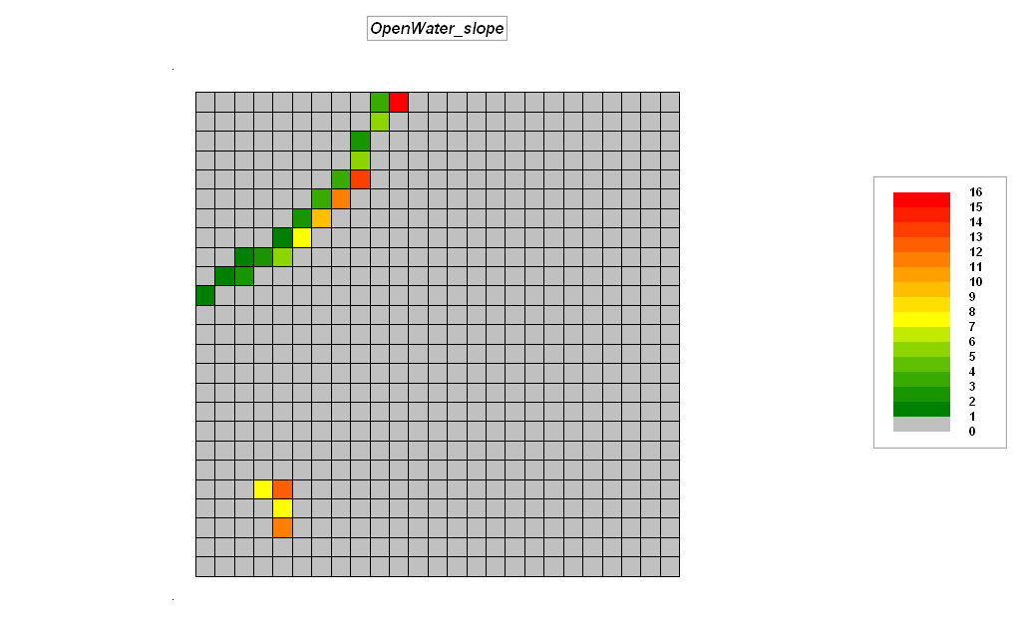

(3b) GIS Modeling (Habitat Suitability Model that Derives, Calibrates and Combines map layers)

The unique spatial combinations of geographic factors often determine habitat quality. In this example, using the Tutor25.rgs database Hugags in this locale have shown a preference for…

- Gentle Slopes (<30%)
- Southerly Aspects (E-W)
- Lower Elevations (<1800 feet)

…are evaluated using computer-based map analysis techniques for Binary, Ranking and Rating suitability models.

Using the flowchart and script listing below, become familiar with the model logic ingrained in each processing step that leads to the final Hugag habitat suitability map.

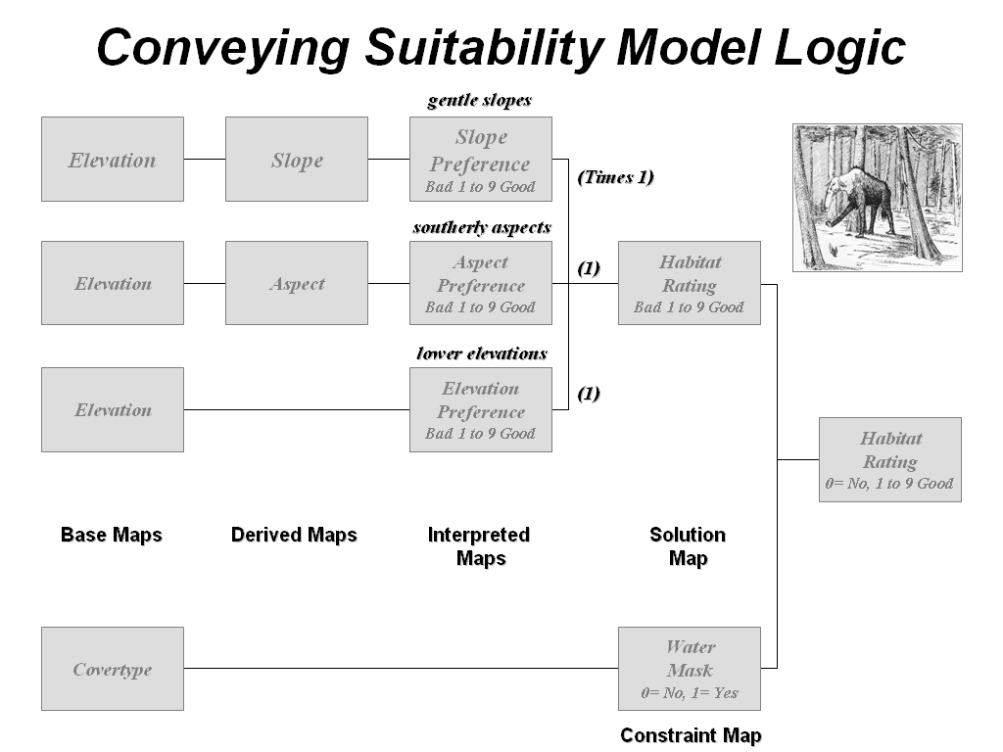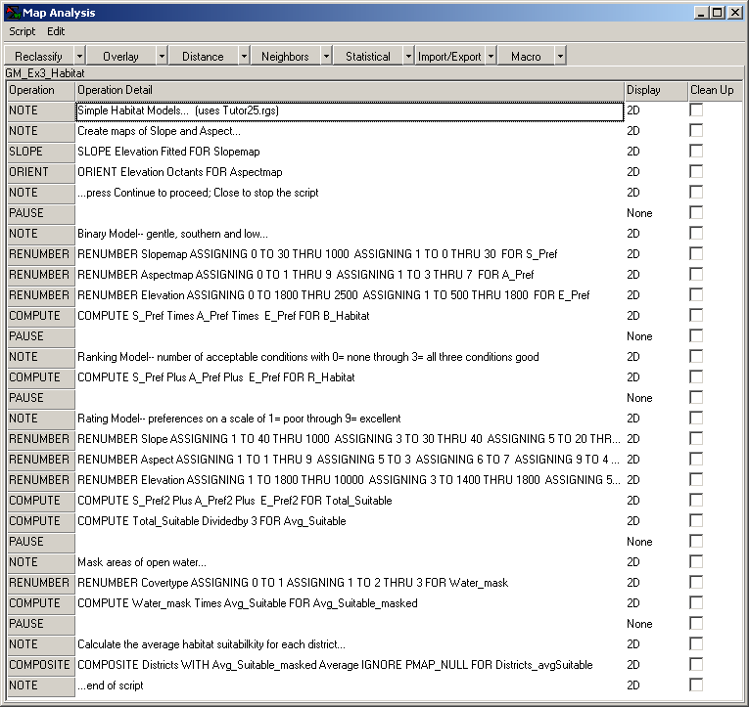

In a manner similar to accessing and implementing the Erosion Potential model in the previous exercise, execute the Hugag Habitat Suitability model by—

Within the Tutor25.rgs database, press the Map Analysis button to pop-up the Map Analysis dialog box.
Select Script→ Open then browse to and select …\Workshop Data→ Scripts→ GM_Ex3_Habitat.scr file.

Execute the command script a line at a time by double-clicking on the line and interpreting the dialog box information. Submit a command line by pressing OK. Relate the processing steps to the discussion in Slide # 5, Part 2 and the hyperlinked Hugag2.ppt slide set.

______________________________________________________

Cross-reference to ESRI Grid and Spatial Analysis operations…

MapCalc Command | Grid / Spatial Analyst
Slope creates a map indicating the slope (1st derivative) along a continuous surface. | Surface function SLOPE
Orient creates a map indicating aspect along a continuous surface. | Surface function ASPECT  Distance function EUCDIRECTION
Renumber assigns new values to the categories on a map. | Reclassification function RECLASS
Compute creates a map as the mathematical or statistical function evaluating an equation using a stack of map layers. | Arithmetic operators  *, +, -, DIV, MOD
Composite creates a map summarizing values from one map that coincide with the categories of another. | Zonal functions ZONALFILL, ZONALMAX, ZONAL MEAN, ZONALMIN, ZONALRANGE, ZONALSTD, ZONALSUM, ZONALVARIETY
Exercise #4 – Measuring Distance and Connectivity (MapCalc)

Access MapCalc using the Tutor25.rgs database by selecting Start→ Programs→ MapCalc Learner→ MapCalc Learner→ Open existing map set→ Tutor25.rgs in the …\WorkshopData\ folder.

Part 1. (Distance and Connectivity). Complete the following commands…

– View Button→ Housing to display the map (note the shape of the road network …a bunch of dots)
– SPREAD Housing TO 20 FOR Housing_simpleprox
This command generates a simple proximity surface from roads that assumes straight-line connectivity “as the crow flies”; view as a 3D Grid display of continuous data

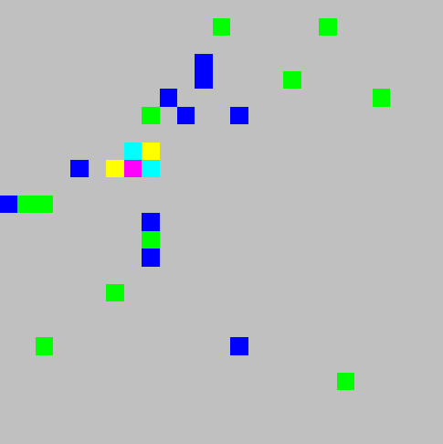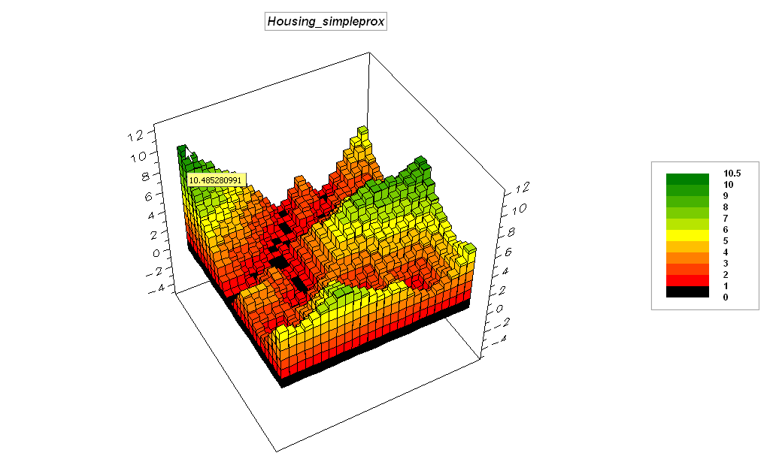

– View Button→ Roads to display the map (note the shape of the road network …like a discus thrower)
– SPREAD Roads TO 20 FOR Roads_simpleprox
This command generates a simple proximity surface from roads that assumes straight-line connectivity “as the crow flies”; view as a 3D Grid display of continuous data

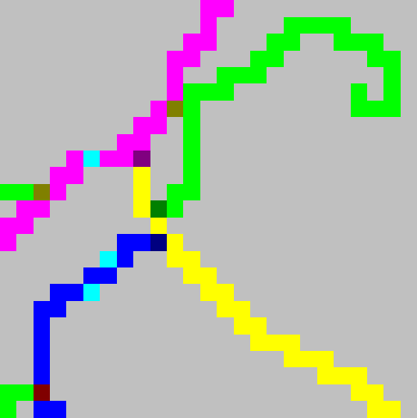

– View Button→ Covertype to display the map (note the values assigned to the various cover types)
– RENUMBER Covertype ASSIGNING 0 TO 1 ASSIGNING 3 TO 2
ASSIGNING 7 TO 3 FOR C_friction

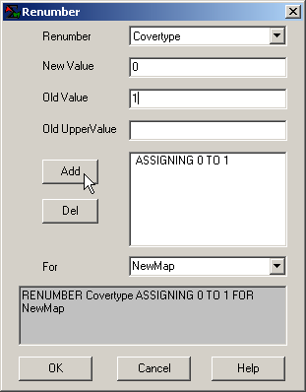 Note: Reassignment phrases are entered by specifying the New Value to replace an Old Value then pressing the Add button to enter the phrase. Repeat for other reassignment phrases.

This command establishes the relative impedance to movement in minutes to cross a grid cell based on cover types— 0= Open Water (absolute barrier), 3= Meadow and 7= Forest (relative barriers)

– SPREAD Roads TO 75 THRU C_friction FOR Road_hikingprox
This command generates an effective proximity surface from road locations that assumes not necessarily straight connectivity “as the crow walks” respecting absolute and relative barriers to movement

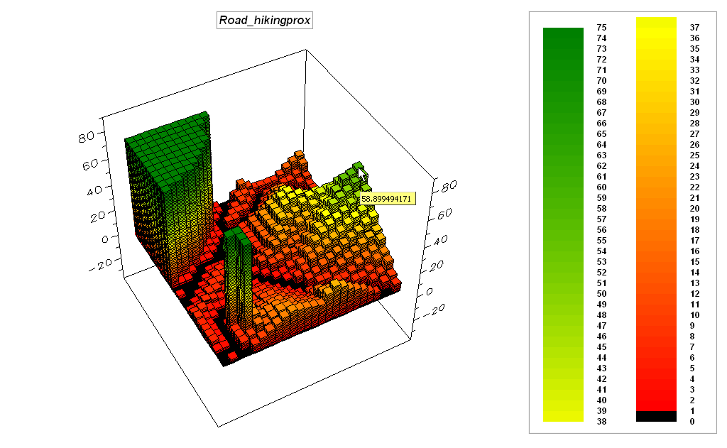

– View Button→ Locations to display the map (note the value and location of the Ranch location)
– RENUMBER Locations ASSIGNING 0 TO 2 THRU 5 FOR Ranch
This command isolates the ranch as a new map

– SPREAD Ranch TO 35 Simply FOR Ranch_simpleprox
This command generates a simple proximity surface from the ranch that assumes straight-line connectivity “as the crow flies”; view as a 3D Grid display of continuous data

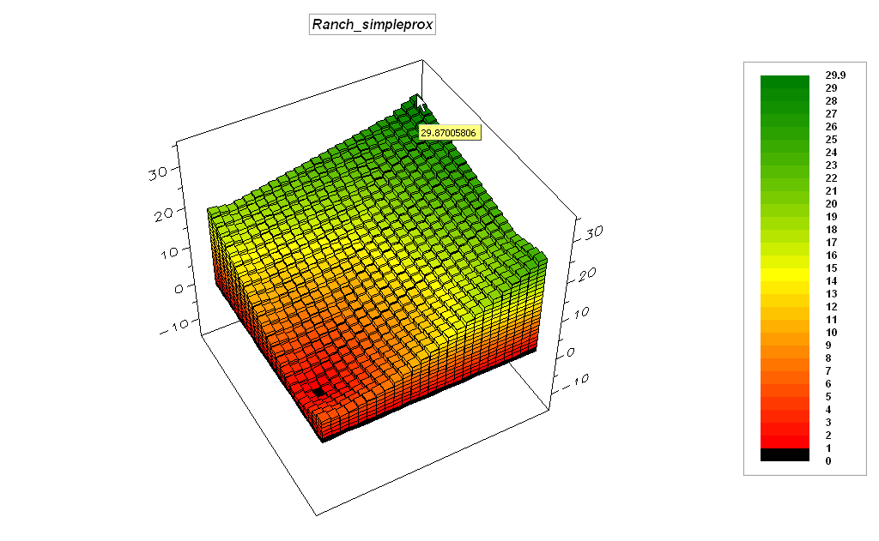

– RENUMBER Roads ASSIGNING 1 TO 1 THRU 43 FOR R_friction
This command establishes the relative impedance to movement in minutes to cross a grid cell of any road type— 0= not road, 1= all road types (relative barriers)

– COVER C_friction WITH R_friction FOR CR_friction
This command combines the cover type and road impedances by replacing C_friction values with R_friction values other than zero (transparent)

– SPREAD Ranch TO 75 THRU CR_friction FOR Ranch_hikingprox
This command generates an effective proximity surface from the ranch that assumes not necessarily straight connectivity “as the crow walks” respecting absolute and relative barriers to movement

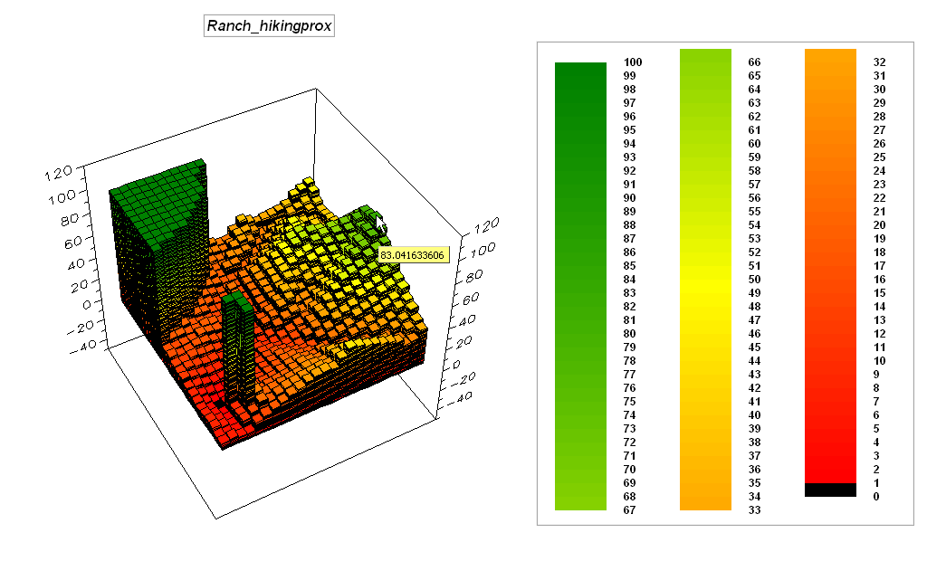

– View Button→ Locations to display the map (note the value and location of the Cabin location)
– RENUMBER Locations ASSIGNING 0 TO 1 ASSIGNING 0 TO 3 THRU 5 FOR Cabin
This command isolates the cabin as a new map

– STREAM Cabin OVER Ranch_hikingprox FOR Path
This command identifies the optimal path (shortest route) as the steepest downhill path over the Ranch_hikingprox surface

– COMPUTE Ranch_hikingprox times path FOR Path_hikingprox
This command isolates the hiking proximity values for the optimal path between the ranch and cabin

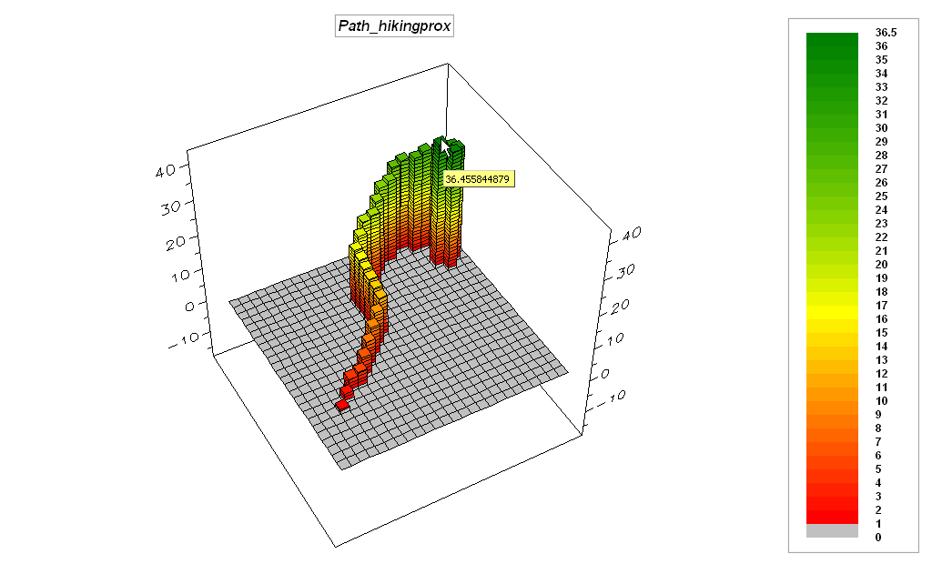

Part 2. (Visual Exposure). Complete the following commands…

– RADIATE Ranch OVER ELEVATION TO 35 AT 5 SIMPLY
FOR Ranch_viewshed
This command generates a map that identifies all of the locations that can be seen from the ranch

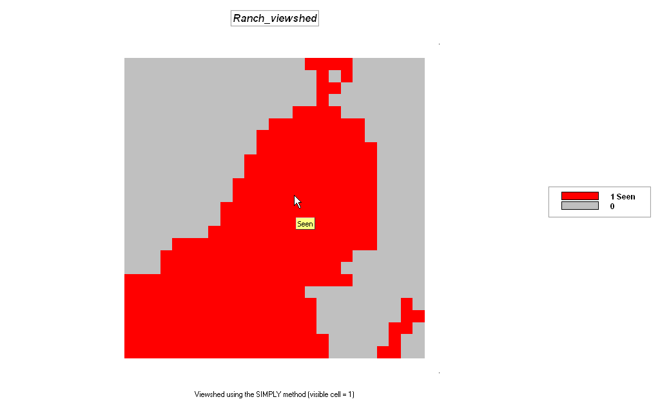

– RADIATE Roads OVER ELEVATION TO 35 AT 5 SIMPLY
FOR Roads_viewshed
This command identifies all of the locations that can be seen at least once from any of the road locations

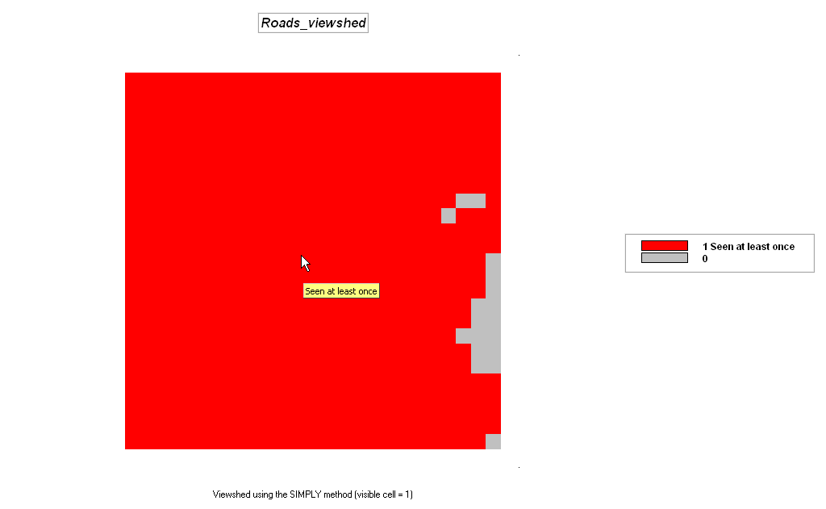

– RADIATE Roads OVER ELEVATION TO 35 AT 5 COMPLETELY
FOR Roads_VExposure
This command generates a surface that identifies the number of road locations visually connected to each location in the project area—visual exposure density surface

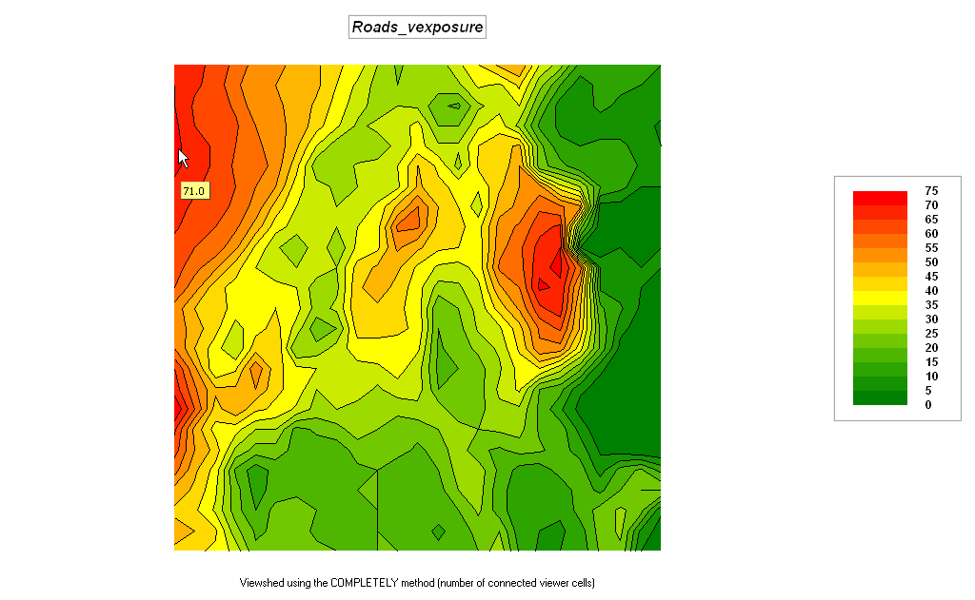
– RADIATE Housing OVER ELEVATION TO 35 WEIGHTED

FOR housing_WeightedVE

The following series of commands complete a simple model that generates a map identifying the relative visual exposure index of human activity

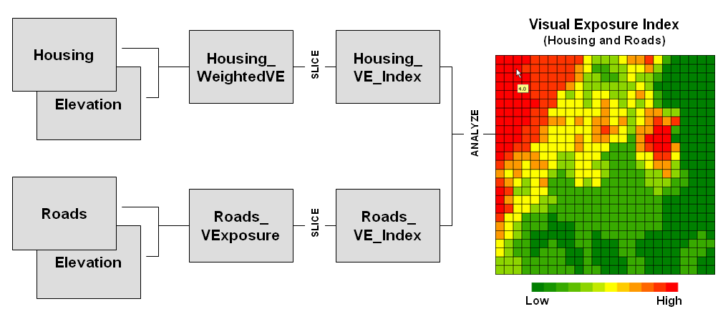

– SLICE Housing_WeightedVE INTO 4 FOR Housing_VE_Index
This command (under the Reclassify group of operators) divides the range of weighted visual exposure to housing into 4 classes from 1= low to 4=high

– SLICE Roads_VExposure INTO 4 FOR Roads_VE_Index
This command divides the range of weighted visual exposure to roads into 4 classes from 1= low to 4=high

– ANALYZE Housing_VE_Index WITH Roads_VE_Index Mean FOR RH_VE_Index_avg
This command (under the Statistics group of operators) averages the two index maps

______________________________________________________

Cross-reference to ESRI Grid and Spatial Analysis operations…

MapCalc Command | Grid / Spatial Analyst
Spread creates a map indicating the shortest effective distance from specified cells to all other locations. | Distance functions CORRIDOR (compute sum), COSTALLOCATION (slice), COSTDISTANCE, EUCALLOCATION, EUDIRECTION (orient), EUCDISTANCE  Shape Analysis functions EXPAND, SHRINK  Hydrologic function WATERSHED, BASIN
Renumber assigns new values to the categories on a map. | Reclassification function RECLASS
Radiate creates a map indicating areas that are visible from specified locations. | Visibility tools VISENCODE, VISIBILITY
Cover creates a new map where non-zero values of the top map replace the values on the previous (bottom) map, or stack of maps. | Selection functions SELECTBOX, SELECTCIRCLE, SELECTMASK, SELECTPOINT, SELECTPOLYGON
Stream creates a map identifying the steepest downhill route along a surface (optimal path). | Distance functions COSTBACKLINK, COSTPATH, PATHDISTANCE  Hydrologic function FLOWDIRECTION (orient)
Exercise #5 – Characterizing Spatial Neighborhoods (MapCalc)

Access MapCalc using the Tutor25.rgs database by selecting Start→ Programs→ MapCalc Learner→ MapCalc Learner→ Open existing map set→ Tutor25.rgs in the …\WorkshopData\ folder.

Complete the following commands…

– SCAN Covertype DIVERSITY WITHIN 2 FOR Covertype_diversity2
…how many cells are within 2-cells of all three cover types?

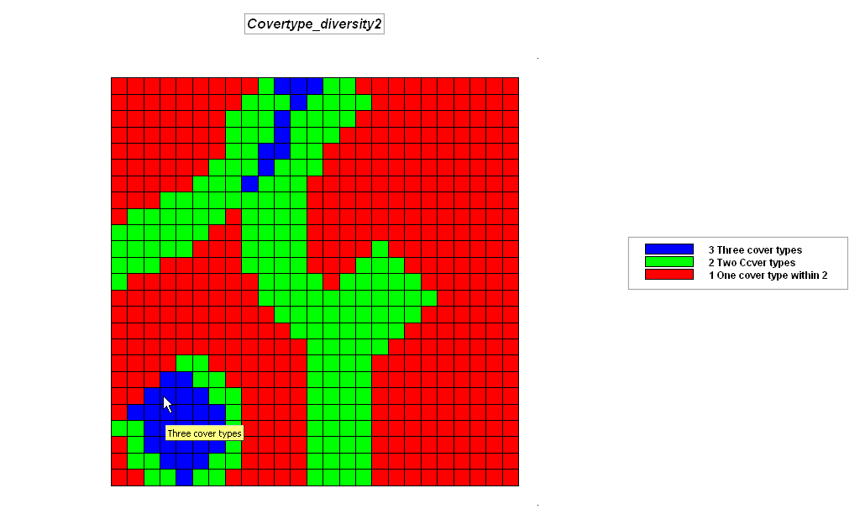

– SCAN Covertype DIVERSITY WITHIN 4 FOR Covertype_diversity4
…how many cells are within 4-cells of all three cover types?

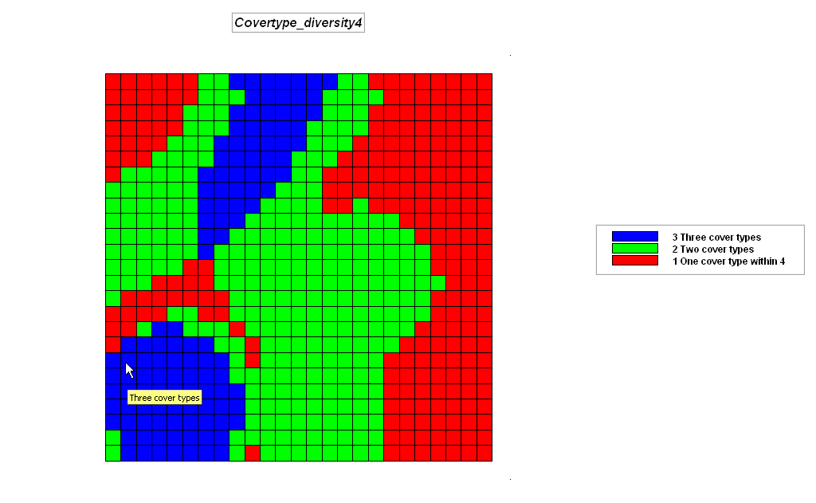

– SCAN COVERTYPE DIVERSITY WITHIN 4 AROUND ROADS
FOR Covertype_diversity4_roads
…where are the most diverse locations along the road network?

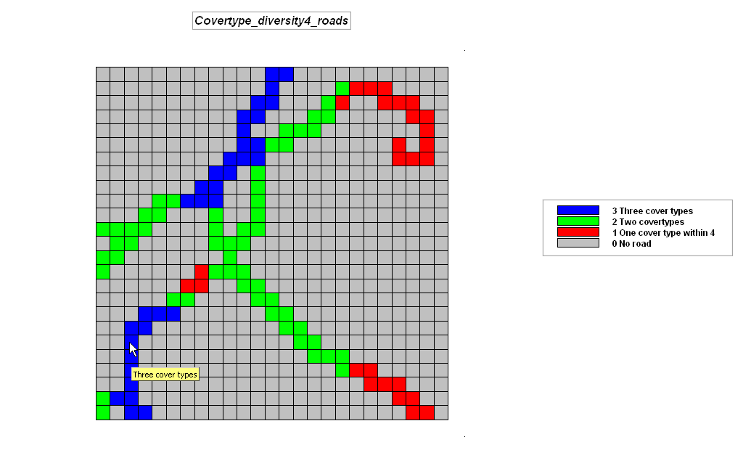

– SCAN ELEVATION AVERAGE WITHIN 4 FOR Elevation_smooth4
– COMPUTE ELEVATION MINUS Elevation_smooth4 FOR Convex_concave_terrain
…what information does the positive and negative sign convey? … the magnitude of the values?

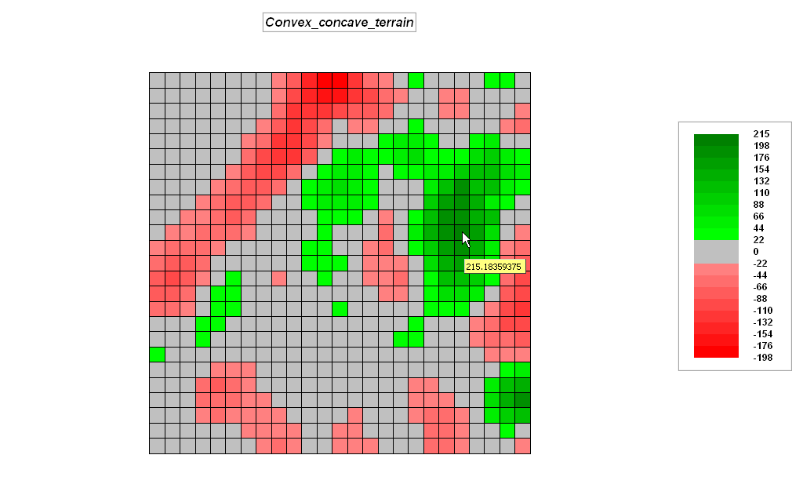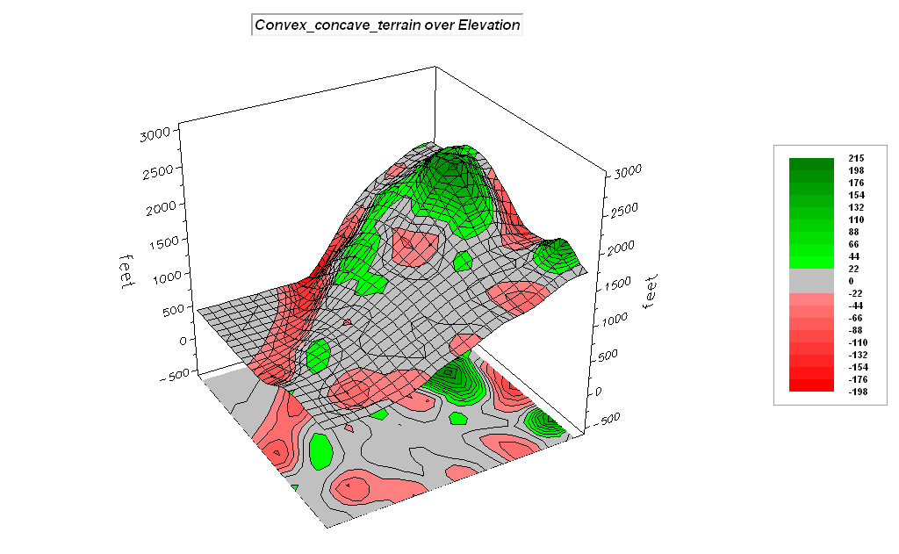

– SCAN SLOPE COFFVAR WITHIN 1 FOR Slope_roughness
…what is the maximum localized slope variation? …where is it?

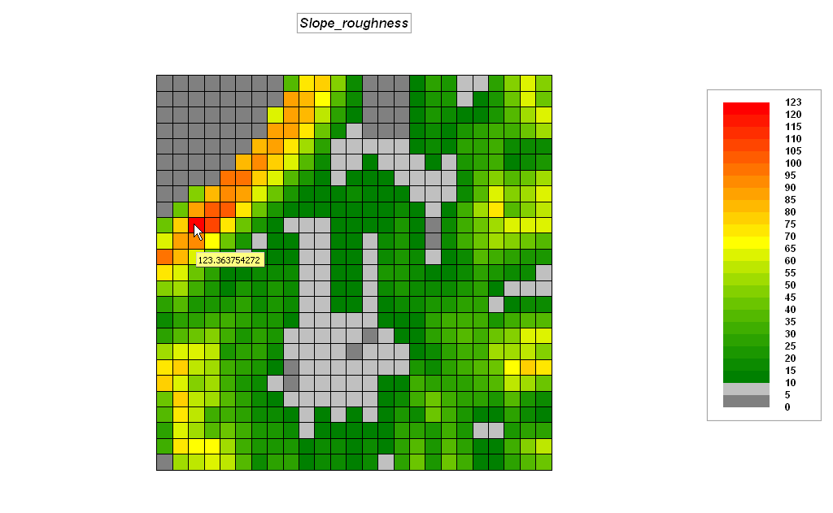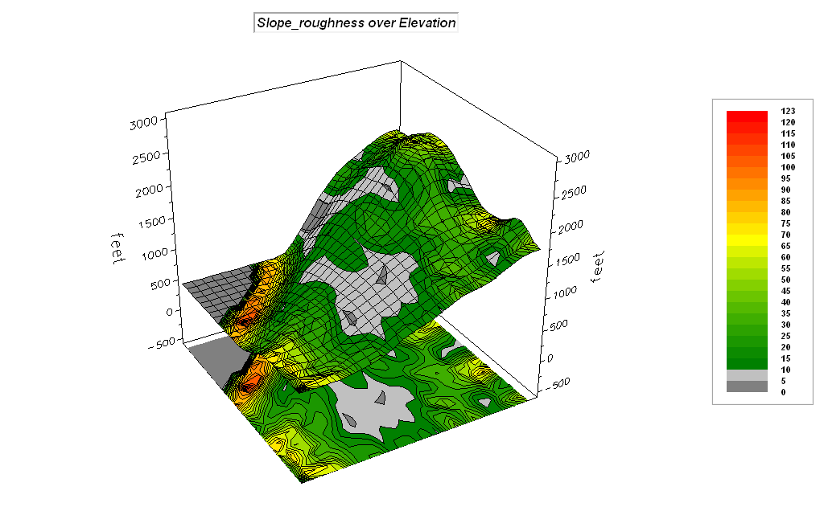

– SLOPE SLOPE FOR What?
…what do you think the values indicate?

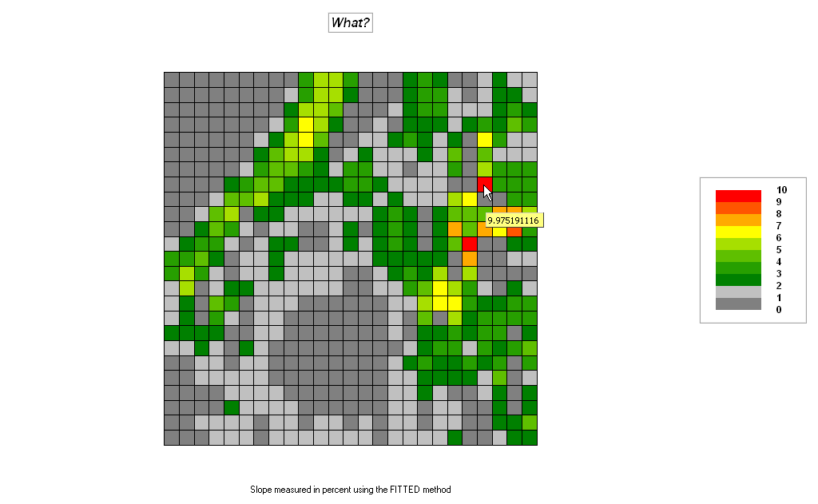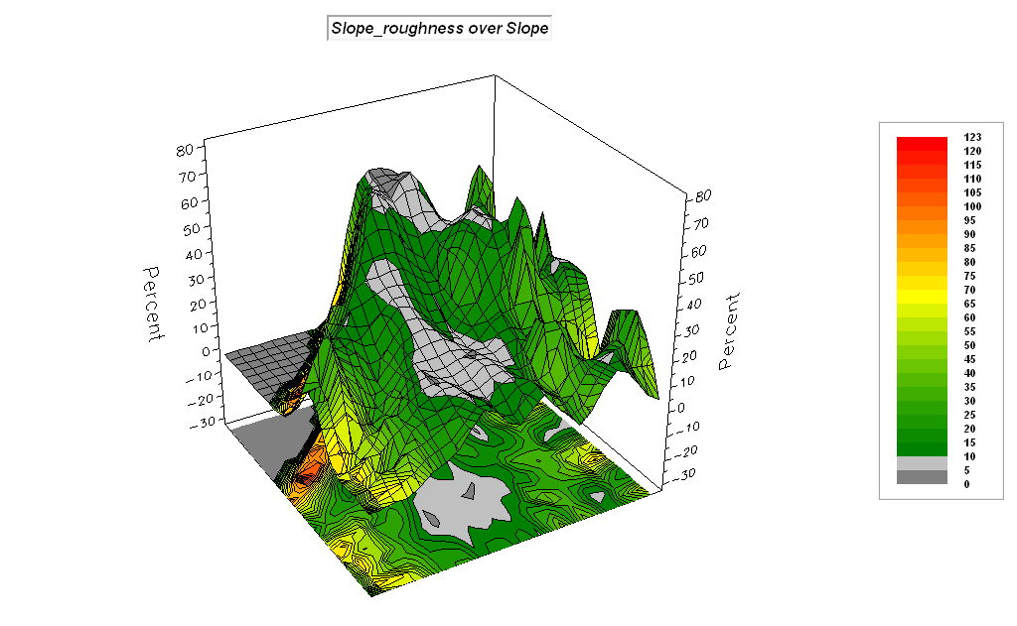

– RENUMBER Ranch_hikingprox ASSIGNING PMAP_NULL TO 100
FOR Ranch_hikingprox_mask (Ranch_hikingprox from the previous exercise)

– SLOPE Ranch_hikingprox_masked FOR What_else?
…what do you think the values indicate?

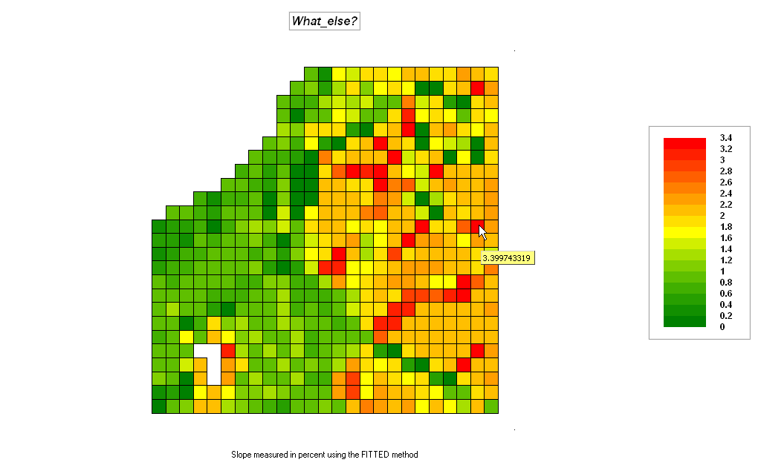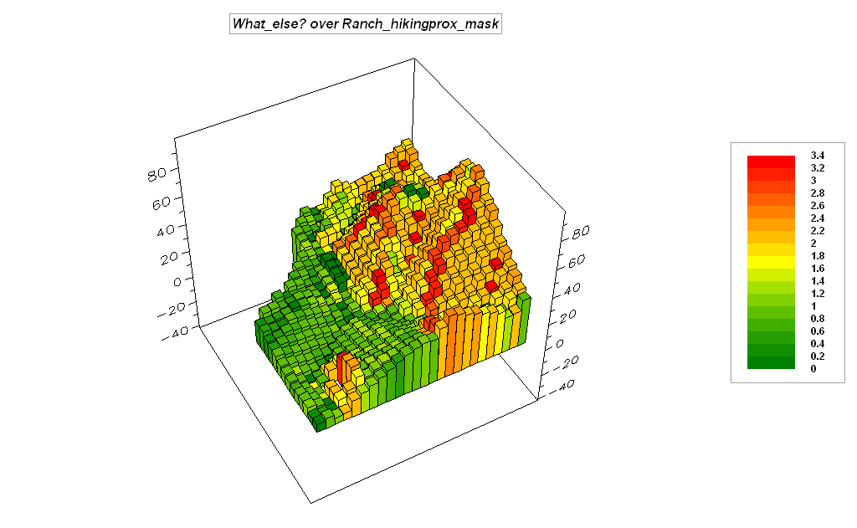

– ORIENT Ranch_hikingprox_masked FOR You_have_to_be_kiding!
…what do you think the values indicate?

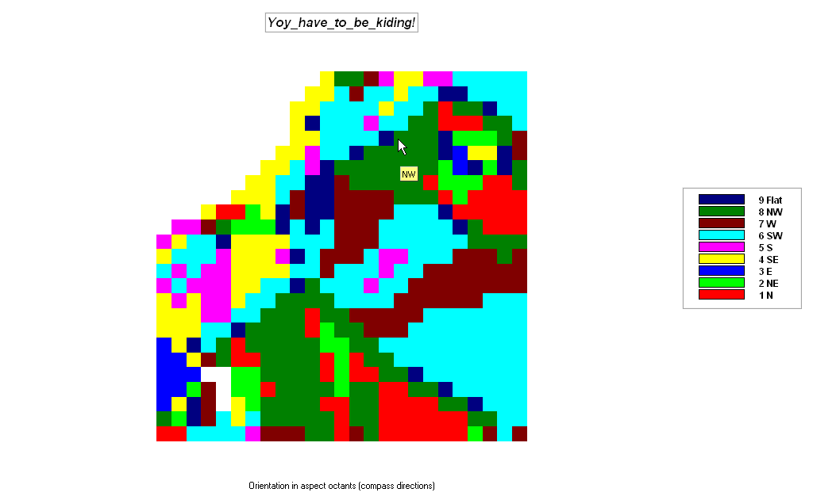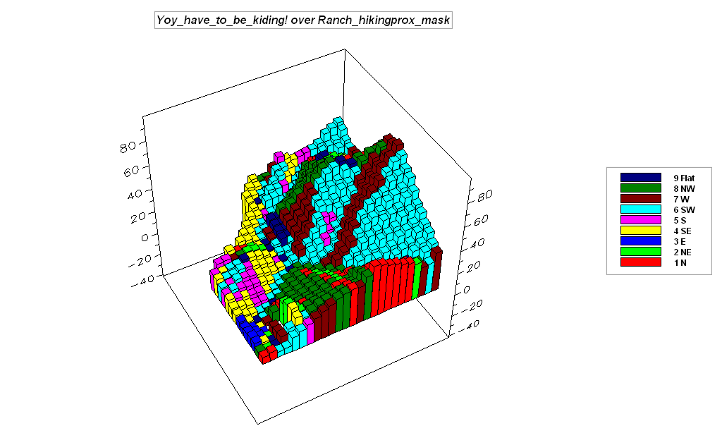

______________________________________________________

Cross-reference to ESRI Grid and Spatial Analysis operations…

MapCalc Command | Grid / Spatial Analyst
Scan creates a map summarizing the values that occur within the vicinity of each cell. | Statistical operation POPULARITY  Focal functions FOCALFLOW, FOCALMAX, FOCALMEAN, FOCALMIN, FOCALRANGE, FOCALSTD, FOCALSUM, FOCALVARIETY  Conditional statement  IF, WHILE, DOCELL  Data Clean-up functions BOUNDARYCLEAN, MAJORITYFILTER, NIBBLE, THIN  Hydrologic functions  FILL, SINK
Compute creates a map as the mathematical or statistical function evaluating an equation using a stack of map layers. | Arithmetic operators  *, +, -, DIV, MOD
Profile creates a map indicating the cross-sectional profile along a continuous surface. | Surface functions  SAI, SHADE
Intersect creates a map by assigning new values to pair wise combinations of the values on two maps. | Combinatorial function COMBINE
Exercise #6 – Surface Modeling (Surfer)

Installing Surfer— The Workshop CD comes with a evaluation copy of the Surfer software (cannot save or print plots). To install Surfer press Start→ Run→ then browse to the …\ Workshop\Surfer\ folder on the CD and select the s8demo.exe file. Follow the onscreen installation instructions. It is recommended that you accept the default specifications as the exercise write-ups assume this installation location.

Accessing MapCalc— To access Surfer press Start→ Programs→ Golden Software Surfer 8→ Surfer 8. Click anywhere to dismiss the banner graphic and follow the exercise directions below to create and display map surfaces.

Uninstalling MapCalc— To uninstall Surfer press Start→ Control Panel→ Add or Remove Programs→ and select Surfer 8 to remove.
______________________________________________

Part 1 – Spatial Interpolation. Access the Surfer software system by double-clicking its icon on the desktop or by pressing Start→ Programs→ Golden Software Surfer 8→ Surfer 8.

Create a continuous grid from discrete point data…

- From the main menu click Grid à Data, then select the Demogrid.dat file in the …\Samples subdirectory. The Scattered Data Interpolation box will pop-up.

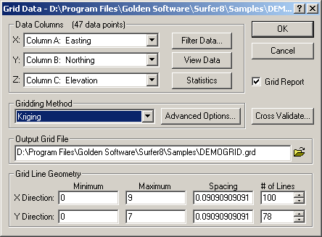

- Data Columns enables the selection of X, Y and Z data fields in a table
- Gridding Method box specifies the interpolation techniques (use Kriging)
- Output Grid File to browse to a folder for storage of the interpolated map
- Grid Line Geometry sets the analysis frame configuration by defining the extent and cell size (use defaults)

Click OK to derive the interpolated surface using default specifications

View a map surface as a contour map…

- From the main menu click MAP à Contour à New Contour map → OPEN and specify the Demogrid_IDW.grd data file you just derived. Click OK to generate a contour plot…

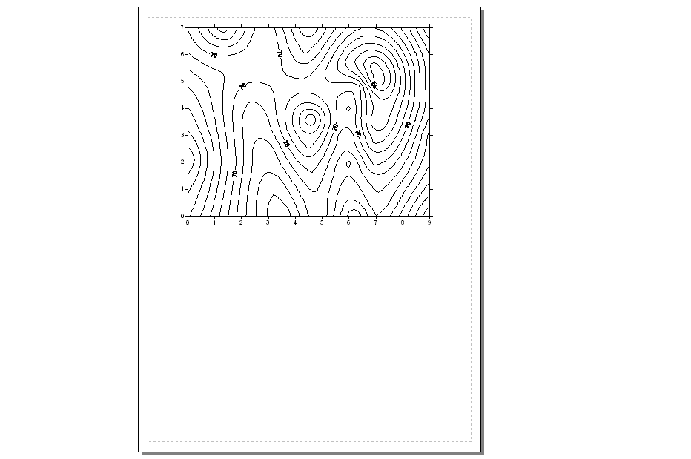

View a map surface as a “surface” plot…

- From the main menu click MAP à Surface à OPEN and specify the Demogrid_IDW.grd data file you just derived. Click OK to generate a “surface” plot…

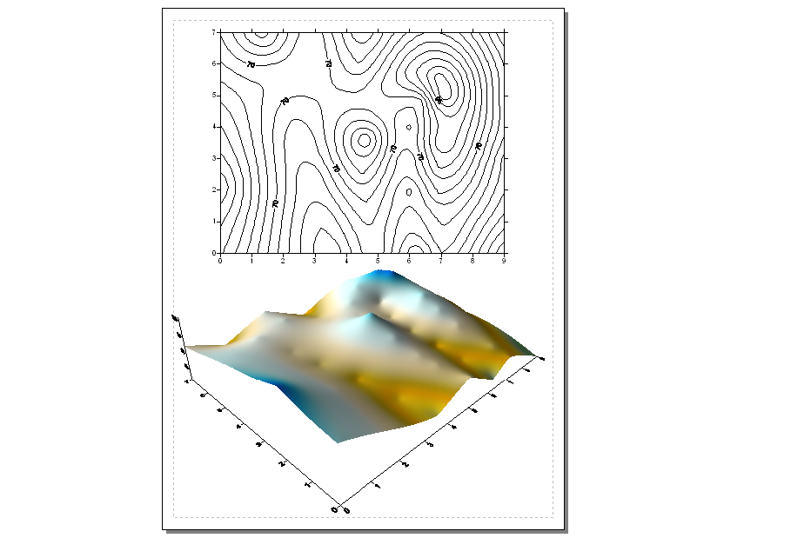

Graphically overlay the two plots…

- Shift/click both plots to select them, then from the main menu click MAP à Overlay Maps to generate a “surface/contour” plot…

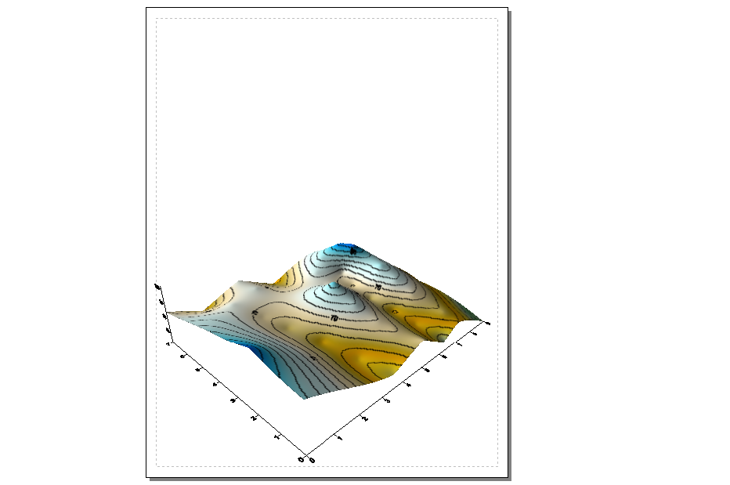

Surfer contains several different spatial interpolation methods. Repeat the processing to create another surface using Inverse Distance Weighted interpolation technique.

- From the main menu click Grid à Data, then select the Demogrid.dat file in the …\Samples subdirectory. The Scattered Data Interpolation box will pop-up.

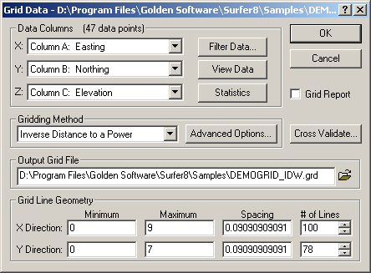 However this time, specify “Inverse Distance to a Power” as the Gridding Method and DEMOGRID_IDW.grid as the Output Grid File.

Generate a Contour map and a Surface map and then overlay the maps as before. Repeat for other interpolation techniques as time and interest permits.

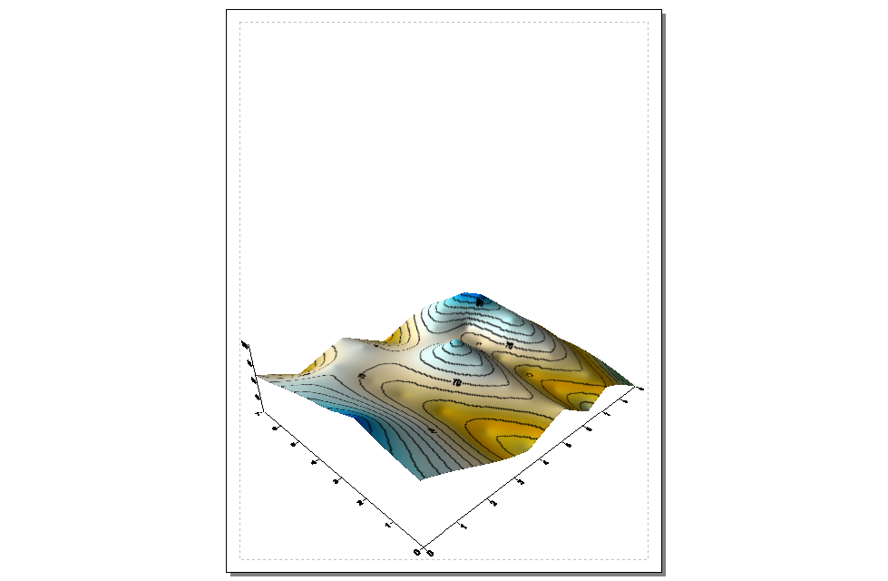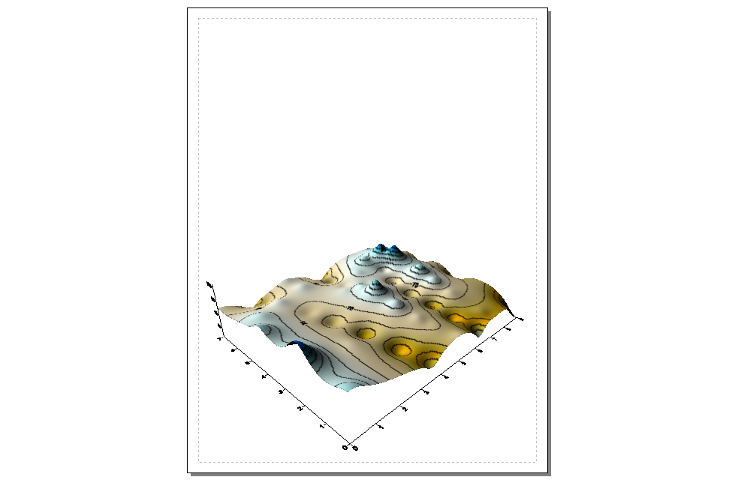
Krig IDW

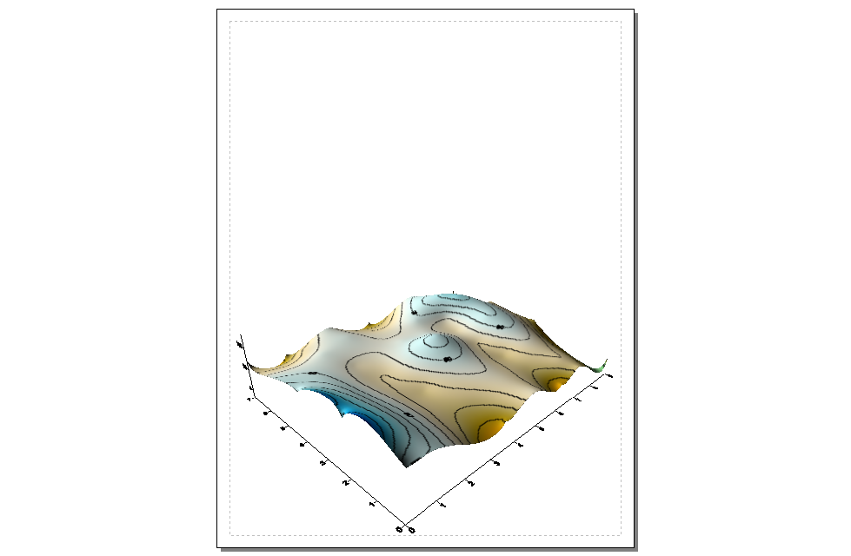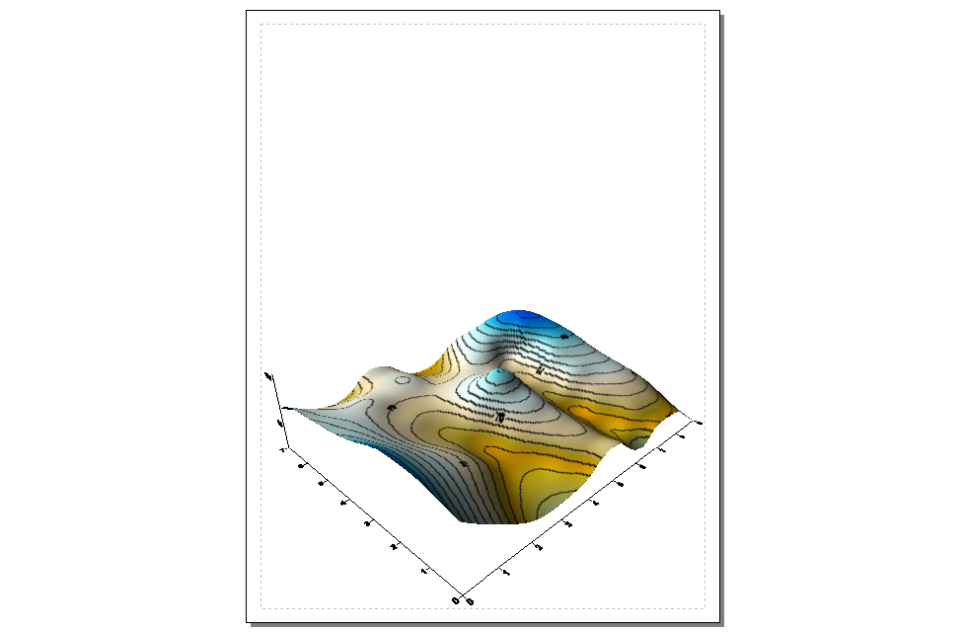
Minimum Curvature Modified Shepard’s

As time and interest permits for optional homework, complete the Surfer Tutorials in the …\Geotechnology_software\Surfer\Surfer_Tutorial\ folder on the Workshop CD.

Part 2 – Density Analysis. For a related experience in Surface Modeling using density analysis, access MapCalc using the Smallville.rgs database by selecting Start→ Programs→ MapCalc Learner→ MapCalc Learner→ Open existing map set→ Smallville.rgs in the …\WorkshopData\ folder.

Complete the following commands…

– View Button→ Total_Customers to display a map identifying the number of customers at each grid location
– SCAN Total_Customers TOTAL WITHIN 6 FOR Customer_density6
This command determines the total number of customers within a specified reach to generate a density surface.

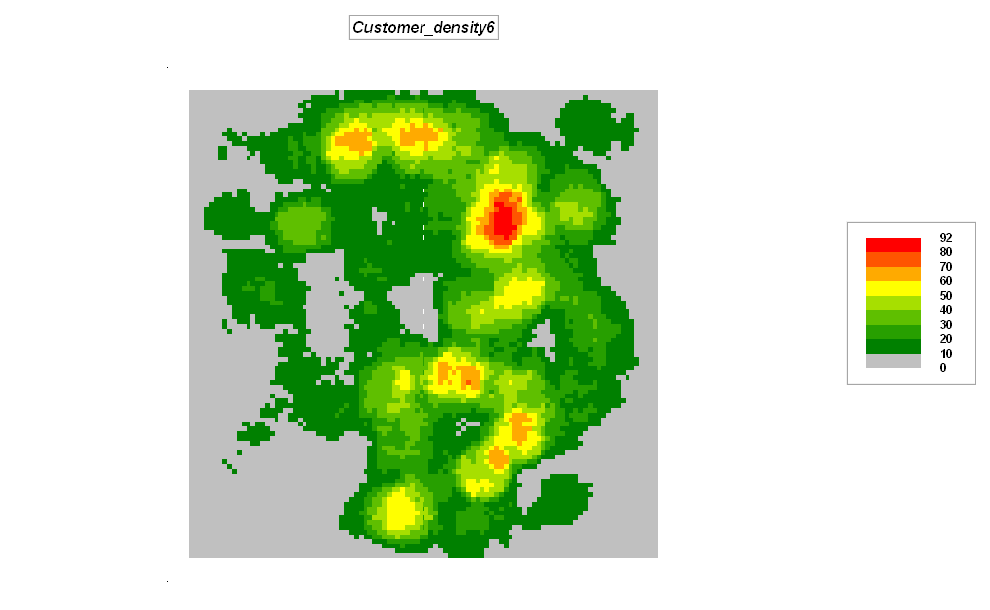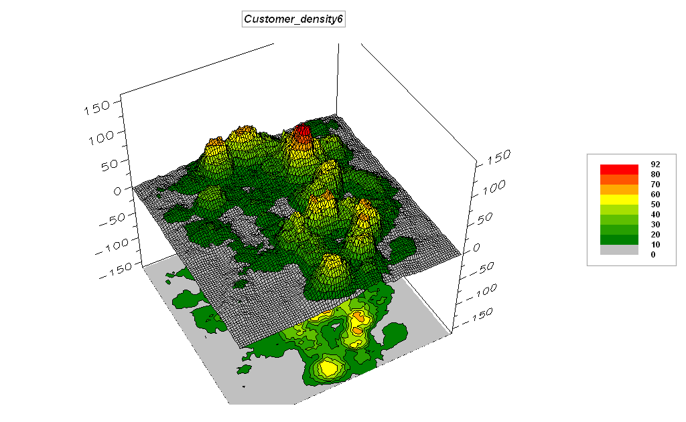

– Right-click on the map and select the Shading Manager. Click on the Statistics tab and note that the average customer density is 17.7 with a standard deviation of 16.0. The breakpoint for unusually high customer densities is 17.7 + 16.0= 33.7.

– RENUMBER Customer_density6 ASSIGNING 0 TO 0 THRU 33.7
ASSIGNING 1 TO 33.7 THRU 1000 FOR Customer_highDensity
This command isolates the locations of high customer density (assigned a value of 1 embedded in zeros)

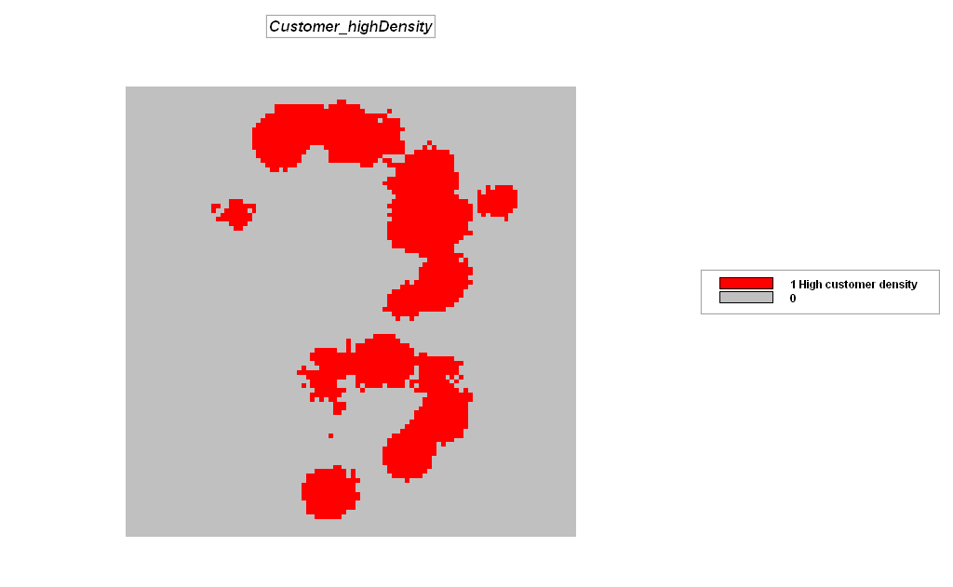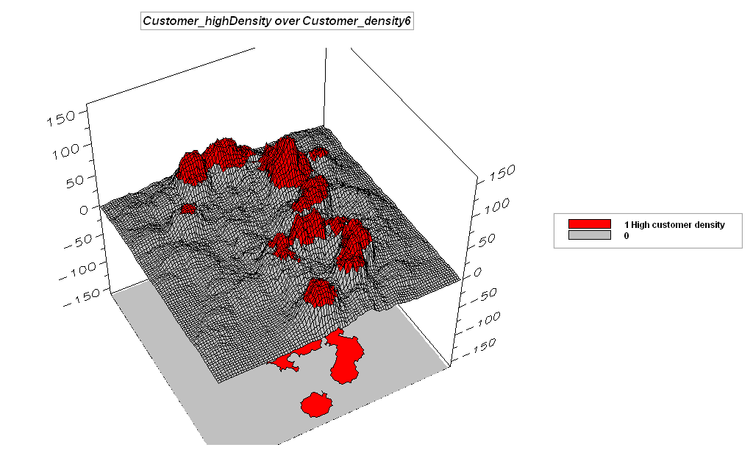

______________________________________________________

Cross-reference to ESRI Grid and Spatial Statistics operations…

MapCalc Surface Modeling Command | Grid / Spatial Analyst
Inverse Distance Weighted performs an inverse distance weighted interpolation of point data. | Statistical Function  IDW
Kriging performs spatial interpolation of point data using the Kriging algorithm. | Statistical Function  KRIG
Grid math creates a map as the mathematical or statistical function evaluating an equation using a stack of map layers. | Arithmetic operators  *, +, -, DIV, MOD

Exercise #7 – Spatial Data Mining (MapCalc)

Access MapCalc using the AgData.rgs database by selecting Start→ Programs→ MapCalc Learner→ MapCalc Learner→ Open existing map set→ AgData.rgs in the …\WorkshopData\ folder.

Visually compare the yield maps for 1997 and 1998.

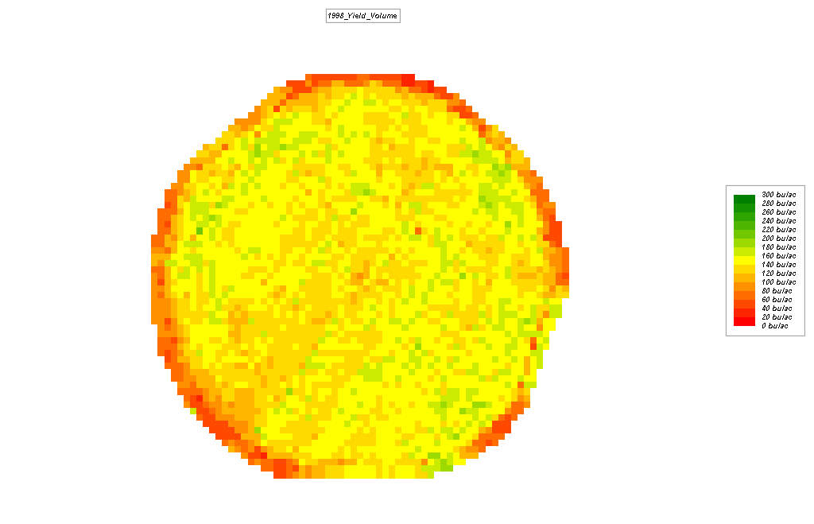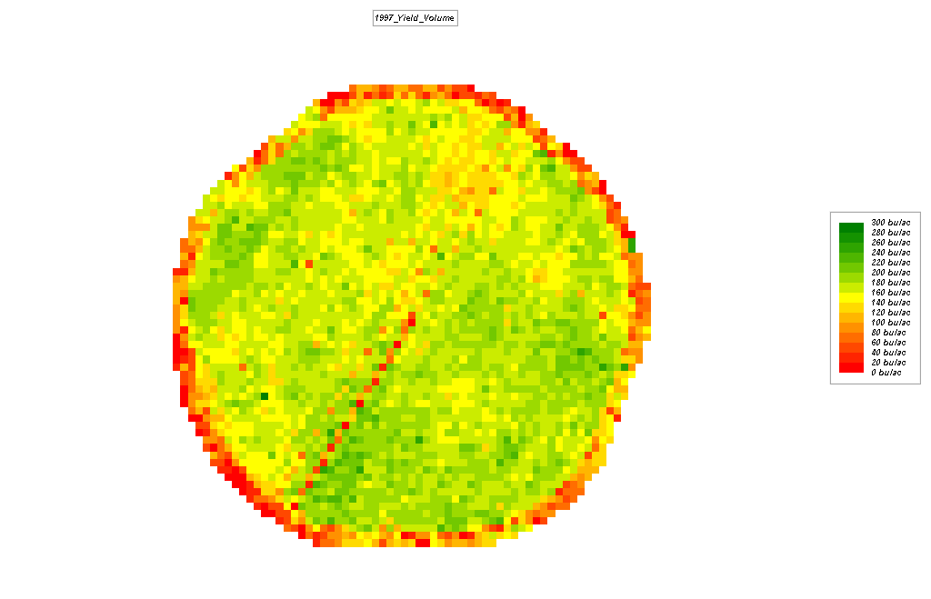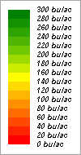
1998_Yield_Volume minus 1997_Yield_Volume

Note: to visual compare to map surfaces, you MUST use the same display types and legend.

Press the Map Analysis button to access the analytical operations then select Overlay→ Calculate and complete the dialog box as shown below using the Columns item to select maps and Functions item to select mathematical operations.

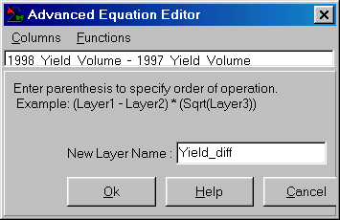 1998_Yield_Volume – 1997_Yield_Volume For Yield_diff

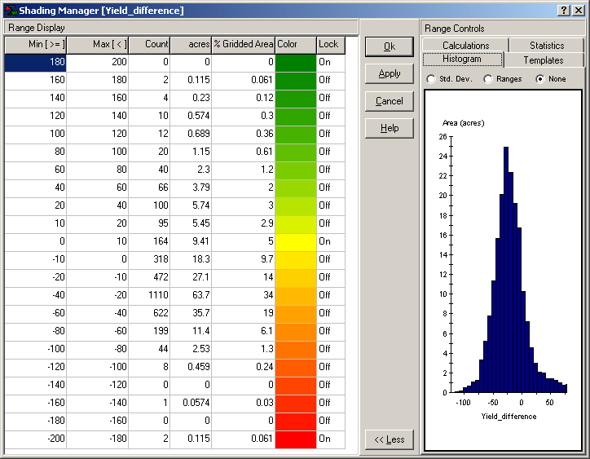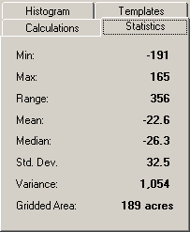

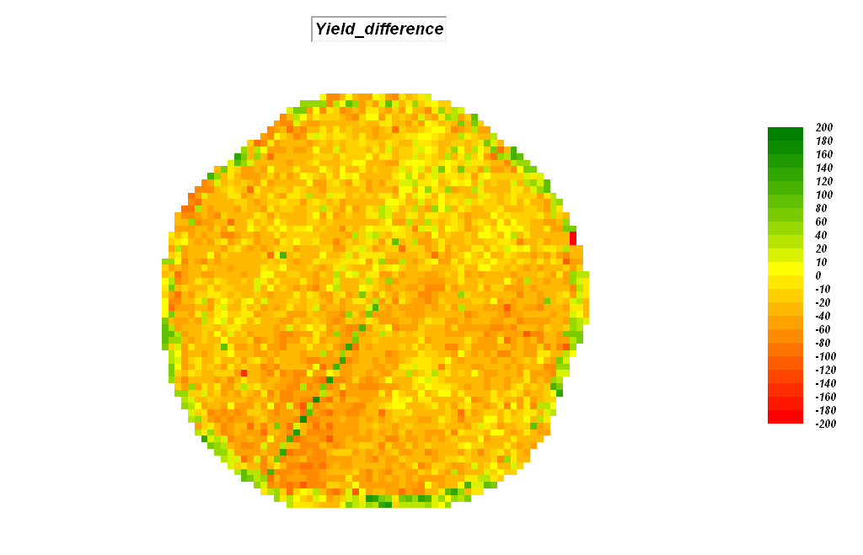 …note that most field locations yield decreased in 1998 (negative values displayed as warmer tones).

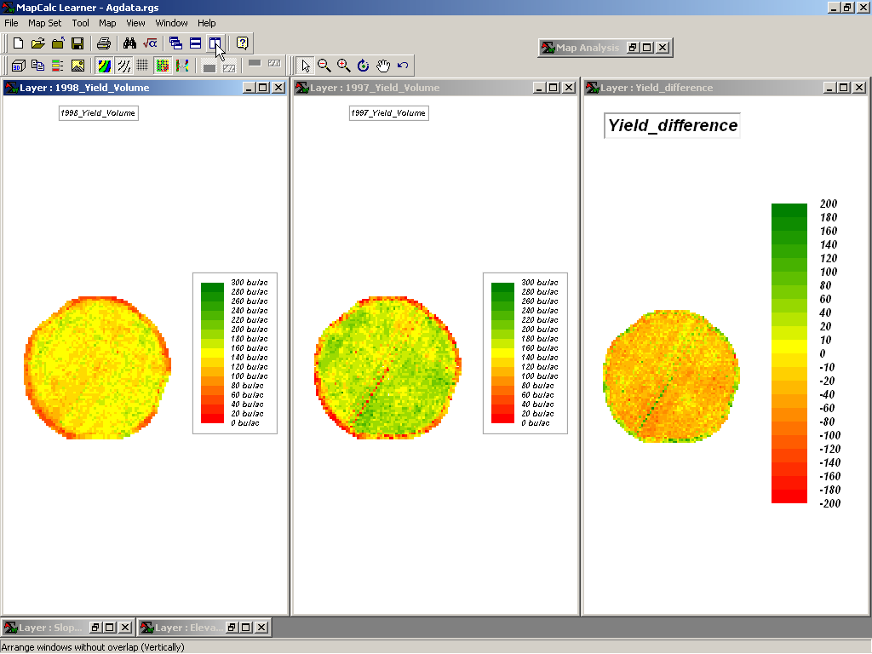

Generate side-by-side map displays of the 1996_Fall_N, 1996_Fall_K and 1996_Fall_TotalN.

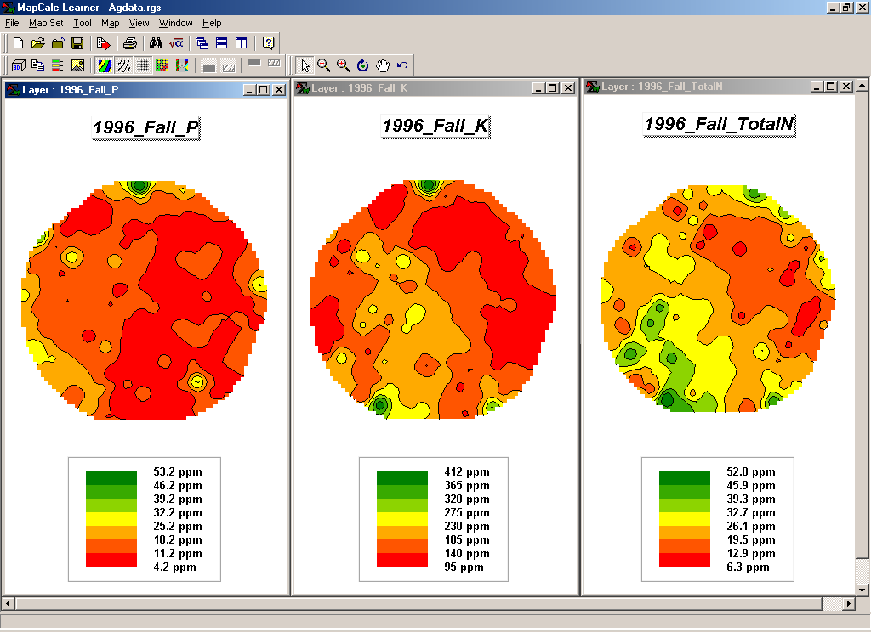 …using the same display type and legend and then pressing the “Arrange Windows without overlap (vertically)” button

Double-click on the Phosphorus map (1996_Fall_P) to pop-up the Data Inspection tool and note how the values for all of the map layers change as you move about the map. Move the cursor to Column 47, Row 11 (position shown in bottom left corner of the display window) and note the values for…

1996_Fall_P= 33.3 1996_Fall_K= 204.1 1996_Fall_TotalN= 28.9 ppm.

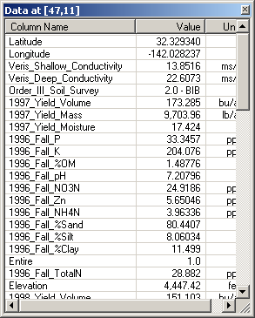

RELATE ((1996_Fall_P, 1, 33.3) WITH (1996_Fall_K, 1, 204.1), (1996_Fall_TotalN, 1, 28.9) FOR PKN_similarity_47_11
This command generates a similarity map based on the “data distance” relationship of the data pattern of a specified location to all other locations. Higher values indicate increasing similarity (100= identical).

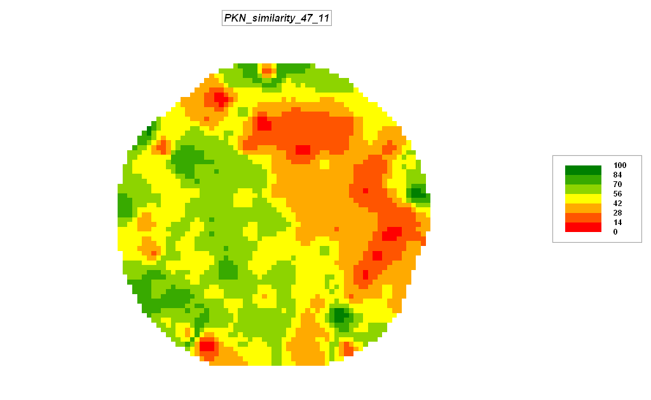

CLUSTER 1996_Fall_P WITH 1996_Fall_K, 1996_Fall_TotalN USING 2 FOR PKN_cluster2
This command subdivides the field into two zones based on the P, K and N data patterns.

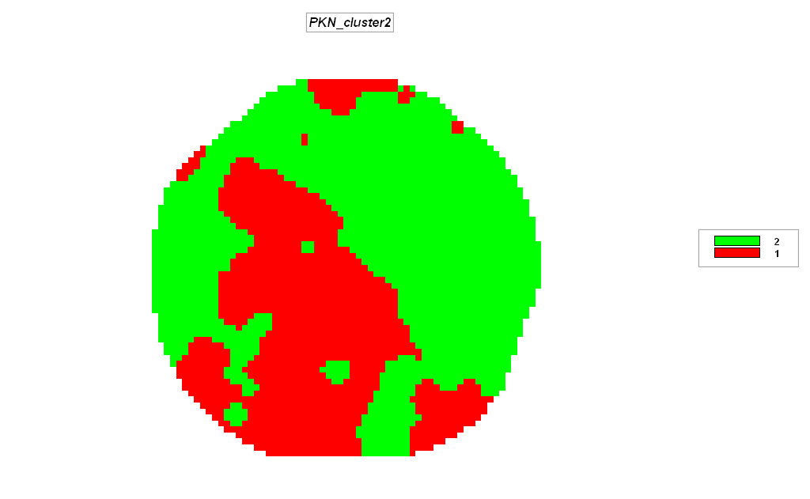

COMPOSITE PKN_cluster2 WITH 1997_Fall_K Average IGNORE PMAP_NULL FOR PKN_cluster2_avgK
This command averages all of the Potassium (K) values occurring within each of the data zones noting that Zone 1 average is 207 ppm compared to Zone 2 at 156 ppm.

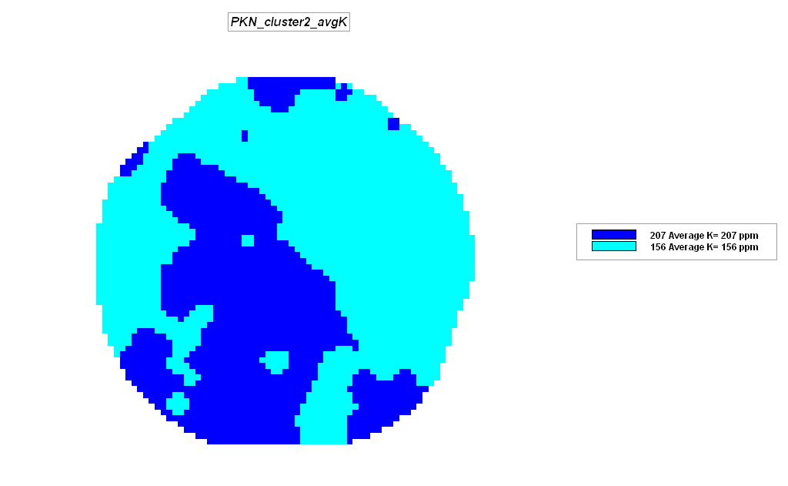

From the main MapCalc menu, select Map Set→ New Graph→ Scatter Plot and specify 1996_Fall_P as the X axis (independent variable) and 1997_Yield_volume as the Y axis (dependent variable) and press OK to generate a scatter plot of the two map variables.

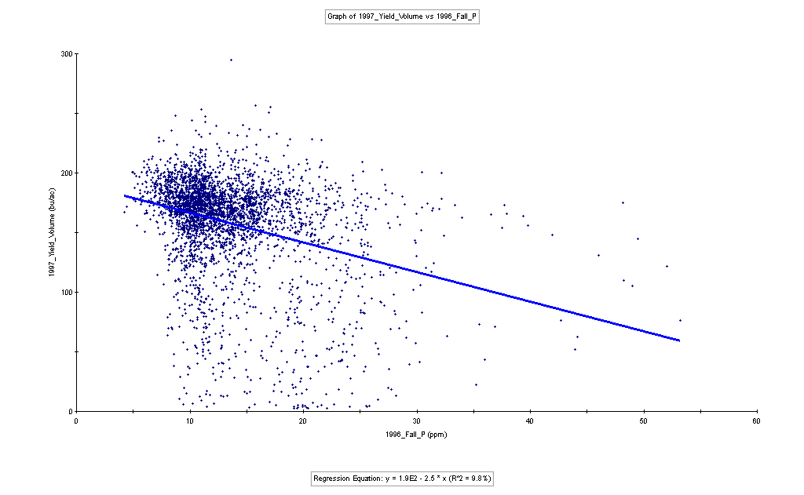

Note: the Univariate Regression equation suggests a negative correlation with increasing amounts phosphorous. This is likely a spurious result as the scatter plot has minimal overall trend with the low R-squared value of 9.8% primarily the result of the few outlier high P values. The bottom line is that this regression prediction equation is not useful.

REGRESS 1997_Yield_Volume WITH 1996_Fall_P, 1996_Fall_K, 1996_Fall_TotalN TO C:\Temp\97Yield_PKNregression.txt FOR 1997_Yield_PKNregression

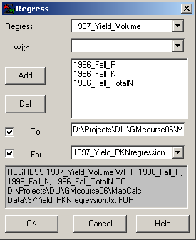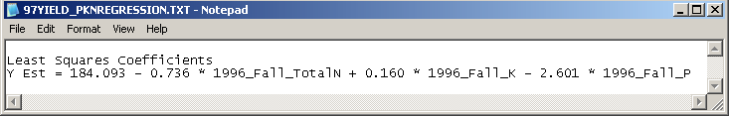
This command generates a Multivariate regression equation predicting Yield from nutrient maps of P, K and N. By requesting a map be generated, a map of the predicted yield is generated…

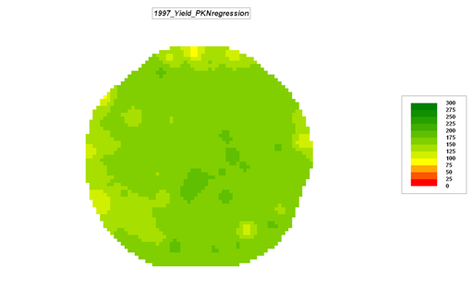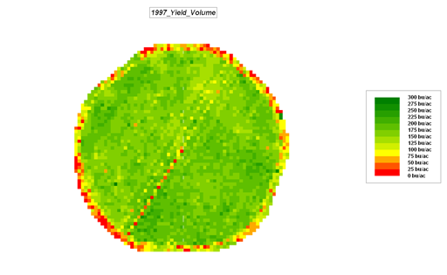
Predicted Yield map Actual Yield map

The predicted and Actual yield maps are not very consistent. In practice the inconsistent yield values along the field edge and access road in the southwest portion of the field would be eliminated to yield a much better prediction equation. Also, a regression tree based on stratified portions of the field would be used to improve the overall prediction.

______________________________________________________

Cross-reference to ESRI Grid and Spatial Statistics operations…

MapCalc Spatial Data Mining Command | Grid / Spatial Analyst
Similarity quantifies the similarity of a map to an evaluation data pattern, or set of comparison values. | No comparable operation
Cluster identifies areas with similar characteristics on a set of map layers. | Image Analyst  CLUSTER
Correlate derives a correlation matrix from a stack of maps. | Image Analyst CORRELATE
Regress performs linear regression analysis by using the "least squares" method to fit a line through a set of data points in multiple maps. | Statistical function REGRESSION

Exercise #8 – Gaining GIS Modeling Experience (MapCalc)

Access MapCalc using the Bighorn.rgs database by selecting Start→ Programs→ MapCalc Learner→ MapCalc Learner→ Open existing map set→ Bighorn.rgs.

Complete the following …

Part 1 – Campground Suitability Model

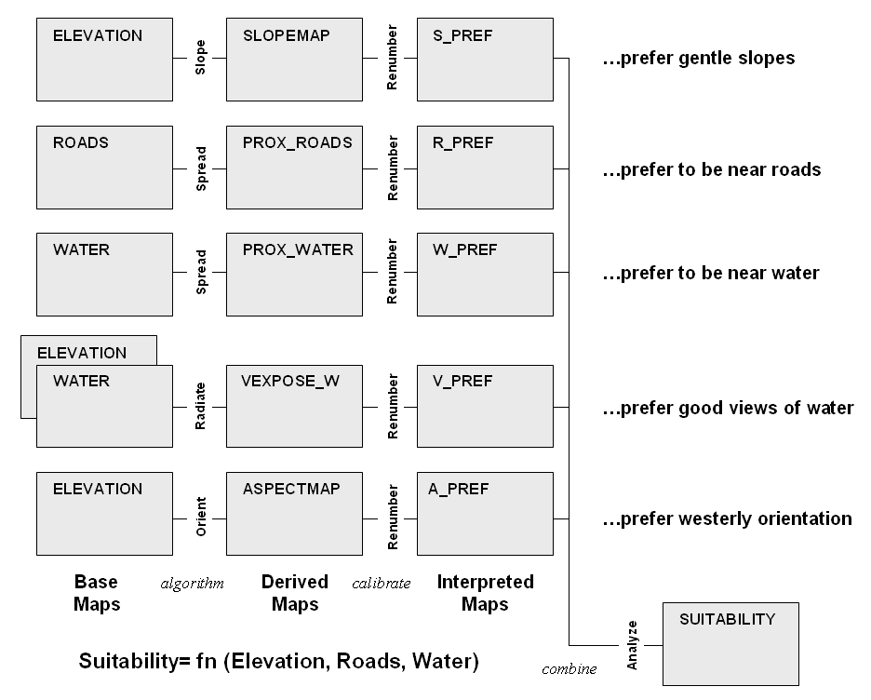

Campground Suitability Model (Flowchart)

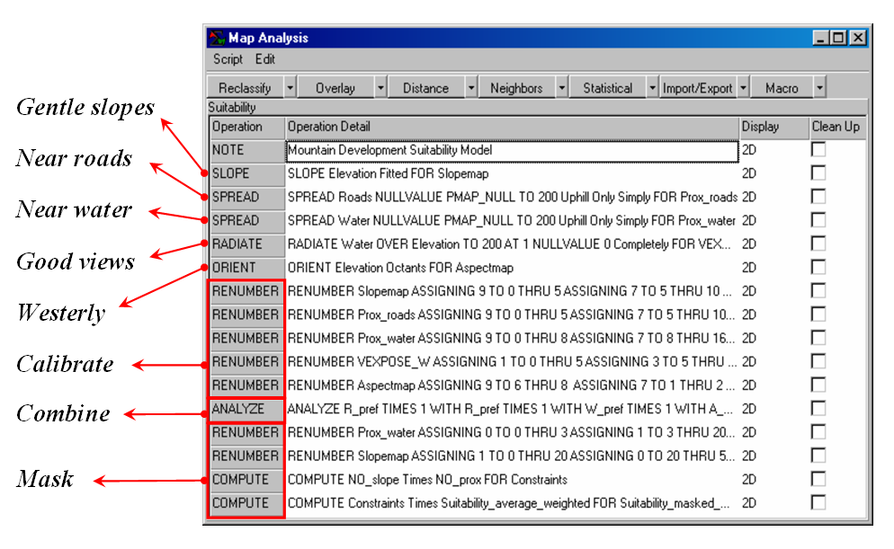

Campground script

Implementing the Basic Campground Suitability Model

From the Map Analysis menu, select Scripts→ Open and select …\Scripts\GM_Ex8_Campground.scr. Execute it a command line at a time under the direction of the instructor. Relate the map analysis operations to the logical flow identified in the flowchart of the Campground Suitability Model and described in the workshop presentation.

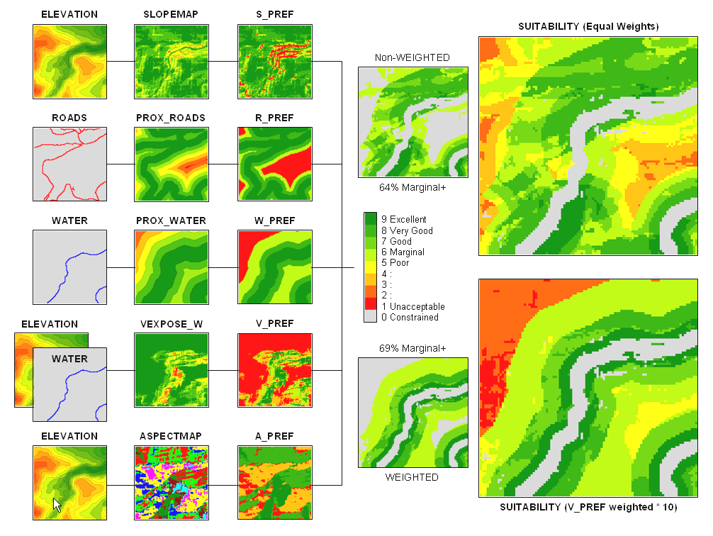

Implementing another point of view (change decision criteria weights)

Generate a different campground suitability map by interactively completing the following sequence of commands…

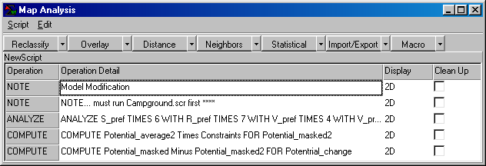

1) Enter a new Analyze command that weights the five preference maps that are weight-averaged as…

ANALYZE S_pref TIMES 6 WITH R_pref TIMES 7 WITH W_pref TIMES 4
WITH V_pref TIMES 10 WITH A_pref TIMES 1 FOR Potential_average2

…to reflect their relative importance.

2) Use the Compute command to mask the constrained areas.

3) Use Compute to compare the simple average and weighted-average maps.

…What was the greatest change? Where did occur? Which decision scenario (Potential or Potential2) had the higher rating?

Part 2 – Optional Exercise in Modeling – Electric Transmission Line Routing Model

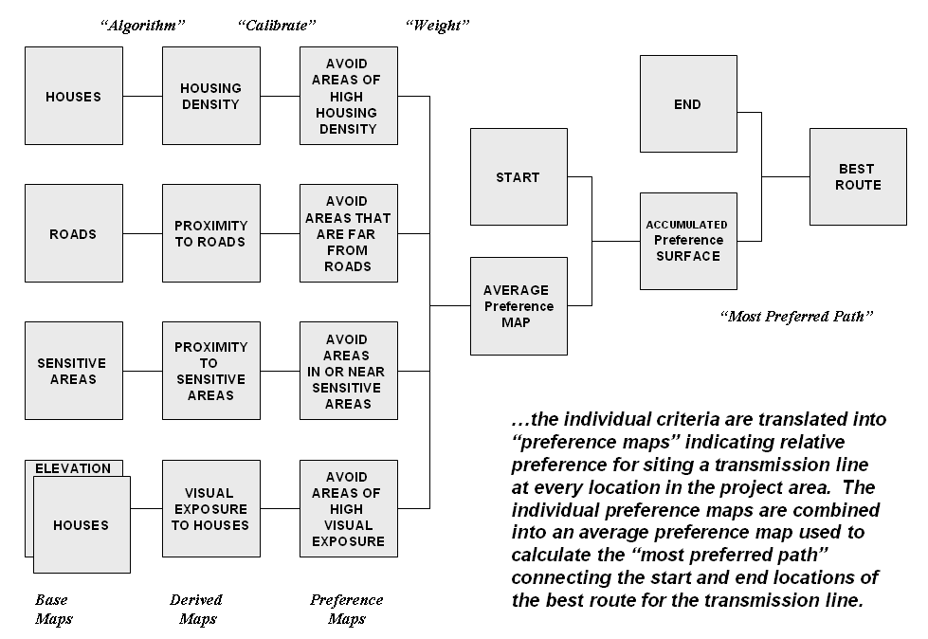

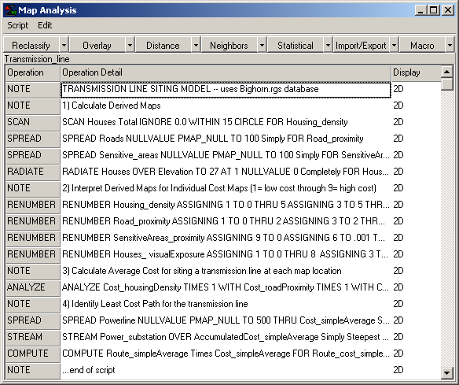

Implementing the Basic Transmission Line Routing Model

From the Map Analysis menu, select Scripts→ Open and select …\Scripts\GM_Ex8_Powerline.scr. Execute it a command line at a time under the direction of the instructor. Relate the map analysis operations to the logical flow identified in the flowchart of the Electric Transmission Line Routing Model and described in the workshop presentation.

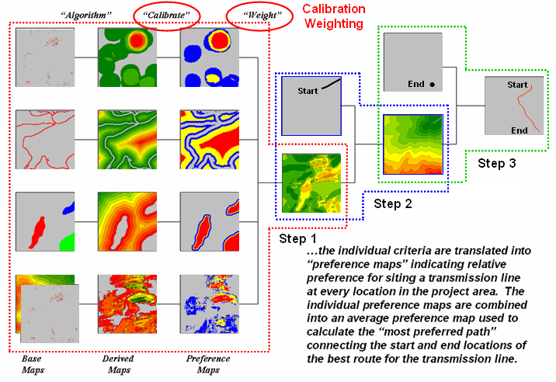

______________________________________________________

Optional Exercise – Data Exchange Procedures (MapCalc)

This exercise provides experience in data exchange using MapCalc. Complete the exercise following the instructions and screen grab then embed results within the instructions as you deem appropriate to document and describe your experience.
SESSION 1. Creating Your Own Database (Empty Map Set)
SESSION 2. Importing Data via Add New Layers
SESSION 3. Importing Data via the Map Analysis Tool
SESSION 4. Importing Data via the File Tool
SESSION 5. Exporting Data via Map Analysis Tool
SESSION 6. Exporting Data via File Tool
SESSION 7. Seamless Data Exchange with Surfer
SESSION 8. Seamless Data Exchange with MapInfo
Note: data for this exercise is in the …\Workshop Data\Special Data\ folder on the Workshop CD
_______________________________________________
SESSION 1. Creating Your Own Database (Empty Map Set)

Click on the Create a new file button or from the main MapCalc menu, select File→ New.

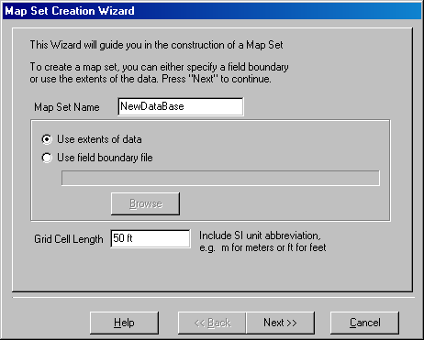 Specify a name for your new data base (e.g., NewDataBase) then press Next.

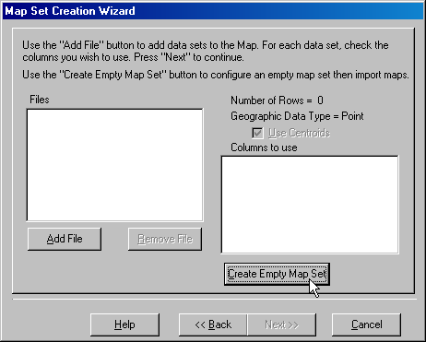 Click on Create Empty Map Set button to pop-up the Grid Parameters dialog box.

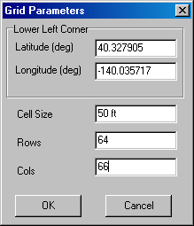 Specify the Latitude and Longitude of the lower-left corner of the analysis grid (e.g., Lat= 40.327905, Lon= -140.035717). Note: MapCalc Evaluation and Learner versions require Lat/Lon WGS84 datum. Academic and Professional versions accept data in a variety of geographic references.

Enter the Cell Size (e.g., 50 feet) and the number of Rows and Columns comprising the analysis grid area (e.g., 64 rows and 66 columns). Click OK to create the empty database.

Data can be entered into the new MapCalc database via several import procedures (see below).

Note: The MapCalc Evaluation and Learner versions can configure analysis grids up to 100 rows by 100 columns. Grid configuration for MapCalc Academic and Professional versions are not software limited but storage and processing requirements are exponential. Interactive processing of grids larger than 500 x 500 is not recommended—use batch process through scripts for large grid configurations.

SESSION 2. Importing Data via Add New Layers

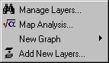 To import an ESRI .shp or MapInfo .tab polygon file, select Map Set→ Add New Layers to pop-up the Adding New Layers wizard.

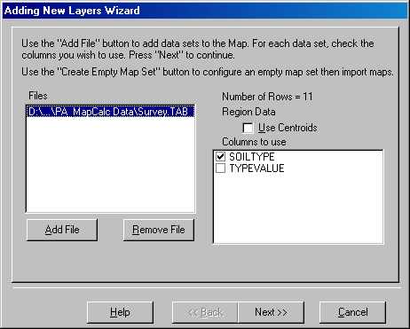 Press the Add File button and specify a file (e.g., Survey.tab), select the data column(s) to use (e.g., SOILTYPE) and click Next. Click Finish to create the map.

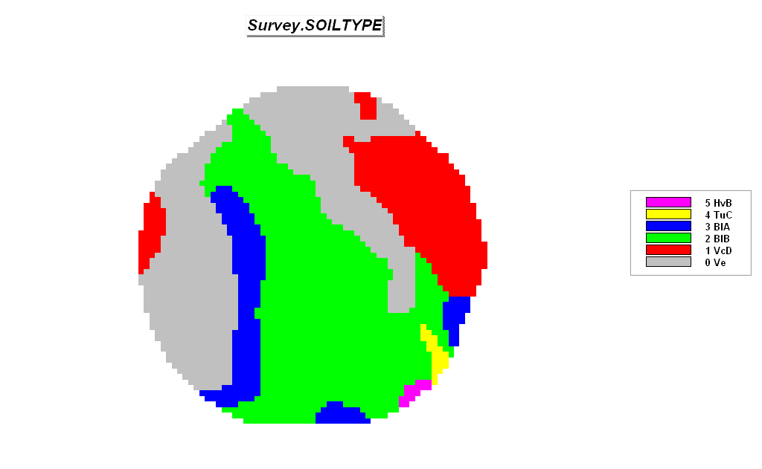
Imported Soil Survey Map from a MapInfo .tab file

If you have a field boundary map in .shp or .tab format you can use it to directly derive the database configuration. Instead of creating an Empty Map Set (section SESSION 1, step 2) press the Add New Layers button as described above. The Latitude and Longitude coordinates will be automatically assigned based on the extent of the boundary file.

SESSION 3. Importing Data via the Map Analysis Tool

Importing data via the Map Analysis tool accepts grid files for individual maps in three standard formats—

Bare Bare ASCII matrix of values, row major order
Grid Grid ASCII format (ESRI Software)
Surfer Surfer ASCII format (Golden Software)

…See section SESSION 5, Exporting Data via Map Analysis Tool for descriptions of these standard grid file formats.

The grid files must have the same configuration as the active database-- #Rows, #Columns, Cell Size and lower-left Registration Coordinates.

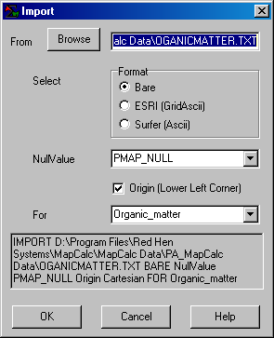 For example, add data in Bare format to the NewDataBase (see SESSION 1 above) by entering Map Analysis→ Import and completing the Import dialog box as—ORGANICMATTER.TXT, Bare, Organic_matter.

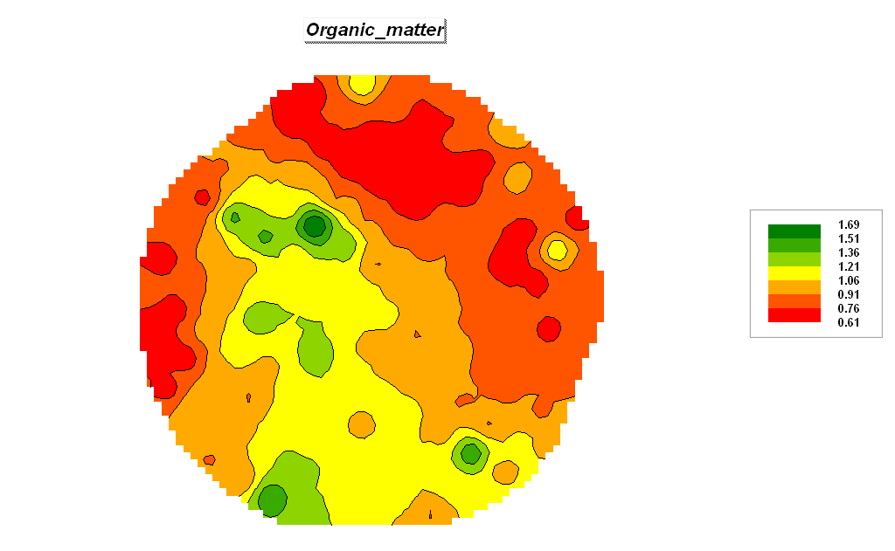
Imported Organic Matter data Map from a Bare matrix (.txt)

SESSION 4. Importing Data via the File Tool

Importing data via the File tool accepts grid files for individual maps in four standard formats—

Bare Bare ASCII matrix of values, row major order
Grid Grid ASCII format (ESRI Software)
Surfer Surfer ASCII format (Golden Software)
MIG Binary Grid format (MapInfo)

…See section SESSION 5, Exporting Data via Map Analysis Tool for descriptions of these standard grid file formats.

The grid files must have the same configuration as the active database-- #Rows, #Columns, Cell Size and lower-left Registration Coordinates.

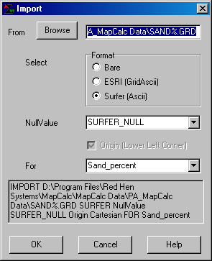 For example, add data in Surfer format to the NewDataBase (see section SESSION 1 above) by entering File→ Import→ and completing the Import dialog boxes as shown—%SAND.grd, Surfer (Ascii), Sand_percent.

SESSION 5. Exporting Data via Map Analysis Tool

Exporting data via the Map Analysis tool creates a grid file for individual maps in four standard formats—

Point Column, Row, Value (nulls skipped)
Grid Grid ASCII format (ESRI)
Bare Bare ASCII matrix of values, row major order
Surfer Surfer ASCII format (Golden Software)

Select Map Analysis→ Import/Export→ Export to pop-up the Export dialog box.

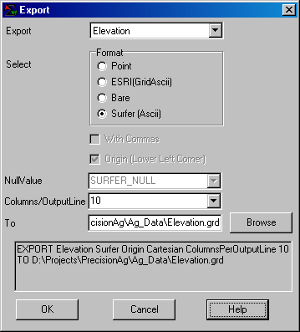 Select the Elevation map, specify Surfer (Ascii) and Browse/Name the file for export (Elevation.grd). Press OK to create the file.

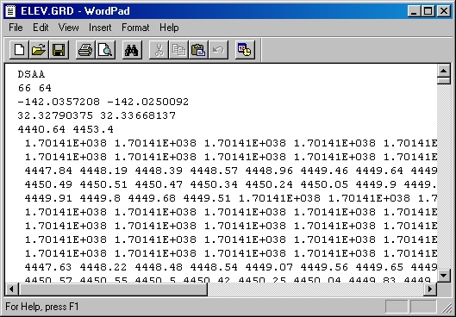 The file generated is a standard text file and can be viewed using any word processing package.

Export formats in the Map Analysis tool include Point (each record contains a Column Row Value triplet), Bare (each record contains all of the values for one row of the grid starting at the top left corner), Surfer GS Ascii and ESRI GridAscii that include header lines with the matrix of data (see below).

Bare Ascii no header lines—

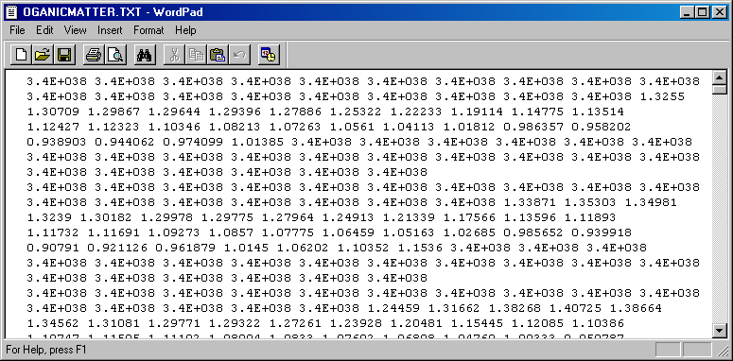

…Data separated by spaces and organized as rows in row-major matrix—contains no geo-referencing information. File must contain a value for each cell location ordered left to right, top to bottom.

Surfer GS Ascii five header lines—
DSAA (ASCII)
66 64 (NCOLS NROWS)
-142.0357208 -142.0250092 (LON Low/High)
32.32790375 32.33668137 (LAT Low/High)
4440.64 4453.4 (Z Low/High)
…Data separated by spaces and organized as rows in row-major matrix (see Bare above)

ESRI GridAscii six header lines—
NCOLS 66
NROWS 64
XLLCORNER -142.0357208 (LON)
YLLCORNER 32.32790375 (LAT)
CELLSIZE 0.000162298
NODATA_VALUE 3.4E+038
…Data separated by spaces and organized as rows in row-major matrix (see Bare above)

SESSION 6. Exporting Data via File Tool

From the Main Menu select File → Export → Data to access the wizard for exchanging data.

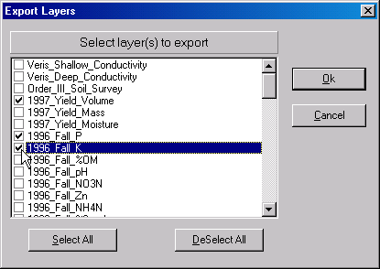 Press the DeSelect All button then click on the boxes next to the 1997_Yield_Volume, 1997_Fall_P and 1997_Fall_K map layers. Press OK to begin the export.

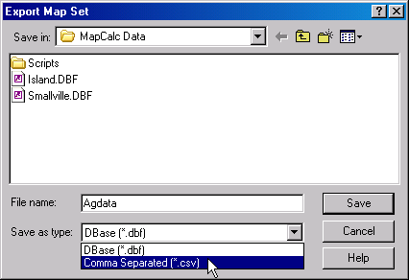 Specify “CSV” as the type and Save the file. This procedure stores the file in the default data folder.

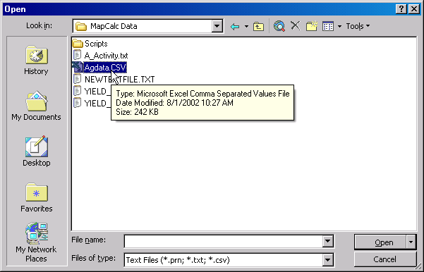 Access Excel by clicking on Start → Programs → Microsoft Excel → File → Open → browse to the …\MapCalc Data\ folder → specify Text Files (*.prn, *.txt, *.csv) as the file type → click on the AgData.csv file → and press the Open button.

The exported file containing the specified map layers will be opened in Excel.

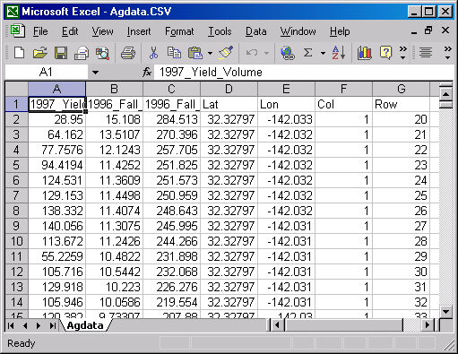

In addition to .CVS format, there are several other standard export formats—

.DBF supports most spreadsheet and database software
.TAB supports MapInfo desktop mapping software
.SHP supports ArcView desktop mapping software
.ACS supports Spatial Analyst software
.GRD supports Surfer software (GS ASCII).

SESSION 7. Seamless Data Exchange with Surfer

Select File→ Export→ Send to Surfer→ Wireframe to automatically transfer the data and launch Surfer provided it is installed on your computer…

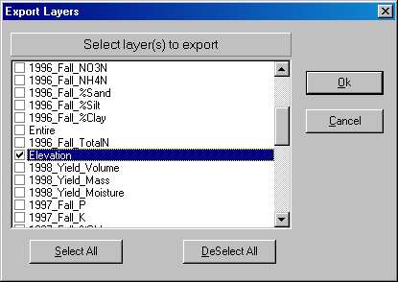 Press the Deselect button, then check the Elevation map and press OK.

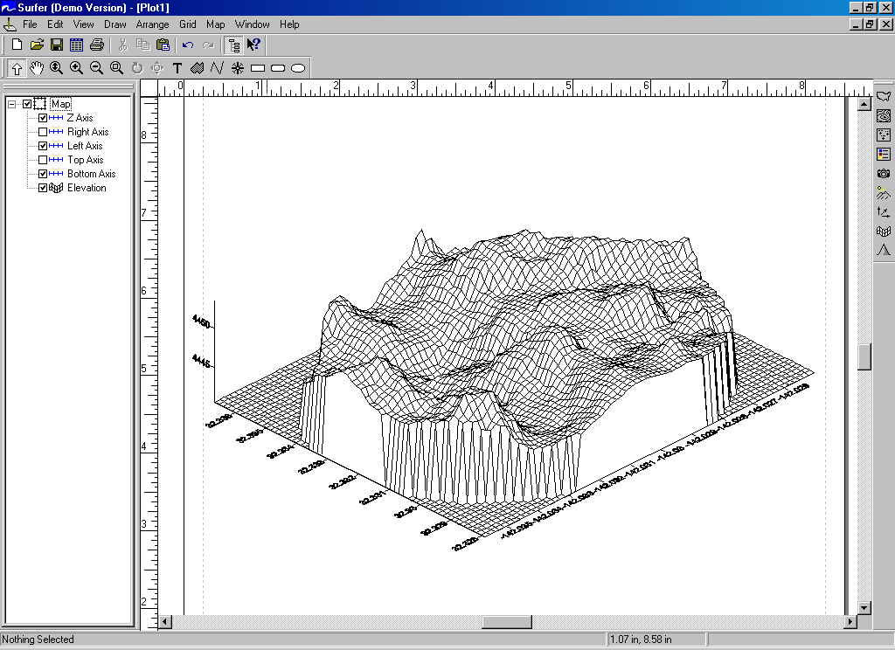

Surfer will be executed and the Elevation data automatically transferred.

SESSION 8. Seamless Data Exchange with MapInfo

Select File→ Export→ Send to MapInfo→ Wireframe to automatically transfer the data and launch Surfer provided it is installed on your computer…

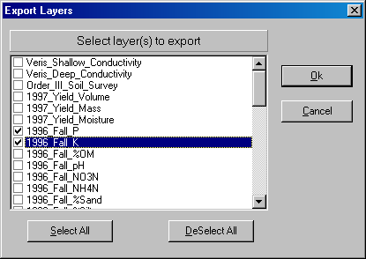 Press the Deselect button, then check the 1996_Fall_P and 1996_Fall_K maps. Press OK.

