Hands on Exercises for

Grid-based Map Analysis and GIS Modeling Workshop

- Exercise #1 – Map Analysis Framework (MapCalc)
- Exercise #2 – Example of a Simple Erosion Potential Model (MapCalc)
- Exercise #3 – Reclassify and Overlay Techniques (MapCalc)
- Exercise #4 – Measuring Distance and Connectivity (MapCalc)
- Exercise #5 – Characterizing Spatial Neighborhoods (MapCalc)
- Exercise #6 – Surface Modeling (MapCalc and Surfer)
- Exercise #7 – Spatial Data Mining (MapCalc)
- Exercise #8 – Gaining GIS Modeling Experience (MapCalc)
- Optional Exercise – Data Exchange Procedures (MapCalc)

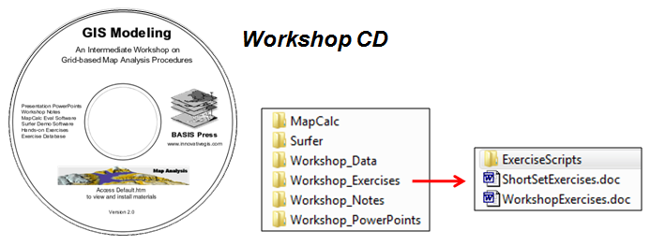 The following “short set” of exercises used in the workshop are designed to demonstrate basic Map Analysis techniques and GIS Modeling considerations. For a more through experience, complete the “full set” of Workshop Exercises as homework using the software contained on the Workshop CD.
____________________________________

(Short Exercise #1) Map Analysis Framework (Raster; grid-based data structure and analysis)

Install MapCalc from the Workshop CD using \MapCalc\mapcalc_learner.exe.
Access MapCalc by Start→ Programs→ MapCalc Learner → MapCalc Learner and select “Open existing map set” then browse to the …\WorkshopData\ folder you copied from the workshop CD and select Bighorn.rgs as the database.

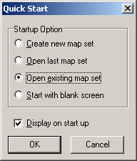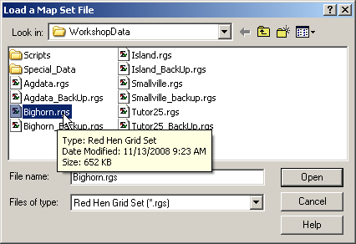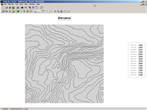

Display Tools

Layer Contour button → mouse-over to identify Elevation values within contour polygons
Layer Mesh button
Toggle 3D View button
Rotate button
Reset View to Defaults button
Zoom-in button → click and drag area on the map to be enlarged
Use Cells button
Select button → mouse-over to identify Elevation values within grid cells

Example Map Analysis (Slope operation identifying terrain steepness)

Map Analysis button, select Neighbors→ Slope

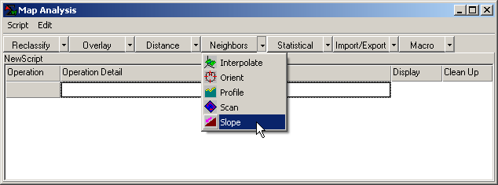 …accessing the Slope command

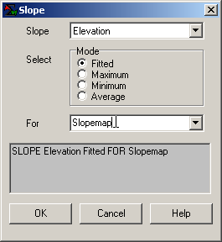 Enter SLOPE Elevation Fitted FOR Slopemap command, then OK button

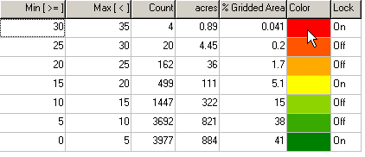 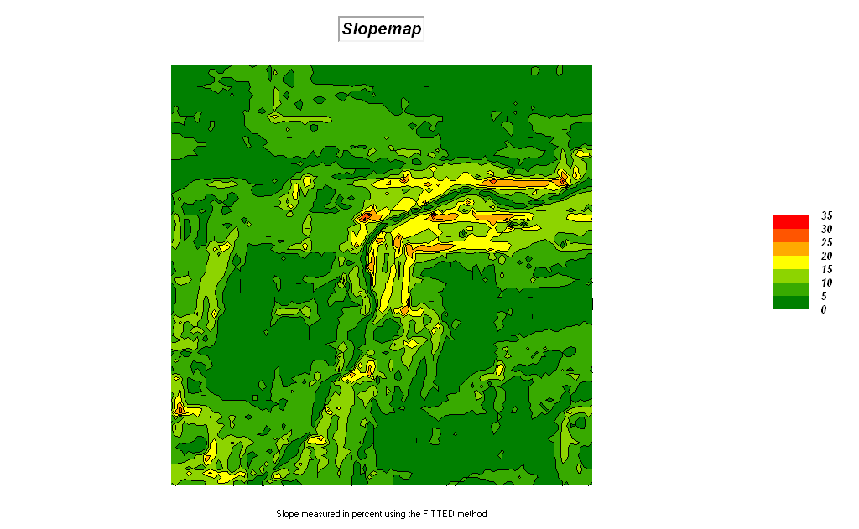 Double-click on Slopemap legend and swap Red (to high values) and Green (to low values) color assignments

View, Rename and Delete Layers button → Elevation → View

And then from the Main Menu at the top, select Map → Overlay → Slopemap

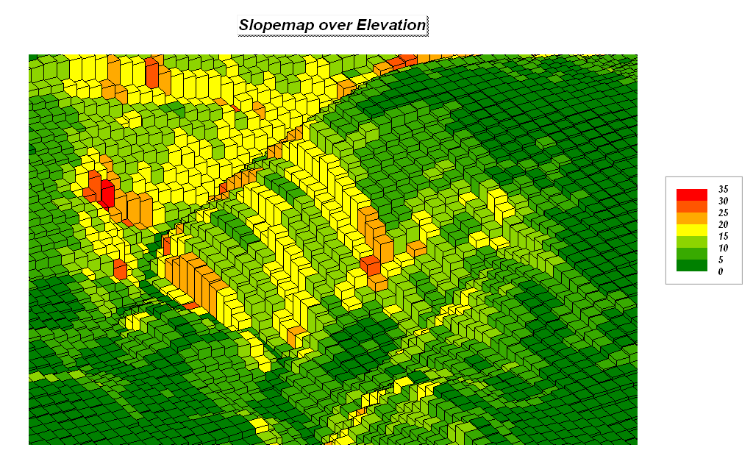 Use Cells button Zoom-in button → click and drag area on the map
____________________________________

(Short Exercise #2) Example of a Simple Physical Model (Erosion Potential Model that Derives, Calibrates and Combines map layers)

Become familiar with the following simple model flowchart and script for estimating soil erosion potential—
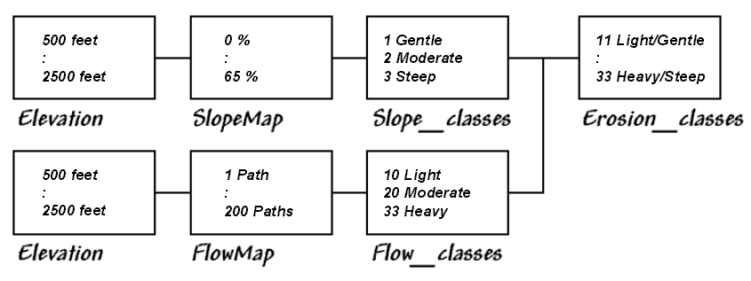

Logical processing sequence (Flowchart)…

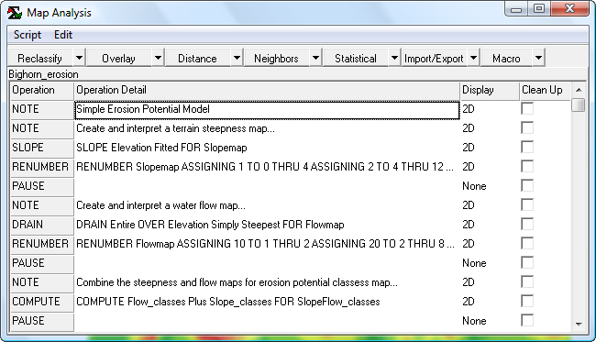 Command sequence (Script)

Press the Map Analysis button to pop-up the Map Analysis dialog box.
Select Script→ Open and then browse to and select Bighorn_Erosion.scr file in the …\WorkshopData\Script\ folder.

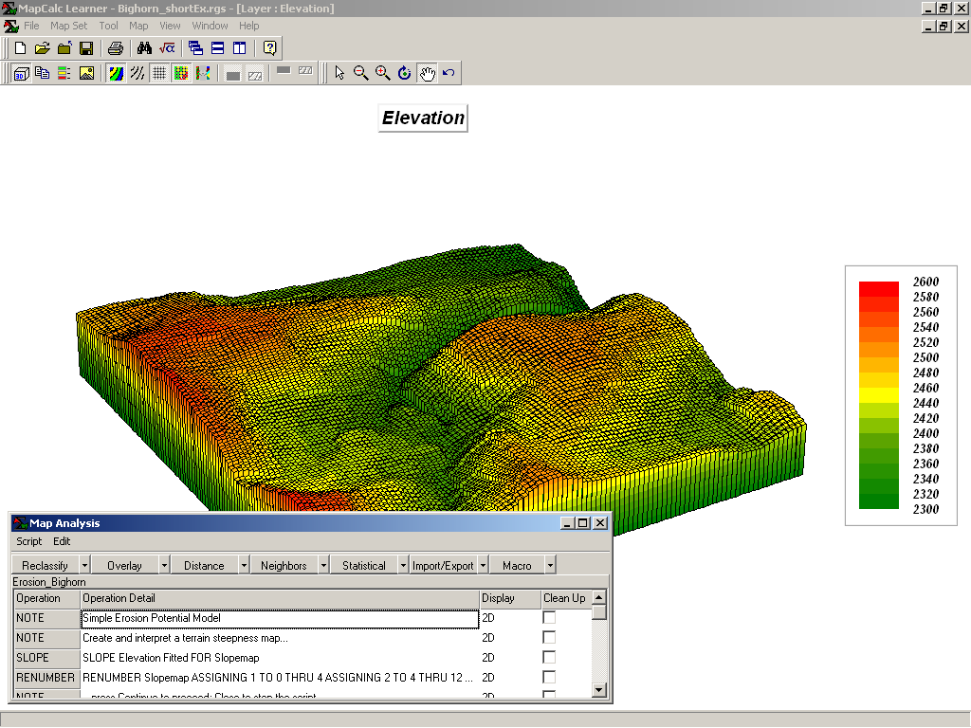 Resize and position the script window to the lower-left portion of the display.

Execute the command script a line at a time by double-clicking on the line and interpreting the dialog box information. Submit a command line by pressing OK. The first portion of the erosion model…

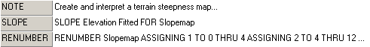

…creates a map of terrain steepness (Slopemap) then “calibrates” the steepness into three classes (1= Gentle, 2= Moderate, 3= Steep). The next portion of the model…

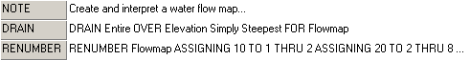

…creates a map of water confluence (Flowmap) then “calibrates” water flow into three classes (10= Light, 20= Moderate, 30= Heavy). The final portion of the model…

…combines the steepness and flow maps into a single erosion potential map (Erosion_classes) to identify each map location by a two-digit code where the first number (tens digit) indicates the flow class and the second number (ones digit) indicates the steepness class. For example, 11= Light/Gentle (low erosion potential) and 33= Heavy/Steep (high erosion potential).

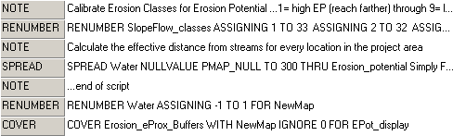

The remaining commands create a variable-width buffer around streams (Full exercise #2).
________________________________________

(Short Exercise #3) Example of a Suitability Model (Habitat Suitability Model that Derives, Calibrates and Combines map layers)

The combination of geographic factors often determine habitat quality. In this example, using the Bighorn.rgs database Hugags in this locale have shown a preference for…

- Gentle Slopes (<10%)
- Southerly Aspects (E-W)
- Lower Elevations (<2450 feet)

…are evaluated using computer-based map analysis techniques for Binary, Ranking and Rating suitability models.

Using the flowchart and script listing below, become familiar with the model logic ingrained in each processing step that leads to the final Hugag habitat suitability map.

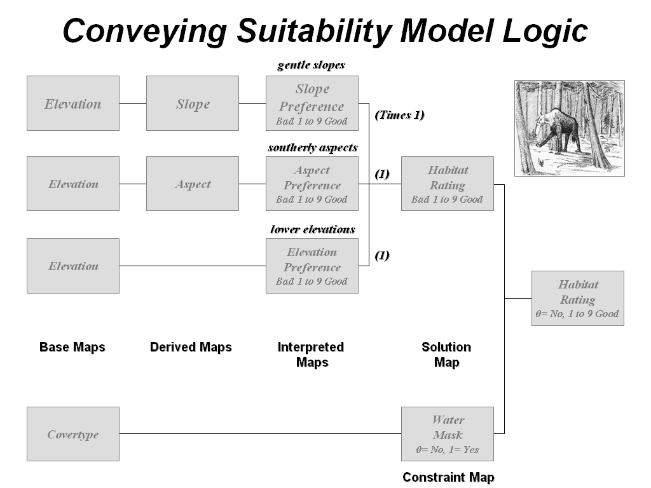

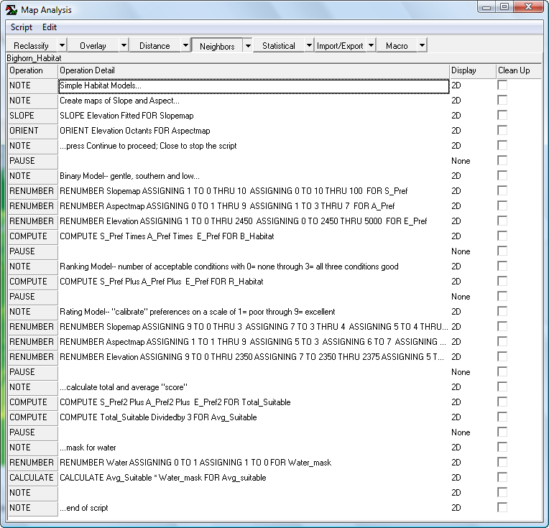

Under the guidance of the instructor, access and complete the suitability model for Hugag habitat by selecting Map Analysis→ Script→ Open→ Bighorn_Habitat.scr in the …\WorkshopData\Script\ folder and completing the processing a line at a time.
_____________________________________

(Short Exercise #4a) Spatial Analysis (Simple and Effective Distance)

Within the Bighorn.rgs database select the Map Analysis button, and then select Distance→ Spread

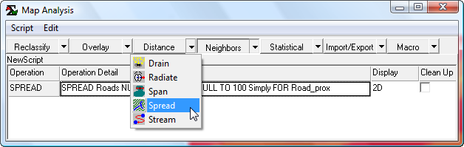 …accessing the Spread command

Simple Distance

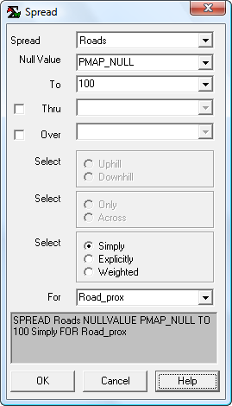 SPREAD Roads NULLVALUE PMAP_NULL TO 200 Simply FOR Road_prox

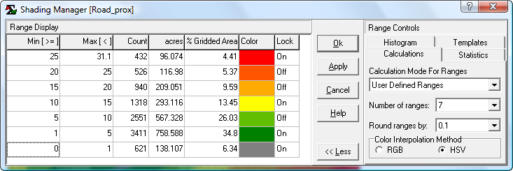 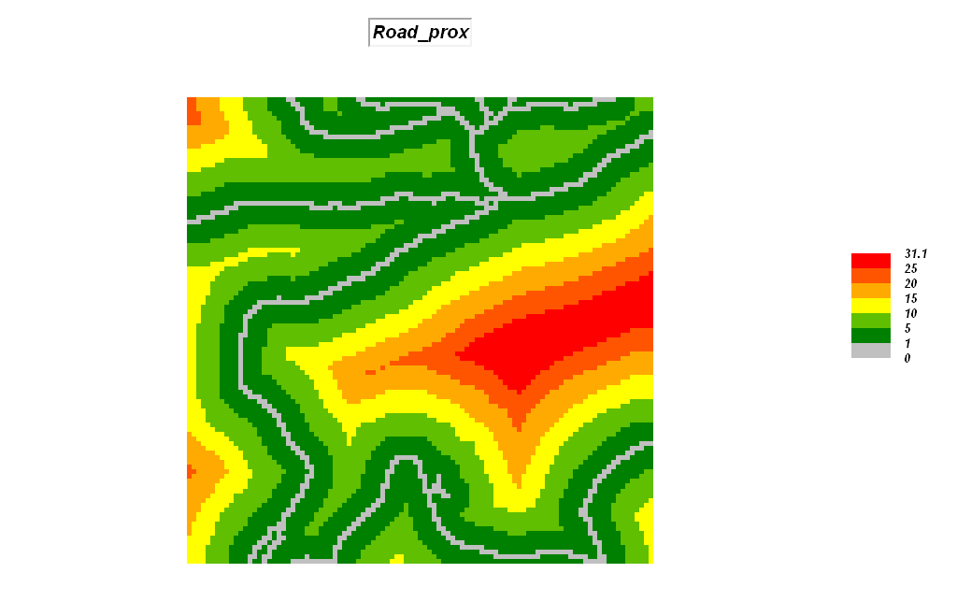 Double-click on the map legend and set the display to “User Defined Ranges” (Calculation Mode), “7” (Number of Ranges), Color settings as shown (Grey, Green to Red with Yellow inflection), enter the Min[>=] values as shown and press OK to create the custom display.

Effective Distance

SLOPE Elevation Fitted FOR Slopemap …already created

RENUMBER SlopeMap
ASSIGNING 1 TO 0 THRU 3
ASSIGNING 2 TO 3 THRU 5
ASSIGNING 3 TO 5 THRU 8
ASSIGNING 4 TO 8 THRU 12
ASSIGNING 5 TO 12 THRU 16
ASSIGNING 6 TO 16 THRU 24
ASSIGNING 7 TO 24 THRU 30
ASSIGNING 8 TO 30 THRU 100
FOR sFriction …identifies increasing relative barrier to hiking movement as terrain steepness increases

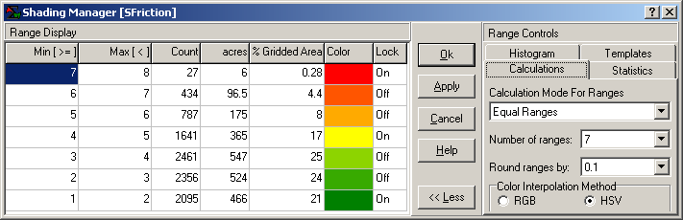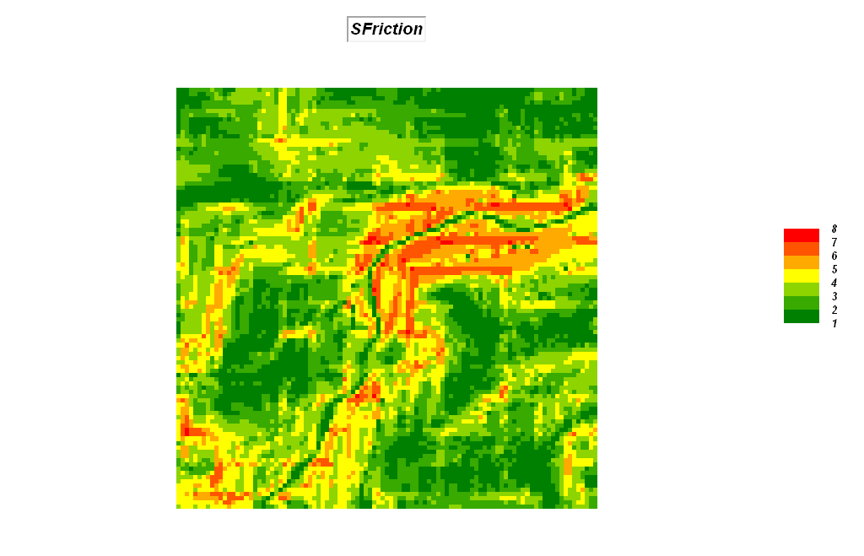

RENUMBER Water
ASSIGNING 1 TO 0
ASSIGNING 0 TO 1
FOR wFriction …identifies water as absolute barrier to hiking movement

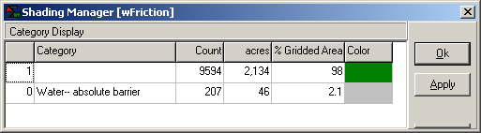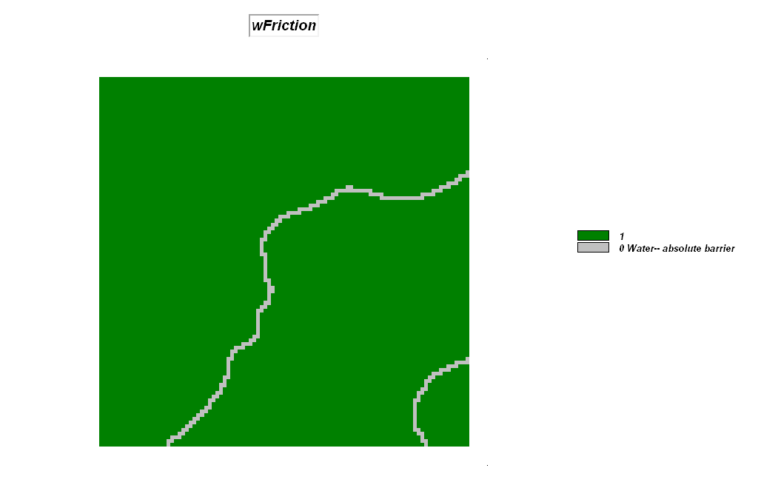

COMPUTE sFriction Times wFriction FOR Friction …combines relative and absolute barriers

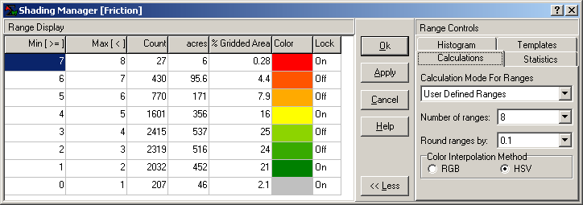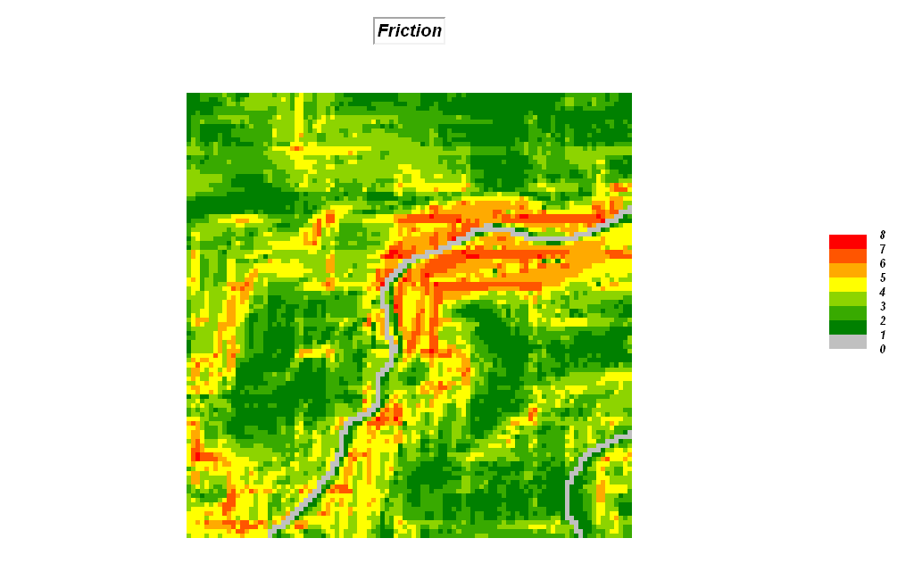

SPREAD Roads NULLVALUE PMAP_NULL TO 200 THRU Friction Simply FOR Road_hikingprox …identifies relative proximity to the nearest road for all locations in the analysis frame.

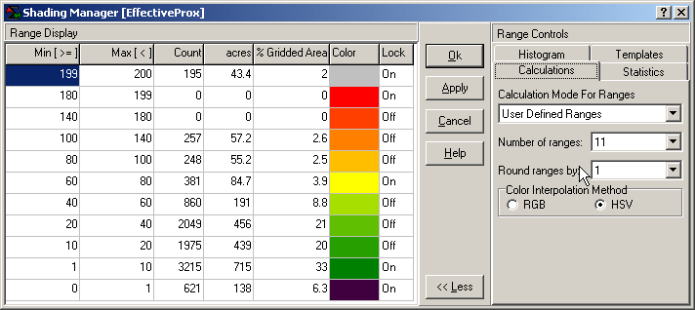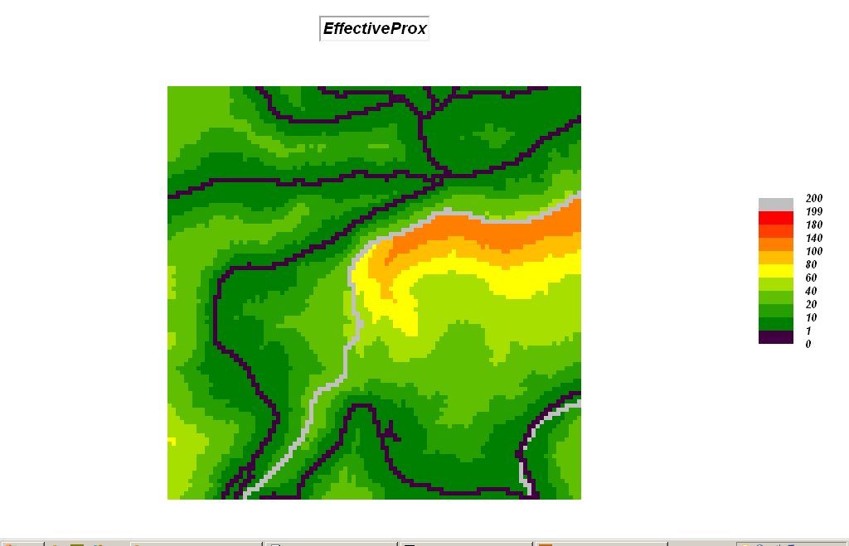
_____________________________________

(Short Exercise #4b) Spatial Analysis (Viewshed, Visual Exposure and Weighted Visual Exposure)

Viewshed

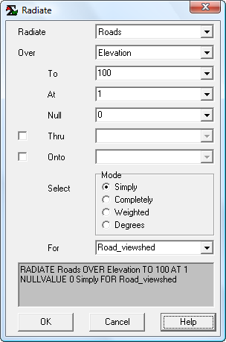 RADIATE Roads OVER Elevation TO 100 AT 1 NULLVALUE 0 Simply FOR Road_viewshed …identifies all locations that are visually connected to at least one road cell as a binary map (1=seen, 0=not seen)

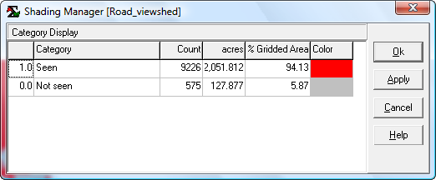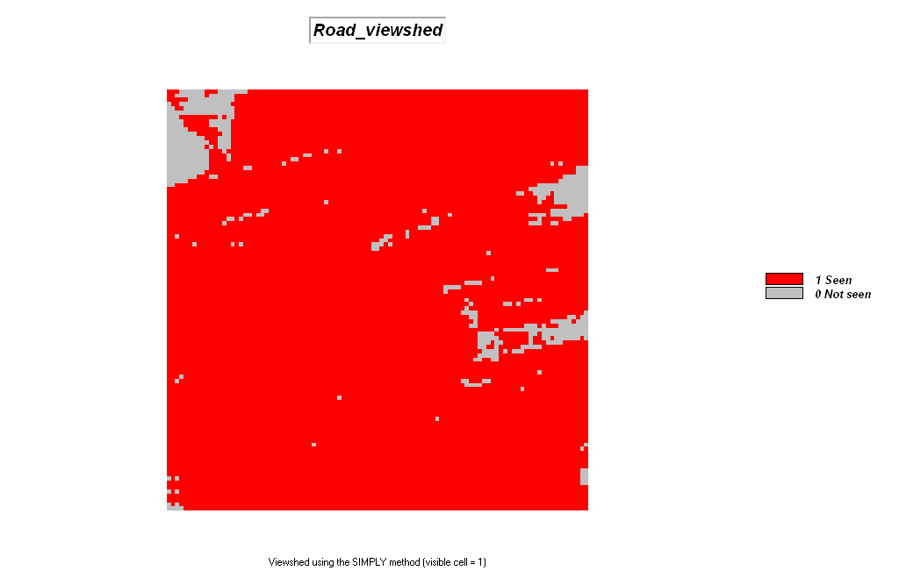

Visual Exposure

Map Analysis button, select Distance→ Radiate

…accessing the Radiate command

RADIATE Roads OVER Elevation TO 100 AT 1 NULLVALUE 0 Completely FOR Road_VExposure …identifies the number of road cells visually connected to each map location (increasing values indicate areas that are increasingly more exposed)

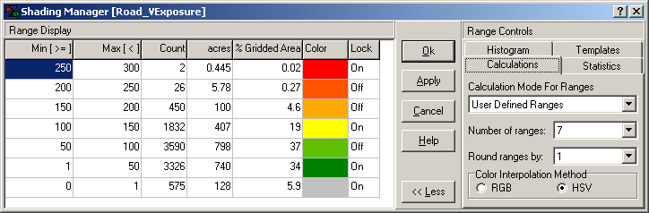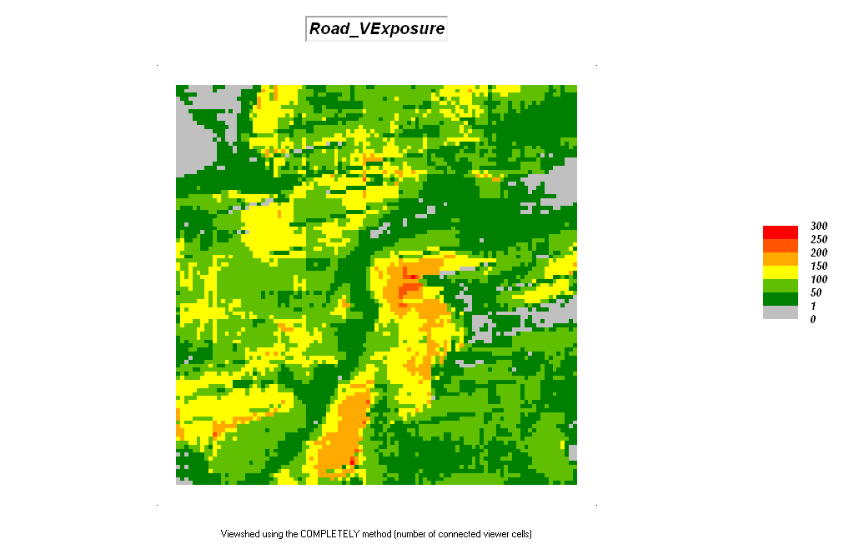

Weighted Visual Exposure

RENUMBER Road_type
ASSIGNING 1 TO 4
ASSIGNING 2 TO 3
ASSIGNING 10 TO 2
ASSIGNING 40 TO 1
FOR Road_classes …calibrates the roads based on relative number of cars

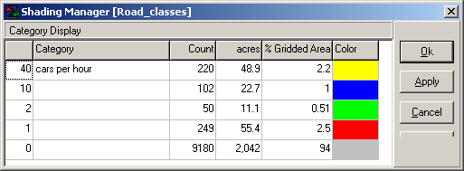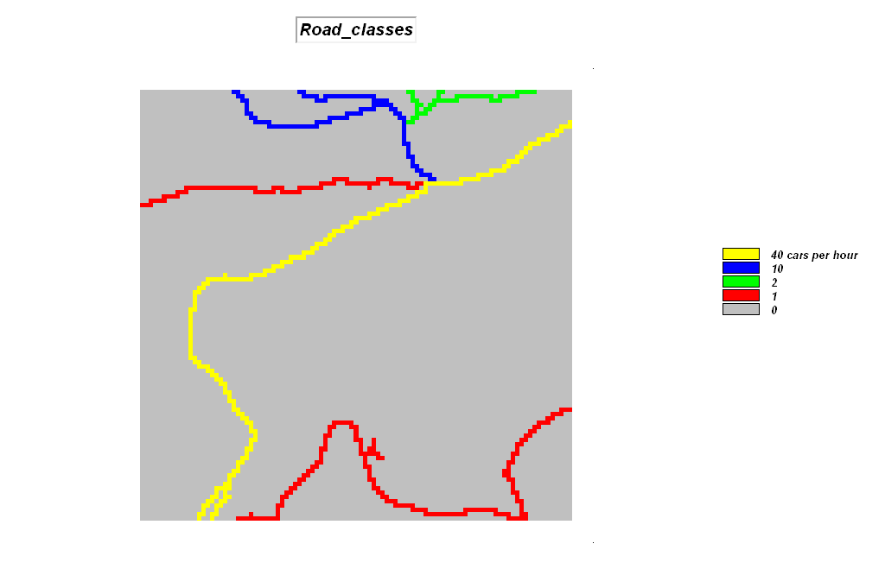

RADIATE Road_classes OVER Elevation TO 200 AT 1 NULLVALUE 0 Weighted FOR wVExposure …identifies the weighted visual exposure for each map location (uses the road type as the weight)

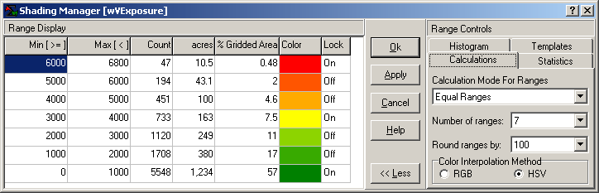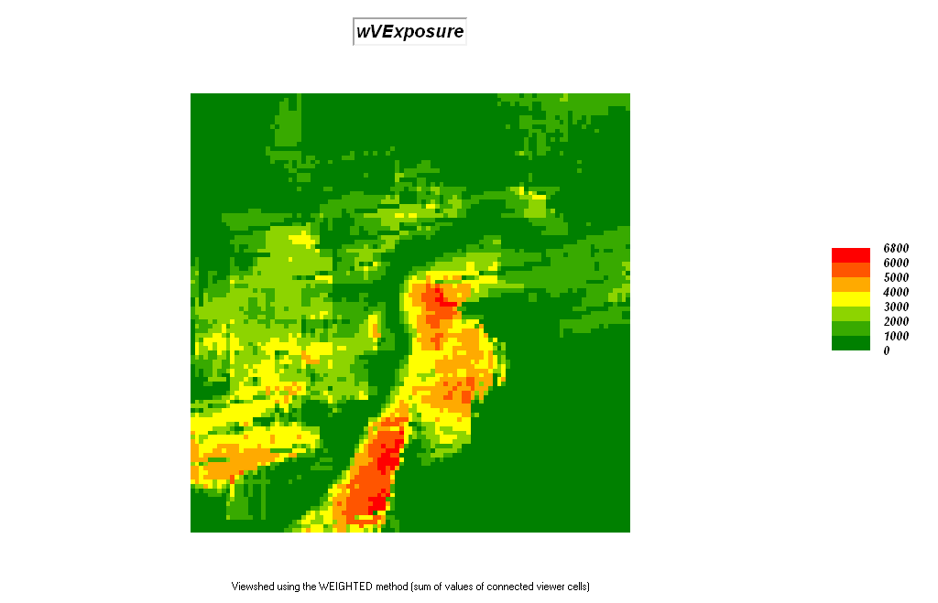
_________________________________________

(Short Exercise #5) Spatial Analysis (Neighborhood operators)

Within the Bighorn.rgs database select the Map Analysis button, and then select Neighbors→ Scan

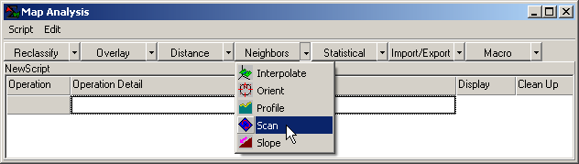 …accessing the Scan command

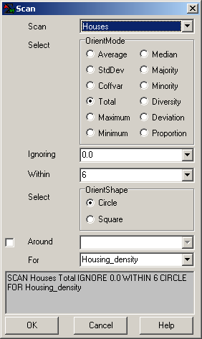 SCAN Houses Total IGNORE 0.0 WITHIN 6 CIRCLE FOR Housing_density …identifies the total number of houses within a 6-cell reach of every map location

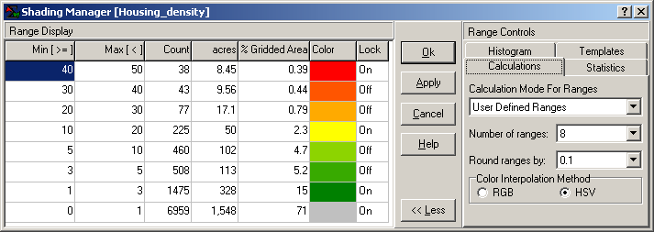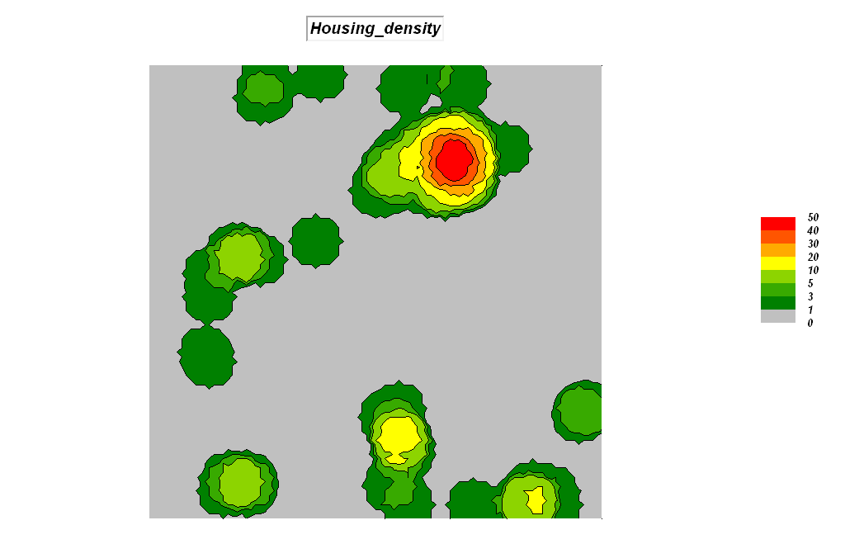

SCAN Covertype Diversity IGNORE 0.0 WITHIN 4 CIRCLE FOR Covertype_diversity …identifies the number of different cover type classes within a 4-cell reach of every map location

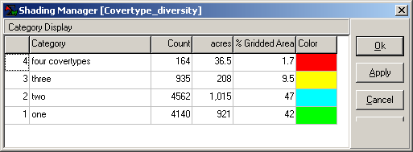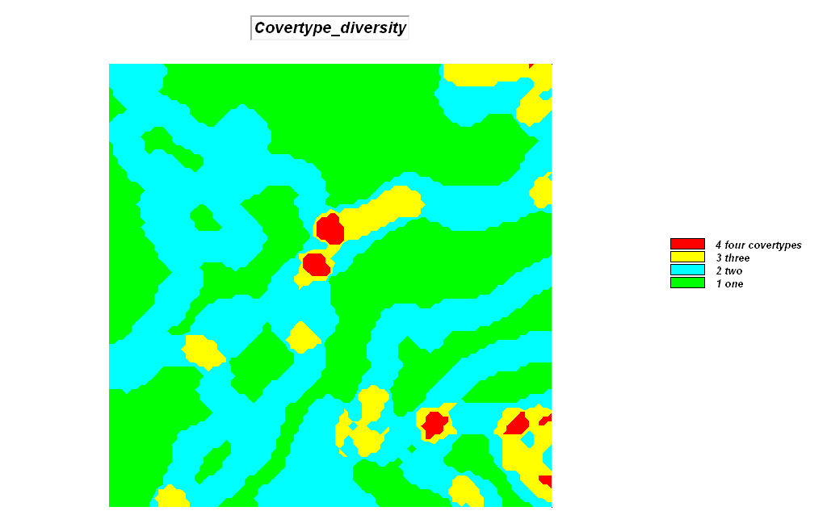

SCAN SlopeMap CoffVar IGNORE 0.0 WITHIN 2 CIRCLE FOR Roughness …identifies the coefficient ([StDev / Mean] * 100) of variation as the relative amount of variation within a 4-cell reach of every map location

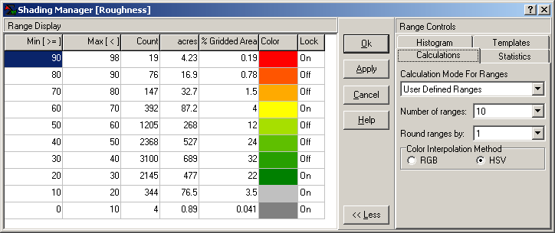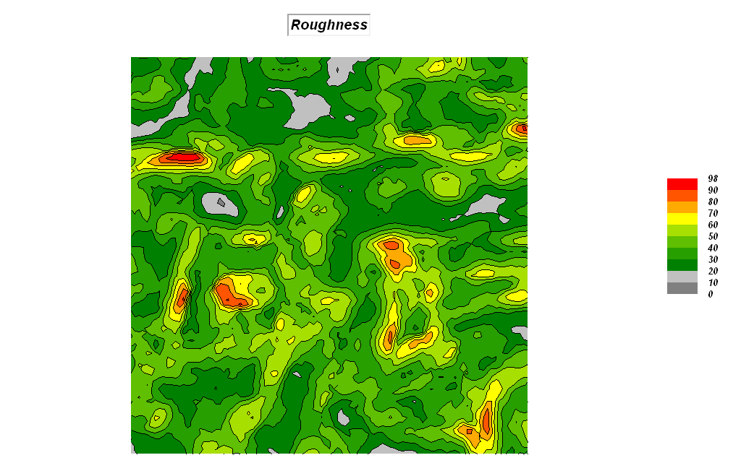

As time and interest permits for optional homework, complete the MapCalc Tutorials on the Workshop CD in the …\Surfer\Surfer_Tutorial\ folder.
_________________________________________

(Short Exercise #6) Surface Modeling (Generating continuous geographic distributions from discrete point sampled data—Density Analysis and Spatial Interpolation)

Density Analysis

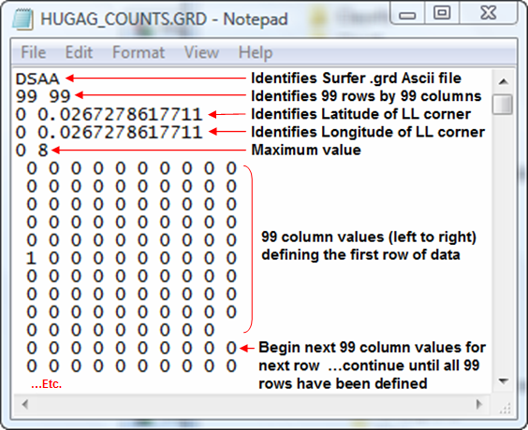 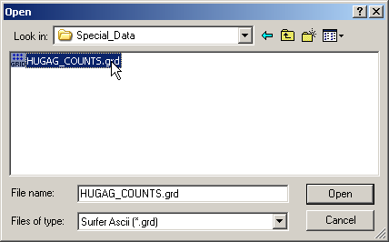 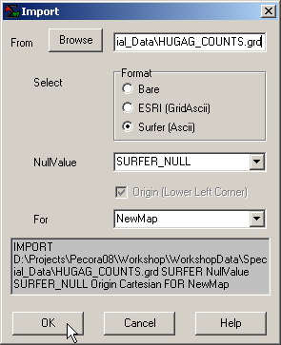 If the Hugag_counts map isn’t in the Bighorn.rgs database, import it by selecting Map Analysis→ Import/Export→ Import→ choose “Surfer (Ascii)” format, browse to the Hugag_counts.grd file in the …\WorkshopData\Special_Data folder you copied from the workshop CD, enter Hugag_counts as the new map name and click OK.

SCAN Hugag_counts TOTAL WITHIN 6 FOR Hugag_density …identifies the total number of Hugag occurrences within a 6-cell reach to generate a density surface of animal activity

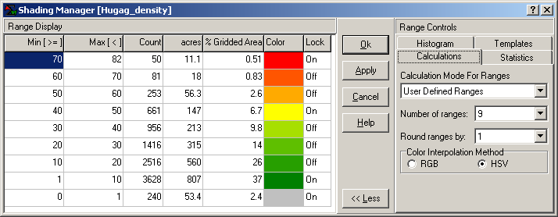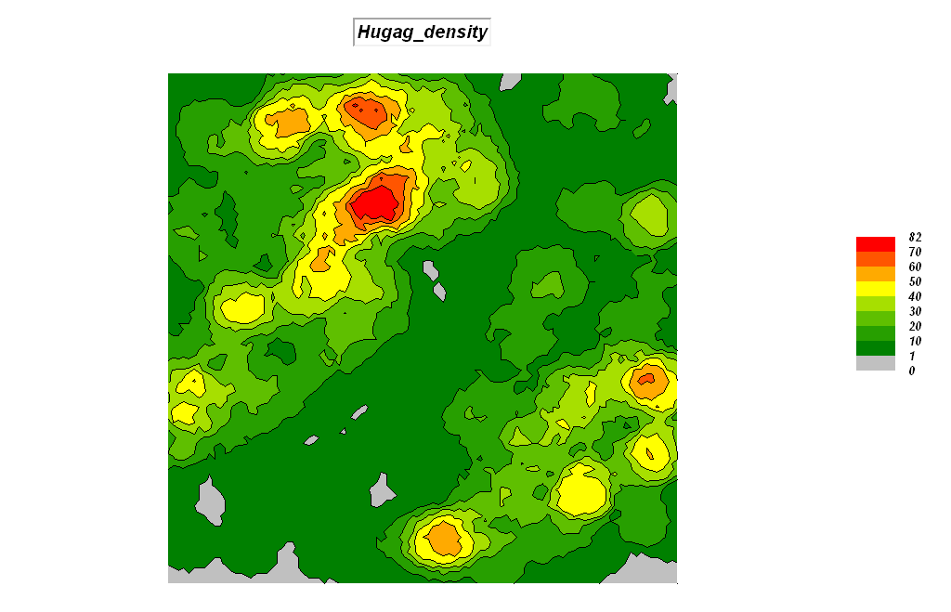

Right-click on the map and select the Shading Manager. Click on the Statistics tab and note that the average customer density is 17.5 with a standard deviation of 15.0 (rounded). Therefore the breakpoint for unusually high Hugag densities is 17.5 + 15.0= 32.5 (Mean + 1 Stdev).

RENUMBER Hugag_density
ASSIGNING 0 TO 0 THRU 32.5
ASSIGNING 1 TO 32.5 THRU 1000
FOR Hugag_highDensity …isolates the locations of high Hugag density (assigned a value of 1 embedded in zeros)

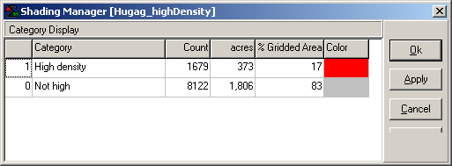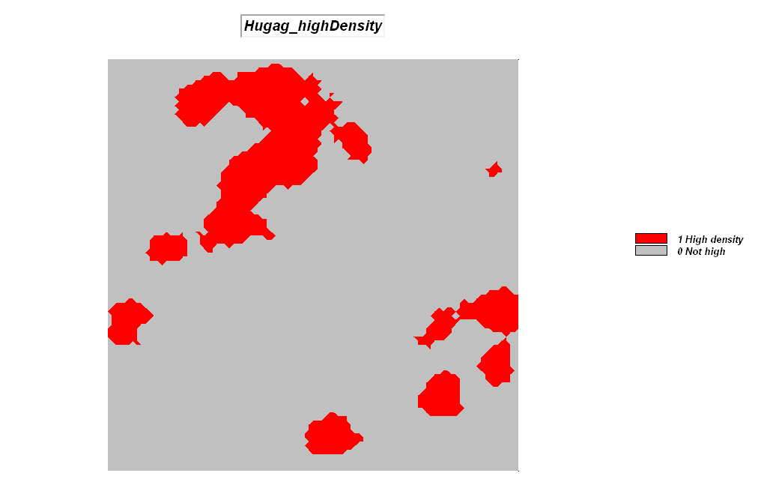

Spatial Interpolation

Install Surfer from the Workshop CD using \Surfer\s8demo.exe.
Access Surfer by Start→ Programs→ Golden Software Surfer 8→ Surfer 8.

Bring the data into Surfer by…

Selecting Grid→ Data→ and browsing to …\Program files\Golden Software\Surfer8\Samples folder and specifying the DEMOGRID.DAT data file. Accept all of the defaults and press OK to generate the interpolated surface.
Selecting Map→ Contour Map→ New contour map and accepting the default DEMOGRID.GRID file specification to generate a Contour map of the interpolated data.
Selecting Map→ Wireframe→ New contour map and accepting the default DEMOGRID.GRID file specification to generate a Wireframe map of the interpolated data.
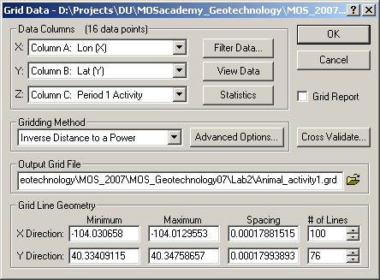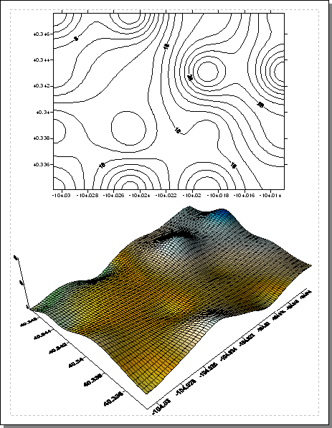

As time and interest permits for optional homework, complete the Surfer Tutorials in the …\Geotechnology_software\Surfer\Surfer_Tutorial\ folder on the Workshop CD.
_________________________________________

(Short Exercise #7) Spatial Data Mining (Similarity and Clustering)

If MapCalc is still open, change to the Precision Farming database by File→ Open→ AgData.rgs. If MapCalc isn’t open, access it by Start→ Programs→ MapCalc Learner → MapCalc Learner and select Agdata.rgs as the database.

Map Analysis button, select Statistical→ Relate

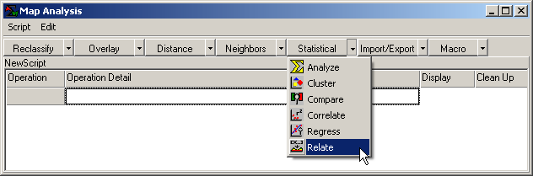 …accessing the Relate command

Similarity

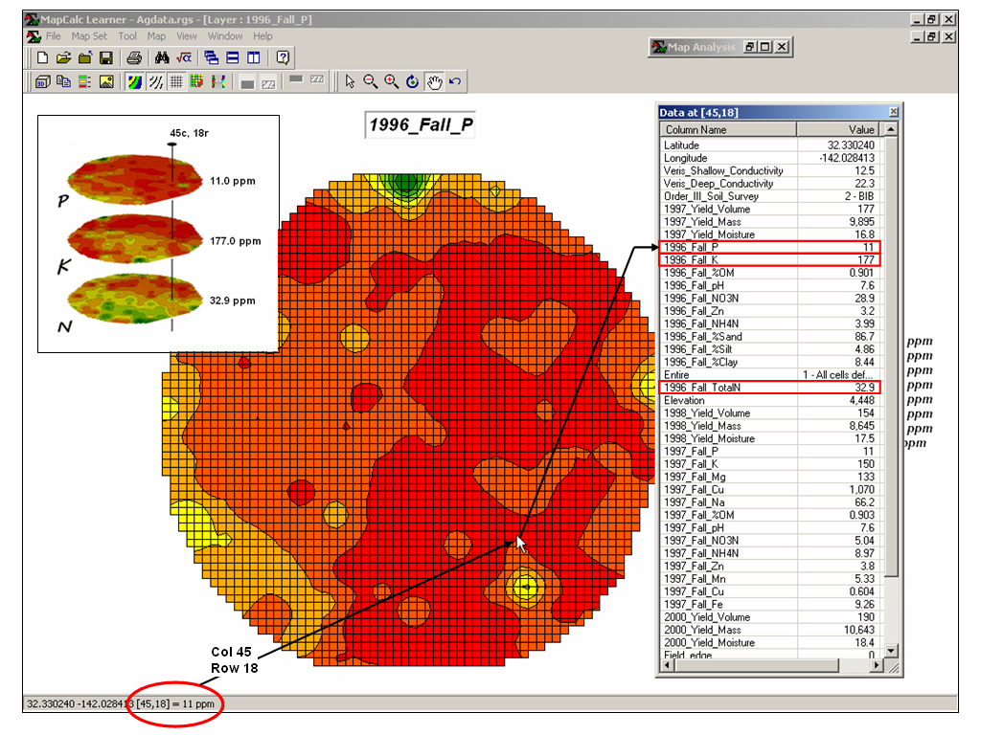 Display the 1996_Fall_P surface and double-click at location 45c, 18r to pop-up the “drill-down” summary of the values at that location for all maps. Note that P= 11.0, K=177.0 and N= 32.9.

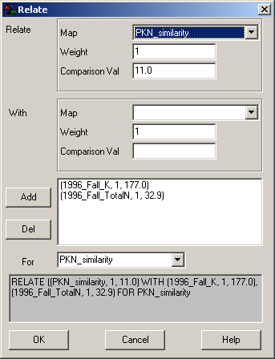 RELATE ((1996_Fall_P, 1, 11.0) WITH (1996_Fall_K, 1, 177.0), (1996_Fall_TotalN, 1, 32.9) FOR PKN_similarity …identifies the relative amount of similarity of each map location to a comparison set of map values

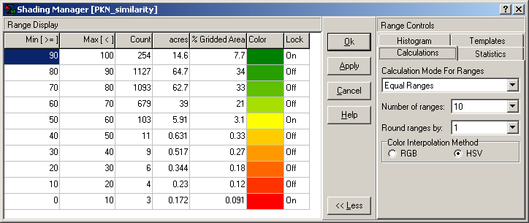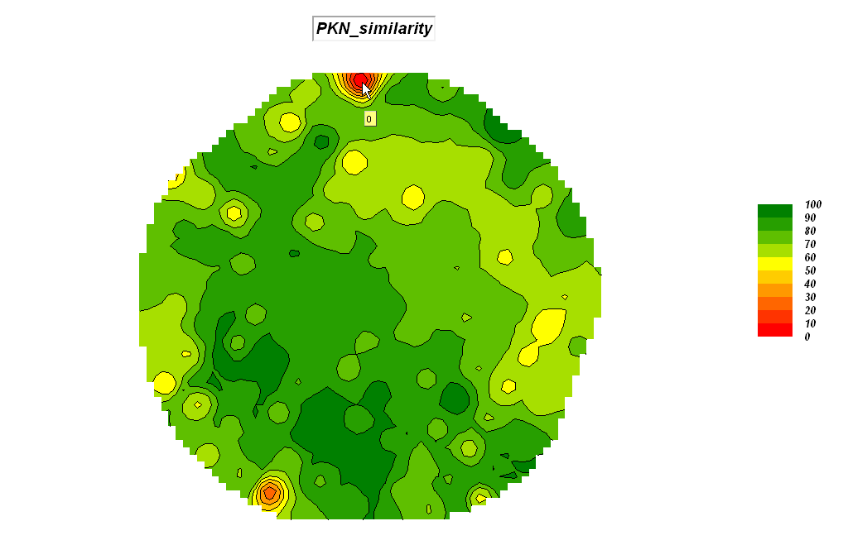

Clustering

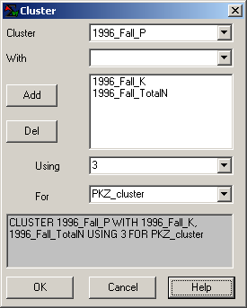 CLUSTER 1996_Fall_P WITH 1996_Fall_K, 1996_Fall_TotalN USING 3 FOR PKZ_cluster …identifies distinctly similar data zones where the data values within a zone are as similar as possible and as different as possible among the data zones

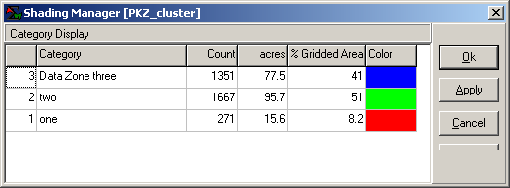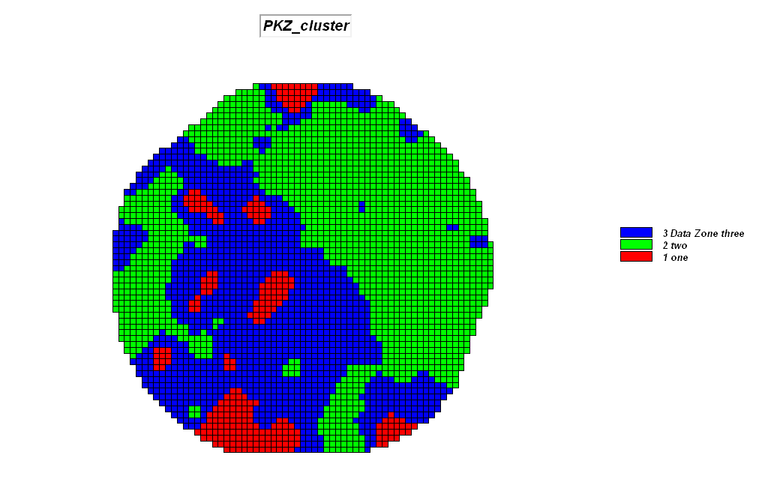
_________________________________________

Script of Short Exercise Solutions (ShortExercise.scr)

