Chapter 2
Surfer Tutorial

Overview
This tutorial introduces you to some of Surfer’s features and shows you the steps to take to produce maps. In addition, the tutorial will help previous Surfer users learn some of the new features and procedures in Surfer 7. The tutorial is designed to take approximately forty minutes to complete. The rest of the User’s Guide contains more information about the features not covered here.

The User’s Guide and the online help system should help answer any other questions you may have about the program. We also provide FAQ’s on our web page: http://www.goldensoftware.com. Technical support is available by telephone (303-279-1021), fax (303-279-0909), and e-mail (surfersupport@goldensoftware.com).

The Surfer tutorial is divided into several lessons. After you have gone through Lesson 2 - Creating a Grid File at least one time, each exercise can then be completed as a separate example. The grid file created in Lesson 2 - Creating a Grid File is needed in Lessons 3 and 4.

Understanding How to Use Surfer
The most common application of Surfer is to create a grid-based map from an XYZ data file. The Grid | Data command uses an XYZ data file to produce a grid file. The grid file is then used by most of the Map menu commands to produce maps. Post maps and base maps do not use grid files.
This flow chart illustrates the relationship between XYZ data files, grid files, contour maps, and wireframe maps.

The flow chart to the right illustrates the relationship between XYZ data files, grid files, contour maps, and wireframe maps.

Starting Surfer
To begin a Surfer session:

- Click on the Windows Start button.

- Navigate to Programs | Golden Software Surfer 7.0 and click the Surfer 7 icon.

- Surfer starts with a new empty plot window. This is the work area where you can produce grid files, contour maps, wireframe maps, vector maps, or any other map type.

Lesson 1 - Creating an XYZ Data File
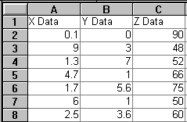
An XYZ data file is a file containing at least three columns of data values. The first two columns are the X and Y coordinates for the data points. The third column is the Z value assigned to the XY point. Although it is not required, entering the X coordinate in Column A, the Y coordinate in Column B, and the Z value in Column C is a good idea. Surfer looks for these coordinates in these columns by default.
A simple XYZ data file. Notice that the X, Y, and Z data are placed in Columns A, B, and C, respectively.

If the data are already in a file, you do not need to create a new XYZ data file as outlined in this section of the tutorial, nor do you need to display the data in a worksheet window. However, if the data are not in a file, you must first create a data file before you proceed with the tutorial.

See Chapter 3, Data Files and the Worksheet for a complete description of XYZ data files, worksheet windows, and how to manipulate data in the worksheet.
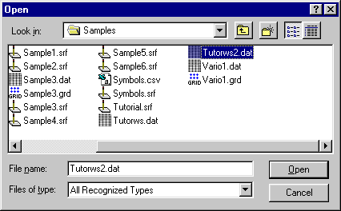
To look at an example of an XYZ data file, you can open TUTORWS2.DAT into a worksheet window:
In the Open dialog box, select the sample file TUTORWS2.DAT included with Surfer.
- Choose the File | Open command, or click the Open tool . The Open dialog box is displayed. This allows you to select the XYZ data file to display in the worksheet window.

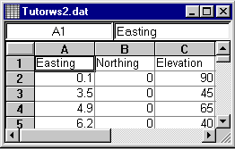
- In the list of files, click TUTORWS2.DAT and the name appears in the File name edit box. Click Open and the file is displayed in the worksheet window.
When a data file is displayed, the name of the file is shown in the title bar of the worksheet window. In this file, row 1 contains descriptive information about each column of data.
- Notice that the X coordinate (Easting) is in Column A, the Y coordinate (Northing) is in Column B, and the Z value (Elevation) is in Column C. Although it is not required, the header text (the text in row 1) is helpful in identifying the type of data in the column, and this information is used in dialog boxes when selecting worksheet columns.

The Surfer worksheet can also be used to create a data file. To open a worksheet window and begin entering data:
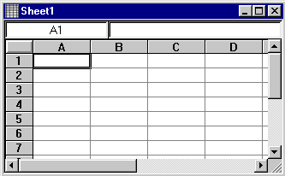
- Choose the File | New command or click the New tool . Click the Worksheet option in the New dialog box. Click OK to display a new empty worksheet window.
Data are entered into the active cell of the worksheet.
The active cell location
The active cell edit box
The active cell is indicated with a heavy border

- The active cell is selected by clicking on the cell or by using the arrow keys to move between cells. The active cell is indicated by a heavy border and the contents of the active cell are displayed in the active cell edit box.

- When a cell is active, enter a value or text, and the information is displayed in both the active cell and the active cell edit box.

- The BACKSPACE and DELETE keys can be used to edit data as you type.

- Press the ENTER key and the data are entered into the cell.

- To preserve the typed data in the active cell, move to a new cell. Move to a new cell by clicking a new cell with the pointer, pressing one of the arrow keys, or pressing ENTER.

Saving the Data File
When you have completed entering all of the data:
- Choose the File | Save command, or click the Save tool . The Save As dialog box is displayed if you have not previously saved the data file.

- In the Save File as Type drop-down list box, choose the Golden Software Data (*.DAT) option from the list.

- Type the name of the file into the File name edit box. Click OK and the file is saved in the Golden Software Data [.DAT] format with the file name you specified. The name of the data file appears at the top of the worksheet window.

Lesson 2 - Creating a Grid File
Grid files are required to produce a grid-based map. Grid-based maps include contour maps, image maps, shaded relief maps, vector maps, and wireframe maps. Grid files are created using the Grid | Data command. The Data command requires data in XYZ columns. We have included a sample XYZ data file (TUTORWS.DAT) with Surfer, for you to see how to produce a grid file. If you need to produce an XYZ data file of your data, see Lesson 1 – Creating an XYZ Data File.

To produce a grid file from TUTORWS.DAT:

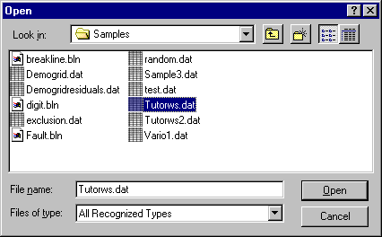
- Choose the Grid | Data command. The Open dialog box is displayed. This allows you to select the XYZ data file used to produce the grid file.
In the Open dialog box, select the sample file “TUTORWS.DAT” included with Surfer.
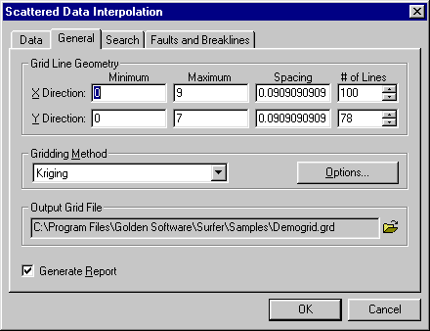
- In the list of files, click the file TUTORWS.DAT. The name appears in the File name edit box below the list of data files. Click Open and the Scattered Data Interpolation dialog box is displayed. Alternatively, you can double-click the data file name to display the Scattered Data Interpolation dialog box.
The Scattered Data Interpolation dialog box allows you to specify the gridding parameters to use when creating the grid file.
- The Scattered Data Interpolation dialog box allows you to control the gridding parameters. Take a moment to look over the various options in each tab of the dialog box. Do not make changes at this time, as the default parameters create an acceptable grid file.

- The Data Columns group under the Data tab specifies the columns containing the X and Y coordinates, and the Z values in the data file.
- The Grid Line Geometry group under the General tab specifies the XY grid limits, the grid spacing, and the number of grid lines (also referred to as rows and columns) to include in the grid file.
- The Gridding Method group under the General tab specifies the interpolation method to use and the parameters controlling the interpolation.
- The Output Grid File group under the General tab specifies the path and file name for the grid file created.
- The Generate Report option under the General tab specifies whether to create a statistical report for the data.
- The Search tab specifies the search radius for each grid node.
- The Faults and Breaklines tab specifies the file name that contains the fault or breakline used while gridding.

- Click OK. In the status bar at the bottom of the window, a display indicates the progress of the gridding procedure. When gridding is complete, the grid file TUTORWS.GRD is created and Surfer beeps to indicate that the grid file has been produced. By accepting the defaults, the grid file uses the same path and file name as the data file, but the grid file has a [.GRD] extension. If Generate Report is checked, a Data Filter Report is displayed. For additional information on the Data Filter Report, see Chapter 4, Creating Grid Files.
The status bar indicates the progress of the gridding procedure.

Lesson 3 - Creating a Contour Map
The Map | Contour Map command creates a contour map based on a grid file. To create a contour map of the TUTORWS.GRD file you just created:

- Choose the Map | Contour Map | New Contour Map command, or click on the Contour tool . The Open Grid dialog box is displayed. The grid file you just created (TUTORWS.GRD) is automatically entered in the File name edit box. Click Open, and the Contour Map Properties dialog box is displayed.
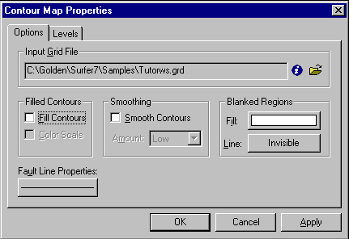
The Contour Map Properties dialog box allows you to control the display of contour lines and color fill on a contour map.
- The default parameters in the Contour Map Properties dialog box create an acceptable contour map. To accept the default parameters, click OK. A contour map is created from TUTORWS.GRD. For more information regarding the Contour Map Properties dialog box, see Chapter 6, Contour Maps.

- If you want the contour map to fill the window, choose the View | Fit to Window command. The view of the contour map is magnified so the map fills the entire plot window.

Changing Contour Levels
After you create a contour map, you can easily modify any of the map features. For example, you might want to change the contour levels displayed on the map. To change any of the map features, double-click on the map to display the Contour Map Properties dialog box.

- Place the pointer inside the limits of the contour map and double-click. The Contour Map Properties dialog box is displayed.

- The Levels tab displays the contour levels and contour line properties for the map. In this example, the contour levels begin at Z = 20. Click on the scroll bar at the right to scroll to the bottom. You can see that the maximum contour level is Z = 100 for this map and that the contour interval is 5.

- You can easily change the contour range and interval. Click the Level button and the Contour Levels dialog box is displayed. This shows the Minimum and Maximum contour level for the map and the contour Interval.

- Double-click in the Interval edit box and the value is highlighted. Type in the value 10 to change the contour interval for this map. Click OK and the Levels tab is updated to reflect the change.
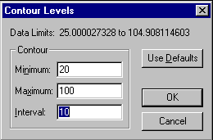
Open the Contour Levels dialog box by clicking on the Levels button on the Contour Map Properties Levels tab.

- Click OK in the Contour Map Properties dialog box and the map is redrawn with the new contour levels.
The contour map is redrawn using new contour levels based on 10-foot contour intervals.

Changing Contour Line Properties
In the Levels tab of the Contour Map Properties dialog box, double-click any of the elements in the list to modify the individual element. For example, you can double-click an individual Z value in the list to change the Z value for that particular contour level. You can also double-click the line style for an individual level to modify the line properties for the selected level. This provides a way to emphasize individual contour levels on the map.

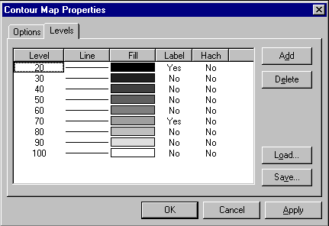
Double-click on the Level value to enter a new Z value for a level.
Double-click on the Line to change line properties for a level.
Double-click on a Fill sample to change the fill properties for a level.
Double-click on these to control the display of contour labels and hachures for a level.
The Levels tab from the Contour Map Properties dialog box. You can double-click on individual elements to set specific parameters for the selected level.

To change contour line properties:

- Double-click the contour map and the Contour Map Properties dialog box is displayed.

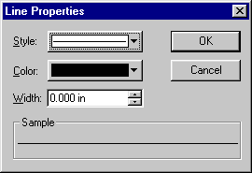
- On the Levels tab, double-click the line sample for the contour level at Z = 70. The Line Properties dialog box is displayed.
The Line Properties dialog box allows you to specify the properties for the selected line.

- From here you can select the line color, style, or width for the selected line. In the Width edit box, click the up arrow, and change the width value to 0.030 in. Click OK and the Levels tab is updated to reflect the change. A width of 0.000 in is equivalent to one pixel of width.
Steps continued on the next page.

- Click OK in the Contour Map Properties dialog box and the map is redrawn. The contour line at Z = 70 is drawn with a thicker line.

The contour line at Z = 70 is bolder than the other contour lines on this map.

Adding Color Fill between Contour Lines
Color fill can be assigned to individual levels in the same way as line properties. Or, you can assign colors based on a gradational spectrum between two colors.

The Levels tab of the Contour Map Properties dialog box shows a correspondence between a level (under the Level button) a color (under the Fill button). Such a color is used to fill in the space between the corresponding level and the next higher level. For example, if the contour levels involved are 20, 30, 40, ..., then the color corresponding to level 20 is used to fill in the space between the level 20 contour and the level 30 contour.

To change color fill:
- Double-click the contour map and the Contour Map Properties dialog box is displayed.
- On the Options tab of the Contour Map Properties dialog box, click the Fill Contours check box.

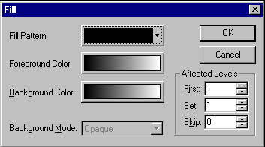
- On the Levels tab, click the Fill button and the Fill dialog box is displayed.
The Fill dialog box allows you to choose the colors for a gradation of colors.

- Click the Foreground Color button and the Color Spectrum dialog box is displayed. This dialog box allows you to select colors to assign to specific Z values. Click on the left anchor point button above the spectrum. Choose the color Blue from the color palette, and click OK. The Foreground Color button is now displayed as a gradation from blue to white in the Fill dialog box. Click OK and the Fill colors in the Contour Map Properties dialog box are updated to reflect the change. For more information on the Color Spectrum dialog box, see Chapter 12, Adding Color to Maps.

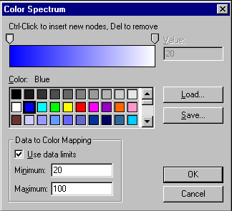
The Color Spectrum dialog box allows the choice of gradational color fill.
- Click OK and the contour map is redrawn with color fill between the contours.

Add, Delete, and Move Contour Labels
Contour label locations can be changed on an individual basis. Labels can be added, deleted, or moved.

To add, delete, and move contour labels:

- Right-click on the contour map and choose the Edit Contour Labels option. You can also edit labels using the Map | Contour Map | Edit Labels command.

- To delete a label, select the label and press the DELETE key on the keyboard. Delete the “70” label in the upper left corner of the map.

- To add a label, press and hold the CTRL key on the keyboard and click on the location on the contour line where you want the new label located. Add a “60” contour label to the lower left portion of the map.

- To move a contour label, click on the label, hold down the left mouse button, and drag the label. Move the “70” contour label on the right portion of the map to the north.
Adjusted contour labels after the add, delete, and move steps described above.

- To exit the Edit Contour Labels mode, press the ESC key.

Modifying an Axis
Every contour map is created with four axes: the Bottom, Right, Top, and Left axes. You can control the display of each axis independently of the other axes on the map. The Bottom axis on this contour map uses a major tick spacing of 1.0, and 2 decimal digits on each of the tick labels. In this exercise both of these parameters are changed, and an axis title is added.

A contour map showing the four axes. In this figure, axis titles are added to indicate the different axes.
To modify an axis:

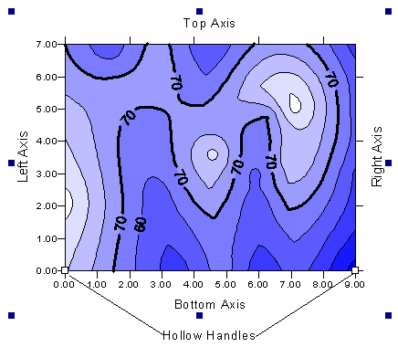
- Move the pointer over one of the axis tick labels on the bottom X axis and left-click the mouse. In the Status Bar at the bottom of the plot window, the words "Map: Bottom Axis" are displayed. This indicates that you have selected the bottom axis of the contour map. Additionally, hollow handles appear at each end of the axis, and solid black handles appear surrounding the entire map. This indicates that the axis is a "sub-object" of the entire map.
Eight solid handles appear around the selected map, and hollow handles appear at the ends of the selected sub-object. In this case, the Bottom Axis is the sub-object.

- Move the pointer over one of the axis tick labels, double-click. The Bottom Axis Properties dialog box is displayed. This provides you with control over the display of the selected axis.
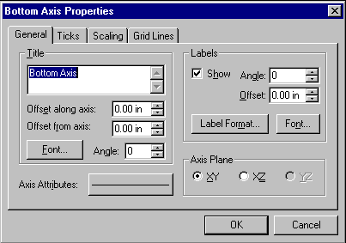
The Bottom Axis Properties dialog box controls the display of the Bottom Axis. If you want to modify the properties for a different axis, double-click on that axis.
- In the Title edit box on the General tab, type "Bottom Axis." This places a title on the selected axis.

- Click on the Scaling tab to display the axis scaling options. In the Major Interval edit box, type the value 1.5. This changes the spacing between major ticks along the selected axis.
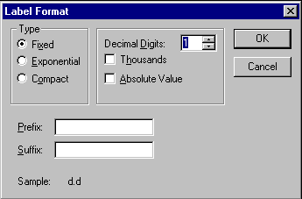
The Label Format dialog box.
- Click on the General tab and then on the Label Format button in the Labels group. The Label Format dialog box is displayed. Click on the down arrow on the Decimal Digits edit box and the value changes to "1." This indicates that only one digit follows the decimal point for the axis tick labels. Click OK to return to the Bottom Axis Properties dialog box.
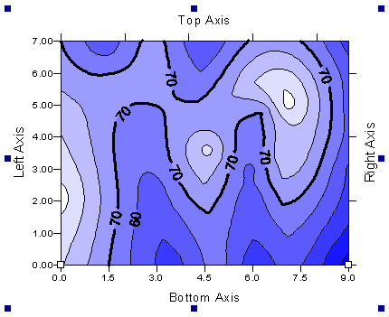
- Click OK in the Bottom Axis Properties dialog box and the map is redrawn. The axis tick spacing and labels are changed, and the axis title is placed below the map.
The axis tick labels and spacing have been modified for this map. An axis title has also been added.

Saving a Map
When you have completed the map or drawing in the plot window, you can save the map to a Surfer file [.SRF] containing all the information necessary to reproduce the map. When you save a map, all the scaling, formatting, and parameters for the map are preserved in the file.

To save a map:
- Choose the File | Save command, or click the Save tool . The Save As dialog box is displayed because the map has not been previously saved.
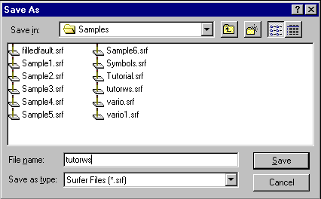
The Save As dialog box.

- In the File name edit box, type TUTORWS.

- Click Save and the file is saved to the current directory, and an [.SRF] extension is automatically added. The saved map remains on the window.

Exporting 3-D Contours
When you have completed a contour map in the plot window, you can save the map to a Surfer file [.SRF], as described above, or you can export the contour lines with associated Z values to an AutoCAD DXF file.

To export contour lines:

- Select the map by clicking on the map in the plot window or by clicking on the map icon in the Object Manager.
- Choose Map | Contour Map | Export Contours.
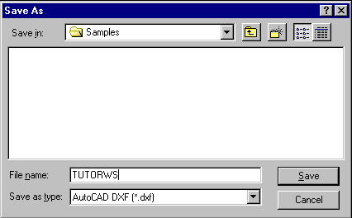
The Save As dialog box.
- In the Save As dialog box, type TUTORWS in the File name edit box.

- Click Save and the file is exported to the current directory. This creates a file titled TUTORWS.DXF which can be opened in any program with an AutoCAD DXF import option.

Lesson 4 - Creating a Wireframe Map
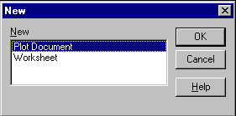
Wireframe maps are three-dimensional representations of a grid file. Wireframe maps are block diagrams generated by drawing lines representing the grid X and Y lines (the grid columns and rows). At each intersection of a column and row (i.e. at each grid node), the height of the surface is proportional to the grid Z value at that point. The number of columns and rows in the grid file determines the number of X and Y lines drawn on the wireframe map.
The New dialog box allows you to specify which type of window to create.

To create a wireframe map in a new plot window:

- Choose the File | New command, or click the New tool . The New dialog box is displayed. Select Plot Document, and click OK. A new empty plot window is displayed.

- Choose the Map | Wireframe command or click the Wireframe Map tool . The Open Grid dialog box is displayed. Choose the grid file TUTORWS.GRD from the list of files, and click OK. The Wireframe Properties dialog box is displayed.
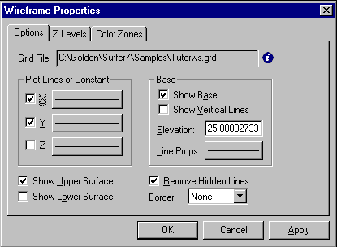
The Wireframe Properties dialog box.
- Click OK to accept the defaults. A wireframe map based on TUTORWS.GRD is drawn. Wireframe maps are drawn with a Z-axis in addition to the other axes.
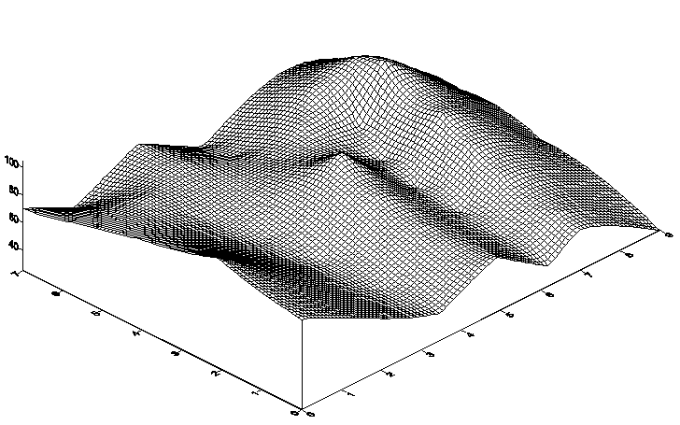
A wireframe map based on TUTORWS.GRD.

Changing the Orientation of a Wireframe Map
Although this example uses a wireframe map to illustrate orientation and tilt, you can perform this operation on most map types in Surfer (excluding image maps and shaded relief maps).

To change orientation and tilt:

- Click the wireframe map and selection handles appear surrounding the map.

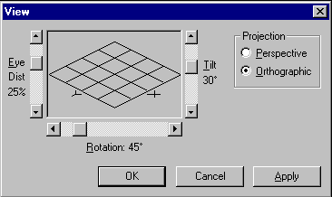
- Choose the Map | 3D View command. The View dialog box is displayed. This box allows you to control the tilt, rotation, and projection type for the selected map.
The View dialog box allows control of the tilt angle, rotation angle, and the projection type.

- Use the Rotation scroll bar to change the rotation to 210°. As you change the rotation angle, the graphic image in the dialog box changes to indicate the orientation.
- Use the Tilt scroll bar to change the angle to 40°.

- Click OK in the dialog box and the wireframe map is redrawn at the new orientation and tilt angles.
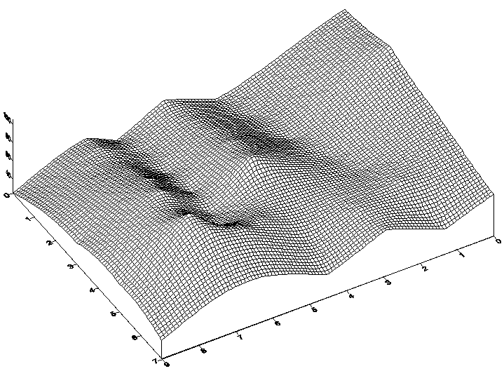
The wireframe map at a new rotation angle and tilt.

Changing the Scaling of a Wireframe Map
You can change the scaling of any map in each of the three cardinal dimensions. In this example, the Z scaling is changed, and the wireframe map becomes somewhat exaggerated in the Z dimension.
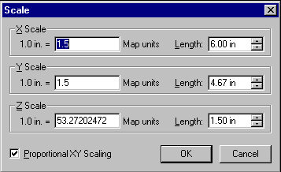
The Scale dialog box specifies the scaling for the selected map.
To change the Z scaling:

- Click the wireframe map, and selection handles appear surrounding the wireframe.

- Choose the Map | Scale command to display the Scale dialog box. This allows you to set the scaling in each of the three cardinal dimensions on the selected map. You can set scaling by entering the number of map units per inch, or by entering the length for the map in page coordinates.

- In the Length edit box of the Z Scale group, type 3. The Map units value changes to reflect the change you made.

- Click OK and the wireframe map is redrawn exaggerated in the Z dimension.
The Z scale on the wireframe map is changed to reflect the exaggeration in the Z dimension.

Adding Color Zones to a Wireframe Map
You can change the line colors of any wireframe map by applying color zones. In this example, we will change color zones gradationally and individually.

To add a color zone to a wireframe map:

- Double-click on the wireframe map, and the Wireframe Properties dialog box is displayed.
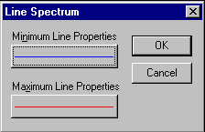
The Line Spectrum dialog box.
- Click on the Color Zones tab.

- Click on the Line button to display the Line Spectrum dialog box.

- Click on the Minimum Line Properties button and the Line Properties dialog box is displayed. From here, you can select the line color, style, or thickness.

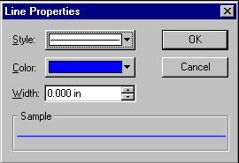
- Click on the Color button and select the color Blue. Click OK and to return to the Line Spectrum dialog box.
The Line Properties dialog box.

- Click on the Maximum Line Properties button and change the line color to red using the steps above.

- Click OK in the Line Spectrum dialog box.

- In the Wireframe Properties dialog box, click the Apply Zones to Lines of Constant X and Y.

- Click OK and the wireframe map is displayed with the gradational colors.

To change the properties of an individual Z value:

- Double-click the wireframe map and the Wireframe Properties dialog box is displayed.

- On the Color Zones tab, double-click the line sample for the contour level at Z = 70. The Line Properties dialog box is displayed.

- From here you can select the line color, style, or width for the selected line. In the Width edit box, click the up arrow and change the width value to 0.030 in. Click OK and the Color Zones tab is updated to reflect the change.

- Click OK in the Wireframe Properties dialog box and the map is redrawn. The color zone at Z = 70 is drawn with a thicker line, and is emphasized on the map.
The wireframe map is redrawn with Z = 70 emphasized.

Lesson 5 - Posting Data Points and Working with Overlays
Post maps are created by placing points on a map and labeling the points. Posting data points on a map can be useful in determining the distribution of data points, as well as placing data or text information at specific points on the map. Data files contain the XY coordinates used to position the points on the map. Data files can also contain the labels associated with each point.

When a new post map is created, it is independent of any other maps in the current plot window. When the two maps are displayed, notice that two sets of axes are also displayed, one set for each map. When you use the Map | Overlay Maps command, the two maps are combined into a single map overlay with one set of axes. See Chapter 13, Positioning and Overlaying Maps for more specific information on creating map overlays.

To overlay maps:

- Choose File | Open to display the Open dialog box. Choose TUTORIAL.SRF and click the Open button to display the contour map contained in TUTORIAL.SRF.
- Choose Map | Post Map | New Post Map or click the Post Map tool . The Open dialog box is displayed. This allows you to select the data file used to produce the post map.

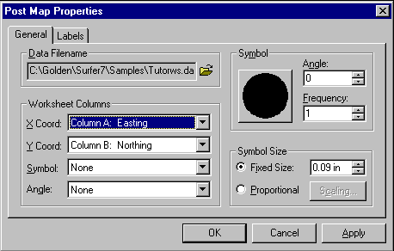
- In the list of files, click TUTORWS.DAT and the name appears in the File name edit box. Click Open and the Post Map Properties dialog box is displayed.
The Post Map dialog box.
- Click the Symbol button and the Symbol Properties dialog box is displayed.

- Choose the filled circle symbol from the Symbol palette and click OK. The selected symbol appears in the Symbol button. This symbol appears at the posted data points on the map.

- In the Fixed Size edit box of the Symbol Size group, specify a size of 0.09 in.

- Click OK and the post map is drawn over the contour map. The contour map and post map are two separate maps on the page. If you look closely at the X-axis, you will notice the two sets of axis tick labels for the two maps.

- To see the two separate maps, place the mouse pointer in the center of the maps and click. Press and hold the left mouse button and move the pointer slightly in any direction. Release the button and the two maps are offset.

- Press the CTRL+A on the keyboard to select both maps.
The two maps are offset slightly to show that the contour map and post map are separate maps.

- Choose the Map | Overlay Maps command and the two maps are combined in a single overlay.
The contour and post maps are combined into a single overlay. This places a point symbol at each data location.

Selecting a Map from the Overlay and Assigning an Object ID
After you create map overlays, you can still modify the individual maps in the overlay. Choose one of the three ways to select the maps in the overlay:

- Double-click the maps,

- Right-click on the map and select the Properties command, or

- Select the desired map in the Object Manager and double-click.

The easiest way to select a map in an overlay is to click on the map name in the Object Manager. However, you can also select the map with the mouse. To select an overlapping map in the plot window using the mouse, you often need to use the CTRL key. Whenever two or more objects occupy the same position in the plot window, you have to use the CTRL key to select the desired object. The CTRL key allows you to cycle through the selection of overlapping objects. For example, if you want to select a text block behind a rectangle, or a wireframe map behind a contour map, hold down the CTRL key and click until the object you want is selected. You can use the status bar to help you to select the object.
The status bar at the bottom of the Surfer window indicates the selected object in the plot window. In this example, the status bar reports that the post map is selected.

To select a map from the overlay, and assign an ID to the map:

- Click the map name in the Object Manager (i.e. "Contour"). If the Object Manager is not open, click Edit | Object Manager. The selected map in the overlay is indicated in the status bar. For example, if the selected map were the contour map, the status bar would indicate "Map: Tutorial Contour Map."

- To select the other map in the overlay, click the map name in the Object Manager. Check the status bar, and it should now report "Map: Post."
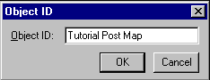
The Object ID dialog box specifies the ID for the selected object.
- When the status bar indicates that the post map is selected, choose Edit | Object ID.

- In the Object ID dialog box, type the name "Tutorial Post Map" and click OK. The status bar reflects the change to the ID for the post map.

Adding Labels to the Post Map in the Overlay
You can add labels to the data points on the post map of the overlay. The post map can be selected by a few different methods, though only the Object Manager method is discussed here.

- Select the overlay by clicking on the map name in the Object Manger ("Tutorial Post Map").

- Right-click on the map name and choose Properties from the pop-up menu to open the Post Map Properties dialog box.

- Click on the Labels tab. In the Worksheet Column for Labels group, click the drop down arrow, and a list of columns in TUTORWS.DAT is displayed.

- Select Column C: Elevation from the list. This column contains the Z values.

- Click the Format button and the Label Format dialog box is displayed. Change the Type to Fixed and the Decimal Digits value to zero, because the precisions of the elevation data points are to the nearest foot. Click OK to return to the Post Map Properties dialog box.
The post map in the overlay is modified to display posted data values at each point.
- Click OK and the overlay is redrawn with labels on each of the data points.

Lesson 6 - Introducing Vector Maps
Vector maps are new to Surfer 7. A vector map is a graphical presentation comprised of a field of small arrows. Each arrow shows a direction and a magnitude associated with the location at which the arrow is drawn. For example, a vector map can depict the local gradients of a topographic surface: the arrows point in the direction of steepest ascent, and the size of the arrows are scaled to the magnitude of the local slopes.
The vector map showing the local gradients of a topographic surface is plotted overlaying a contour map.

Surfer offers two types of vector maps: a 1-grid vector map and a 2-grid vector map. In a 2-grid vector map the two components of the vectors (i.e. magnitude and direction, or ΔX and ΔY) are given by two separate grid files. This is described in detail in Chapter 8, Vector Maps.

The two components of a 1-grid vector map are automatically generated from a single grid file by numerically calculating the gradient of the represented surface. By default, the 1-grid vector map draws vectors pointing in the direction of steepest descent, with the vector lengths are scaled by the magnitude of the local slope.

Creating a 1-Grid Vector Map
You can create a 1-grid vector map and overlay it on a wireframe map to produce a map showing the flow of water on a topographic surface.

- Choose the File | New command, or click the New tool . The New dialog box is displayed. Select Plot Document, and click OK. A new empty plot window is displayed.
- Choose the Map | Vector Map | New 1-Grid Vector Map command. The Open Grid dialog box is displayed. The grid file you just created (TUTORWS.GRD) is automatically entered in the File name edit box. Click Open, and the Vector Map Properties dialog box is displayed.
- The default parameters in the Vector Map Properties dialog box create an acceptable vector map. To accept the default parameters, click OK. A vector map is created from TUTORWS.GRD. For more information regarding the Vector Map Properties dialog box, see Chapter 8, Vector Maps.
- Choose the Map | Wireframe command or click the Wireframe Map tool . The Open Grid dialog box is displayed. Choose the grid file TUTORWS.GRD from the list of files, and click OK. The Wireframe Properties dialog box is displayed.
- Select Plot Lines of Constant Z. Deselect the Plot Lines of Constant X and Plot Lines of Constant Y. Click OK to accept the remaining default parameters. A wireframe map based on TUTORWS.GRD is drawn.
- Press CTRL-A, or choose the Edit | Select All command, to select both the vector map and the wireframe map. Choose the Map | Overlay Maps command to overlay the two maps.
The vector map showing the local gradients is plotted overlaying a wireframe map showing lines of constant Z.
- If you want the map to fill the window, choose the View | Fit to Window command. The view of the map is magnified so the map fills the entire plot window.

