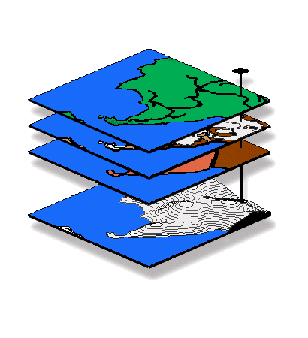
Introduction to GIS Modeling
…an introductory course in map analysis

GEOG 3110, University of Denver, Winter Term 2013

Midterm Exam

This exam is a 2.5 hours, closed book affair taken over the Internet (honor system) — at your convenience anytime after 8:00 am, Wednesday, February 15 and must be completed by 5:00 pm, Tuesday, February 19. You will download the exam (time/date stamped at our website) and submit the completed document within 2.5 hours via email to jberry@innovativegis.com.

BE SURE to save your completed Word file before you exit to submit it!!!

Name ________________________________

Date _______________ Time started ___________ Time completed _____________

Part I — (50 Points) Choose ONLY five of the following eight 10-point questions (i.e., do not answer three). Please <insert> your answers in the space below the question.

1. (10 points) Identify and discuss the three fundamental “types of map features” used in desktop mapping (vector-based systems). Identify and discuss the fourth type that is extensively used in GIS modeling (grid-based systems)?

2. (10 points) What is the distinction between a discrete “map” and a continuous “map surface”? Be sure your answer describes the differences in the data types, as well as the display type differences.

3. (10 points) Define and describe the differences among the following distance terms…

Simple Distance—

Simple Proximity—

Effective Proximity—

Optimal Path—

4. (10 points) What does the value 0 (zero) indicate on the resultant map when you subtract two travel-time surfaces? What does the sign of a map value (positive or negative) indicate? What information does the magnitude of a map value provide?

5. (10 points) Contrast the concepts of “simple buffer distance” (vector analysis) and “effective proximity buffer” (grid-based analysis).

6. (10 points) Identify and briefly explain the differences between the three map analysis approaches in overlaying maps.

7. (10 points) Identify and briefly describe the four processing levels of a suitability model. Which levels involve “real” geographic information (could validate through direct field measurement) and which involve “decision context” information (cognitive and cannot be validated through direct field measurement)?

8. (10 points) Identify and discuss the differences in information contained in the following types of visibility maps…

Simple Viewshed—

Visual Exposure Density Surface—

Weighted Visual Exposure Density Surface—

Part II — Choose ONLY one of the following three 50-point questions (i.e., do not answer two)…

9. (50 points) Referring to the following diagram, if the cell size is 100 meters, what is the Simple Distance from point A to point B (in meters)? What is the Effective Distance (in minutes) considering the relative friction factors (friction units in minutes; -0.0 indicates an absolute barrier) indicated in the upper portion of each grid cell?

Show your calculations and answers in the spaces provided below.



Simple Distance calculations — <show your calculations here>

Simple Distance = ___________________

Effective Distance calculations — <show your calculations here>

Effective Distance = ____________________

10. (50 points) What is the maximum slope (center to eight adjacent neighbors) for the 3x3 window composed of elevation values shown below, given 1) that the elevation values (in meters) are indicated in the upper portion of each cell, 2) that the grid cell size is 100 meters, and 3) that the square root of 2 is 1.414? Expand you answer to include a very brief discussion of how the “Fitted” slope algorithm works.
Show your calculations and answers in the spaces provided below.

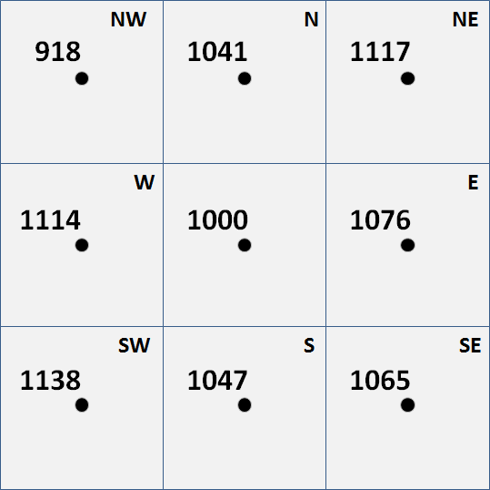

Slope calculations = <show your calculations here>

Maximum slope = __<calculated value>__ __<cell ID>__

Very brief discussion of how the “Fitted” slope algorithm works —

11. (50 points) Briefly describe how Region-wide Overlay (Composite) works. Use the example of determining the average visual exposure for each district in a project area in your discussion.

Part III — Choose ONLY one of the following three 50-point questions (i.e., do not answer two)…

12. (50 points) What information would be generated by the following MapCalc command sequence—

Note: Briefly discuss each processing step being sure to comment of the characteristics of the input map, processing undertaken and the characteristics of the output map—organization and presentation of your answer is important.

Spread Housing to 35 For Housing_proximity
Renumber Housing_proximity Assigning 1 to 0 Thru 5 Assigning 0 to 5 Thru 35 For Mask1
Slope Elevation Fitted For Slopemap
Renumber Slopemap Assigning 1 to 0 Thru 15 Assigning 0 to 15 Thru 1000 For Mask2
Compute Mask1 times Mask2 For Special_conditions
Composite Districts With Special_conditions Total For What?

13. (50 points) Given the base map of Total_customers (Smallville.rgs database), Given the base map of Total_customers (Smallville.rgs database), create a housing density map that identifies the total number of customers within 1500 feet (6-cell radius reach; circle), then isolate all of the map locations of high customer density that are over 1 standard deviation above the mean.

Note: use MapCalc and SnagIt to capture and embed your solution; be sure you identify the command and briefly discuss the processing for each step in your solution—organization and presentation of your answer is important.

14. (50 points) Given base maps of Covertype and Elevation (Tutor25.rgs database), generate a map analysis that assigns the average slope for forested locations that are southerly oriented (from 135 to 225 degrees azimuth).

Note: use MapCalc and SnagIt to capture and embed your solution; be sure you identify the command and briefly discuss the processing for each step in your solution—organization and presentation of your answer is important.

