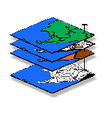
Exercise #8 — Surface Modeling
GIS Modeling, GEOG 3110, Geography Department, University of Denver

Team Members _____<enter names >_____
Date _____<enter date>______

If you haven’t already, install Surfer from the class CD on your personal computer. Surfer is already installed on all of the GIS lab computers.

Part 1 – Visualizing Surface Data in Surfer

Visualizing Terrain Surface Data…

Access the Surfer demo system pressing Start→ Programs→ Golden Software Surfer 8→ Surfer 8 Demo.

Generate examples of the six different displays of the elevation data for Mount St. Helens in Oregon by selecting…
Map→ <select display type>→ browse to …\Samples\HELENS2.GRD grid file

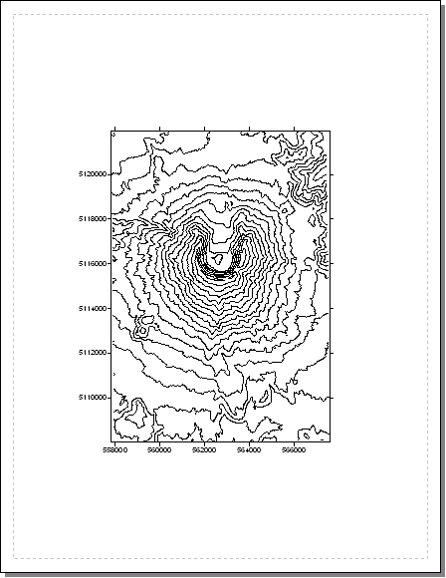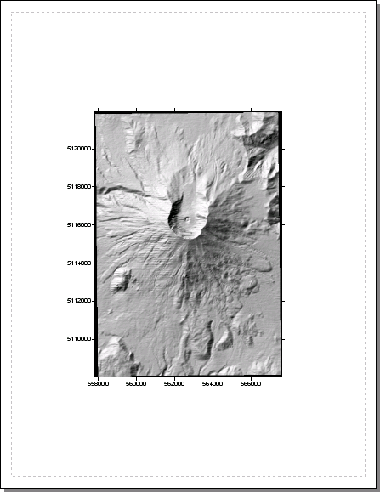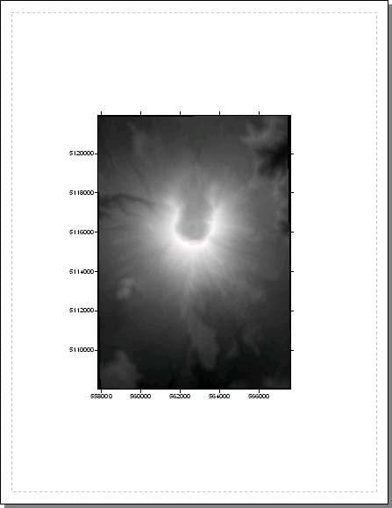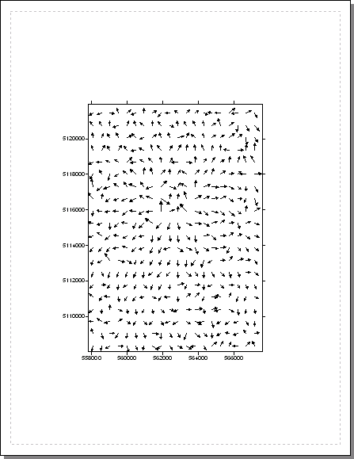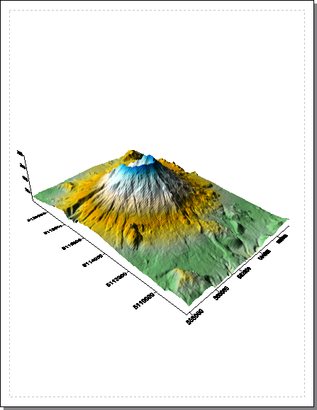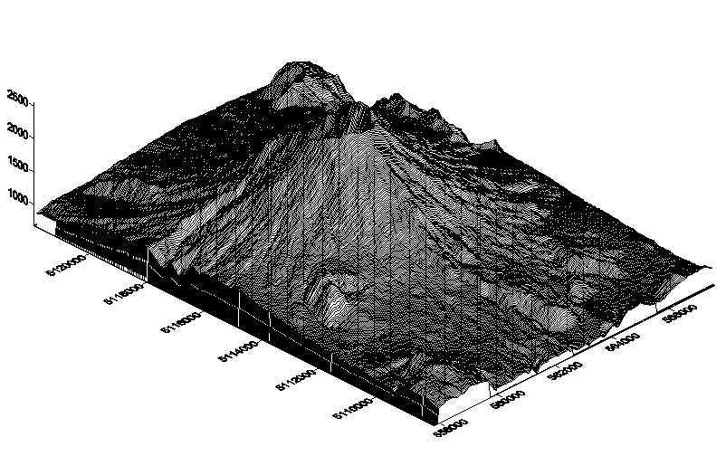
Contour Shaded Relief Image Vector Surface Wire-frame

Question 1. Embed your favorite three Surfer displays (of the six available) of the Mt. Saint Helens terrain surface in the table below by clicking in a cell and pasting the SnagIt capture. Add the figure number, title and appropriate descriptive information about the display to the right of the graphic— e.g., “Figure 1. Contour Map. This display...” Be sure to check out some of the options for each display and incorporate in the display as you deem appropriate and then note the options in your description.

<insert 3 screen grabs and brief descriptions in the appropriate locations in the table below>

<insert screen grab>  <Insert Display Type as # & Title> | <insert description of display to the left>
<insert screen grab>  <Insert Display Type as # & Title> | <insert description of display to the left>
<insert screen grab>  <Insert Display Type as # & Title> | <insert description of display to the left>

Useful Tip: to create a table in Word like the one above—1) click where you want to position the table, 2) select Table→ Insert→ specify the number of columns and rows and press OK to create. Move the cursor to the extreme upper-left corner and click on the pop-up icon () to select the entire table. Select Table→ Table Properties→ click on the “Borders and Shadings” button to pop-up the dialog box for customizing the table’s appearance. I selected the shaded line for the Border tab Style and pale blue for the Shading tab Fill color.

Investigating Mapped Data and Surfaces…

Data View
The Demogrid.dat data set was used to generate the interpolated surface you will be displaying. You can view a listing of the data by selecting File→ Open…→ Demogrid.dat from the main menu. In the table, click and drag the values in the “Elevation” column then select Data→ Statistics note the statistics that can be calculated and generate the statistics by pressing OK. Close the Data View window.

Plot View
In the main menu in the Plot View window select Map→ Post Map→ New Post Map… and then select Demogrid.dat.

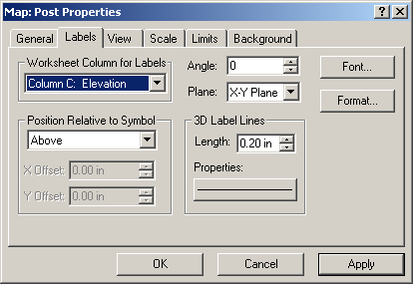 Click on the Labels Tab and insure that the Column C: Elevation is set as the “Worksheet Column for Labels” and that 0.30in is set for the “3D label Lines Length.”

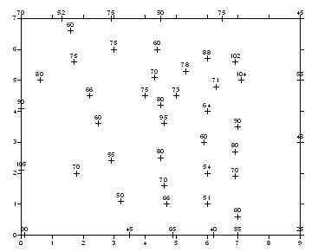 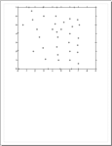 Click and drag the Post map to the top of the plot canvas. Note the spatial pattern of the point sample values.

Generating Contour Plots…

From the main menu click MAP à Contour à New Contour map then specify the Demogrid.grd and click OK to generate a default contour map.

Double-click on the contour plot to access the Contour dialog box…

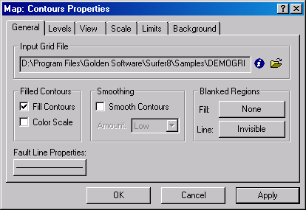 …Check the “Fill Contours” box and press OK.

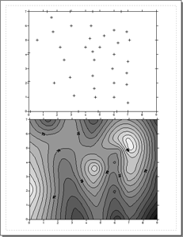…Screen Grab the two maps (Post and 5 foot Contour) and embed as directed in Question 2 below.

Double-click on the contour plot to re-access the Contour dialog box, then click on the Level Tab get the following specifications table.

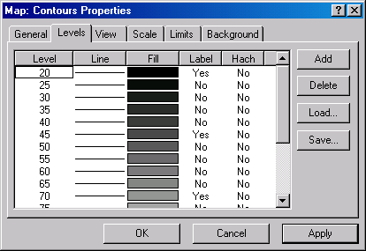 Level Tab

Change the contour interval by clicking on the Level Button and entering a different value (e.g. change from 5 to 10).

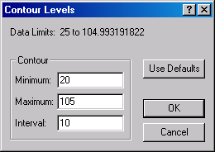 Click OK à OK to redisplay the map. Screen Grab the two maps (Post and 10 foot Contour) and embed as directed in Question 2 below.

Question 2a. Embed screen grabs of the two contour maps (plots with 5 and 10 contour intervals, respectively) you just created below (side-by-side)...

<insert screen grab(s) and discussion>

What is the visual effect of perceived precision/accuracy by decreasing the contour interval from 5 to 10?

<insert answer>

Is the actual “level of detail” of the elevation data in the display increased in a contour map with more intervals?

<insert answer>

What defines the actual “spatial resolution” contained in any map surface (data)?

<insert answer>

Reset the contour interval to 5 feet.

Double-click on the 5-interval plot to pop-up the Contour dialog box, switch to the Levels tab, then double-click on the “Fill” button to pop-up the Fill dialog box.

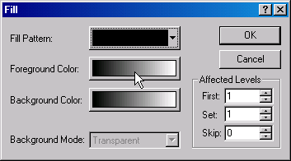 Click on the Foreground Color button to pop-up the Color Spectrum dialog box.

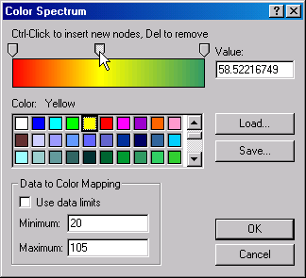 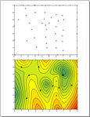 Click on the left arrow (lowest value) just above the color spectrum and assign “red” as the color. Click on the right arrow (highest value) and assign “green.” Ctrl/click in the middle of the spectrum and assign “yellow” for the color inflection point. Click OK, OK and OK to generate the color filled contour plot (be sure that “Fill Contours” is checked on the General tab). Click on the plot then resize and reposition it to the bottom of the workspace.

Question 2b. Embed a screen grab of your “color-filled” 5-foot contour map with data posting below…

<insert screen grab and discussion>

Generating 3D Wireframe Plots…

From the main menu click Map à Wireframe, then select the Demogrid.grd file and press Open to generate a default wireframe plot of the same data. Click, drag and resize the Wireframe Map to the bottom of the workspace.

Double-click on the wireframe plot to access the Wireframe Properties dialog box.

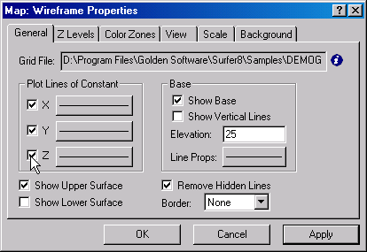 General Tab. Click to “check” the boxes for X, Y, Z then click OK. Repeat the procedure (3 times) specifying only X, only Y and only Z to see the differences various line patterns make (choose your favorite line pattern for the last display). Note that the Z Levels Tab and Color Zones Tab allow you to change the “colors and fills” of the Z line (stacked contours).

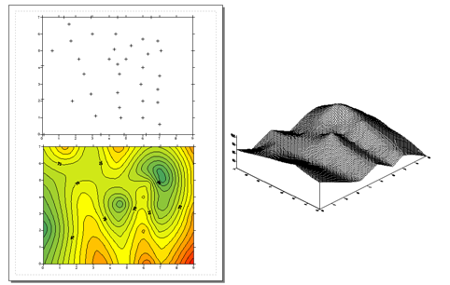 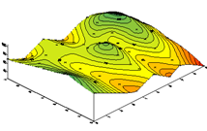 You can graphically superimpose the geo-registered displays. Shift-click on the Wireframe surface, then the Contour map and then the Post Map to select all three displays (“green handle” boxes will surround all three). NOTE that the order of selection for the overlay is important: Wireframe (first/bottom), then Contour, and then Post (last/top). Then select Map→ Overlay Maps from the main menu.

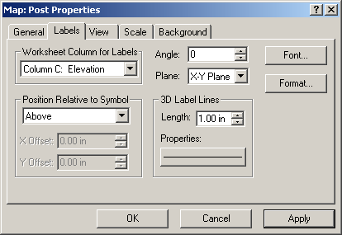 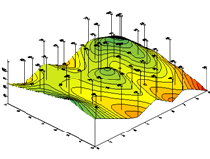 Double-click on the superimposed surface to pop-up the Post Properties dialog box and select the Labels tab. Select the Elevation values as the Column and set the Length to 1.00 inch. Press OK to post the elevation labels.

Question 2c. Embed a screen grab of the superimposed Contour map, Wireframe map and Post map and below…

<insert screen grab and discussion>

Click on the superimposed plot and select Map→ Break Apart Overlay to separate the Post map from the Contour/Wireframe. Repeat to separate the Contour map from the Wireframe surface and reposition the three separate graphic objects as before (again, note that the order is important).

Double-click on the Wireframe surface plot to pop-up its dialog box. Select the View tab to access the View dialog box.

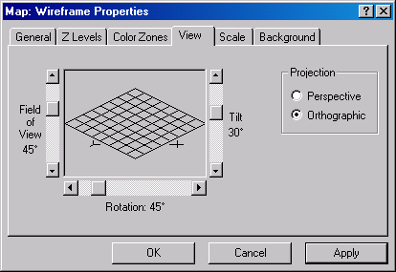 View Dialog Box. The schematic grid in the window represents the base of the surface (note the “typical” settings of Tilt= 30, Rotation= 45 and FOV= 45). Moving the sliding bars and clicking OK will cause the 3D plot to Tilt, Rotate and change the Eye Distance.

There are two 3D projection types— Orthographic and Perspective. Orthographic projection displays the X, Y lines as projected onto a plane resulting in parallel lines. Perspective projection, on the other hand, creates a visual effect with lines converging as distance is increased. The Eye Distance slider only operates in the Perspective projection mode.

“Play” with the various settings for the three graphic objects for you favorite altered view of each then superimpose them for a final display and embed with discussion below.

Question 2d. Embed below a screen grab of your favorite altered view of the 3D wireframe surface…

<insert screen grab and discussion>

Understanding Z-scale in 3D Plots…

Reset the 3D View factors to the default ones identified in the View tab shown above. From the main menu, click Map à Scale to pop-up the Scale dialog box.

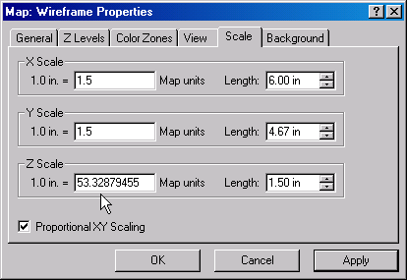 Scale Dialog Box

The horizontal scaling (X and Y) must be the same for both axes when plotting geographic data. This is assured by checking the Proportional XY Scaling box. The Z Scale determines the degree of vertical exaggeration and is independent of the X and Y scaling. Change the automatically assigned Z Scale factor to about one-half its value (to 25.0) and click OK. Repeat the procedure to change the Z Scale Factor to about twice its automatically assigned value (to 100.0).

Question 3. Embed the screen grabs of the three maps you just generated with different Z-scale factors (default, half, twice)…

<insert screen grab(s) and discussion>

What was the visual effect of changing the Z Scale value?

<insert answer>

Part 2 – Generating Interpolated Surfaces

Creating Surfaces from Point Sampled Data…

From the main menu click Grid à Data…, then select the SAMPLE3.dat file in the \Samples folder and press Open to access a set of point sampled data. Click on the View Data button to view the individual data values

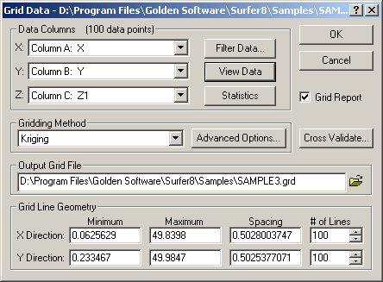 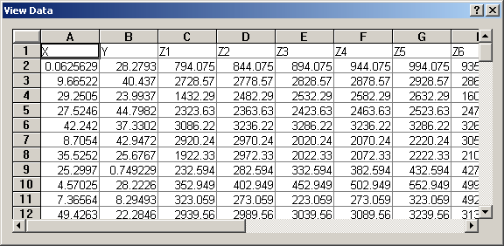 Note that each row represents a sample point (100 samples) with the first two columns identifying the relative position of the points (X, Y) followed by a time series of data (six sample periods).

In the Z field in the Data Columns portion of the dialog box, specify column 1.

Click the Statistics button to review the summary of the point data that will be used in the interpolation.

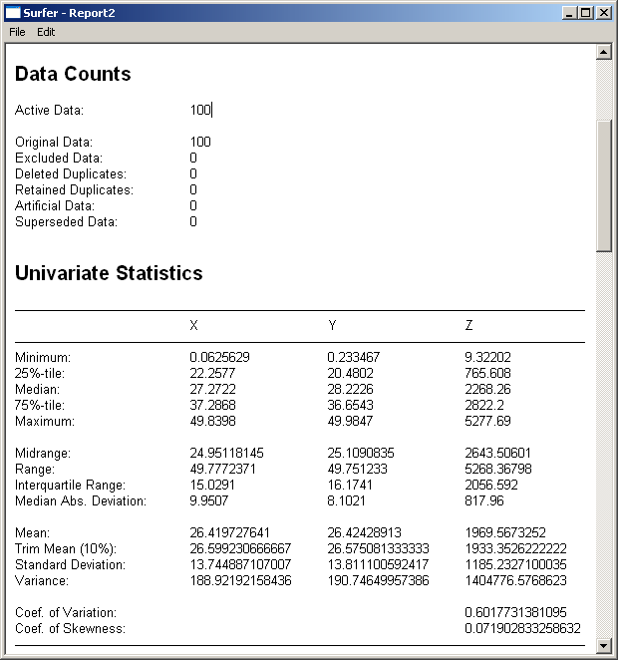 Screen grab the Data Counts and Univariate Statistics information for later use.

Step 1. 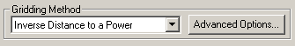 Set the Gridding Method to “Inverse Distance to a Power.”

Step 2. 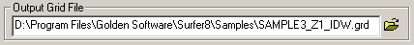 Set the Output Grid File name to …\Sample3_Z1_IDW.grd as the filename.

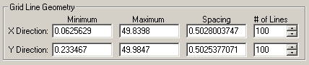 Note for later use the default settings for the fields in the Grid Line Geometry portion of the dialog box.

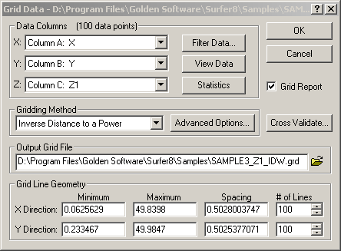 Step 3. Screen grab the completed dialog box and then press the OK button to create the interpolated surface. Briefly checkout the Gridding Report and then close its window.

Step4a. From the main menu, select Map→ Contour Map→ New Contour Map and specify the …\Sample3_Z1_IDW.grd file you just created (or Z2, Z3, etc.) to generate a contour plot of the interpolated surface.

Step4b. From the main menu, select Map→ Surface and specify the …\Sample3_Z1_IDW.grd file you just created (or Z2, Z3, etc.) to generate a surface plot of the interpolated surface.

Step 4c. Click on one of the plots, and then Shift/Click on the other to select both plots (green handle symbols will surround both plots). From the main menu, select Map→ Overlay Maps to superimpose the two plots. Move the combined plot to the top of the canvas.

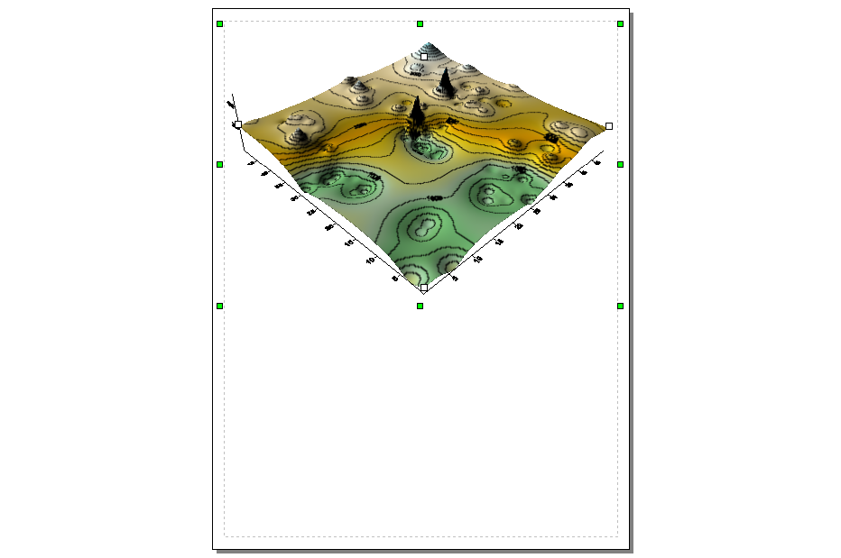 Combined Plot with IDW surface on top.

Repeat the processing (Steps 1-4) to generate a similar analysis for the Kriging griding method using the same data (Z1 or Z2, Z3, etc.). Screen grab the same set of intermediate results and the final combined plot with both interpolated surfaces (IDW on top and Kriging below).

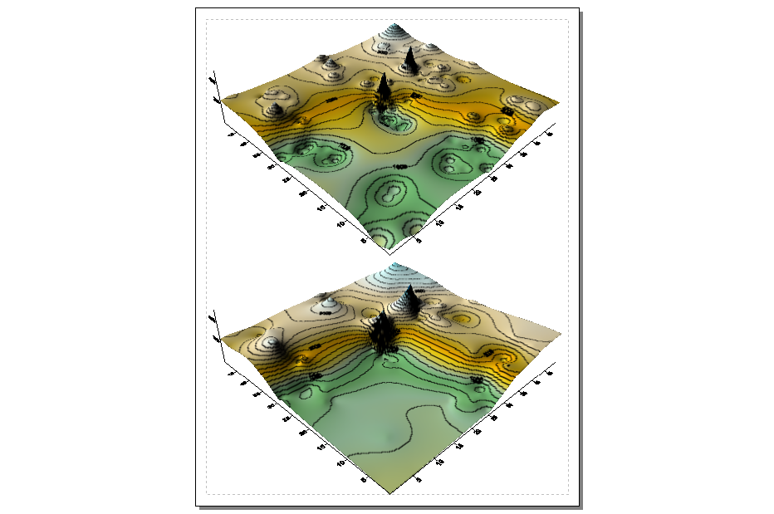 Double-click on both of the plots to insure that their display settings are the same so the visual comparison is valid. Screen grab the Combined Plot with the IDW surface on top and the Kriging surface on the bottom for later use (Question 4 below).

Comparing Interpolated Surfaces…

Now generate a Difference Surface to quantify the interpolation differences between the Krig and the IDW surfaces. Select Grid→ Math→ …\Samples\Sample3_Z1_IDW.grd to pop-up the Grid Math dialog box. Complete the dialog box as shown below…

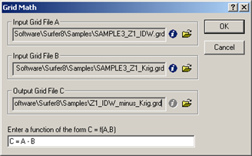 …and press OK to generate the IDW_minus_Krig difference map and display as a “Surface” map.

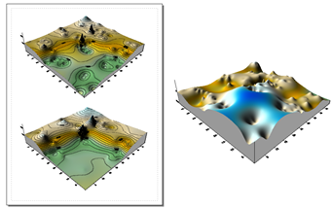 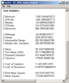 Be sure to double-click on the difference surface, select the General Tab and click on the “i” button to pop-up the statistics about the map surface—these will be helpful in framing your response to question #4.

Question 4. Embed the screen grab of the two interpolated surfaces you generated…

<insert screen grab(s) and discussion>

Embed the screen grab of the difference surface you generated…

<insert screen grab(s) and discussion>

What is the maximum, minimum and average difference between the two interpolated surfaces? Be sure your answer discusses the interpretation of the “sign” and “magnitude” of the differences.

<insert answer>

Question 5. Armed with classroom discussion, your hands-on experience and the screen grabs, write a brief report summarizing the conceptual and processing insights into spatial interpolation you gained.

<insert brief report>

Question 6. Based on classroom discussion and the Surfer Manual Help file, briefly describe the concept of the “Search Window” for both the IDW and Kriging techniques.

<insert answer>

What factors are common to both IDW and Krig techniques and what are the main differences between the two techniques?

<insert answer>

Other Major Surfer Griding Methods:
- Modified Shepard's uses an inverse distance weighted least squares method. As such, Modified Shepard's Method is similar to the Inverse Distance to a Power interpolator, but the use of local least squares eliminates or reduces the "bull's-eye" appearance of the generated contours. Modified Shepard's Method can be either an exact or a smoothing interpolator.
- Radial Basis Function interpolation is a diverse group of data interpolation methods. In terms of the ability to fit your data and to produce a smooth surface, the Multiquadric method is considered by many to be the best. All of the Radial Basis Function methods are exact interpolators, so they attempt to honor your data. You can introduce a smoothing factor to all the methods in an attempt to produce a smoother surface.
- Natural Neighbor is quite popular in some fields. The procedure considers a set of Thiessen polygons (the dual of a Delaunay triangulation). If a new point (target) were added to the data set, these Thiessen polygons would be modified. In fact, some of the polygons would shrink in size, while none would increase in size. The area associated with the target's Thiessen polygon that was taken from an existing polygon is called the "borrowed area." The Natural Neighbor interpolation algorithm uses a weighted average of the neighboring observations, where the weights are proportional to the "borrowed area."
- Minimum Curvature is widely used in the earth sciences. The interpolated surface generated by Minimum Curvature is analogous to a thin, linearly elastic plate passing through each of the data values with a minimum amount of bending. Minimum Curvature generates the smoothest possible surface while attempting to honor your data as closely as possible.
- Polynomial Regression is used to define large-scale trends and patterns in your data. Polynomial Regression is not really an interpolator because it does not attempt to predict unknown Z values. There are several options you can use to define the type of trend surface.
- Nearest Neighbor assigns the value of the nearest point to each grid node. This method is useful when data are already evenly spaced, but need to be converted to a Surfer grid file. Alternatively, in cases where the data are nearly on a grid with only a few missing values, this method is effective for filling in the holes in the data.
- Triangulation with Linear Interpolation uses the optimal Delaunay triangulation. The algorithm creates triangles by drawing lines between data points. The original points are connected in such a way that no triangle edges are intersected by other triangles. The result is a patchwork of triangular faces over the extent of the grid. This method is an exact interpolator.
___________________

Note: Submit Optional question answers as separate Word document files with the Question number and your name (e.g., Optional_8-1_yourName.doc)…do not include them with the normal weekly lab reports.

Optional Exercise 8-1 (3 points total possible). Complete any or all of the Surfer Tutorials… Lesson 1 – Creating an XYZ Data File, Lesson 2 – Creating a Grid File, Lesson 3 – Creating a Contour Map, Lesson 4 – Creating a Wireframe, Lesson 5 – Posting Data Points and Working with Overlays, Lesson 6 – Introducing Surfaces. Make a brief write up (including screen grabs of import steps) for each of the sections you complete describing the general considerations, procedure and tips you learn along the way. Individually name each of the tutorials you complete (e.g., Surfer_tutorial1.doc) and submit them separately. The MapCalc Tutorials are on the MapCalc CD or you can view on the class website (under “Links to Homework Assignments” Week 8).

Optional Exercise 8-2 (3 points possible). Repeat the processing described in Part 4 to generate and visually compare two additional interpolated surfaces using the same processing of IDW and Krig but for another period data (Z2, Z3, etc).

Embed below screen grabs and discussion for the two additional maps you just generated…

<insert brief report similar to the one in question 4>

Optional Exercise 8-3 (3 points possible). Repeat the processing described in Part 4 to generate and visually compare two additional interpolated surfaces the same Z1 period data but using two other interpolation techniques (Minimum Curvature, Modified Shepard’s, etc).

Embed below screen grabs and discussion for the two additional maps you just generated…

<insert brief report similar to the one in question 4>

Optional Exercise 8-4 (3 points possible). In your own words explain the differences among the six basic spatial sampling patterns of Grid, Staggered Start, Random Start, Systematic Unaligned, Clustered and Simple random as explained in the lecture and readings. Assume you are explaining the terms to a client that has minimal math/stat expertise.

