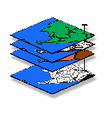
Exercise #3 — Reclassify and Overlay (MapCalc)
GIS Modeling, GEOG 3110, University of Denver

Team Members: _____ enter team member names _____
Date: _____ enter date ______

Part 1. Review of Display Forms, Display Types, Data Types

Question 1. Considering the potential display settings of …

Rarely is the default map display appropriate …you need to specify appropriate Display Settings
- Display Form | …2D/3D Toggle — 2D planimetric map (flat) or 3D surface plot (perspective)
- Display Type | … Use Cells — Lattice (generally used with continuous quantitative data type) or Grid (generally used with discrete qualitative data type)
- Display Analysis Frame | … Layer Mesh— on or off
- Display Data Type | … Data Type— Discrete (choropleth/qualitative) or Continuous (isopleth/quantitative) …considering Isopleth gradients or Choropleth abrupt boundaries for Geographic distribution; Qualitative (nominal, ordinal, binary) or Quantitative (interval, ratio) for Numeric distribution
- Thematic Grouping | … Shading Manager Settings— #Ranges, Calculation Mode, Color Pallet ramp for continuous maps or Color assignments and Labeling for discrete maps you generate.  Note: you can assign labels to discrete maps by clicking on the Category column of the Shading Manager and entering a brief text description.

Note: Use the Open button to select a new database. Use the View button to select the maps for viewing.

1a) Considering the Display Form, Display Type, Mesh on/off, Data Type and Shading manager Settings which combination would be most appropriate for displaying the following maps in the Island.rgs database (explain your choices by discussing the geographic and numeric nature of the data)—

Depth map— Insert your answer…

Roads map— Insert your answer…

Watersheds map— Insert your answer…

1b) Considering the Display Form, Display Type and Data Type, which combination would be most appropriate for displaying the following maps in the Agdata.rgs database (explain your choices by discussing the geographic and numeric nature of the data)—

1996_Fall_%Clay map— Insert your answer…

z2000_Image_8_30_NDVI map— Insert your answer…

Order_III_Soil_Survery map— Insert your answer…

Part 2. Using Reclassify Operations

Question 2. Complete the following commands, embed the resultant map, and briefly explain the result by interpreting the map values generated. Be sure your map display best represents the information generated by using the appropriate settings (Display Form, Display Type and Data Type …

Display the Covertype map (with legend) for reference …use Tutor25.rgs database

Example screen grab and discussion:

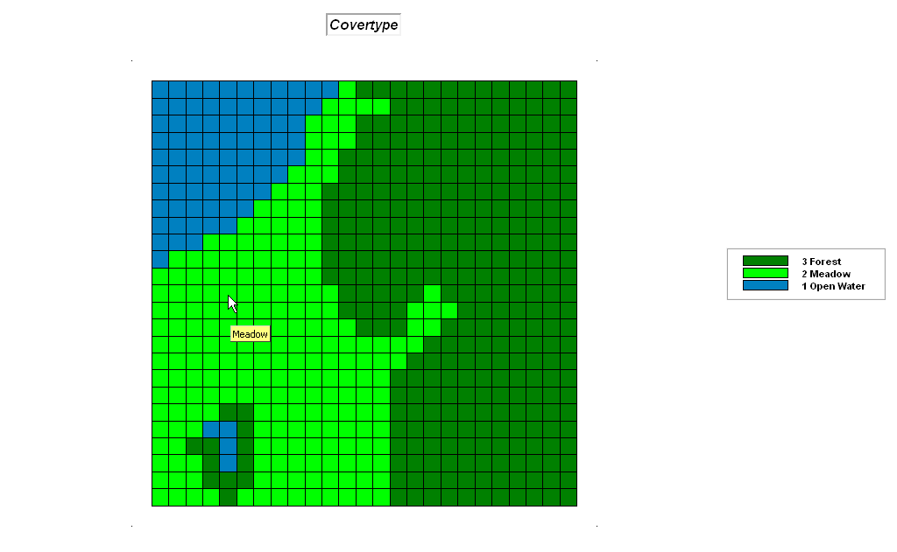 The Covertype map contains Qualitative data (nominal) that is Discretely distributed in geographic space (choropleth). As such, it is best displayed in 2D Grid using cells with layer mesh on as the stored values do not form gradients in either numerical or geographic space.

SIZE Covertype FOR Covertype_size

Example screen grabs and discussion:

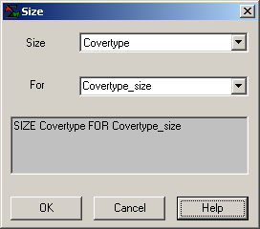 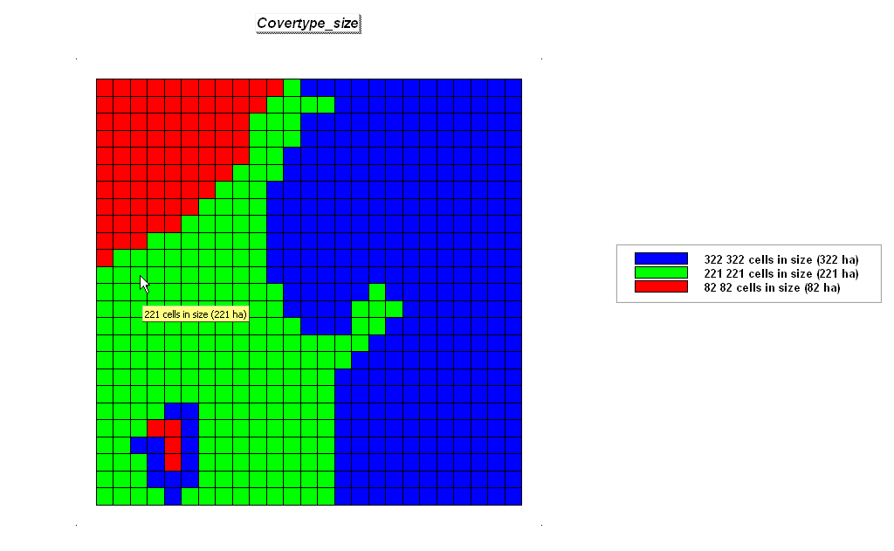 The Size command assigns new values according to the size of the area associated with each map category. In this instance the input map is Covertype (Nominal/Discrete data) and the output map is Covertype_size (Quantitative/Discrete data). The size algorithm “counts” the number of cells for each map category (stored value). …B+/A- grade work

Example extended discussion resulting in solid A/A+ grade work by adding your own thinking beyond the explicit question requirements:

Size works on Qualitative data but is not well-suited for Quantitative data as usually far too many values are present. The processing results in most of the map being assigned the cell size value of 1 because the numerous map values (e.g., Elevation mapped data) rarely are the same. For example,” sizing” the Elevation map…

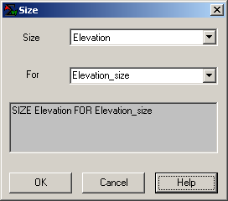 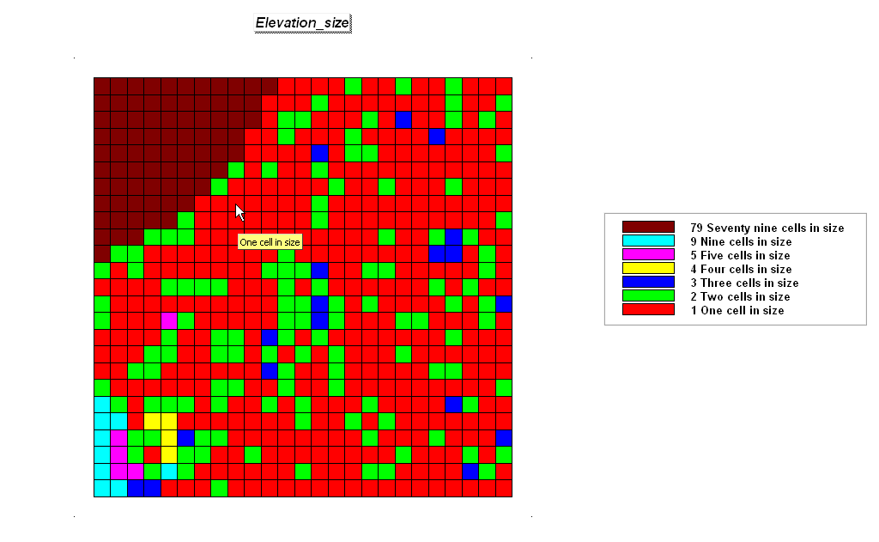 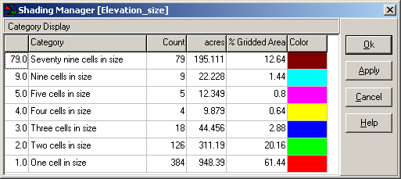 …identifies that “one cell in size” elevation values occur in 64% of the map area (384/1= 384 times; each value is unique). “Three cells in size” areas occur in 2.88% of the analysis window (18/3= 6 times; six sets of the same value). However, the “size map of Elevation” does identify a large group (79 cells in size) of constant elevation (flat) in the upper-left corner of the project area—corresponds to a portion of a lake.

Now on your own, complete the processing and write-up for the following commands in a manner similar to the above examples using the Tutor25.rgs database…

CLUMP Covertype AT 1 Diagonally FOR Coverclumps

insert screen grab(s) and discussion

SIZE Coverclumps FOR Coverclump_size

insert screen grab(s) and discussion

CONFIGURE Coverclumps Edges FOR Coverclump_edges

insert screen grab(s) and discussion

SLICE Elevation INTO 10 ZeroFill FOR Elev_contours

insert screen grab(s) and discussion

Part 3. Using Overlay Operations

Question 3. Using the Tutor25.rgs database, complete the following commands, embed the input and resultant maps and briefly explain how the algorithm calculated the result (interpret the map values generated). Be sure to comment on the display types you used and note the data types for both the input and resultant maps.

Display the Covertype map (with legend) for reference

insert screen grab and discussion

Display the Water map (with legend) for reference

insert screen grab and discussion

COMPUTE Covertype Times 10 FOR Covertype_10

insert screen grab(s) and discussion

CALCULATE Covertype_10 + Water FOR CW_code

insert screen grab(s) and discussion

CROSSTAB Covertype WITH Water Simply

insert screen grab(s) and discussion

INTERSECT Covertype WITH Water Completely FOR CW_intersect

insert screen grab(s) and discussion>

COVER Covertype_10 WITH Water IGNORE 0 FOR CW_covered

insert screen grab(s) and discussion

COMPOSITE Covertype WITH Slope Average IGNORE PMAP_NULL
FOR Covertype_avgSlope

insert screen grab(s) and discussion

Part 4. Implementing a Simple Habitat Model …to determine which locations are acceptable

Manual, Tutorials
Question 4. Complete the following three-part analysis of animal habitat and embed the maps you create implementing the exercise instructions as indicated below.

Access the MapCalc system using the Tutor25.rgs database, click on the “Grid Analysis” button, then enter the following commands using the “Reclassify” and “Overlay” classes of commands.

- Hugags like gentle slopes…
Display Slope
(Screen-grab the SLOPE map display, paste in the upper-right cell of the table below and resize to a 2-inch width)
(Map Analysisà Reclassifyà Renumber)
RENUMBER SLOPE FOR S_PREF ASSIGN 0 TO 30 THRU 1000 ASSIGN 1 TO 0 THRU 30
(Screen-grab the RENUMBER dialog box, paste in the top-center cell of the table below and resize to a 2-inch width)
Display S_PREF

- Screen-grab an appropriate display of the derived SLOPE map paying attention to Data Type, Display Type, Display Form, paste in the upper-left cell of the table below and then resize the graphic to a 2-inch width.
- Screen-grab the RENUMBER Command Dialog box, paste in the upper-middle cell and then resize to a 2-inch width.
- Screen-grab/paste/resize the S_PREF map in the upper-right cell.
- Insert an appropriate discussion for each of the screen-grabbed graphics in its corresponding box as indicated.

Embed the screen grabs and briefly describe the processing that took place making sure that you include reference to the input map(s), analytical operation and output map, as directed in the table blow…

insert screen-grab of SLOPE map | insert screen-grab of the RENUMBER dialog box | insert screen-grab of S_PREF
insert discussion of SLOPE map | insert RENUMBER discussion | insert discussion of S_PREF map

- Hugags like southerly aspects…
Display Aspect
(Map Analysisà Reclassifyà Renumber)
RENUMBER ASPECT ASSIGN 0 TO 1 THRU 9 ASSIGN 1 TO 3 THRU 7 FOR A_PREF
Display A_PREF

insert screen-grab of ASPECT | insert screen-grab of the RENUMBER dialog box | insert screen-grab of A_PREF
insert discussion of ASPECT | insert RENUMBER discussion | insert discussion of A_PREF

- Hugags like lower elevations…
Display Elevation
(Map Analysisà Reclassifyà Renumber)
RENUMBER ELEVATION ASSIGN 0 TO 1800 THRU 2500 ASSIGN 1 TO 500 THRU 1800 FOR E_PREF
Display E_PREF

insert screen-grab of ELEVATION | insert screen-grab of the RENUMBER dialog box | insert screen-grab of E_PREF
insert discussion of ELEVATION | insert RENUMBER discussion | insert discussion of E_PREF

- Now find areas meeting all three good habitat “preferences” (binary model)…

COMPUTE S_PREF TIMES A_PREF TIMES E_PREF FOR B_HABITAT
Display B_HABITAT

insert screen-grab of the COMPUTE dialog box | insert screen-grab of B_HABITAT
insert COMPUTE discussion | insert discussion of B_HABITAT

- Finally (whew!!!), on your own create and employ a Constraint map that eliminates potential habitat locations from your B_habitat map that occur in Open Water as identified on the Covertype map. Hint: a quick review of the Campground siting model’s Constraints Masking sub-model you implemented in Exercise #1 might be useful.

Insert screen grabs and discussion for this step…

Before you quit, save your listing of commands as a script so you can recall and modify it at a later date…Map Analysisà Scriptà Save As… and give it a name that will be unique (e.g., Tutor25_exer4_Bhabitat.scr) and place it in an appropriate folder (e.g., …\Week4). Also, save the current database …File→ Save As… and give it a name that will be unique (e.g., Tutor25_exer4.rgs) and place it in the same folder.

Insert screen grab of the script window and then briefly describe how a script works…

_________________________________

Note: Submit Optional question answers as separate Word document files with the Question number and your name (e.g., Optional_3-1_yourName.doc)…do not include them with the normal weekly lab reports.

Optional Question 3-1 (3 extra credit points possible; complete individually and submit your write-up of your experience as a separate email). Create a flowchart of the processing for the Binary Habitat model you implemented in Exercise #3,Part 4 above including the Constraint correction you did on your own. You can draw the flowchart in PowerPoint, capture it with SnagIt, and then embed the graphic as directed below (see guidelines graphic below). Be sure your flowchart identifies the data ranges for each of the maps involved in the processing.

With reference to your flowchart, write a short description of the simple Hugag habitat model you implemented as indicated below.

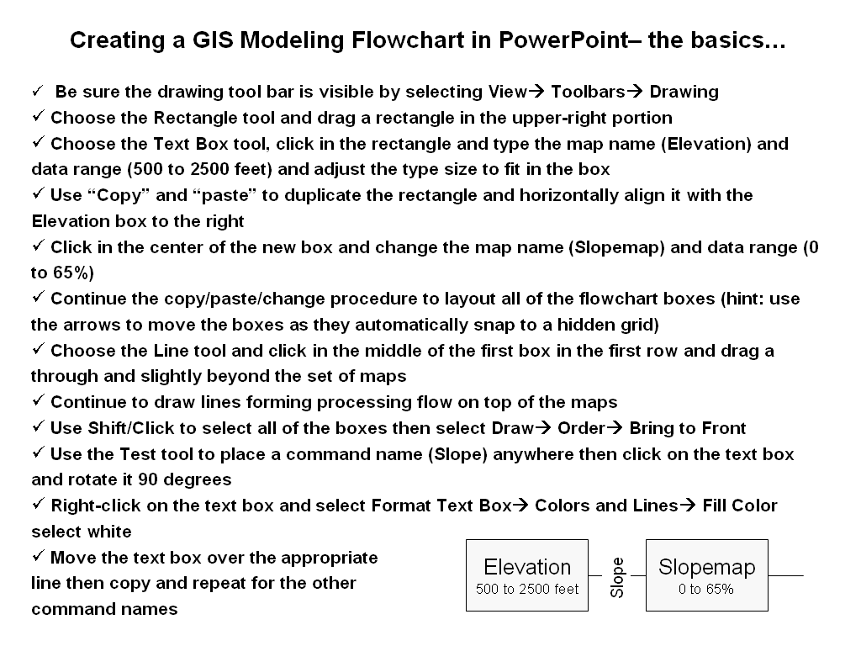

Insert your Flowchart below and briefly describe the important logical steps in the processing…

Optional Question 3-2 (3 extra credit points possible; complete individually and submit your write-up of your experience as a separate email). Generate “simply” and “completely” crosstab tables for the Roads and Covertype maps and interpret the information both reports contain.

Insert appropriate screen grabs and discussion…

Optional Question 3-3 (3 extra credit points possible; complete individually and submit your write-up of your experience as a separate email). Based on your accumulated GIS modeling expertise create a map of the average suitability rating (Avg_suitability_masked map) for each cover type parcel identified on the Covertype map in the Tutor25.rgs database.

Step 1) Embed side-by-side screen grabs of the dialog box of the command you used to identify “individual cover type parcels” and the individual cover type map generated. In your own words describe how the analysis operation you used works.

Embed the command, screen grab(s) and discuss your solution

Step 2) Embed side-by-side screen grabs of the dialog box of the command you used to calculate the “average suitability” for each parcel and the map generated that identifies the average suitability for each parcel. In your own words describe how the analysis operation you used works.

Embed the command, screen grab(s) and discuss your solution

Optional Question 3-4 (3 extra credit points possible). Develop, flowchart, implement using Tutor25.rgs database and prepare a brief report with embedded screen grabs of important intermediate maps and operations describing a GIS model that identifies the average wildfire fuel loading index for each district (Districts map) assuming—

Covertype Considerations (CC): forested areas= 9, meadow areas= 5 and open water areas= 0 (non-combustible);

Terrain Slope Considerations(SC): >35%= 9, 20-35%= 7, 10-20%= 4, 0-10%= 1; and,

Terrain Aspect Considerations(AC): South/Southwest= 9, West/Southeast= 7, East= 5, Northwest/Northeast= 3 North= 1.

The fuel loading index is calculated as [((.5 * CC) * (.3 * SC) * (.2 * AC)) / 1.556]

Insert appropriate screen grabs and discussion…

Optional Question 3-5 (3 extra credit points possible). Using Tutor25.rgs and the Composite command create maps that calculate the Average and Coefficient of Variation maps for the 200 foot contour polygons of Elevation. Display the three maps (Elevation, Elev_avg and Elev_coffvar) and screen-grab both the display and the corresponding Shading Manager table. Prepare a short discussion of the results and comment on how this added information compares with the traditional interpretation of a 2D contour paper map.

Insert appropriate screen grabs and discussion…

