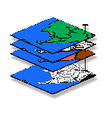
Exercise #2 — Maps As Data (MapCalc)
GIS Modeling, GEOG 3110, University of Denver

Team Members: _____<enter team member names >_____
Date: _____<enter date>______

Part 1. Understanding Basic Concepts and Terms

Question 1. Based on the lecture and readings briefly define and discuss the following concepts surrounding “the level of detail” in mapped data—

Map Scale— Insert your answer…

Spatial Resolution— Insert your answer…

Thematic Resolution— Insert your answer…

Minimum Mapping Resolution— Insert your answer…

Temporal Resolution— Insert your answer…

Comment on how mismatched scale/resolution in a set of maps can affect GIS analysis and modeling.

Insert your answer…

Question 2. Based on the lecture and readings briefly define and discuss the following map data types. Be sure your definitions include discussion of which terms refer to the numeric distribution and which refer to the geographic distribution of mapped data.

Nominal — Insert your answer…

Ordinal — Insert your answer…

Interval — Insert your answer…

Ratio — Insert your answer…

Binary — Insert your answer…

Choropleth — Insert your answer…

Isopleth — Insert your answer…

Access the MapCalc system using the Tutor25.rgs database.

Screen grab and insert below a 3-D lattice display of the Slope map.

Insert figure (don’t forget to include a Figure Number, a Caption and to Reference/discuss the figure in the text of your answer)…

What is the Data Type of the Slope map? ...what is its Display Type?…what is its Display Form? —

Insert your answer…

What is the interpretation of a terrain steepness of 0%? Insert your answer…

Is a location with a 20% slope twice as steep as a location with 10% slope? Insert your answer…

Why are there no negative slope values? Insert your answer…

Screen grab and insert below a 2-D grid display of the Districts map.

Insert figure (don’t forget to include a Figure Number, a Caption and to Reference/discuss the figure in the text of your answer)…

What is the Data Type of the Districts map? ...what is its Display Type?…what is its Display Form? —

Insert your answer…

Could you calculate a slope map from the discrete Districts map instead of the continuous Elevation surface? Insert your answer…

What, if any, would be the interpretation of its slope values? Insert your answer…

Part 2. Characterizing Geographic Space …Discrete versus Continuous

Access the MapCalc system using the Tutor25.rgs database and display a 2-D lattice contour plot of the Elevation map.

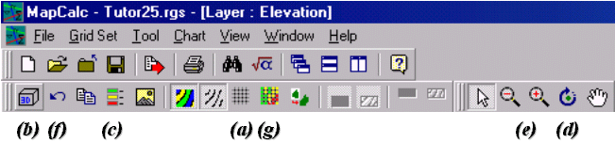 MapCalc Display Tools

Click on the Layer Mesh icon (a) to superimpose the 25x25 analysis grid.
Click on the Toggle 3-D View icon (b) to get a lattice (wireframe) plot of the map surface.
Click on the Shading Manager icon (c) to pop-up the thematic mapping window.

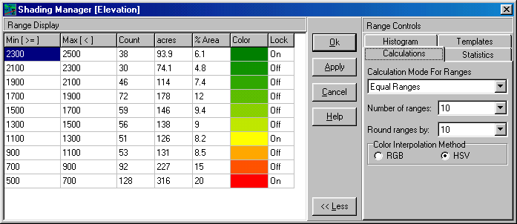 Shading Manager
Note that the current settings for “Calculation Mode for Ranges is Equal Ranges” and the “Number of Ranges is 10”

Assign the Calculation tab settings to Mode= Equal Ranges and Ranges= 7. Note the changes in pattern of the colored zones, then press OK. Cut/paste the results as a 2D continuous Lattice display into the table below (Question 3).

Just for fun (you are having fun, right?) and get an idea of some additional Display Control buttons…

- Click on the Rotate icon (d) then click and drag the plot to rotate the display.
- Click on the Zoom In/Out buttons (e) to rescale the plot.
- Click on the Reset View to Defaults icon (f) to return the plot to its standard form.
- Click on the Use Cells icon (g) to view the surface as an extruded plot.

Change the calculation tab settings to Mode= Equal Count and Ranges= 7. Note the changes in pattern of the colored zones, then press OK. Cut/paste the results as a 2D continuous Lattice display into the table below (Question 3).

Change the calculation tab settings to Mode= +/- 1 Standard Deviation and Ranges= 7. Note the changes in pattern of the colored zones, then press OK. Cut/paste the results as a 2D continuous Lattice display into the table below (Question 3).

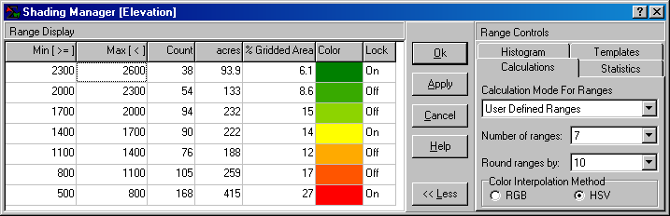
Change the calculation tab settings to Mode= User Defined and Ranges= 7. Under the Min [>=] column in the Shading Manager table enter the following values from the bottom to the top— 500, 800, 1100, 1400, 1700, 2000 and 2300. Under the Max [<] column enter 2600 at the top. Note the changes in pattern of the colored zones, then press OK. Cut/paste the results as a 2D continuous Lattice display into the table below (Question 3).

Question 3. Complete the table below (including Display and screen grabs you deem important to your discussion) of the “Thematic Mapping” processing you just completed. Include discussion of the Data Ranges and Cell Membership as reported in the Shading Manager table for each of the four categorizations (Equal Ranges, Equal Count,+/- 1 Standard Deviation and User Defined).

Insert your figures and write-up in the table below…

<insert 2D continuous Lattice map>  Figure 3-1. Equal Ranges calculation mode. | <insert 2D continuous Lattice map>  Figure 3-1. Equal Count calculation mode.
<insert Shading Manager table> | <insert Shading Manager table>
<insert your discussion> | <insert your discussion>

<insert 2D continuous Lattice map>  Figure 3-1. +/- Std Dev calculation mode. | <insert 2D continuous Lattice map>  Figure 3-1. User Defined calculation mode.
<insert Shading Manager table> | <insert Shading Manager table>
<insert your discussion> | <insert your discussion>

Which of the above four different thematic displays do you think “best represents” the map surface? Explain your reasoning.

Insert your answer…

Question 4. Repeat the process for your favorite method (Equal ranges, Equal Count or +/- 1 Standard Deviation) using Ranges= 5 for the number of intervals. Insert screen captures below as side-by-side displays for both the Ranges= 7 map (from above question) and the Ranges= 5 map you just generated.

<insert “Ranges 5” display> | <insert “Ranges 7” display>
<insert caption> | <insert caption>

Describe the differences in the two plots and discuss their impacts on the thematic display of the continuous surface data.

Insert your answer…

Part 3. GIS Modeling… Simple Erosion Model

Access the MapCalc system using the Tutor25.rgs database and on the Main Toolbar, click on the Grid Analysis icon, and use the map analysis tools to complete the following series of commands.

Click on the Slope icon (under the Neighbors button) and specify…

Map Analysis→ Neighbors → Slope

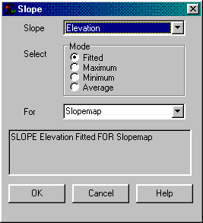 SLOPE Elevation Fitted FOR Slopemap

Note that the slope values form a gradient from 0% (flat) to 65% (steep) that is automatically “categorized” into seven intervals with colors “ramped” from Red to Yellow to Green.

Note that the default map display for the Slope command is continuous data type.

Click on the Renumber icon (under the Reclassify button) and specify…

Map Analysis→ Reclassify → Renumber

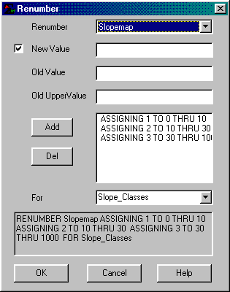 RENUMBER Slopemap ASSIGNING 1 TO 0 THRU 10 ASSIGNING 2 TO 10 THRU 30 ASSIGNING 3 TO 30 THRU 1000 FOR Slope_Classes

…by individually entering the “assigning” phrases (ASSIGNING <New Value> TO <Old value> THRU <Old UpperValue>) and pressing the “Add” button after each phrase is complete to add it to the list.

Note that the default map display for the Renumber command is discrete data type.

In displaying maps, be sure to set the most appropriate 2D or 3D display form, Grid or Lattice display type and Discrete or Continuous data type for a proper display of the data (not always the default display).

Click on the Drain icon (under the Distance button) and specify…

Map Analysis→ Distance → Drain

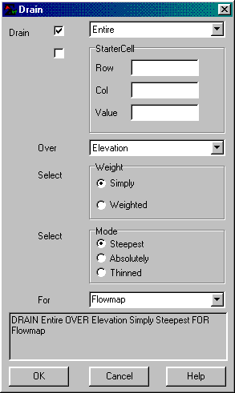 DRAIN Entire OVER Elevation FOR Flowmap

Note that the default map display for the Drain command is continuous data type.

Click on the Renumber icon (under the Reclassify button) and specify…

Map Analysis→ Reclassify → Renumber

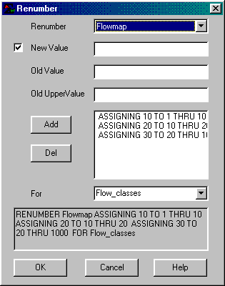 RENUMBER Flowmap ASSIGNING 10 TO 1 THRU 10 ASSIGNING 20 TO 10 THRU 20 ASSIGNING 30 TO 20 THRU 1000 FOR Flow_classes

Click on the Compute icon (under the Overlay button) and specify…

Map Analysis→ Overlay → Compute

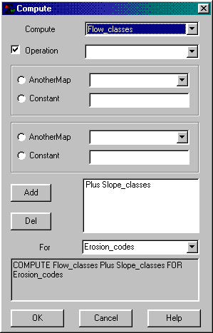 COMPUTE Flow_classes Plus Slope_classes FOR Erosion_codes

Note that the default map display for the Compute command is continuous data type.

Remember to switch to a “2D grid” display of the “discrete” data type for a proper display of categorical data (2-digit code).

The following flowchart outlines the steps you just completed…

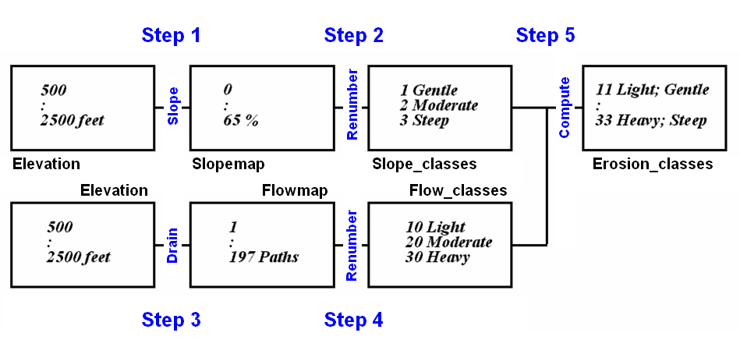

Question 5. Create a “narrative flowchart” with embedded maps displays that describes the five processing steps of the erosion model. For example, the first step description would include at a minimum—

Example answer for Step 1 in the Erosion Model flowchart…

Step 1. Derive a map of Terrain Steepness (Slopemap) using the command—

Slope Elevation for Slopemap

Note: Be sure you embed screen captures of the input map(s) (Elevation in this case) and output map (Slopemap) and include “Figure Title and Caption” with the all embedded screen grabs, such as…

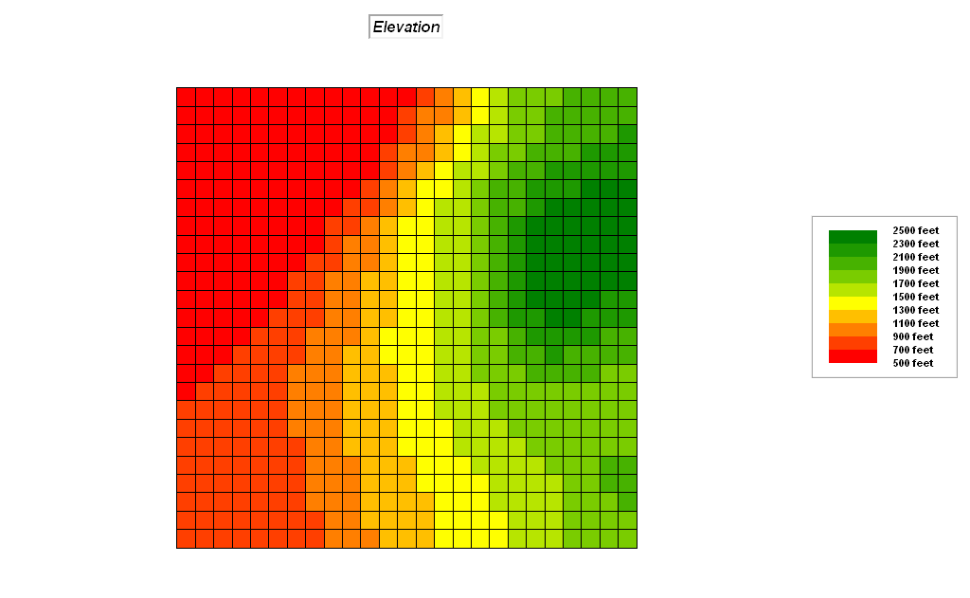 | 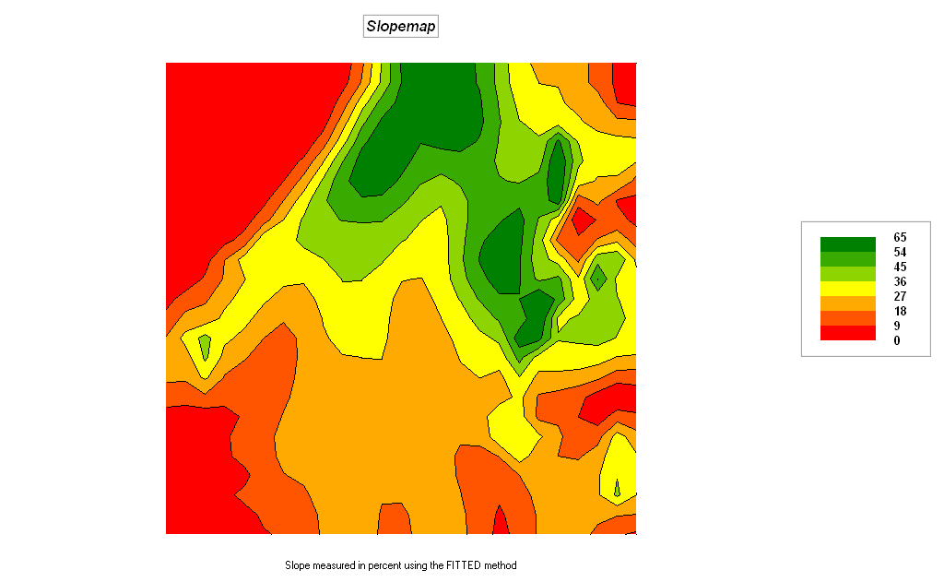
Figure 5-1. 2D Grid Display of the Elevation Map (input). | Figure 5-2. 2D Lattice Display of the Slopemap (output).

Note: Be sure your answer includes a short discussion of what is happening in the processing step. Be sure to reference the embedded figures and identify the display and data types of the maps, such as…

Figure 5-1 is a 2D grid display of the Elevation data (Base Map; figure 5-1) containing ratio data from 500 to 2500 feet. The terrain data is analyzed using the Slope command to create a Slopemap (Derived Map; figure 5-2) containing ratio data from 0% slope (flat) to 65% (steep). Note that the steepest terrain is located in the north-central portion of the project area (green tones).

Slope values for each cell are calculated using the eight neighbor cells, that is, a 3x3 window is used for each calculation. The value is applied as a percent, to the centroid of the center cell. The default procedure aligns a best-fitted plane to the values in the window, and assigns the slope of the plane to the center cell. The window then shifts over one cell and the process repeats. Other options use the maximum, minimum or average of the eight individual slopes in the slope window.

…Now on your own, repeat the descriptions for the other four Steps of the simple erosion model.

Step 2. Insert your answer for this step in a similar fashion as in the example above …

Step 3. Insert your answer for this step in a similar fashion as in the example …

Step 4. Insert your answer for this step in a similar fashion as in the example …

Step 5. Insert your answer in a similar fashion as the example for this step…

Question 6. Considering the combined categories of “Heavy_flow and Steep_terrain”, “Heavy_flow and Moderate_terrain” and “Moderate_flow and Steep_terrain on the Erosion_Classes map you just created, use the Shading Manager to graphically identify just these areas of significant erosion potential as Red and all other locations of lesser erosion potential as Light Gray. Embed a screen grab of your map and legend below.

Insert figure…

How many acres and proportion of the total study area falls under the significant erosion potential class (color= red)? Where do they mostly occur?

Insert your answer…

Use the sequence Map Analysis→ Reclassify→ Renumber to generate a map called High_erosion that isolates the areas of significant erosion potential (“Heavy_flow and Steep_terrain”, “Heavy_flow and Moderate_terrain” and “Moderate_flow and Steep_terrain) with the new value of 1 assigned to areas with significant erosion potential and new value of 0 assigned to all other areas. Embed a screen grab of your map and legend below.

Insert figure…

How many acres and proportion of the total study area falls under the significant erosion potential class (value= 1)? Where do they mostly occur?

Insert your answer…

Describe the “significant difference” between the Graphic (Shading Manager) and Numeric (Renumber) versions of the areas of high erosion potential.

_________________________________
Note: Submit Optional question answers as separate Word document files with the Question number and your name (e.g., Optional_2-1_yourName.doc)…do not include them with the normal weekly lab reports.

Optional Question 2-1 (extra credit= 3 points possible; complete individually and submit your answer as a separate email). Based on class discussion and your experience viewing the data structures/formats for MapCalc, Surfer and ESRI Grid describe the similarities/differences and advantages/disadvantages among the three approaches to storing grid-based mapped data. Use the Slope map in the Tutor25.rgs database (MapCalc_Tutor25_rgs.txt, SLOPE_Tutor25_Surfer_grd.txt and SLOPE_Tutor25_Esri_asc.txt in the …\MapCalc Data\Misc folder) for illustration and discussion similar to the slide set presentation used in class to describe the data structure/format of the Elevation map.

Insert your discussion with figures then email as separate file…

Optional Question 2-2 (extra credit= 3 points possible; complete individually and submit your answer as a separate email). Based on the class discussion and assigned, optional and other readings you may find, write a short essay (less than 750 words) discussing the differences in assumptions, approaches, and applications in Computer Mapping, Spatial Database Management and GIS Analysis/Modeling systems. Assume you have been asked to write the essay for a magazine like National Geographic with readers who have an interest and good but basic understanding of science. Your charge is the communicate the breadth of modern map analysis.

Insert your short essay…

Optional Question 2-3 (extra credit= 3 points possible; complete individually and submit your answer as a separate email). On your own, develop and implement an additional new criterion to the Campground Suitability model you completed in Exercise #1 that recognizes most campers want to be “within and near forested areas.”

Hint: the solution requires manually entering a series of commands similar to the criterion to be “close to roads,” however in this case using the Forests map (base map), proximity to forests (Derived map) to create a calibrated map (Interpreted map) such that 0 to 2 cells away is Most Preferred (rating= 9) and a preference gradient of your choice to 6 to 100 cells away as Least Preferred (rating= 1). Don’t forget to modify the Analyze command that computes the average rating for all criteria (now six individual rating maps), as well as “masking” for the constraints and user the same legend (Shading Manager settings) as before for the final map.

Insert the additional commands you used (e.g., SPREAD Forests NULLVALUE PMAP_NULL TO 100 Simply FOR Proximity_forests)…

Screen grab and then paste the display of your final “masked” map (Potential_masked2) below…

Insert figure…

Discuss the procedure you developed for favoring the location of the campground within or near forested areas. Be sure your answer 1) identifies the input map(s), processing operation and output map for each step, and 2) describes the interplay of the input and output map values at each step.

Insert your answer…

Optional Question 2-4 (extra credit= 3 points possible; complete individually and submit your answer as a separate email). Note: this optional exercise should only be undertaken by students with considerable previous experience with ArcGIS. Use the MapCalc cross-reference to Esri Grid commands available on the companion CD…



…and the ArcGIS Help (Spatial Analyst) in the GIS lab to complete the translation table below for the basic Campground Suitability Model you completed in Exercise #1. Be sure your answer addresses any disparities in the commands.

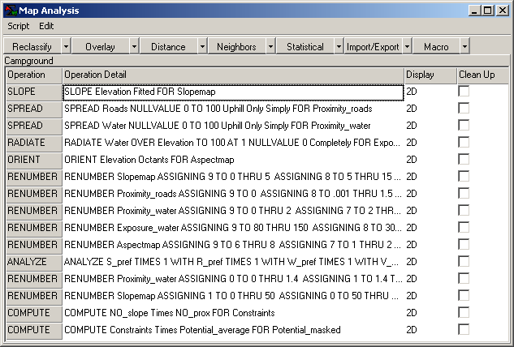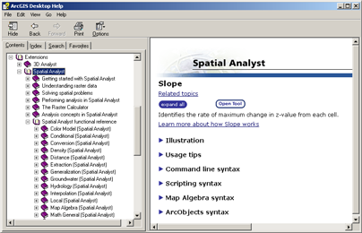

MapCalc  Command | Processing Achieved  …what information is derived | Esri Grid  Command
SLOPE Elevation… | Creates a map of terrain steepness expressed in percent inclination; input is a base map of Elevation; Esri SLOPE provides an option for output values to be in degrees as well as percent | SLOPE
SPREAD Roads…
SPREAD Water…
RADIATE Water…
ORIENT Elevation…
RENUMBER Slopemap…
RENUMBER Proximity_roads…
RENUMBER Proximity_water…
RENUMBER Exposure_water…
RENUMBER Aspectmap…
ANALYZE S_pref… | Calculates a weighted average of a “stack” of map layers; input is the set of derived campground preference layers calibrated from 1= least preferred through 9= most preferred; Esri WEIGHTED OVERLAY requires building a separate weighted overlay table | WEIGHTED OVERLAY
RENUMBER Proximity_water…
RENUMBER Slopemap…
COMPUTE N0_slope…
COMPUTE Constraints…

