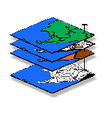
Optional Exercise #10 — Import/Export (MapCalc)
GIS Modeling, GEOG 3110, University of Denver

Name _____< name >_____
Date _____<enter date>______

Complete the exercise following the instructions and screen grab then embed results within the instructions as you deem appropriate to document and describe your experience.

Submit Optional question answers as separate Word document files with the Question number and your name (e.g., Optional_Ques10_1_Berry.doc).
_________________________________

Note: the special data for Optional Exercise #10 is available for download as a self-extracting zip file from the class website under the “Course Homework Assignments” section, “Week 10.”
Optional Question 10-1. Data Exchange (MapCalc). (5 extra credit points possible).
SESSION 1. Creating Your Own Database (Empty Map Set)
SESSION 2. Importing Data via Add New Layers
SESSION 3. Importing Data via the Map Analysis Tool
SESSION 4. Importing Data via the File Tool
SESSION 5. Exporting Data via Map Analysis Tool
SESSION 6. Exporting Data via File Tool
SESSION 7. Seamless Data Exchange with Surfer
SESSION 8. Seamless Data Exchange with MapInfo
_______________________________________________
SESSION 1. Creating Your Own Database (Empty Map Set)

Click on the Create a new file button or from the main MapCalc menu, select File→ New.

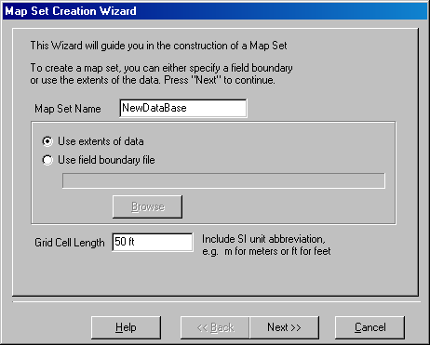 Specify a name for your new data base (e.g., NewDataBase) then press Next.

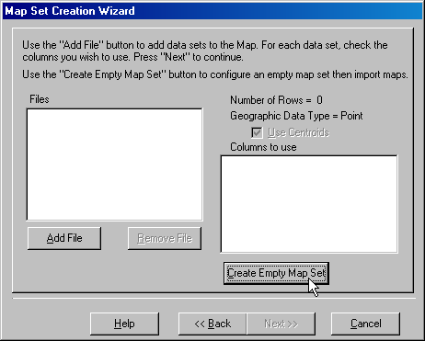 Click on Create Empty Map Set button to pop-up the Grid Parameters dialog box.

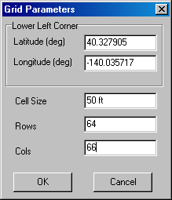 Specify the Latitude and Longitude of the lower-left corner of the analysis grid (e.g., Lat= 40.327905, Lon= -140.035717). Note: MapCalc Evaluation and Learner versions require Lat/Lon WGS84 datum. Academic and Professional versions accept data in a variety of geographic references.

Enter the Cell Size (e.g., 50 feet) and the number of Rows and Columns comprising the analysis grid area (e.g., 64 rows and 66 columns). Click OK to create the empty database.

Data can be entered into the new MapCalc database via several import procedures (see below).

Note: The MapCalc Evaluation and Learner versions can configure analysis grids up to 100 rows by 100 columns. Grid configuration for MapCalc Academic and Professional versions are not software limited but storage and processing requirements are exponential. Interactive processing of grids larger than 500 x 500 is not recommended—use batch process through scripts for large grid configurations.

SESSION 2. Importing Data via Add New Layers

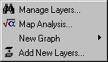 To import an ESRI .shp or MapInfo .tab polygon file, select Map Set→ Add New Layers to pop-up the Adding New Layers wizard.

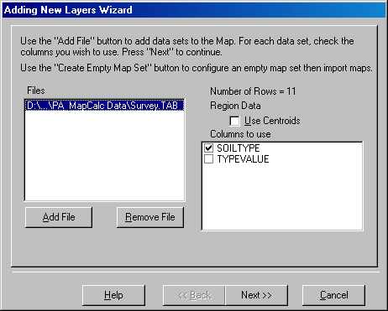 Press the Add File button and specify a file (e.g., Survey.tab), select the data column(s) to use (e.g., SOILTYPE) and click Next. Click Finish to create the map.

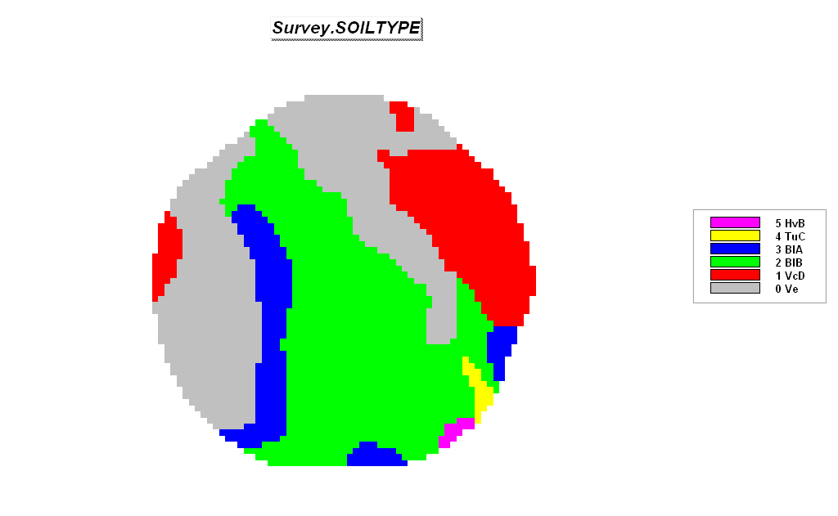
Imported Soil Survey Map from a MapInfo .tab file

If you have a field boundary map in .shp or .tab format you can use it to directly derive the database configuration. Instead of creating an Empty Map Set (section SESSION 1, step 2) press the Add New Layers button as described above. The Latitude and Longitude coordinates will be automatically assigned based on the extent of the boundary file.

SESSION 3. Importing Data via the Map Analysis Tool

Importing data via the Map Analysis tool accepts grid files for individual maps in three standard formats—

Bare Bare ASCII matrix of values, row major order
Grid Grid ASCII format (ESRI Software)
Surfer Surfer ASCII format (Golden Software)

…See section SESSION 5, Exporting Data via Map Analysis Tool for descriptions of these standard grid file formats.

The grid files must have the same configuration as the active database-- #Rows, #Columns, Cell Size and lower-left Registration Coordinates.

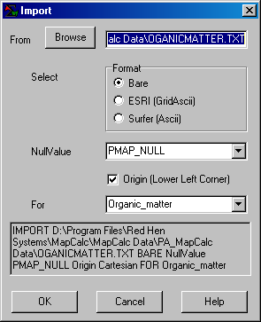 For example, add data in Bare format to the NewDataBase (see SESSION 1 above) by entering Map Analysis→ Import and completing the Import dialog box as—ORGANICMATTER.TXT, Bare, Organic_matter.

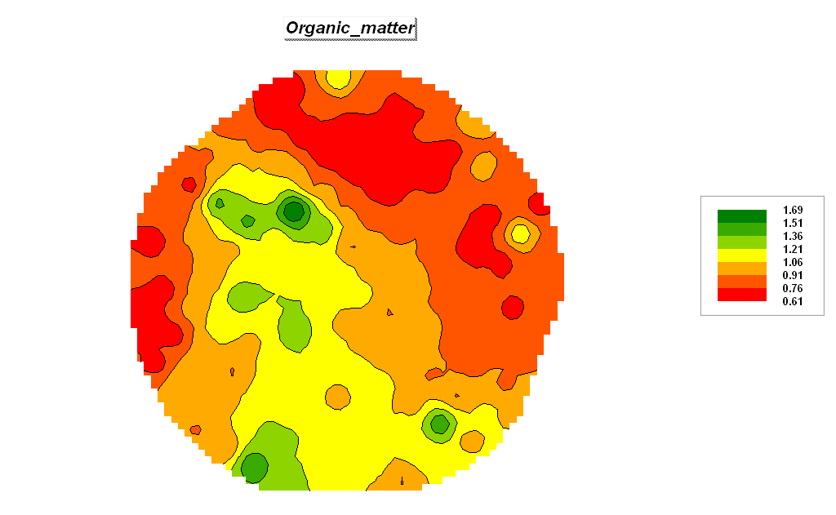
Imported Organic Matter data Map from a Bare matrix (.txt)

SESSION 4. Importing Data via the File Tool

Importing data via the File tool accepts grid files for individual maps in four standard formats—

Bare Bare ASCII matrix of values, row major order
Grid Grid ASCII format (ESRI Software)
Surfer Surfer ASCII format (Golden Software)
MIG Binary Grid format (MapInfo)

…See section SESSION 5, Exporting Data via Map Analysis Tool for descriptions of these standard grid file formats.

The grid files must have the same configuration as the active database-- #Rows, #Columns, Cell Size and lower-left Registration Coordinates.

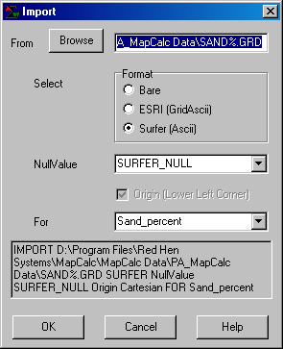 For example, add data in Surfer format to the NewDataBase (see section SESSION 1 above) by entering File→ Import→ and completing the Import dialog boxes as shown—%SAND.grd, Surfer (Ascii), Sand_percent.

SESSION 5. Exporting Data via Map Analysis Tool

Exporting data via the Map Analysis tool creates a grid file for individual maps in four standard formats—

Point Column, Row, Value (nulls skipped)
Grid Grid ASCII format (ESRI)
Bare Bare ASCII matrix of values, row major order
Surfer Surfer ASCII format (Golden Software)

Select Map Analysis→ Import/Export→ Export to pop-up the Export dialog box.

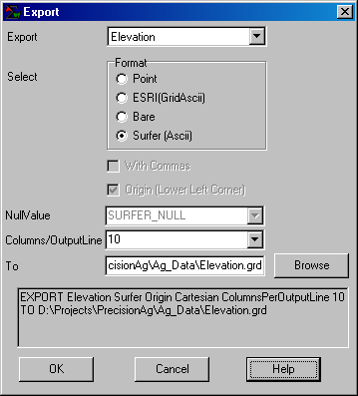 Select the Elevation map, specify Surfer (Ascii) and Browse/Name the file for export (Elevation.grd). Press OK to create the file.

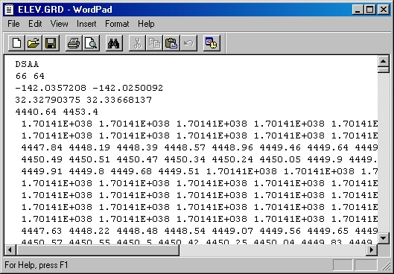 The file generated is a standard text file and can be viewed using any word processing package.

Export formats in the Map Analysis tool include Point (each record contains a Column Row Value triplet), Bare (each record contains all of the values for one row of the grid starting at the top left corner), Surfer GS Ascii and ESRI GridAscii that include header lines with the matrix of data (see below).

Bare Ascii no header lines—

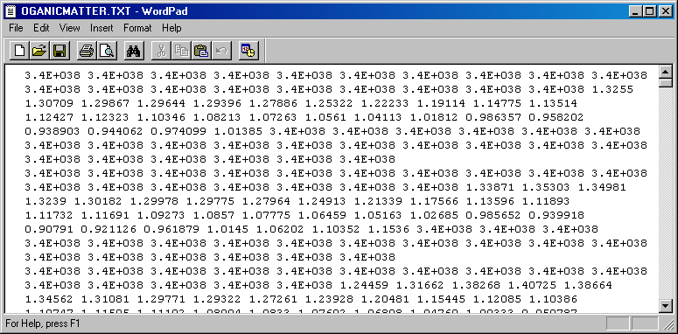

…Data separated by spaces and organized as rows in row-major matrix—contains no geo-referencing information. File must contain a value for each cell location ordered left to right, top to bottom.

Surfer GS Ascii five header lines—
DSAA (ASCII)
66 64 (NCOLS NROWS)
-142.0357208 -142.0250092 (LON Low/High)
32.32790375 32.33668137 (LAT Low/High)
4440.64 4453.4 (Z Low/High)
…Data separated by spaces and organized as rows in row-major matrix (see Bare above)

ESRI GridAscii six header lines—
NCOLS 66
NROWS 64
XLLCORNER -142.0357208 (LON)
YLLCORNER 32.32790375 (LAT)
CELLSIZE 0.000162298
NODATA_VALUE 3.4E+038
…Data separated by spaces and organized as rows in row-major matrix (see Bare above)

SESSION 6. Exporting Data via File Tool

From the Main Menu select File → Export → Data to access the wizard for exchanging data.

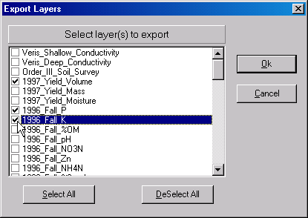 Press the DeSelect All button then click on the boxes next to the 1997_Yield_Volume, 1997_Fall_P and 1997_Fall_K map layers. Press OK to begin the export.

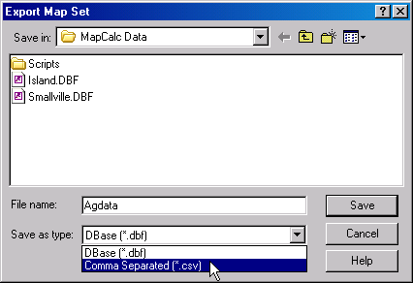 Specify “CSV” as the type and Save the file. This procedure stores the file in the default data folder.

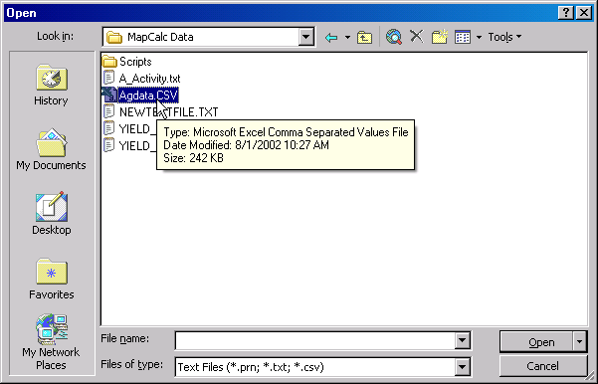 Access Excel by clicking on Start → Programs → Microsoft Excel → File → Open → browse to the …\MapCalc Data\ folder → specify Text Files (*.prn, *.txt, *.csv) as the file type → click on the AgData.csv file → and press the Open button.

The exported file containing the specified map layers will be opened in Excel.

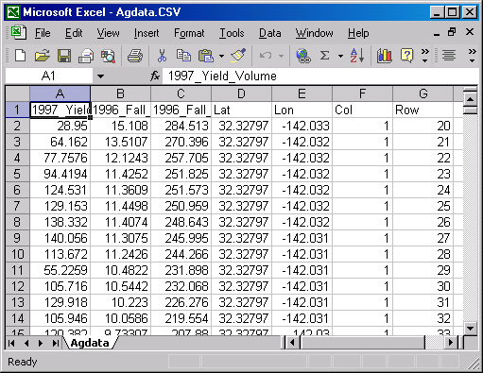

In addition to .CVS format, there are several other standard export formats—

.DBF supports most spreadsheet and database software
.TAB supports MapInfo desktop mapping software
.SHP supports ArcView desktop mapping software
.ACS supports Spatial Analyst software
.GRD supports Surfer software (GS ASCII).

SESSION 7. Seamless Data Exchange with Surfer

Select File→ Export→ Send to Surfer→ Wireframe to automatically transfer the data and launch Surfer provided it is installed on your computer…

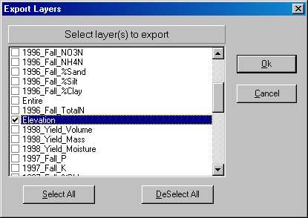 Press the Deselect button, then check the Elevation map and press OK.

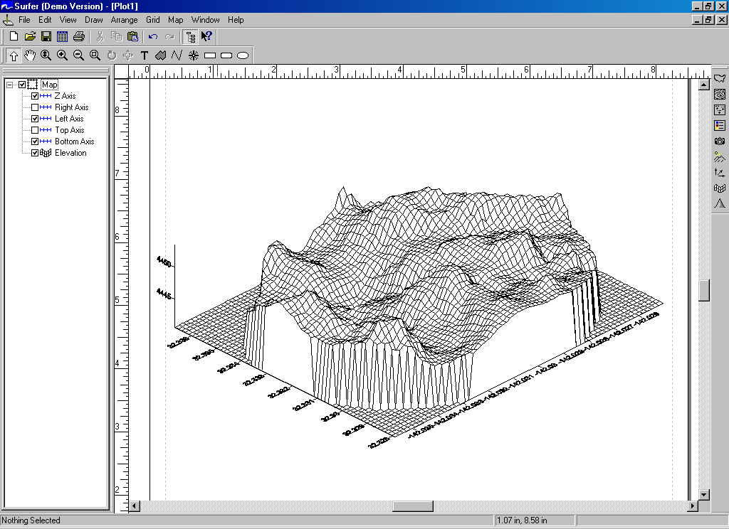

Surfer will be executed and the Elevation data automatically transferred.

SESSION 8. Seamless Data Exchange with MapInfo

Select File→ Export→ Send to MapInfo→ Wireframe to automatically transfer the data and launch Surfer provided it is installed on your computer…

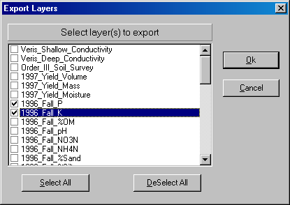 Press the Deselect button, then check the 1996_Fall_P and 1996_Fall_K maps. Press OK.

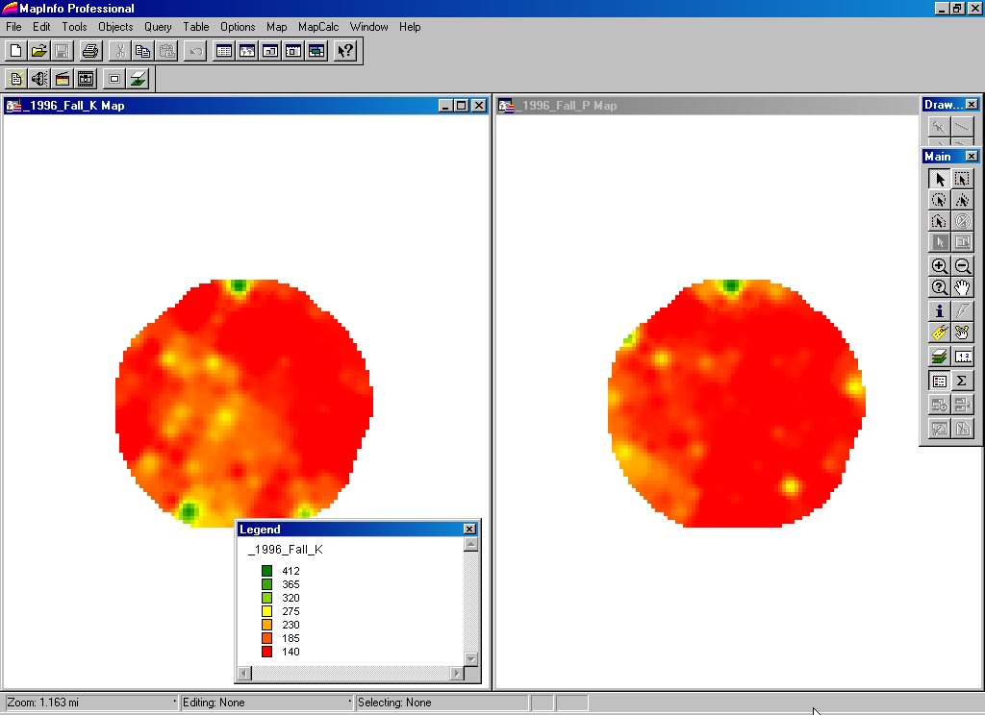

_________________________________________

Optional Question 10-2. MapCalc Spatial Interpolation. (3 extra credit points possible).

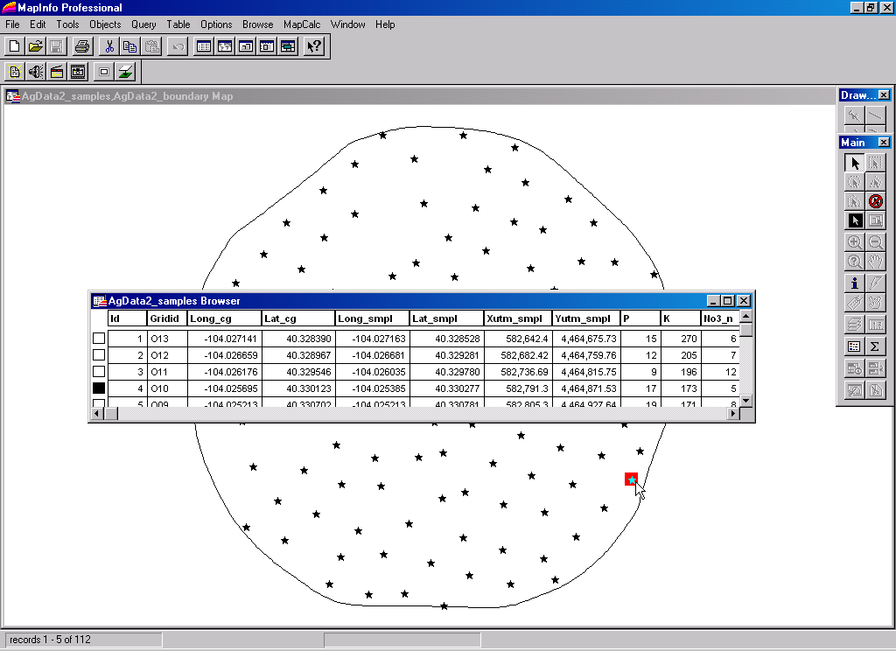 Point Samples (MapInfo)
Note: point data for interpolation must be in either ESRI (.shp) or MapInfo (.tab) format.

Step 1. The first step in the Interpolation Wizard identifies the Name of the new data set, the Extent (boundary) and the Gridding Resolution (cell size).

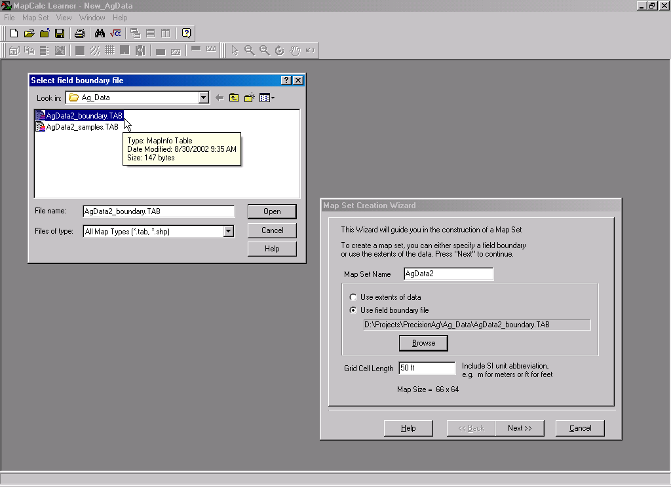 Interpolation Wizard Step 1

- Enter the new map set name as AgData2
- Select Use Field Boundary File, browse to the MapCalc Data folder and specify AgData2_boundary.tab
- Specify the Grid Cell Size as 50 feet
- Press the Next button.

Step 2. The second step identifies the point sampled data you want to map (P <phosphorous>, K <potassium>, NO3_N <nitrogen>). These specifications identify the “data fields” (columns) in the sample data table that will be used—the X,Y (Longitude, Latitude) positions each data point and the measured value reports the results of chemical analysis for each soil sample.

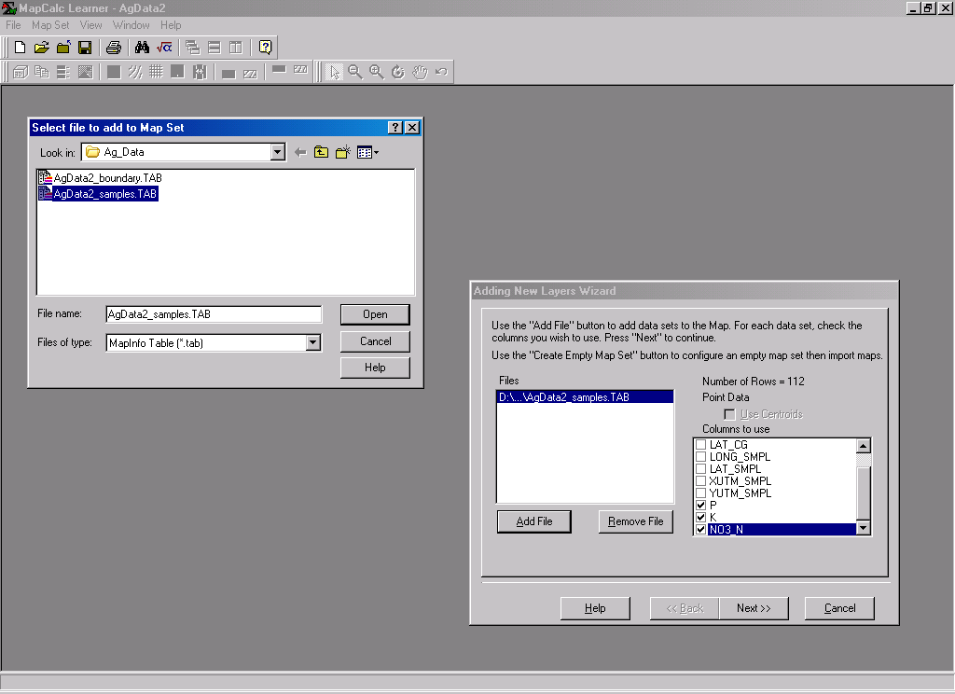 Interpolation Wizard Step 2
Note: The data must be in lat/Lon WGS84 projection for the MapCalc Learner version. MapCalc Academic and Professional versions contains projection conversion.

- Press the Add File button and browse to the AgData2_samples.tab table containing the sample data
- Check the P, K and NO3_N as the Columns to use at the bottom of the listing
- Press the Next button.

Step 3. The final step specifies the interpolation technique and appropriate parameters to use.

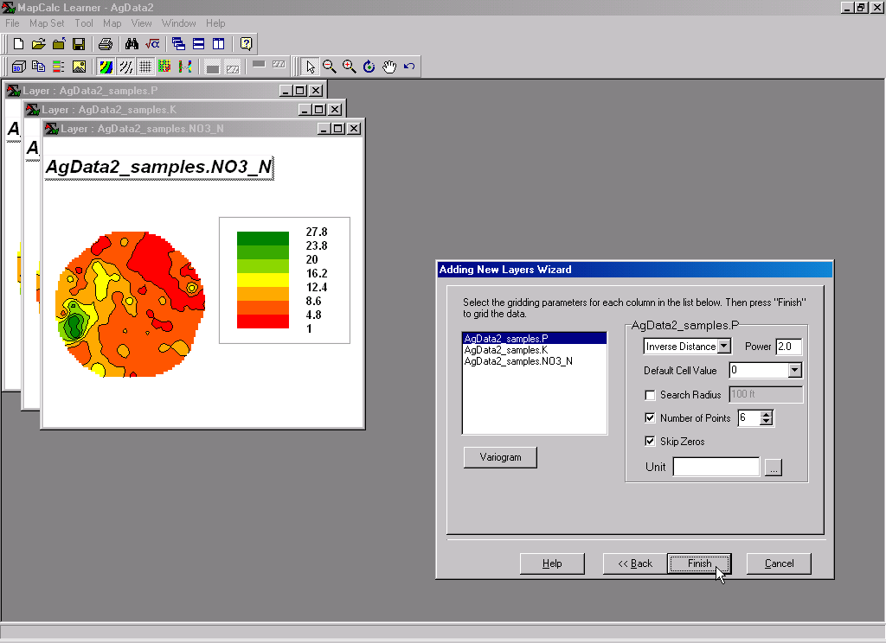 Interpolation Wizard Step 3

- Press the Finish button to interpolate the three maps using the default Inverse Distance Square technique and parameters.

Use the Tile Vertically button to generate side-by-side displays of all three maps.

