
Exercise #1 — Dissecting a Suitability Model (MapCalc)
GIS Modeling, GEOG 3110, University of Denver

Team Members: _____<enter team member names >_____
Date: _____<enter date>______

Part 1. Become familiar with the MapCalc Tutorials and MapCalc User’s Guide posted on the class websites.

The MapCalc User’s Guide are available online for download and printed copies in the lab. Through the class exercises you will be learning all of the material in the MapCalc Tutorials (and much more). However, if you want to get a jump on the operation of the software (and a few extra credit points) you might work through the tutorials on your own (see Optional Exercise 1-1 at the end of this exercise).

In completing this exercise, you might find the Application Example entitled “Identifying Campground Suitability” helpful. To access this example, go to the online version of the “Application Examples” and then click on the Identifying Campground Suitability item…

Identifying Campground Suitability <click for Internet link>: A recreation specialist needs to generate a map that identifies the relative suitability for locating a campground. In an initial planning session it was determined that the best locations for the campground is on gently sloping terrain, near existing roads, near flowing water, with good views of surface water and oriented toward the west. (Matches Tutorial Lesson 7; uses MapCalc Learner Tutor25.rgs database)

Part 2. Downloading Exercise Documents

Download the Exercise #1 homework template (Exer1.doc) by…

- Accessing the class web site at…
http://www.innovativegis.com/basis/Courses/GMcourse12/

- Under the “Course Homework Assignments” section, right-click on “Overview” link in the line
Week 1 – Overview [Exer1.doc - Dissecting a suitability model (MapCalc)]

- Specify your personal workspace as the folder for saving the Exer1.doc file.

- Open the document in Word and enter your answers after each question.

- After collaborating with your team members and editing/refining/enhancing/finalizing a joint report, submit one copy with all team members names (e.g., (e.g., Exer1_Johnson_Smith_Jones.doc) and email the completed exercise as an attachment to jberry@innovativegis.com.

Completing the Exercise. Each exercise consists of a series of map analysis steps that you will enter. The early exercises explicitly describe the processing and command sequences (Exercises 1 and 2) and progress to questions that require you to formulate your own solutions (Exercise 6, Mini-project). In the following exercise you will execute a stored script that evaluates a Campground Suitability model. Your write-up will demonstrate your understanding of processing steps.

Grading Criteria. The team report must be well organized, professionally prepared (be sure Spelling and Grammar tools in Word are turned on), clearly presented and containing answers that are concise and succinct. An “A” report must contain discussion that goes beyond simply answering the questions …demonstration of comprehension beyond the mechanics and basic understanding of the main points in the exercise. The completed reports are professional documents, not a terse lab notes.

Part 3. Dissecting a Suitability Model’s “Logic”

Identifying Campground Suitability — a recreation specialist needs to generate a map that identifies the relative suitability for locating a campground at every location in a project area. In an initial planning session it was determined that the best locations for the campground is on gently sloping terrain, near existing roads, near flowing water, with good views of surface water and oriented toward the west.

Question 1. Based on class discussion and readings, list and briefly describe the five Model CRITERIA used to determine Campground Suitability model (sub-models identified as rows in the flowchart).

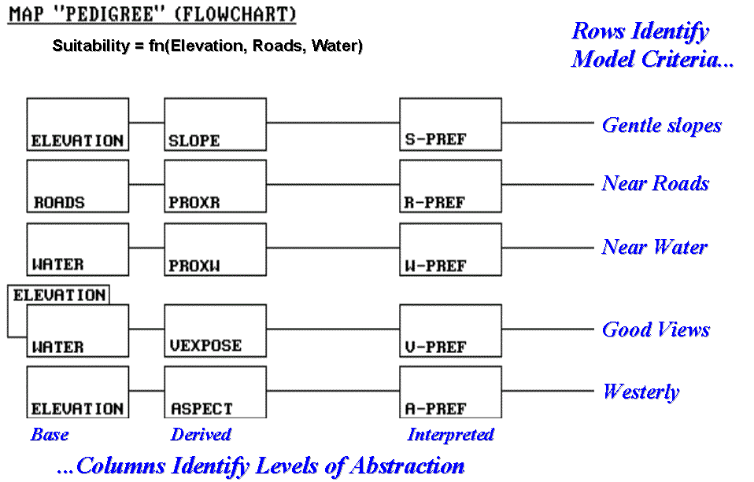

Insert your answer…

Suggest and briefly describe two additional spatial criteria that might be added to extend the model’s logic.

Insert your answer…

Question 2. Based on class discussion identify and briefly discuss the four Analysis LEVELS comprising the Campground Suitability model (identified as columns in the flowchart).

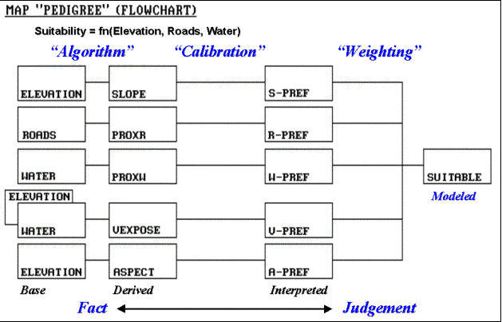

Insert your answer…

Suggest how you might “empirically evaluate” the results of the Derived maps (i.e., confirm that the derived values are “reasonable” estimates). Extended discussion might include the difference between model results Verification versus Validation.

Insert your answer…

Part 4. Executing the Tutor25_Campground.scr Script. Access MapCalc using the Tutor25.rgs database in your personal workspace folder—

Display each of the Base Maps in the Campground model by…
- From the Main Tool Bar, click on the Manage Layers button then choose the name of a base map (Elevation; Roads; Water).
- Double-click on a base map’s legend to pop-up its complete Shading Manger table and note the relative proportion of each map category.

Open the Campground Suitability script by…
- From the Main Tool Bar, click on the Map Analysis button.
- From the Map Analysis Menu select ScriptàOpen and specify “Tutor25_Campground.scr” in the …\MapCalc Data\Scripts\ folder.

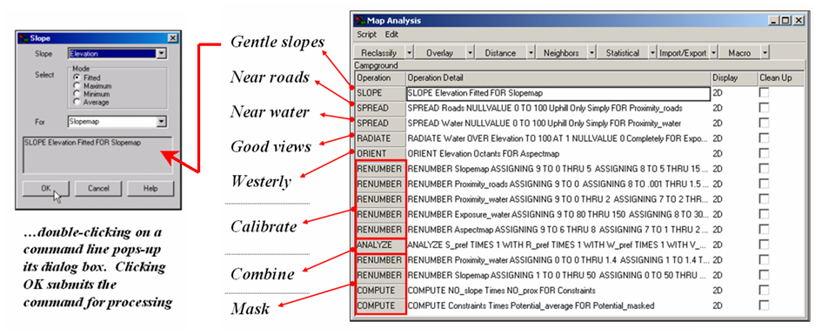

The following questions link the processing flowchart (model logic) to its implementation using the Tutor25.rgs database (command script).

Question 3. Complete the following table identifying the base map(s), analytical operation used and the information contained in each of the five "derived maps” used in modeling campground suitability. Dissection of the first derived map command “SLOPE Elevation Fitted FOR Slopemap” is shown.

Base  Map(s) | Analytical Operation | Derived  Map | Information  Contained
Elevation | Slope | Slopemap | Relative terrain steepness expressed as “percent slope” is assigned to each grid cell; minimum value on the map is 0% (flat) and the maximum value is 65% (steep); the steepest locations are in the north central portion of the project area
Roads | Spread | Proximity_roads

Question 4. Complete the following table summarizing the calibration step for interpreting the relative preference for a campground of the categories on each of the “derived” map layers.

Derived  Map | Analytical Operation | Calibration Assignments | Preference  Map
Slopemap | Renumber | Assigning 9 (Most Preferred) to 0 through 5 …gentle  Assigning 8 to 5 through 15  Assigning 5 to 15 through 25 …moderate slopes  Assigning 3 to 25 through 40  Assigning 1 (Least Preferred) to 40 through 100 …steep | S_pref
Proximity_roads | Renumber |  | R_pref

Question 5. Explain what processing is achieved in the following command. Be sure your discussion identifies the input maps, output map and processing options employed. Also, discuss its place in the overall Suitability Model processing flow (analysis Levels).

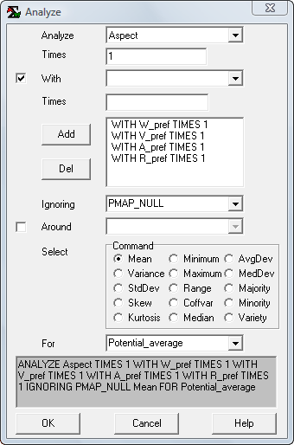 ANALYZE Aspect TIMES 1 WITH W_pref TIMES 1 WITH V_pref TIMES 1 WITH A_pref TIMES 1 WITH R_pref TIMES 1 IGNORING PMAP_NULL Mean FOR Potential_average

Insert your answer…

Question 6. Explain the use of the “masking” procedure that eliminates open water (too wet) and very large slopes (too steep) as “impossible places” for a campground.

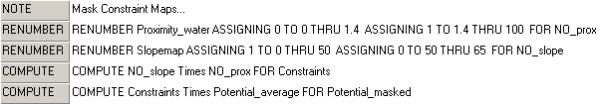

Be sure your answer 1) identifies the input map(s), processing operation and output map for each of the four steps, and 2) describes the interplay of the input and output map values.

Insert your answer…

Question 7. Use the Shading Manager to modify the legend of the overall suitability map (Potential_masked) as described below…

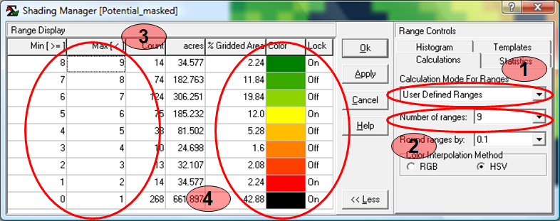

Access the Shading Manager while the Potential_masked map is active (displayed with blue Windows top strip) by clicking on the Shading Manager button or by double-clicking on the legend of the map display, and then…
- Set the Calculation Mode to “User Defined ranges.”
- Set the Number of ranges to “9.”
- Enter the cutoffs for each category range by clicking on the “Min” column value and entering the lower range values of 0, 4, 5, 6, 7 and 8. Click on the top value of the “Max” column and enter 9.
- Click on the Color for range 0 to 1 set to black; range 1 to 2 set to dark red; range 5 to 6 set to yellow; and range 8 to 9 set to dark green. Insure that the Toggle On/Off for the color Lock matches the sequence shown above.
…press “OK” to display the overall suitability map using the new settings.

Use SnagIt to screen grab and then paste the display of the final “masked” map (Potential_masked) below…

Insert figure…

Briefly describe spatial distribution (pattern) of the relative campground suitability you see …generally where are the best and worst locations? Comment on any inconsistencies you see.

Insert your answer…

_________________________________
Note: Submit Optional question answers as separate Word document files with the Question number and your name (e.g., Optional_1-1_yourName.doc)…do not include them with the normal weekly lab reports. You can complete optional questions anytime during the term, including finals week.

Optional Question 1-1 (extra credit= 3 points possible for completing all six lessons; complete the report individually (not in a team) and submit your write-up of your experience as a separate email).

There are several tutorials on the companion CD at…
\MapCalc_learner\MC_Tutorials\MapCalc_tutorial.pdf

…or accessed from the Class Webpage via the Internet or from the Class Folder in the GIS lab.

Lesson 1 – Displaying Maps
Lesson 2 – Understanding Data Types
Lesson 3 – Using the Shading Manager
Lesson 4 – Setting Map Properties
Lesson 5 – Data Inspection and Charting
Lesson 6 – Creating New Maps

Complete the set of tutorials and create your own summary that explains, illustrates and elaborates on the more important things you leaned from each of the tutorial lessons.

Insert your Lesson 1 summary…

Insert your Lesson 2 summary…

Insert your Lesson 3 summary…

Insert your Lesson 4 summary…

Insert your Lesson 5 summary…

Insert your Lesson 6 summary…

Optional Question 1-2 (extra credit= 3 points possible). Using the online cross-reference to ESRI Grid/ Spatial Analyst commands (http://www.innovativegis.com/basis/MapCalc/MCcross_ref.htm), complete the following table identifying corresponding ESRI commands and comment on the similarities and differences in the command capabilities, procedures and options based on the user manual/help information for both systems.

MapCalc  Command | Grid/Spatial Analyst  Command | Comments
Slope
Spread
Radiate
Renumber
Analyze
Compute

Prepare a succinct outline and short summary describing the conceptual organization of the Spatial Analyst commands in a similar manner as the organizational structure ingrained in MapCalc’s Framework you will experience in this class—

MapCalc Classes of Analytic Operations:

- Spatial Analysis
- Reclassify (Position, Initial Value, Size, Shape, and Contiguity)
- Overlay (Location-specific, Region-wide)
- Distance (Distance, Proximity, Movement, Optical Path Connectivity, Visual Conncetivity)
- Neighbors (Characterizing Surface Configuration, Summarizing Values)

- Spatial Statistics
- Surface Modeling (Density Analysis, Spatial Interpolation, Map Generalization)
- Spatial Data Mining (Descriptive, Predictive, Prescriptive)

