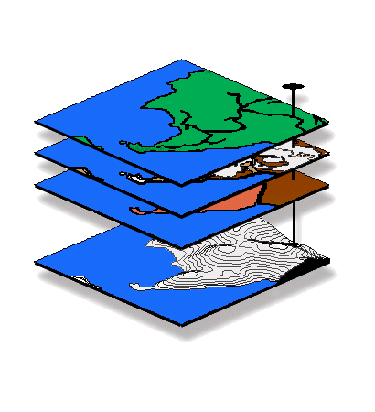
Introduction to GIS Modeling
…an introductory course in grid-based map analysis

GEOG 3110, University of Denver

Midterm Exam

This exam is a 2.5-hour, CLOSED BOOK/NOTES affair taken over the Internet (honor system) — at your convenience anytime after 8:00 am, Friday, February 11 and must be completed by 5:00 pm, Wednesday, February 16th. You will download the exam (time/date stamped at our class website) and submit the completed document within 2.5 hours via email to jberry@innovativegis.com.

BE SURE to save your completed Word file as Exam1<your name>.doc before you exit and email as an attachment!!!

Name _<enter name>___________________

Date _<enter date>______ Time started _<time>_____ Time completed _<time>____

Part I (50 total points possible) — Choose ONLY five of the following seven 10-point questions on “Terminology, Procedures and Basic Concepts” (i.e., do not answer two). Enter your answers in the space provided below each question.

Question 1. (10 points). Briefly explain the difference between the following pairs of terms—

Traditional GIS and Spatial Analysis—

Traditional Statistics and Spatial Statistics—

Question 2. (10 points). Define and briefly describe the differences among the following distance terms.

a) Simple Distance—

b) Simple Proximity—

c) Effective Proximity—

d) Optimal Path—

e) Optimal Path Density—

Question 3. (10 points). What is the distinction between a discrete “map” and a continuous “map surface.” Be sure to discuss the differences in terms of numerical and geographic data type, as well as displayed map appearance.

Question 4. (10 points). Identify and discuss the three fundamental “types of map features” used in desktop mapping (vector-based systems).

Identify and discuss the fourth type that is extensively used in GIS modeling (grid-based systems)?

Question 5. (10 points). Identify and briefly describe the differences in information contained in the following types of visibility maps:

Simple Viewshed—

Visual Exposure Density Surface—

Weighted Visual Exposure Density Surface—

Net-Weighted Visual Exposure Density Surface—

Question 6. (10 points). Contrast the concepts of “simple buffer distance” (vector analysis) and an “effective proximity buffer” (grid-based analysis). Be sure your answer includes a brief discussion of “absolute” and “relative” barriers effect on movement.

Question 7. (10 points). Explain the contention that “map scale” does not exist in a GIS. Briefly discuss the concept of “resolution” as a more appropriate concept for use with digital maps.

Part II — Choose ONLY one of the following three 50-point questions on “How Things Work” (i.e., do not answer two).

Question 8. (50 points). Referring to the following diagram, which points (B,C and/or D) can be seen from point A? …given 1) that the elevation values (in meters) are indicated in the upper portion of each cell, 2), grid cell size is 100 meters, and 3) that the square root of 2 is 1.414. Expand you answer to include a brief discussion how this procedure is used in viewshed and visual exposure analysis.

Show your calculations and answers in the spaces provided below.

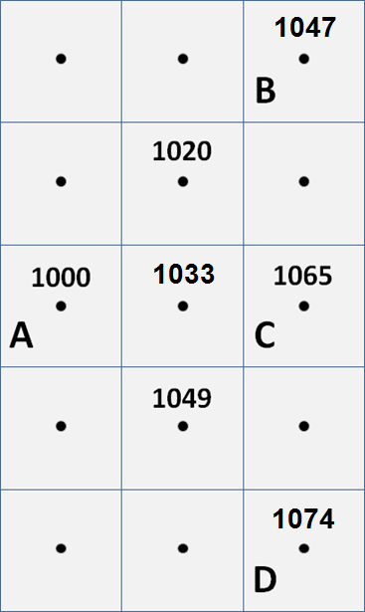

Visual connectivity calculations = <show your calculations here>

A to B = __<seen or not seen>__

A to C = __<seen or not seen>__

A to D = __<seen or not seen>__

Brief discussion how this procedure is used in Viewshed and visual exposure analysis—

Question 9. (50 points). Define “narrowness” (MapCalc Span command) and describe how a narrowness value is computed for a location within a map feature, such as a meadow. Be sure your answer defines discusses the concept of the “shortest cord.”

Question 10. (50 points). What is the maximum, minimum and average slope (center to eight adjacent neighbors) for the 3x3 window composed of elevation values shown below, given 1) that the elevation values (in meters) are indicated in the upper portion of each cell, 2) that the grid cell size is 100 meters, and 3) that the square root of 2 is 1.414? Expand you answer to include a very brief discussion how this procedure could be used in applications other than terrain analysis.

Show your calculations and answers in the spaces provided below.

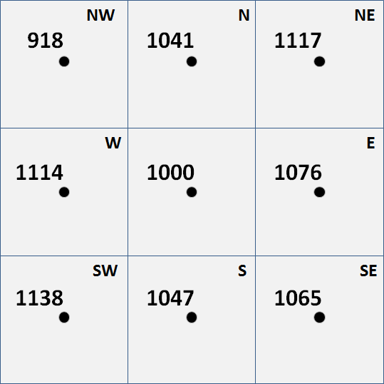

Slope calculations = <show your calculations here>

Maximum slope = __<calculated value>__ __<cell ID>__

Minimum slope = __<calculated value>__ __<cell ID>__

Average slope = __<calculated value>__ __<cell ID>__

Brief discussion how this procedure could be used in applications other than terrain analysis—

Part III — Choose ONLY one of the following three 50-point questions on “Mini-Exercises” (i.e., do not answer two).

Question 11. (50 points). Given base maps of Roads and Covertype (Tutor25.rgs database) generate a map that assigns a proximity to roads value for just the forested locations.

Note: use MapCalc and SnagIt to capture and embed your solution below; be sure you identify the command and briefly discuss the processing for each step in your solution.

Question 12. (50 points). Given the base map of Total_customers (Smallville.rgs database), create a map that identifies pockets of high customer density (over 1 standard deviation above the mean) that are within a quarter of a mile (6-cell radius reach; circle).

Note: use MapCalc and SnagIt to capture and embed your solution below; be sure you identify the command and briefly discuss the processing for each step in your solution.

Question 13. (50 points). What information would be generated by the following MapCalc command sequence—

Spread Housing to 35 For Housing_proximity
Renumber Housing_proximity Assigning 1 to 0 Thru 5 Assigning 0 to 5 Thru 35 For Mask1
Slope Elevation Fitted For Slopemap
Renumber Slopemap Assigning 1 to 0 Thru 15 Assigning 0 to 15 Thru 1000 For Mask2
Compute Mask1 times Mask2 For Special_conditions
Composite Districts With Special_conditions Total For WhatMap

Be sure your answer describes the information in the output map generated in each of the six steps.

