
Exercise #9 — Spatial Data Mining
GIS Modeling, GEOG 3110, University of Denver

Team Members _____<enter names >_____
Date _____<enter date>______

Part 1 – Visualizing Map comparisons (the following questions use Agdata.rgs database)

Complete the following processing and include your responses immediately below each question.

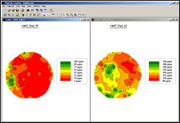 Access MapCalc using the Agdata.rgs database. Generate side-by-side 2D Lattice displays of the 1997_Fall_P (phosphorous) and 1997_Fall_K (potassium) maps as shown. Be sure the two maps use the SAME LEGEND (Hint: use “User Defined Ranges” and the “Save Template” options in the Shading Manager).

Question 1. Screen-grab the composite graphic and embed below.

<insert screen grab>

In general terms, describe any similarities and differences you” see” (visual interpretation) in the spatial patterns of the P and K maps.

< insert discussion >

Screen grab and embed the Shading Manager summary table for both maps with the Histogram tab selected. Discuss the similarities and differences between the two maps reported in their summary tables.

< insert screen grabs and discussion >

Part 2 – Comparing Discrete Maps

Generate a “Coincidence_summary” map between categorized 1997_Yield_volume and 1998_Yield_volume data using the Statistics tab in the Shading Manager table to identify the average (Mean) and standard deviation (St. Dev.) for both maps.

First create the two categorized maps (1997_Yield_classes and 1998_Yield_classes) for the two periods by renumbering the base maps to the binary progression of map values as indicated below—

1997_Yield_ Low = 1 = less than 1 StDev below the mean
1997_Yield_ Medium = 2 = between -1 StDev and + 1 StDev
1997Yield_ High = 4 = more than 1 StDev above the mean

1998_Yield_ Low = 8 = less than 1 StDev below the mean
1998_Yield_ Medium = 16 = between -1 StDev and + 1 StDev
1998_Yield_ High = 32 = more than 1 StDev above the mean

…then use “Compute plus” to combine the two maps for a Coincidence_summary map. Be sure to display the maps in as a Discrete data type with appropriate colors and labels for each of the categories.

Question 2. Embed screen-grabs of the two categorized maps and the Coincidence_summary map…

<insert screen grabs>

Complete the Coincidence Summary Table below using the summary cell counts in the Shading Manager table of the Coincidence_summary map you generated…

Coincidence Summary Table | 1997_Yield_classes Map
1998_Yield_classes Map |  | Low | Medium | High | Total | Percent
1998_Yield_classes Map | Low
1998_Yield_classes Map | Medium
1998_Yield_classes Map | High
1998_Yield_classes Map | Total |  |  |  |  | --
1998_Yield_classes Map | Percent |  |  |  | --

Note: For the main portion of the table, Total = sum of column and row counts and Percent same = ((#Same / Total) *100). For the overall portion of the table (boxed area), Overall Total = sum of Total column (or row) and Overall Percent Same = (Sum of #Same) / Overall Total) * 100)

Based on discussions in lecture and readings, briefly discuss the information in the “Coincidence Summary Table.” Be sure your discussion includes comments on the relative percentages of coincidence for the diagonal elements (Same, no change), Above Diagonal elements (Decrease) and below Diagonal elements (Increase)

< insert discussion >

Briefly comment (don’t implement) on how you might be able to determine if these two maps are significantly different (statistical tests).

< insert discussion >

Briefly comment on how a farmer might use the coincidence information.

< insert discussion >

Part 3 – Comparing Continuous Surface Maps

Calculate a “Percent_Difference” map between the 1997 and 1998 yield volume data …where the general percent difference equation is %Difference = ((New – Old) / Old) * 100. In this case, use the 1997 data as the “base” for evaluating the map equation …

Percent_Difference = ((1998_Yield_volume - 1997_Yield_volume) / 1997_Yield_volume) * 100

Question 3. Embed a screen-grab of the “Percent_Difference” map…

<insert screen grab>

Briefly describe the patterns you “see” (visual interpretation) in the Percent_Difference map.

< insert discussion >

Briefly describe the statistical summary in the Percent_Difference Map’s Shading Manager. Be sure to investigate the Statistics and Histogram tabs.

< insert discussion >

Part 4 – Identifying Unusual Areas

Using the Statistics tab in the Shading Manager table to identify the mean (Average) and standard deviation (StDev) calculate the following cut-off values for the 1997_Fall_P and 1997_Fall_K maps to identify areas of unusually high and low phosphorous and potassium in the field:

Question 4.

Unusually high P cutoff = P_mean + P_stdev = ___ < insert answer>___
Unusually low P cutoff = P_mean - P_stdev = ___ < insert answer>___

Unusually high K cutoff = K_mean + K_stdev = ___ < insert answer>___
Unusually low K cutoff = K_mean - K_stdev = ___ < insert answer>___

Using the 1997_Fall_P and 1997_Fall_K maps, create four binary maps identifying areas of unusually High_P=1, Low_P= 2, High_K=4 and Low_K= 8 with the background on all four binary maps = 0. Create a compound graphic containing all four maps with appropriate lables.

Embed the compound graphic showing all four maps…

<insert screen grab(s)>

Use Calculate to combine all four maps such that unique values and labels identify all possible combinations of the four unusual levels of P and K in the field. Be sure to label the 0 value condition.

Embed a screen-grab of the “unusual areas” map with labels…

<insert screen grab>

Based on discussions in lecture and readings, briefly discuss the “level-slicing” processing you just completed and the information it generated. Be sure your discussion includes comments on both visual interpretation and summary statistics of the “unusual areas” results.

< insert discussion >

Part 5 – Calculating a Similarity Map

Maximize the 1997_Fall_P window, switch to grid display format and add the layer mesh for reference. Move the cursor to the field location Column=8, row= 24 using the coordinate reference in lower left corner of the screen. Double-click at this location and note the 1997_Fall_P and _K and values—96.5 and 160, respectively—that represents the “data pattern” for the location.

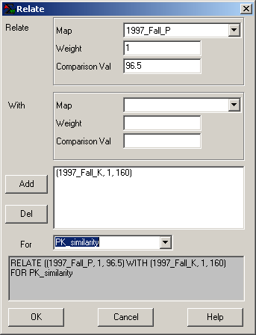 Select Map Analysis→ Statistics→ Relate and complete the dialog box as shown to calculate a PK_similarity map for the map location 8c, 24r. Set the display to a 2D continuous grid with a color ramp of 10 intervals in steps of 10 from 0= red to 100= green and with a yellow inflection point at 40 to 50.

Question 5. Screen-grab the PKN Similarity map and its shading manager table with the statistics tab showing and embed below…

<insert screen grab>

Complete the flowing table for the map locations identified using the Data Inspection tool by double-clicking on the PKN Similarity map and moving the cursor over the locations noted blow.

Note: the Column, Row locations as you move the mouse over the map are indicated at the top of the “drill-down” data table.

Similarity Table | Column | Row | 1997_Fall_P  Value | 1997_Fall_K  Value | Similarity  Value
Base Point | 8 | 24 | 96.5 | 160 | 100.0
Location 1 | 8 | 25
Location 2 | 30 | 12
Location 3 | 7 | 43
Location 4 | 49 | 22
Location 5 | 30 | 12
Location 6 | 48 | 5
Location 7 | 45 | 33
Location 8 | 48 | 45

Based on the data summary in the table, comment on how the similarity value changes as the P and K values change.
Hint: keep in mind that P=96.5 and K=160 are the base comparison values for assessing similarity.

< insert discussion >

Based on discussions in lecture and readings, briefly discuss the “similarity” processing you just completed and the information it generated.

< insert discussion >

Part 6 – Calculating a Cluster Map

Press the Map Analysis button and select Statistical→ Cluster and complete the dialog box as shown below…

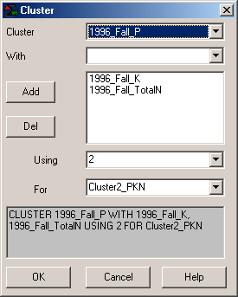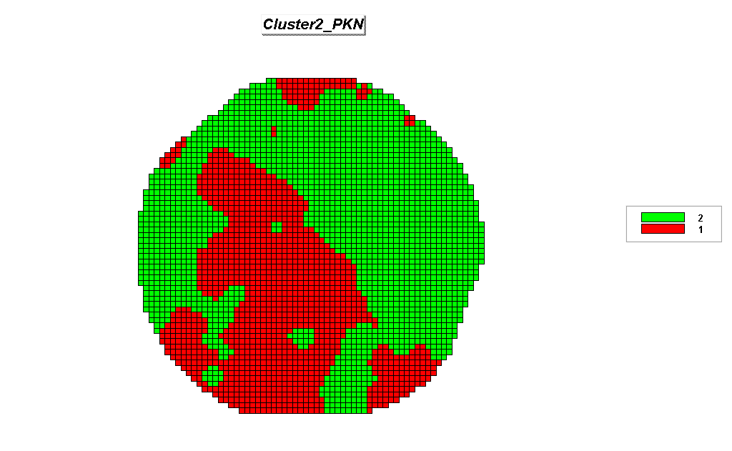

CLUSTER 1996_Fall_P WITH 1996_Fall_K, 1996_Fall_TotalN USING 2
FOR Cluster2_PKN

Question 6. Repeat the cluster analysis of the 1996_Fall P, K and TotalN levels specifying 3 and 4 clusters. Embed side-by-side displays (2D Grid discrete maps) of the 2, 3 and 4 cluster results below. Be sure that you retain the colors for the previous groupings as shown below—cluster 1= red and cluster 2= green for 2 clusters; original cluster 1=red, original cluster 2=green and new cluster 3= blue for 3 clusters; and original cluster 1= red, original cluster 2= green, original cluster 3= blue and new cluster 4= yellow for 4 clusters)…

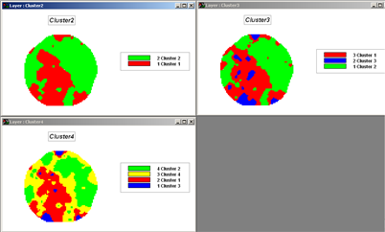
<insert screen grab(s)>

Discuss any relationships you detect among the three maps. (Aside: don’t do the Composite analysis to determine how separable the clusters are).

< insert discussion >

Part 7 – Deriving a Dependent Variable Map (the following questions use Smallville.rgs database)

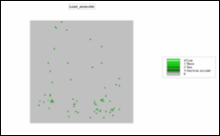 Use the View tool (binoculars) to generate a display of the Loan_accounts map in the Smallville.rgs database; screen grab and embed below.

Select Map Analysis → Neighbors→ Scan and complete the following command.

SCAN Loan_accounts Total IGNORE 0.0 WITHIN 15 CIRCLE FOR Loan_concentration

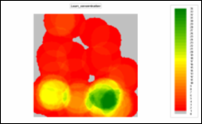 Use the Shading Manager to theme the map with 35 User Defined Ranges (1 unit interval) from 0 (light grey) to 1 (red) through 34 to 35 (green) with a yellow color inflection at mid-range; screen grab and embed below.

Question 7. Screen grab and embed the displays of the Loan_accounts and Loan_concentration maps below (be sure to include a caption with a short description for the processing and results).

<insert screen grab(s) and discuss>

Part 8 – Generating Scatter Plots of Map Correlation and Univariate Regression Equation

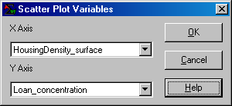 Generate a Scatter Plot and Regression equation for Loan_concentration and each of the HomeValue_surface, HousingDensity_surface, and HomeAge_surface maps (three separate plots) by selecting Map Set→ New Graph→ Scatter Plot and complete the dialog box as shown.

Question 8. Screen grab and embed the scatter plots below…

<insert screen grabs>

Considering Loan_concentration as the Dependent variable (Y axis) and HomeValue_surface as the Independent variable (X axis), what is the 1) linear regression equation calculated for the two maps and 2) its R-squared value?

1) Regression equation= ___<insert answer here>___

Identify, interpret and discuss the “slope” and “intercept” parameters of the equation. In your discussion, include an example prediction calculation of loan concentration for a location having a home value = 300 (thousand dollars).

< insert discussion and example calculation>

2) R-squared index= ___<insert answer here>___

Interpret and discuss the R-squared value.

< insert discussion >

Part 9 – Generating a Multivariate Regression Equation

Now generate a multivariate regression equation (more than one independent map variable) by Map Analysis→ Statistics→ Regress and completing the following command.

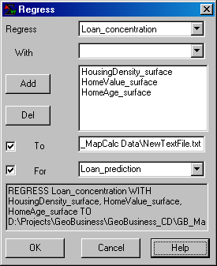

Note the regression equation generated…

Y Estimated = -9.157 + 0.097 * HomeAge_surface + 0.067 * HomeValue_surface
- 1.557 * HousingDensity_surface

Use the Shading Manager to apply the same legend as the Loan_concentration map—
34 User Defined Ranges (1 unit interval) from 0 (light grey) to 1 (red) through 34 (green) with a yellow color inflection at mid range to the Loan_prediction map.

Question 9. Create, screen grab and embed a side-by-side display of the Loan_concentration (Actual) and Loan_prediction (Predicted) maps below…

<insert screen grab>

Briefly discuss any patterns you see in the visual comparison of the ‘actual” and “predicted” maps.

< insert discussion >

_________________________________

Submit Optional question answers as separate Word document files with the Question number and your name (e.g., Optional_Ques9_1_Berry.doc)…do not include them with the normal weekly lab reports.

Optional Question 9-1 (3 extra credit points possible). Evaluating Regression Performance

Using the Loan_concentration and Loan_prediction maps you generated in in Parts 8 and 9 above, select Map Analysis→ Overlay→ Calculate and complete the following command to calculate the difference between the actual and predicted loan concentration maps.

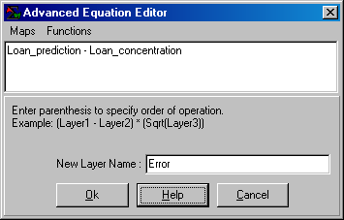

9-1a. Screen grab and embed the Error map and its Shading Manager table with Statistics tab displayed below…

<insert screen grab>

Briefly describe the error map in terms of its numeric and spatial distributions.

< insert discussion >

9-1b. Select Reclassify→ Renumber the Error map to generate a new map called Error_classes that isolates three error zones—
Zone 1 – Unusually high over estimate (greater than +1SD)
Zone 2 – Mean +/- 1 StDev
Zone 3 – Unusually high under estimate (less than -1SD)

Screen grab and embed the Error_classes map and its Shading Manager below…

<insert screen grab>

Based on the map and table you generated, how successful do you think the prediction equation is?

< insert discussion >

How do you think it might be used in business planning?

< insert discussion >

Optional Question 9-2 (3 extra credit points possible; note: you must complete Optional Exercise 8-1 before beginning this exercise). Complete the following processing—

- RENUMBER Error_classes ASSIGNING PMAP_NULL TO 2 THRU 3 FOR Error_class1
- COMPUTE Loan_concentration Times Error_class1 FOR Loan_concentration1
- COMPUTE HousingDensity_surface Times Error_class1 FOR Housing_density_surface1
- COMPUTE HomeValue_surface Times Error_class1 FOR HomeValue_surface1
- COMPUTE HomeAge Times Error_class1 FOR HomeAge_surface1
- REGRESS Loan_concentration1 WITH Housing_density_surface1, HomeValue_surface1, HomeAge_surface1 TO D:\Temp\NewTextFile.txt FOR Loan_prediction1

…to generating a Stratified Regression Equation for the error class 1 region derived in Part 4.

Enter the Entire Project Area (from Exercise 9, Part 3) and the Error Class 1 regression equations (calculated using above steps) in the table below.

 | Regression Equation
Entire project area equation (Part 3) | <insert Entire equation>
Error Class 1 equation (above) | <insert Error1 equation>

Briefly discuss any similarities or differences you note in the equations…

< insert discussion >

Evaluate the Error Class 1 regression equation for the entire project area to generate a Loan_prediction1 map and an Error1 map. Use the Error_class1 map to as a mask, and then screen grab and embed the maps in the table below.

Comparison of Prediction/Error Maps (masked for Error1 zone)
Using Entire Project Area Equation | Using Error_Class1 Equation
<insert masked Loan_prediction map> | <insert masked Loan_prediction1 map>
<insert masked Error map> | <insert masked Error1 map>

Briefly discuss any similarities or differences you note in the maps…

< insert discussion >

Optional Question 9-4 (3 extra credit points possible). In your own words explain the statistical terms Mean, Standard Deviation, Skewness, Kurtosis, Median, and Quartile Range as discussed in lecture and any outside references you find helpful. Assume you are explaining the terms to a client that has minimal math/stat expertise.

Optional Question 9-4 (3 extra credit points possible). Use the Interpolation Wizard in MapCalc to generate soil nutrient maps of P, K and NO3_N for a farmer’s field (instructions below). Embed screen captured graphics, discussion and comments as you deem appropriate to describe the processing.

Optional Question 9-5 (3 extra credit points possible; requires Excel prowess). Export the Loan_concentration, Use Excel to calculate three separate regression equations for the Error Classes derived in Optional question 8-1.

Error Class | Regression Equation
Class 3 (greater than +1SD)
Class 2 (Mean +/- 1SD)
Class 1 (less than 1SD0

Hint: File→ Export→ Data, select Error_classes, Loan_concentration, HousingDensity_surface, HomeAge_surface, and HomeValue_surface, and then specify Smallville_loan as the File name and CSV as the File type. Access the File in Excel then “Sort” on Error_classes. Use the “Data Analysis” add-in to calculate the “Regression” equation for each of the three error class sections of the data file.

Optional Question 9-6. (3 extra credit points possible). Using the Bighorn.rgs database, complete the following analysis that uses two different techniques for investigating the spatial coincidence and correlation between the simple proximity to roads (Road_prox; Simple, To 150) and the housing density (Housing_density; Total, Within 6) occurring in the project area.

Coincidence Summary Approach. Embed key intermediate maps and final map with the Shading Manager for each:

<Insert Road_Prox> | <Insert Housing_density>
<Insert Road_prox_classes> | <Insert Housing_density_classes>
<Insert Coincidence_map> | <Insert Coincidence_ShadingManager>

Based on the Shading Manager summary statistics complete the following table:

 | Proximity to Roads Classes
Housing  Density  Classes |  | Low (0-3 cells away) | Medium (3-7) | High (>7) | Totals
Housing  Density  Classes | Low (0-10 houses)
Housing  Density  Classes | Medium (10-20)
Housing  Density  Classes | High (>20)
Housing  Density  Classes | Totals

Briefly discuss the coincidence statistics in the table and how general relationships between the two maps can be interpreted…

< insert discussion >

Scatterplot/Regression Approach. Embed key intermediate maps and scatter plot:

<Insert Road_Prox> | <Insert Housing_density>
<Insert Scatterplot Road_Prox (X) versus Housing_density (Y)>

Complete the following table:

Regression Equation
R-squared:

Briefly discuss the regression/correlation statistics in the table and how general relationships between the two maps can be interpreted…

< insert discussion >

Optional Question 9-7. (3 extra credit points possible). Complete the following processing and write-up of the results—

1) Generate a map showing three clusters using the HousingDensity_surface, HomeValue_surface and HomeAge_surface maps in the Smallville.rgs data base. Enter your results in the “master table” at the end of this question.

2) Derive a multivariate regression equation and its prediction map for Cluster #1 area using the HousingDensity_surface, HomeValue_surface and HomeAge_surface maps in the Smallville.rgs data base as independent variables and Loan_concentration as the dependent variable. Enter your results in the master table.

Hint: you need to create a binary map to mask the cluster areas by Renumber the cluster map assigning 1 to Cluster #1 and PMAP_NULL to everything else. Use this map to isolate the data for the independent and dependent maps before deriving the regression equation and prediction map.

3) Repeat the processing to derive regression equations and prediction maps for Clusters #2 and #3 areas. Enter your results in the master table.

Hint: be sure you use a consistent map legend for all of the prediction maps

4) Combine the three individual prediction maps into a single prediction map.

Hint: use the Cover command.

5) Derive the multivariate regression equation and its prediction map for the entire project area as described in part 4. Enter your results in the master table.

6) Visually compare the results of the Combined and Entire predictions maps and comment on similarities and differences you see at the end of the master table.

<insert Cluster Map from step 1>
<insert caption/description>
<insert Regression equation for Cluster 1 from step 2>
<insert actual Loan_concentration map>  Loan_concentration Map | <insert Cluster #1 Prediction map>  <insert caption and short discussion>
<insert Regression Equation for Cluster 2 from step 3>
<insert actual Loan_concentration map>  Loan_concentration Map | <insert Cluster #2 Prediction map>  <insert caption and short discussion>
<insert Regression Equation for Cluster 3 from step 3>
<insert actual Loan_concentration map>  Loan_concentration Map | <insert Cluster #3 Prediction map>  <insert caption and short discussion>
Visual Comparison of Combined and Entire Prediction Maps
<insert actual Loan_concentration map>  Loan_concentration Map | <insert Combined Prediction map; step 4>  <insert caption and short discussion>
<insert actual Loan_concentration map>  Loan_concentration Map | <insert Entire Prediction map: step 5>  <insert caption and short discussion>

<insert your comments on similarities and differences you see; step 6>

Optional Question 9-8. (3 extra credit points possible). Complete the following processing and write-up of the results—

1) The 2000_Image_8_30_NDVI map in the AgData2.rgs database depicts the Normalized Density Vegetation Index (NDVI indicating relative plant vigor at the end of the growing season— NDVI= ((NIR – Red) / (NIR + Red)). Create a NDVI_zones map that identifies three zones of 1) unusually Low (minimum value to Mean – 1 Stdev),Ttypical (Mean – 1 Stdev to Mean + 1 Stdev) and unusually High (Mean + 1 Stdev to maximum value). Enter your results in the “master table” at the end of this question.

2) Derive a multivariate regression equation and its prediction map for the Low Zone area using the 2000_Image_8_30_NDVI as independent variables and 2000_yield_volume as the dependent variable. Enter your results in the master table.

Hint: you need to create a binary map to mask the cluster areas by Renumber the cluster map assigning 1 the Low zone and PMAP_NULL to everything else. Use this map to isolate the data for the independent and dependent maps before deriving the regression equation and prediction map.

3) Repeat the processing to derive regression equations and prediction maps for Typical and High zones. Enter your results in the master table.

Hint: be sure you use a consistent map legend for all of the prediction maps

4) Combine the three individual prediction maps into a single prediction map.

Hint: use the Cover command.

5) Derive the multivariate regression equation and its prediction map for the entire project area based on the entire2000_Image_8_30_NDVI (indeprndent) and 2000_yield_volume (dependent). Enter your results in the master table.

6) Visually compare the results of the Combined and Entire predictions maps and comment on similarities and differences you see at the end of the master table.

<insert NDVI_zones Map from step 1>
<insert caption/description>
<insert Regression equation for Low zone from step 2>
<insert actual 2000_yield_volume map>  2000 Yield Volume Map | <insert Low zone Prediction map>  <insert caption and short discussion>
<insert Regression Equation for Typical zone from step 3>
<insert actual 2000_yield_volume map>  2000 Yield Volume Map | <insert Typical zone Prediction map>  <insert caption and short discussion>
<insert Regression Equation for High zone from step 3>
<insert actual 2000_yield_volume map>  2000 Yield Volume Map | <insert High zone Prediction map>  <insert caption and short discussion>
Visual Comparison of Combined and Entire Prediction Maps
<insert actual 2000_yield_volume map>  2000 Yield Volume Map | <insert Combined Prediction map; step 4>  <insert caption and short discussion>
<insert actual 2000_yield_volume map>  2000 Yield Volume Map | <insert Entire Prediction map: step 5>  <insert caption and short discussion>

<insert your comments on similarities and differences you see; step 6>

