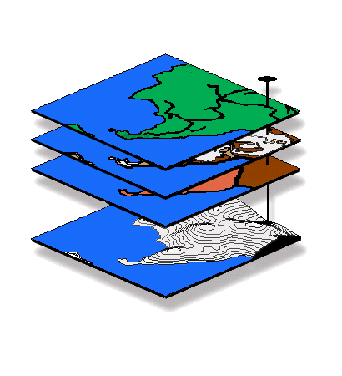
Introduction to GIS Modeling
…an introductory course in grid-based map analysis

GEOG 3110, University of Denver

Midterm Exam

This exam is a two-hour, CLOSED BOOK/NOTES affair taken over the Internet (honor system) — at your convenience anytime after 8:00 am, Friday, February 12 and must be completed by 5:00 pm, Wednesday, February 17th. You will download the exam (time/date stamped at our class website) and submit the completed document within 2.0 hours via email to jberry@innovativegis.com.

BE SURE to save your completed Word file as Exam1<your name>.doc before you exit and email as an attachment!!!

Name _<enter name>___________________

Date _<enter date>______ Time started _<time>_____ Time completed _<time>____

Part I — Choose ONLY five of the following seven 20-point questions (i.e., do not answer two). Enter your answers in the space provided below each question.

Question 1. (20 points). Identify and discuss the three fundamental “types of map features” used in desktop mapping (vector-based systems).

Identify and discuss the fourth type that is extensively used in GIS modeling (grid-based systems)?

Question 2. (20 points). What is the distinction between a “map” and a “map surface?”

Question 3. (20 points). Define and describe the differences among the following distance terms.

a) Simple Distance—

b) Simple Proximity—

c) Effective Proximity—

d) Optimal Path—

e) Optimal Path Density—

Question 4. (20 points). What does the value 0 (zero) indicate on the resultant map when you subtract two travel-time surfaces from two different locations in a given project area?

What does the sign of a map value (positive or negative) on the difference surface indicate?

What information does the magnitude of a map value on the difference surface?

Question 5. (20 points). Contrast the concepts of “simple buffer distance” (vector analysis) and “effective proximity buffer” (grid-based analysis).

Question 6. (20 points). Identify and briefly describe the four processing levels of a suitability model.

Which levels involve “real” geographic information (could validate through direct field measurement) and which involve “decision context” information (cognitive and cannot be validated through direct field measurement)?

Question 7. (20 points). Identify and briefly describe the differences in information contained in the following types of visibility maps:

Simple Viewshed—

Visual Exposure Density Surface—

Weighted Visual Exposure Density Surface—

Net-Weighted Visual Exposure Density Surface—

Part II — Choose ONLY one of the following three 25-point questions (i.e., do not answer two).

Question 8. (25 points). In MapCalc’s Radiate command for calculating visual connectivity, how do the “simply,” “completely,” and “weighted” options affect the resultant map?

Explain what the “At <height>” and “Thru <surface>” options do.

Question 9. (25 points). Referring to the following diagram, if the cell size is 100 meters, what is the Simple Distance from point A to point B (in meters)? What is the Effective Distance (in minutes) considering the relative friction factors (friction units in minutes; -0.0 indicates an absolute barrier) indicated in the upper portion of each grid cell?

Show your calculations and answers in the spaces provided below.

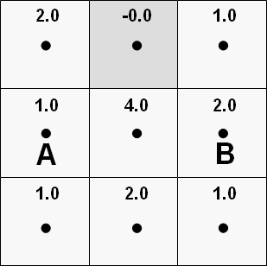

Simple distance calculations = <show your calculations here>

Simple Distance = __<calculated value>__ __<units>__

Effective distance calculations = <show your calculations here>

Effective Distance = __<calculated value>__ __<units>__

Question 10. (25 points). Briefly describe how region-wide overlay (Composite) works.

Use the example of determining the average Slope (Slope_map) for each District (Districts_map) in a project area in your discussion.

Finally, explain how the Coefficient of Variation in slope (Slope_map) for each District (Districts_map) would be calculated and how the result might be interpreted for use in wildlife habitat modeling.

Part III — Choose ONLY one of the following three 25-point questions (i.e., do not answer two).

Question 11. (25 points). Given base maps of Roads, Elevation and Watersheds (Island.rgs database), develop a simple map analysis model that will assign a “visual exposure to Roads value” to just the cell locations defining the watersheds.

Note: use MapCalc and SnagIt to capture and embed your solution below; be sure you identify the command and briefly discuss the processing for each step in your solution.

Question 12. (25 points). Given the base map of Total_customers (Smallville.rgs database), create a map that identifies pockets of high customer density with over 35 customers within a quarter of a mile (6-cell radius reach; circle).

Note: use MapCalc and SnagIt to capture and embed your solution below; be sure you identify the command and briefly discuss the processing for each step in your solution.

Question 13. (25 points). Given base maps of Covertype and Elevation (Tutor25.rgs database) develop and implement a map analysis model that assigns the average slope for forested locations that are southerly oriented (from 135 to 225 degrees azimuth).

Note: use MapCalc and SnagIt to capture and embed your solution below; be sure you identify the command and briefly discuss the processing for each step in your solution.

