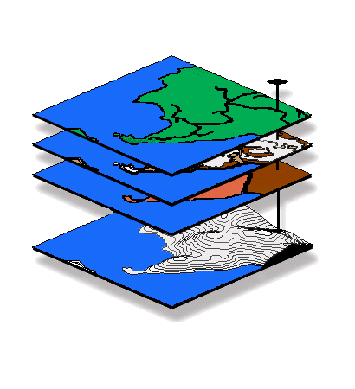
Introduction to GIS Modeling
…an introductory course in map analysis

GEOG 3110, University of Denver

Exam 2 – Spatial Statistics

This exam is a 2.0 hour, closed book/notes affair taken over the Internet (honor system) at your convenience— posted on the class website by 10:00 am, Thursday, March 11th and must be completed by 5:00 pm, Tuesday, March 16th. You will download the exam (time/date stamped at our website) and submit the completed document within 2.0 hours. BE SURE to save your completed Word file before you exit to submit it!!!
…and email the completed document to me (jberry@innovativegis.com) within 2.0 hours.

Name ________________________________

Date _______________ Time started ___________ Time completed _____________

Questions on Terminology, Procedures and Basic Concepts…

Choose ONLY FIVE of the following seven questions (i.e., do not answer two; total of 100 points possible)…

1) <20 points possible>. What information is lost when you assign a single value to a polygon (e.g., average lead concentration in well water for an entire county with hundreds of potable wells) based on a set of field samples collected within the county? Be sure your answer includes a brief discussion of how spatial statistics would provide a different “view” of the same data.

Answer #1 here…

2) <20 points possible>. What is the differences among spatial “interpolation,” spatial “extrapolation.” Be sure your answer identifies which of the two processing conditions usually results in more accurate estimates and why.

Answer #2 here…

3) <20 points possible>. What information is provided by the 1) “arithmetic sum of the signed residuals” and 2) “average unsigned residual” when assessing interpolation performance (residual analysis)? Be sure your answer comments on how the residual analysis can be used to generate a map of interpolation error.

Answer #3 here…

4) <20 points possible>. Identify and briefly discuss 1) one approach used to compare discrete maps and 2) one approach that can be used to compare map surfaces. Be sure your answer includes a brief discussion of the strengths and weaknesses of the two approaches you describe.

Answer #4 here…

5) <20 points possible>. Briefly describe the conceptual difference between the “numeric distribution” and the “spatial distribution” of field-sampled data. Be sure your answer discusses the differences in conceptual perspective between “Central Tendency” and “Variation Mapping.”

Answer #5 here…

6) <20 points possible>. What is the difference between “spatial autocorrelation” and “spatial correlation?” Be sure your answer addresses the fundamental traditional statistics assumption of “variable independence.”

Answer #7 here…

7) <20 points possible>. What is the difference between and “spatial analysis” and “spatial statistics?” Be sure your answer includes a couple of examples of procedures for both map analysis approaches.

Answer #8 here…

Questions on “How Things Work”…

Choose ONLY TWO of the following four questions (i.e., do not answer two; total of 50 points possible)…

9) <25 points possible>. In your own words explain the major differences between “Inverse Distance Weighted” and “Kriging” interpolation approaches as explained in the lecture and readings. Assume you are explaining the terms to a client that has minimal math/stat and GIS expertise.

Answer #9 here…

10) <25 points possible>. Given two maps of point field samples for two different time periods (June and August) that identify the geographic position (longitude, latitude) and total number of animals encountered (count), briefly describe the map analysis processing steps used to—
1) generate two continuous animal activity map surfaces (IDW interpolation),
2) calculate two maps identifying “pockets” of unusually high animal activity (Renumber), and
3) compare the two discrete maps of high animal activity (Crosstab).

…assume you are explaining the processing to a fellow student that has minimal math/stat and GIS expertise.

Answer #10 here…

11) <25 points possible>. In your own words explain the major differences between “Inverse Distance Weighted” and “Kriging” interpolation approaches as explained in the lecture and readings. Assume you are explaining the terms to a client that has minimal math/stat expertise.

Answer #11 here…

12) <25 points possible>. Given a binary masking map of the field edge (0= edge, 1= interior) and two map surfaces of corn yield (bushels per acre) for two consecutive years, briefly describe the map analysis processing steps used to—
1) generate a difference surface (Calculate),
2) normalize the difference for a percent change map (Calculate),
3) mask to eliminate the field edge (Calculate), and
4) identify locations of significant change of having more than 30% difference (Renumber).

…assume you are explaining the processing to a farmer that has minimal math/stat and GIS expertise.

Answer #12 here…

