GIS and Technical Oz

A Discussion of the History, Driving Forces and Future Directions
Guiding the Evolution/Revolution of Geotechnology

Presented by

Joseph K. Berry

W. M. Keck Scholar in Geosciences, Geography Department, University of Denver
Principal, Berry & Associates // Spatial Information Systems
Email jberry@innovativegis.com — Web www.innovativegis.com/basis/

In just three decades, GIS technology has dramatically changed our perspective on both what constitutes a map and the information it contains. Manually drafted maps have traditionally emphasized accurate location of physical features. However the journey from the map room to the conference room and a car’s dashboard has extended maps from static wall hangings to interactive mapped data. This new perspective marks a turning point in the use of maps— from one emphasizing physical descriptions of geographic space (descriptive mapping), to one of interacting with maps and successfully visualizing/communicating influences of spatially based factors (spatial reasoning). This presentation investigates the context, conditions and forces driving the transition from maps to mapped data, map analysis, multimedia mapping and beyond.

Online reference: www.innovativegis.com/basis/Papers/Other/Geotechnology/Geotechnology_history_future.htm

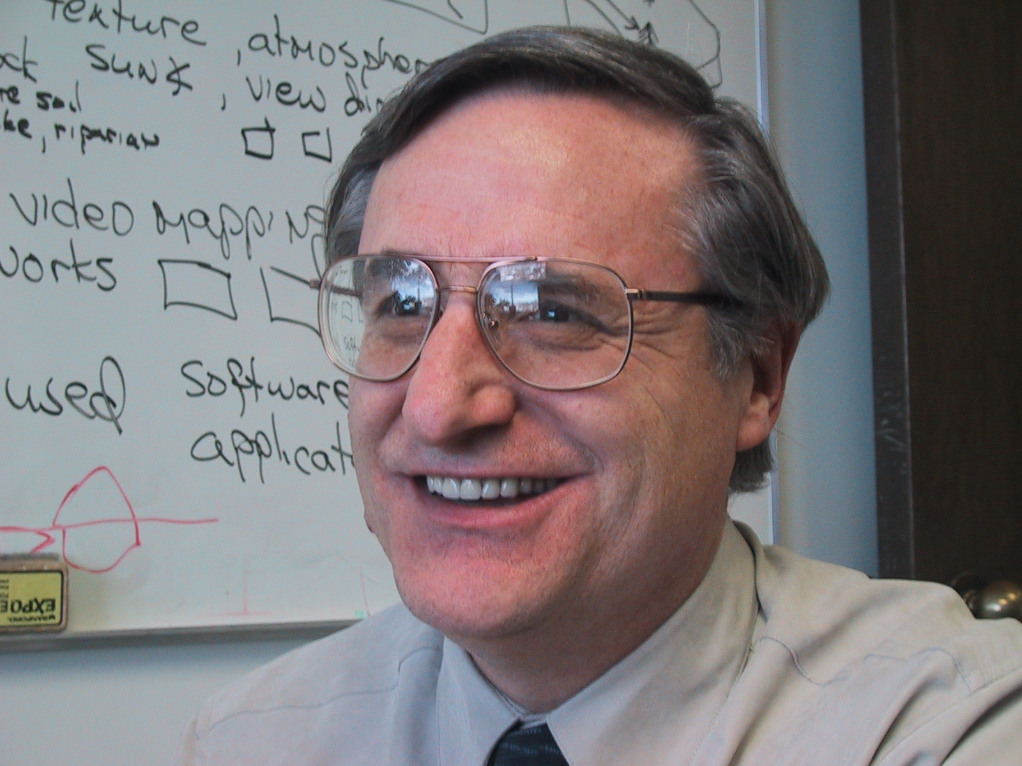
Joseph K. Berry is a leading consultant and educator in the application of Geographic Information Systems (GIS) technology. He is the principal of BASIS, consultants and software developers in GIS technology and the author of the “Beyond Mapping” column for GeoWorld magazine for over eighteen years. He has written more than two hundred papers on the theory and application of map analysis techniques, and is the author of the popular books Beyond Mapping Spatial Reasoning and Map Analysis. Since 1976, he has presented college courses and professional workshops on geospatial technology to thousands of individuals from a wide variety of disciplines. Dr. Berry conducted basic research and taught courses in GIS for twelve years at Yale University's Graduate School of Forestry and Environmental Studies, and is currently the W. M. Keck Visiting Scholar in Geosciences at the University of Denver and a Special Faculty member at Colorado State University. He holds a B.S. degree in forestry from the University of California, Berkeley, a M.S. in business management and a Ph.D. emphasizing remote sensing and land use planning from Colorado State University.
www.innovativegis.com/basis/

